

Portfolio Website

Software Requirements Specification

23rd April 2024

Anuj Kumar
K22KR

Prepared for
Continuous Assessment 3
Spring 2024

Revision History

Date | Description | Author | Comments
22/04/24 | Version 1 | Anuj Kumar | First Revision

Table of Content

1. Introduction 1
1.1 Purpose 1
1.2 Scope 1
1.3 Definitions, Acronyms, and Abbreviations 1
1.4 References 1
1.5 Overview 1
2. General Description 2
2.1 Product Perspective 2
2.2 Product Functions 2
2.3 User Characteristics 2
2.4 General Constraints 2
2.5 Assumptions and Dependencies 2
3. Specific Requirements 2
3.1 External Interface Requirements 3
3.1.1 User Interfaces 3
3.1.2 Hardware Interfaces 3
3.1.3 Software Interfaces 3
3.1.4 Communications Interfaces 3
3.2 Functional Requirements 3
3.2.1 <Functional Requirement or Feature #1> 3
3.2.2 <Functional Requirement or Feature #2> 3
3.5 Non-Functional Requirements 4
3.5.1 Performance 4
3.5.2 Reliability 4
3.5.3 Availability 4
3.5.4 Security 4
3.5.5 Maintainability 4
3.5.6 Portability 4
3.7 Design Constraints 4
3.9 Other Requirements 4
4. Analysis Models 4
4.1 Data Flow Diagrams (DFD) 5
5. Github link…………………………………………………………………………………………………….5
5. CLIENT APPROVAL PROOF……………..…………………………………………………………………….5
A. Appendices 5
A.1 Appendix 1 5
A.2 Appendix 2 5

### Software Requirements Specification (SRS) for Portfolio Website with Snake Game

1. **Introduction**

The Portfolio Website with Snake Game is a web application designed to serve a dual purpose – showcasing the professional work of an individual through a portfolio display and providing a classic Snake Game for entertainment. This document outlines the comprehensive requirements for the development of this software.

2. **Functional Requirements**

- **Portfolio Section**

1. The website shall have a dedicated section to present the individual's professional portfolio, providing a platform to exhibit various projects, achievements, and expertise.

2. Users shall be able to navigate through different projects, and each project shall include interactive details such as title, description, images, and videos to effectively showcase the work.

3. The portfolio section shall incorporate filtering options to facilitate users in categorizing projects based on different criteria, such as type, industry, or technology used, enhancing accessibility and user experience.

- **Snake Game**

1. The website shall offer a classic Snake Game with easily comprehensible and responsive controls.

2. The game interface shall display the current score, the highest score achieved by the user, and the length and growth of the snake, providing engaging feedback during gameplay.

3. Users shall have the ability to start, pause, and reset the game at any point, ensuring a seamless and enjoyable gaming experience.

3. **Non-Functional Requirements**

- **Usability**

1. The website shall prioritize an intuitive and user-friendly interface, enabling smooth and effortless navigation between the portfolio section and the snake game, promoting user engagement and satisfaction.

2. The Snake Game shall incorporate clear and comprehensive instructions on gameplay, ensuring that users understand the game mechanics and controls, contributing to an enjoyable and easily accessible gaming experience.

- **Performance**

1. The website shall be optimized to load within 3 seconds, maximizing user retention and satisfaction by providing a fast and efficient browsing experience.

2. The Snake Game shall operate seamlessly, free from lags or delays, ensuring swift and responsive feedback to user input, thereby maximizing user enjoyment and engagement.

- **Security**

1. The website shall adhere to best practices for security to safeguard user data and privacy, employing robust measures to prevent unauthorized access and ensure a secure browsing environment for users.

4. **User Interface Requirements**

- The website shall feature a visually appealing, modern, and professional design to attract and engage users, reflecting the individual's expertise and creativity in both professional and gaming contexts.

- The Snake Game shall incorporate a responsive design, ensuring compatibility with diverse screen sizes and devices, enabling users to enjoy seamless gameplay across various platforms.

5. **System Requirements**

- **Hardware Requirements**

1. Users shall be able to access the website using a wide range of devices, including desktop computers, laptops, tablets, and smartphones, ensuring optimal accessibility and reach.

2. The Snake Game shall be playable on devices utilizing standard input methods, such as keyboard, mouse, or touch screen, enabling users to enjoy the game effortlessly across different devices.

- **Software Requirements**

1. The website shall be compatible with modern web browsers, including Google Chrome, Mozilla Firefox, and Safari, ensuring a consistent and seamless browsing experience for users across various platforms.

2. The Snake Game shall be implemented using HTML5, CSS3, and JavaScript, ensuring cross-platform compatibility and enabling users to enjoy the game across a diverse range of devices and browsers.

6. **Conclusion**

The Portfolio Website with Snake Game aims to deliver a versatile and engaging user experience, harmoniously combining a professional showcase with recreational entertainment. By meticulously meeting the outlined requirements, this software will offer a seamless and immersive experience, aligning with the individual's creative vision and professional expertise.

This Software Requirements Specification serves as a comprehensive blueprint for the development and implementation of the Portfolio Website with Snake Game.

9. Github Links & Screenshots
LINK:

Website :


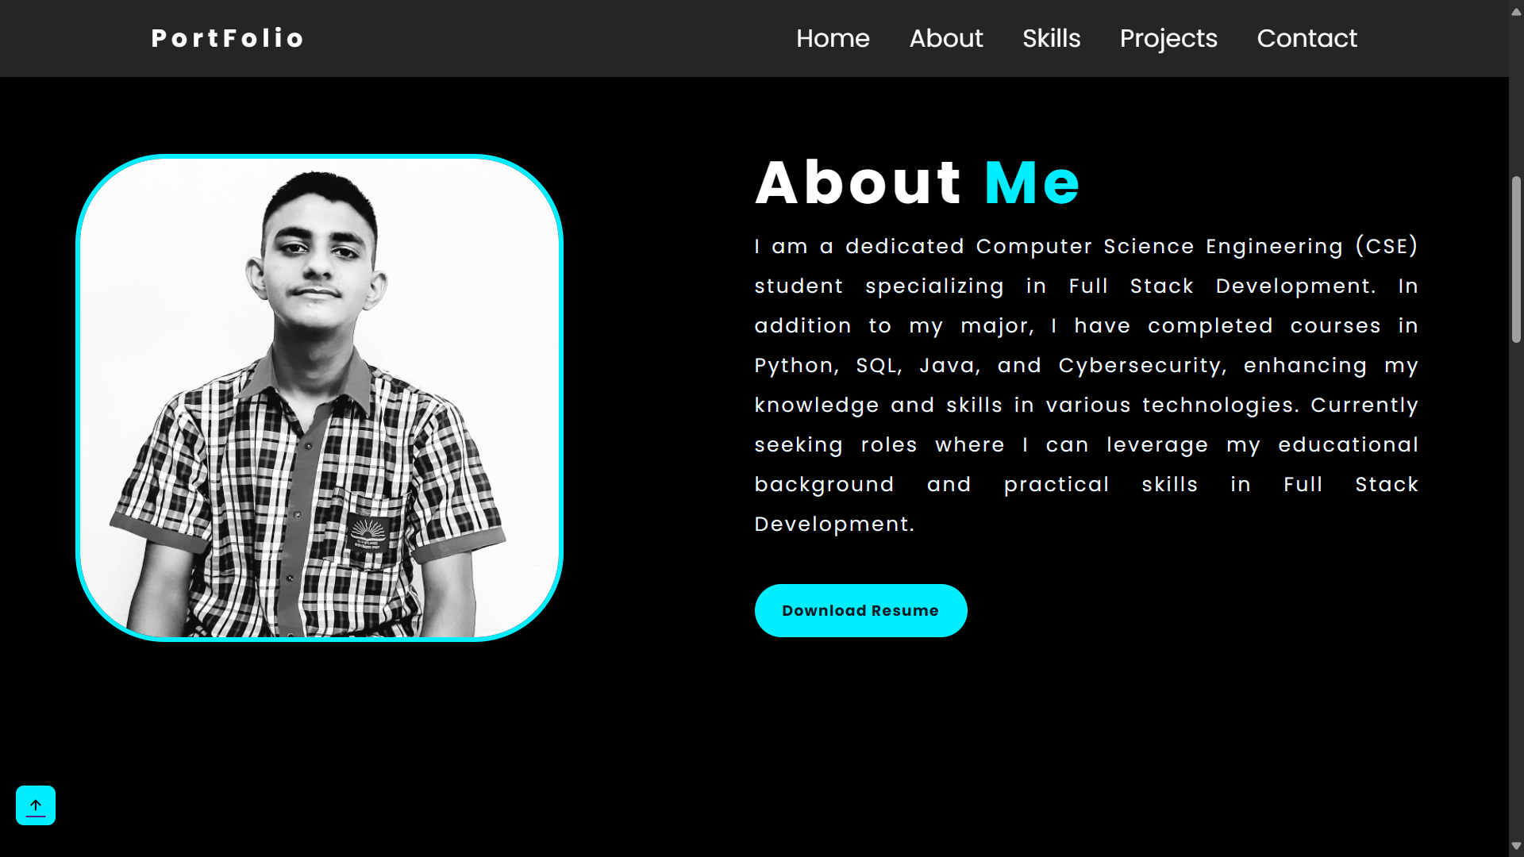

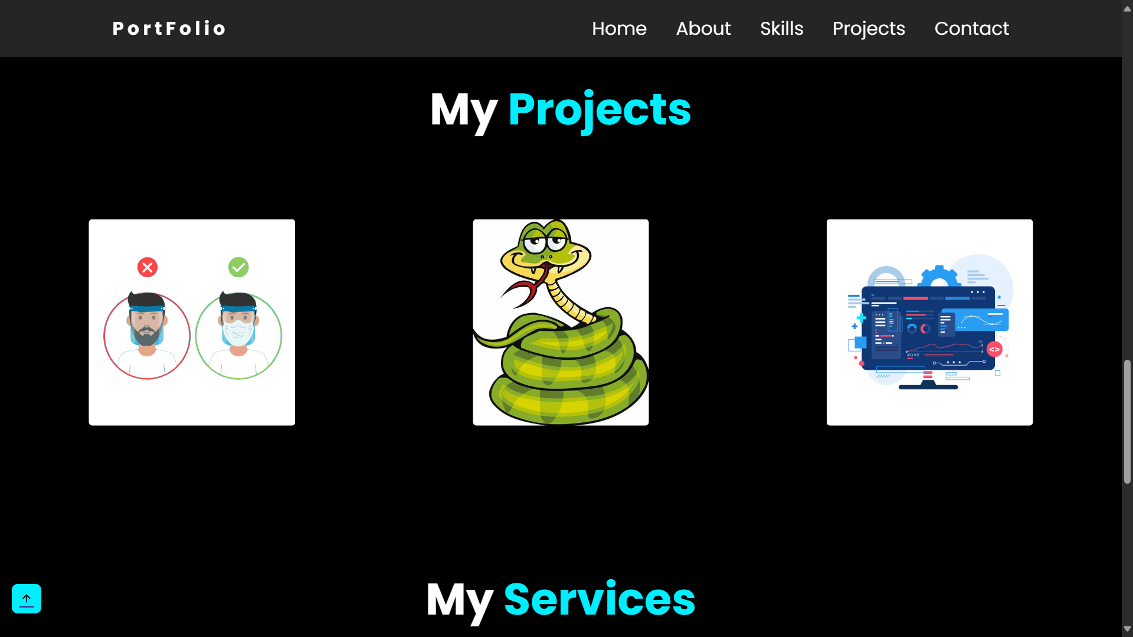

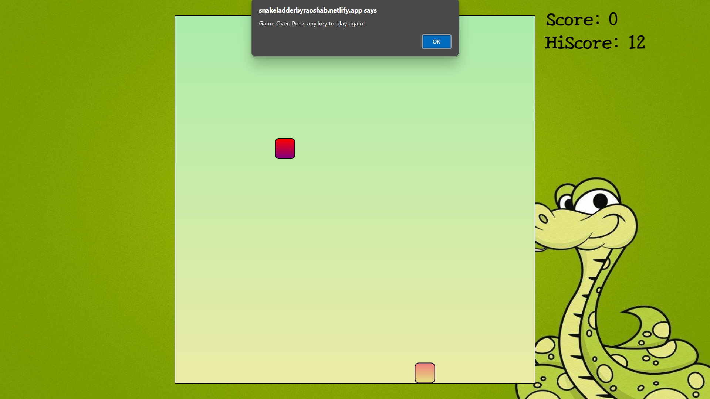

SOURCE CODE:
