

Swami Vivekanand Institute of Engineering & Technology
Affiliated to
I.K. Gujral Punjab Technical University
Department of Civil Engineering
Synopsis Report
On
Industrial & Software Training
Session (2025-2026)

Submitted By: Nirajan kumar yadav
Semester: 8th
University roll number: 2207406
Training Organization Name: Hanu AI
Duration of Training: 22nd December 2025 to 22nd April 2026
Submission Date: 28th May 2026

Under the guidance of: ……………

Submitted to: ……………. HOD’S Signature: ……………

ACKNOWLEDGEMENT

I express my sincere gratitude to all those who supported and guided me throughout the completion of my academic and industrial training.
I would especially like to thank Manav Sir, Prerna Kalra Ma’am, Rahul Kalra Sir, Kaushik Bharti Sir, Vedik Sir, and Mrs. Shivani Guleria Ma’am for their valuable guidance and encouragement.
I am also thankful to my faculty members and colleagues for their continuous support during this training period.



Index

1. Introduction

1.1 Introduction to Organizations

1.2 Objectives

1.3 Scope of Training

2. Organization Profile

2.1 Overview of the Organization
2.2 Company Overview
2.3 Services and Solutions
2.4 Specialized Solutions
2.5 Leadership Team
2.6 Contact Information

3. Industrial & Software Training Overview

3.1 Description of Training
3.1.1 Work Profile (As a Project Associate & Surveyor)
3.2 Key Learning Areas
3.3 Tools and Technologies Used
3.3.1 Hardware Tools
3.3.2 Software/Technology
3.4 Step-by-Step Workflow: AI-Based Road Survey Video Recording

4. Standard operation procedure (sop)

4.1 Introduction

4.2 Survey Purpose

4.3 Pre Survey Condition

4.4 Before Leaving Condition

4.5 At Survey Purpose Location

4.5.1 Camera Setup for pavement

4.5.2 Camera Set Furniture

4.6 Before Survey Start

4.7 During Survey
4.8 Uploading Raw Data To Cloud.
4.9 Key Learning Area.

5. Tasks and Projects Completed

5.1 National Highway Authority of India (NHAI)
5.2 Punjab Public Works Department (PWD) & Punjab Mandi Board (PMB)
5.3 Gujrat R&B (Road and Building)
5.4 Haryana Municipal Corporation Roads

6. Dashboard Presentation AND Data Submission

6.1 Dashboard Presentation
6.2 Data Submission

7. Learning Outcomes

7.1 Skills Acquired
7.1.1 Technical & Analytical Skills
7.1.2 Data Analysis & Visualization
7.1.3 Communication & Collaboration
7.1.4 Project Management
7.1.5 Adaptability and Problem Solving

8. Challenges & Solutions

8.1 Challenges Faced and Their Solutions
8.1.1 Data Collection & Accuracy Issues
8.1.2 Traffic Congestion & Management
8.1.3 Integration of Smart Technologies
8.1.4 Public Compliance & Awareness
8.1.5 Cybersecurity Risks in Traffic Systems

9. Conclusion

9.1 Summary of Training as a Surveyor at RoadAthena / Hanu AI
9.2 Recommendations

10. Annexures / Appendices

11. Glossary of Terms

12. References

13. Self-Reflection / Personal Growth

INTRODUCTION

- INTRODUCTION TO ORGANIZATIONS

Hanu AI, operating under the brand name RoadAthena, is a forward-thinking technology company at the intersection of artificial intelligence, civil engineering, and infrastructure intelligence. The company’s core mission is to modernize and digitize the way public infrastructure—particularly road networks—is monitored, assessed, and managed. With a strong emphasis on automation and data-driven insights, RoadAthena uses cutting-edge AI models to evaluate pavement conditions, detect structural defects, and identify roadside assets such as signboards, barriers, lane markings, and medians.
The organization primarily caters to governmental and civic clients, including high-profile entities like the Ministry of Road Transport and Highways (MoRTH), National Highways Authority of India (NHAI), Public Works Department (PWD), and Punjab Mandi Board (PMB), Gujrat R&B (Road and Building) PWD, Haryana Municipal Corporation Roads .These institutions rely on Roadathena’s digital survey solutions to plan and implement road maintenance schedules, assess infrastructure aging, and improve traffic safety across urban and rural landscapes. The company combines AI-driven defect detection with geospatial analysis and cloud computing to deliver accurate, scalable, and timely intelligence for public infrastructure planning.
By integrating hardware (camera and GPS systems), software (AI models and annotation platforms), and cloud services (like Amazon S3 and OneDrive), RoadAthena offers a comprehensive end-to-end solution for smart road management, enabling faster decision-making, cost optimization, and reduced dependence on manual surveys.

- OBJECTIVES
The training program at Hanu AI was designed to provide a multi-dimensional learning experience, blending theoretical understanding with practical application. As a Project Associate, I was given the opportunity to immerse myself in various aspects of AI-powered civil infrastructure evaluation.
The following were the key objectives of the training:
- To understand the fundamentals and applications of AI in civil infrastructure management: This included learning how machine learning and computer vision techniques are used to analyze visual road data and generate actionable insights for engineers and policymakers.
- To contribute actively to AI-based road surveying as a civil engineering trainee: I participated in several field surveys across both urban and rural roads, assisting in camera calibration, GPS logging, and real-time data monitoring.
- To learn the real-world implementation of AI solutions in transportation: I worked on integrating raw data with backend AI systems, enabling me to witness how theoretical AI models are deployed in real environments to detect defects and classify infrastructure elements.
- To analyze and validate road survey data for accuracy and completeness: Through hands-on experience with quality control tools and annotation software, I performed manual tagging, validated model outputs, and reviewed inconsistencies to ensure high data accuracy.
- To develop problem-solving skills by handling equipment setup and software bugs: Field challenges such as camera failures, GPS connectivity issues, and data sync errors allowed me to develop quick troubleshooting methods and adaptive thinking.
- To become proficient in technical documentation and reporting standards: I maintained logs, upload records, and technical reports that were shared with stakeholders for review and feedback, strengthening my written communication and professional documentation skills.

- SCOPE OF TRAINING

- The scope of my training at Hanu AI was broad and highly relevant to emerging trends in civil engineering. This experience exposed me to the convergence of traditional infrastructure development and modern data science technologies such as Artificial Intelligence (AI), Geographic Information Systems (GIS), and Road Safety Audit (RSA)

- The training bridged the often-significant gap between theoretical knowledge and real-world field practice. In the classroom, we learn about pavement design, structural failures, and surveying techniques.

- But at Hanu AI, I had the chance to apply those concepts practically—interpreting real-time data, reviewing AI-driven defect predictions, and participating in the design of intelligent road asset management systems.

- More importantly, the training emphasized intelligent transportation systems (ITS)—an area gaining significant momentum in India and globally.

- I gained exposure to technologies that go beyond traditional surveying, such as automated defect detection, smart traffic monitoring, predictive maintenance planning, and geospatial infrastructure mapping.

- This experience opened my eyes to how the future of civil engineering lies in data-driven innovation, and how engineers must evolve as both technical builders and intelligent system integrators.

- The training gave me a holistic view of the entire infrastructure management lifecycle—from ground survey to AI deployment to decision-making—and prepared me to thrive in modern civil engineering roles that demand technical agility, data literacy, and interdisciplinary collaboration.

ORGANIZATION PROFILE

2.1 Overview of the Organization

Company Name: HanuAI
Website: https://hanuai.com
Headquarters: CPM 50, 2nd Floor, Central Plaza, Emaar Mohali Hills, Sector 105, Mohali, Punjab, India – 140308
Email: info@hanu.ai
Founders: Manav Singal, Prerna Kalra
Industry: Artificial Intelligence, Software Development, Computer Vision
Core Focus: AI-driven automation, intelligent infrastructure solutions, and digital transformation services.

2.2 Company Overview

HanuAI is an innovative technology company dedicated to developing cutting-edge artificial intelligence solutions aimed at automating processes and enhancing operational efficiency across various industries. The company's mission is to empower organizations by providing intelligent, data-centric tools that streamline workflows and facilitate informed decision-making.

2.3 Services and Solutions

- Automated Data Labeling: Utilizing prompt-based, model-assisted, and active learning methods for efficient and accurate data annotation.
- AI Services: Providing advanced AI capabilities such as predictive analytics and natural language processing to optimize business operations.
- Knowledge Graph Integration.
- Vision AI: Implementing computer vision technologies for automated object detection and image classification, enhancing visual data analysis.

- App & Web Development: Delivering customized software, application, and web development services tailored to specific digital needs.

2.4 Specialized Solutions

- AI-Based Pavement Defect Detection.
- Pavement Condition Analysis (PCI).
- Road Safety Audit & Black Spot Identification.
- GIS-Based Road Mapping & Asset Inventory.
- AI Video Analytics for Highway Inspection.
- Digital Twin & Smart Road Monitoring.
- Automated Reporting & Dashboard System.
- Predictive Maintenance & Rehabilitation Planning.
- NHAI/IRC Standard Compliance Solutions.

2.5 Leadership Team

- Manav Singal: Co-Founder
- Prerna Kalra: Co-Founder
- Rahul Kalra: Growth Officer

2.6 Contact Information

Address: CPM 50, 2nd Floor, Central Plaza,
Emaar Mohali Hills, Sector 105, Mohali, Punjab, India – 140308
Email: info@hanu.ai
Website: https://hanuai.com

INDUSTRIAL & SOFTWARE TRAINING OVERVIEW

3.1 Description of Training

During my industrial training at Hanu AI, I had the unique opportunity to work closely with government departments including the National Highways Authority of India (NHAI), Public Works Department (PWD), and the Punjab Mandi Board (PMB). Gujrat R&B (Road and Building) PWD, Haryana Municipal Corporation Roads. The core focus of this training was to assist in AI-powered road condition assessments and help ensure the accuracy, completeness, and reliability of surveyed infrastructure data. Our team accompanied field officials during on-site surveys to evaluate the performance of AI tools used in civil infrastructure analysis.
The training process began by interpreting GPS coordinates shared by authorities to identify starting and ending points of each road segment. Using mapping apps and on-ground reference points, we verified whether the road sections corresponded to department-approved boundaries. A critical part of this process was ensuring that no part of the road went unsurveyed or misaligned, especially in areas with frequent GPS signal fluctuation.
We were also responsible for troubleshooting hardware and field-related issues, such as improper GPS plotting, power loss in data recording devices, disconnection of camera modules, or weak mobile reception—each of which could disrupt the integrity of the survey footage. These technical hurdles taught us to adapt and develop quick solutions, such as restarting modules, using offline GPS logging, or switching camera mounts when necessary.

3.1.1 Work Profile:

As a Project Associate and Surveyor:

- One of my primary responsibilities involved the setup, calibration, and operation of AKASO and GO-PRO 13 BLACK cameras mounted on survey vehicles. This task required attention to detail—ensuring the camera captured the entire lane width, signage, road boundaries, and obstacles with clarity.

- Simultaneously, we connected the cameras to mobile devices using the Akaso app, and attached the U-Blox GPS module, initiating real-time geo-tracking via the SW Maps application.

- We were instructed to maintain consistency in video resolution and GPS precision throughout the journey. Once the data was recorded, we uploaded the video footage and corresponding GPX files to OneDrive cloud storage. After successful upload, the videos were queued for script-based processing using proprietary software that performed AI-based defect detection and classification.

- After collecting video footage and GPS logs, I uploaded the raw data to OneDrive & S3 maintaining strict data hygiene protocols such as naming conventions, folder hierarchies, and logging details for each upload. This structured approach ensured that the backend teams could process the data efficiently using Python-based scripts integrated with AI models.

3.1.2 Post-processing Involvement:
- The training did not end at data collection. I was actively involved in post-processing tasks, including reviewing video footage for missing annotations or undetected elements such as road furniture, signage, or pavement distress.
- If any items were overlooked by the AI, we manually tagged them using internal data annotation portals.
- This manually enriched data was then patched into the original video timelines, after which the compiled results were uploaded to the company's RA (RoadAthena) portal.
- This portal served as a centralized system for stakeholders to view survey footage alongside annotations, GPS mapping, and defect markers.
- The final dataset underwent triple-layer validation, ensuring it met the expected accuracy benchmarks before being approved
  - Key Learning Areas

Throughout the training, I was introduced to a wide range of technical insights and real-world challenges in AI-based civil engineering. I learned how AI models analyze video footage to detect infrastructure issues and how essential human intervention is in verifying and correcting those results. While AI automates repetitive tasks, I came to understand that it still requires human oversight for reliability.
I became familiar with various types of road surface defects as per IRC:82 & Road furniture as Per IRC:67 such as mandatory signs, warning signs, chevrons, and median barriers. This knowledge was essential not only for accurate annotation but also for training the model with domain-specific tags.
Moreover, the training highlighted the importance of coordination between hardware and software, where camera feed, GPS data, and AI analysis needed to work seamlessly across platforms.

  - Tools and Technologies Used :

3.3.1 Hardware Tools:

- AKASO / GO-PRO 13 BLACK – High-resolution video recording for road survey.
- U-Blox GPS Modules – Real-time location tracking with high accuracy.
- SW Maps App – Used for live geospatial mapping and route monitoring.
- GPX Logger– Real-time location tracking with high accuracy.

3.3.2 Software/Technology:

- Proprietary AI Tools – Used for video defect detection and road furniture classification.
- Python Scripts – For automating data upload, download, and preliminary processing.
- Cloud Platforms (OneDrive, Amazon S3) – For organizing and transferring data.
- RA Portal – Used for dashboard-level review, video playback, and reporting.
- Annotation Software – Internal tools for manual tagging and patching of data.

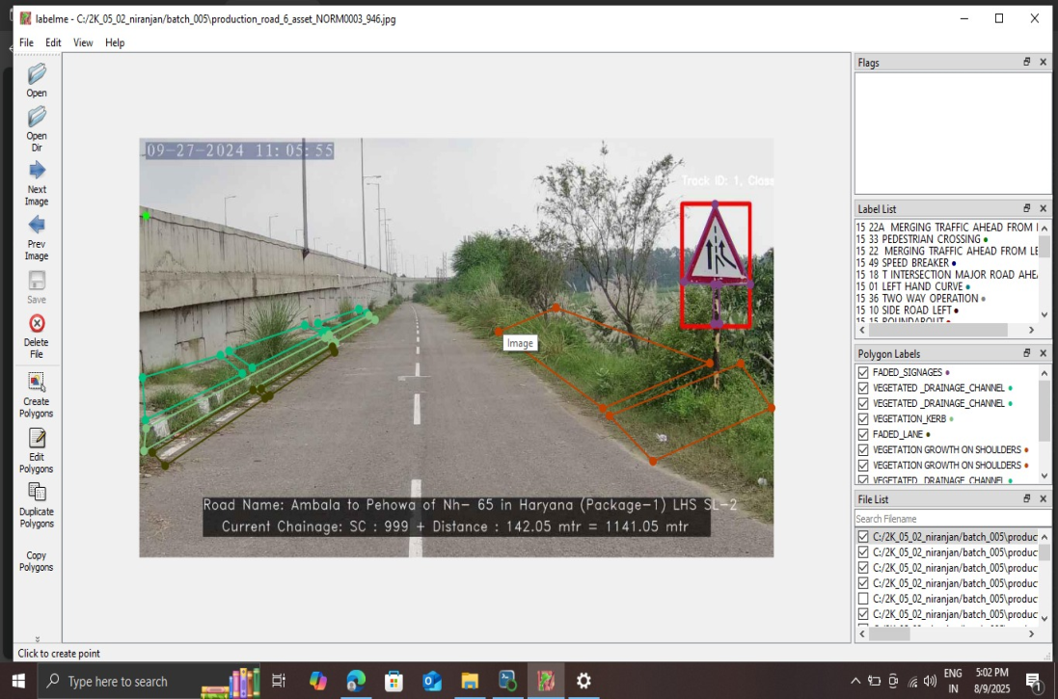

FIG:1.1 ANNOTATION

4. STANDARD OPERATION PROCEDURE (SOP)

4.1 Introduction

4.2 Survey Purpose

4.3 Pre Survey Condition

4.4 Before Leaving Condition

4.5 At Survey Purpose Location

4.5.1 Camera Setup for pavement

4.5.2 Camera Set Furniture

4.6 Before Survey Start

4.7 During Survey
4.8 Uploading Raw Data To Cloud.
4.9 Key Learning Area.

4.1 Introduction
We conduct AI-based Pavement Condition Assessment, Road Signboard Inspection, and Road Safety Audit to improve infrastructure quality and enhance overall road safety.

4.2 Survey Purpose
To collect high-quality video and GPX data of road signage for analysis

4.3 Pre-Survey Coordination
Route plan is provided in advance.
Coordinate with the site engineer,(authorised person) 2–3 days before survey.request them to arrangepatroling team.
Fix the date and time of the survey.

4.4. Before Leaving:
Check camera, power bank, SSD for working condition and full charge.

At Location:- Meet site engineer.- Confirm starting and ending chainage.-

4.5.1 CAMERA SETUP FOR PAVEMENT SURVEY

A. Camera installed on the top middle of the back glass of the survey vehicle, positioned to face outward for a clear view.

B. The camera mounting height should be between 1.55 m and 1.65 m from ground level to the camera point.

C. The camera should capture a linear distance of 15–20 meters, with a field width of at least 5–10 meters as required.

D. The camera needs to be mounted on the front windshield with proper alignment so that it can capture both the pavement and roadside furniture clearly in a single frame.

E. Maintain a downward tilt angle between 10° to 20°.

F. The tilt should allow clear capture of Road surface (pavemen)

    - CAMERA SETUP FOR FURNITURE SURVEY
- The camera must be installed in a front-facing position.
- Maintain a downward tilt angle between 8° to 12°.
- The tilt should allow clear capture of Road

  - Before Survey Start.

-Check Important Setting Of Camera
- -Resolution Should be 4k
- -Stabilization should be on
- -Time stamp of video and gpx should be same
- -Take a test recording before survey start.
- GPX and Video Start Procedure.
- -Before starting the survey, allow the GPX signal to fully stabilize.
- -Ensure that the GPS signal strength and accuracy are satisfactory.
- -Once the GPX is stable, start both GPX recording and video recording simultaneously.
- -Confirm that the GPX and video timestamps are properly synchronized.

4.7 During Survey
  - Use the survey sheet to record start and end time of video.
  - Record GPX tracks (MCW, IR, SR, LR,RR,LINK ROAD etc. ).
  - Create roads with the help of road survey application.

4.8: Uploading Raw Data to Cloud Storage

- The recorded data—consisting of both video and GPS files—is then uploaded to OneDrive & S3, a secure cloud platform. Proper naming conventions and directory structures are followed to maintain data organization.

- This step is foundational for the downstream processing pipeline and must be done with high attention to detail to prevent misclassification or data loss.

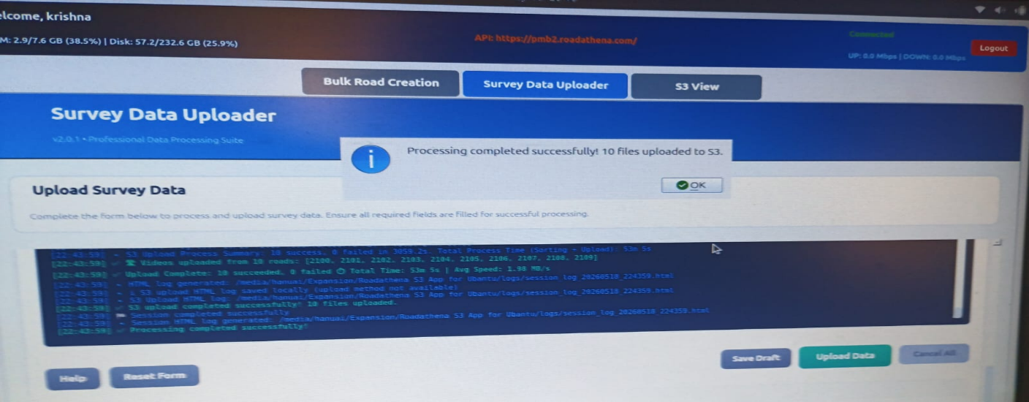

FIG:1.2 DATA UPLOADING APPLICATION

4.9 KEY LEARNING AREAS: -

My industrial training at Hanu AI was a transformative experience that significantly enhanced my understanding of how Artificial Intelligence (AI) is revolutionizing civil infrastructure monitoring. One of the first and most striking lessons I learned was the extent to which AI can automate routine, repetitive, and labour-intensive tasks in road infrastructure management. Activities such as road defect detection, object classification, and report generation—which would traditionally require hours of manual effort—are now handled in seconds by AI models trained on annotated datasets.

However, I also realized an equally important truth: AI is not flawless. Despite its capabilities, AI can make incorrect predictions, especially in complex, low-light, or poorly structured environments. For instance, it may misidentify a faded pedestrian marking or completely miss a broken signage due to occlusion or low contrast. This led me to understand the vital importance of human involvement in validating AI output. A concept I encountered repeatedly during the training was the “triple-check” system, wherein every output generated by the AI was cross-verified by human reviewers at three levels—automated, semi-automated, and fully manual. This triple-layer quality assurance workflow taught me the critical role humans play in making AI more robust, reliable, and applicable to real-world scenarios.

Another valuable learning outcome was developing a clear understanding of different types of highway surface defects.

Knowledge about IRC:82 For maintenance of Bituman Pavement.

- TASKS AND PROJECTS COMPLETED

5.1 NHAI – National Highways Authority of India

- One of the most critical components of my training involved working on national highway projects under the authority of NHAI. These tasks required a high level of precision, coordination, and technical understanding due to the vast stretches of roads and the traffic density involved.

Project of NHAI

PIU – JAIPUR
Project Names:

- Rajasthan Border (Km 0.000) to Salasar (Km 154.141) of NH-52 and 58 (old-65) in Rajasthan
- Salasar (Km 151.141) to Nagaur (Km 270.735) of NH-65 in Rajasthan
3. Short Term Improvement & Routine Maintenance of Two-lane with paved shoulders of Manoharpur-Dausa section of NH-11A (New NH-148) from Km. 0.000 (Design Ch. 0.000) to Km. 62.318 (Design Ch.62.318)

PIU – BIKANER
4. Raisinghnagar Poogal section of NH 911.
5. Khajuwala Poogal Bap section of NH 911A & 911.

PIU – PUNE
6. Four laning Dharampuri-Lonand from km. 117.00 to 166.40 (Pkg-IV) on Mohol-Alandi Section NH-965.
7. Six Laning of Pune – Satara section from Km 725.000 to 865.350 (Length Km 140.350) in the State of Maharashtra to be executed as BOT (TOLL) on DBFOT pattern under NHDP Phase.
8. Construction of Integrated Structures along with development of other allied structures on both sides of Chandani Chowk Junction (Ch. 842.580) of NH-4 in Pune City in the state of Maharashtra on
PIU – PANDHARPUR
9. Khudus - Dharampuri km 77.8 to km 117.0 Pkg III of Mohol Alangi-RCW.
10. Mohol - Wakhari km 0.0 to km 44.77 Pkg. I of Mohol Alangi-RCW.
11. Patas-Vasunde Phata - Baramati Bypass-RCW.

PIU – JODHPUR
12. Rasisar (near Bikaner)-Deogarh (near Dhandhaniya) (Phase-I) (AJ/RD-Package-1).
13. Rasisar (near Bikaner)-Deogarh (near Dhandhaniya) (Phase-I) (AJ/RD-Package-2)-30km.
14. Rasisar (near Bikaner)-Deogarh (near Dhandhaniya) (Phase-I) (AJ/RD-Package-3)-30km.
15. Jodhpur Ring Road Package-I [4-laning of Dangiawas (Km. 96.595) to Jajiwal (Km. 283.500).
16. Deogarh (near Dhandhaniya)-Rajasthan/Gujarat Border (Phase-I) (AJ/DRGB-Package-8).

PIU – PALANPUR
17. Sanchore - Santalpur from km 4.888 - km 35.000 of NH-754K (AJ-RGBS-Package-1).
18. Sanchore - Santalpur from km 67.000 - km 99.000 of NH-754K (AJ-RGBS-Package-3).
19. Sanchore - Santalpur from km 99.000 - km 130.073 of NH-754K (AJ-RGBS-Package-4).

PIU – WARANGAL

20. Tanamcherla to Jamandlapally Section of NH-365 (From Km.72.6 – Km 121).
UPC- N/08002/06003/TS.

21. Mangalwarpet to Mallampalli Section of NH-365 (From Km.154 – Km 187).
UPC- N/09056/01001/TS.

22. Operation and Maintenance of 2/4 Lane with paved shoulders of stretch from (i) Km 154/000 to 187/000 of Mangalwarpet to Mallampalli section; (ii) Km. 72/600 to 121/000 of Tanamcherla to Jamandlapally section of NH-365.
UPC- N/08002/06008/TS.

PIU – KHAMMAM 1

23. Four laning of Kodad to Khammam section of NH-365A under NH(O) (Design Length= 31.80Km).
UPC- N/09058/01001/TS.

24. Operation and Maintenance of 2 Lane with Paved shoulder from Km.71.200-Km.121.000 on AP-Telangana border to Rudrampur section of NH-30 (NH-221) on Performance based Maintenance Contracts (PBMC) mode.
UPC- N/09054/01005/TS.

PIU – KHAMMAM II:

25. Four laning of Suryapet to Khammam section of NH-365 BB (Design 0.42Km-59.046 Km).
UPC- N/05011/01001/TS.
PIU – VIZIANAGAM:

26. Development of Six Lane Jakkuva – Korlam Section of NH-130CD Road from km 396.800 to km 421.100 under Raipur – Visakhapatnam Economic Corridor in the state of Andhra Pradesh under Bharatmala Pariyojana on Hybrid Annuity Mode (Pkg 2).
UPC- N/04018/05003/AP.

27. Development of Six Lane Kantakapalle – Sabbavaram Section of NH-130CD Road from Km 445.100 to Km 464.662 under Raipur – Visakhapatnam Economic Corridor in the state of Andhra Pradesh under Bharatmala Pariyojana on Hybrid Annuity Mode (Pkg-4).
UPC- N/04018/05005/AP.
- My primary responsibility was to survey the main carriageways and service roads using AI-integrated camera systems. These roads, characterized by high-speed traffic and multi-lane layouts, demanded constant vigilance to ensure consistent video coverage without frame losses or obstructions. The AKASO and GO-PRO 13 Black cameras were calibrated to capture both the width and depth of the roadways, including surface conditions, signage, and safety barriers.

- One of the key challenges during the NHAI assignments was ensuring consistent frame coverage at highway speeds. Vehicles often travel at 80–100 km/h on these roads, making it essential to maintain stability in camera angles and GPS synchronization. My training in GPS module handling, particularly with U-Blox chips and the SW Maps app, helped me ensure that the timestamped video data remained accurate and well-aligned with geo-coordinates.
- A vital part of my responsibility was the verification of road lengths and structural conditions under the guidance of Highway Engineers (HE) appointed by NHAI. We conducted joint inspections to confirm the accuracy of the survey data, reviewed any ambiguous areas like underpasses or service diversions, and made note of possible anomalies that could affect AI-based classification model.

Photograph Captured During NHAI Field Survey

F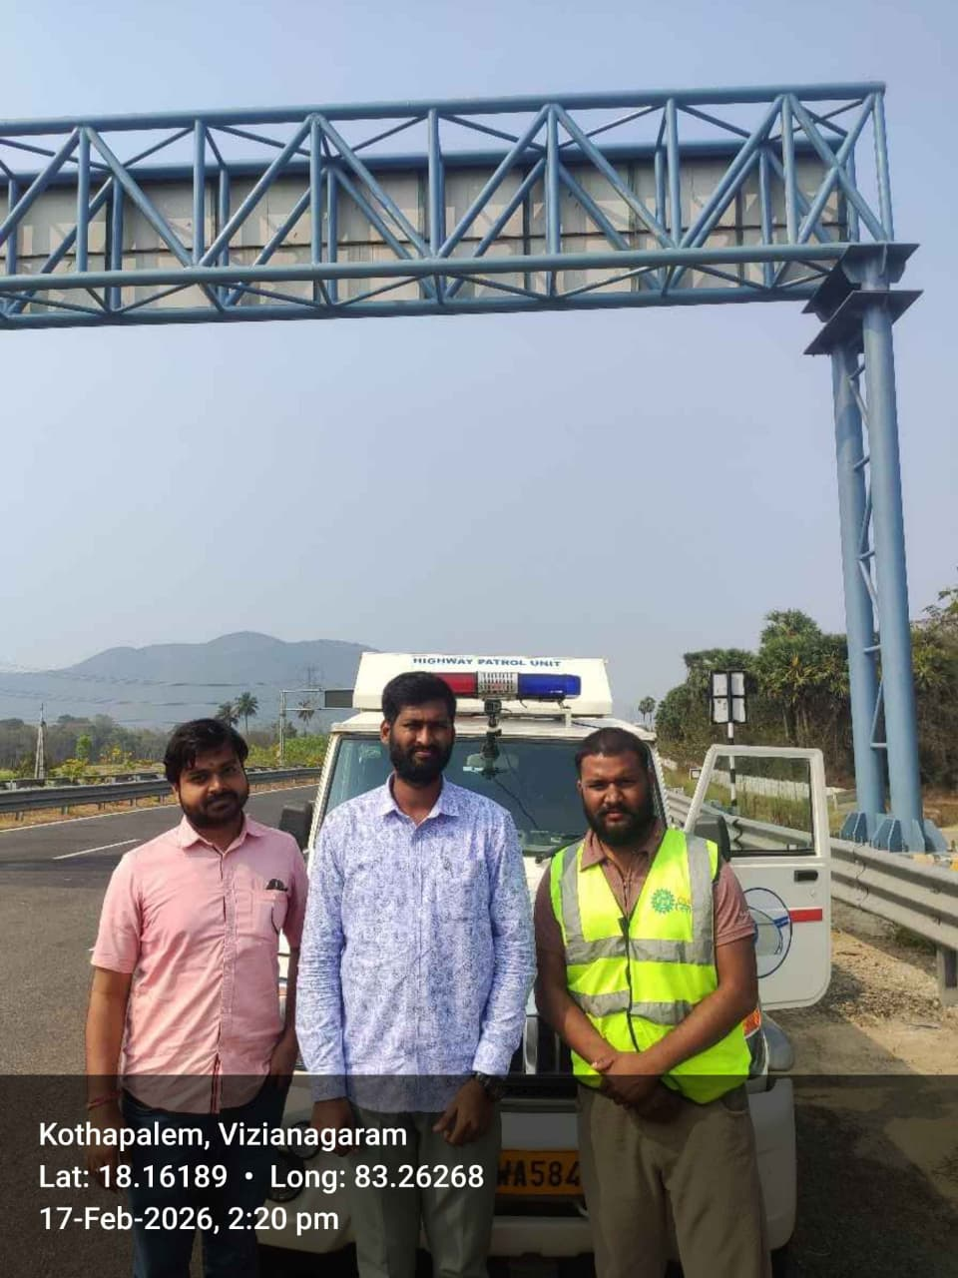

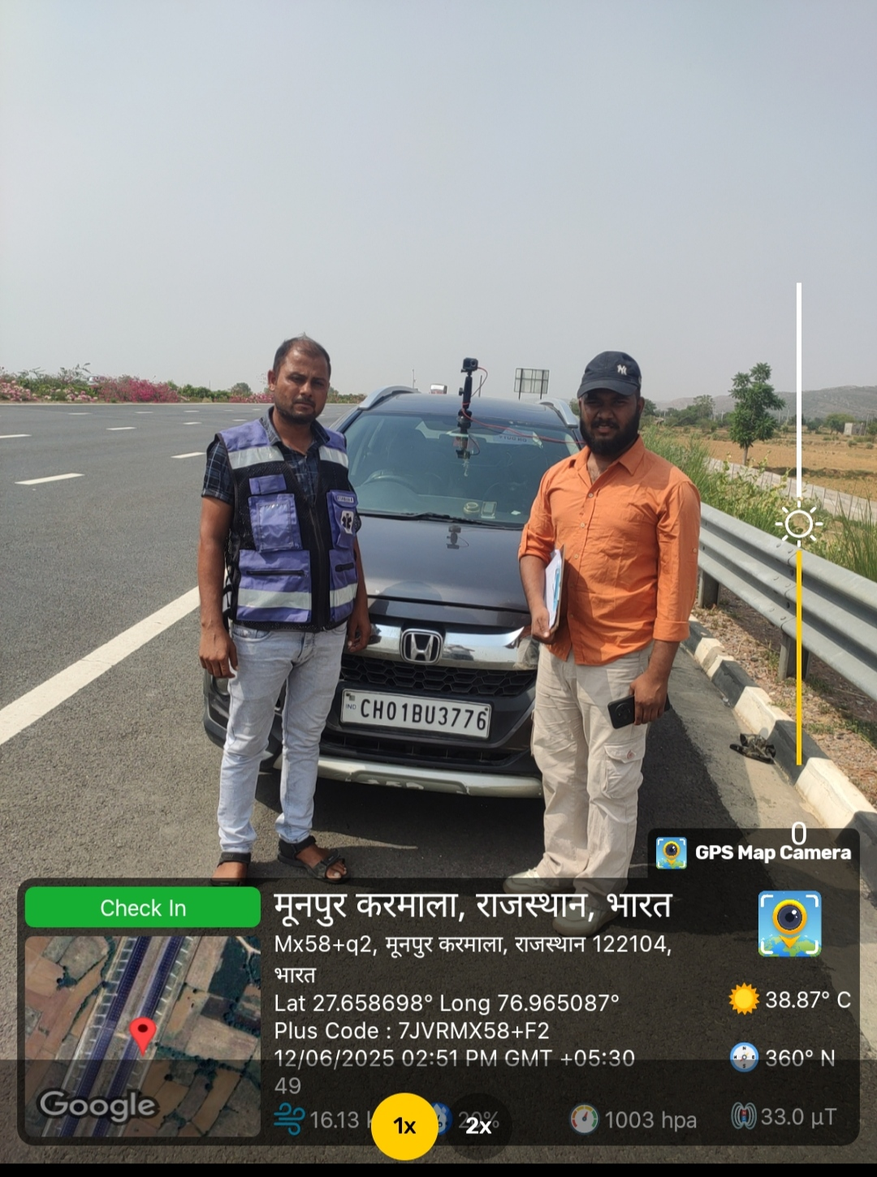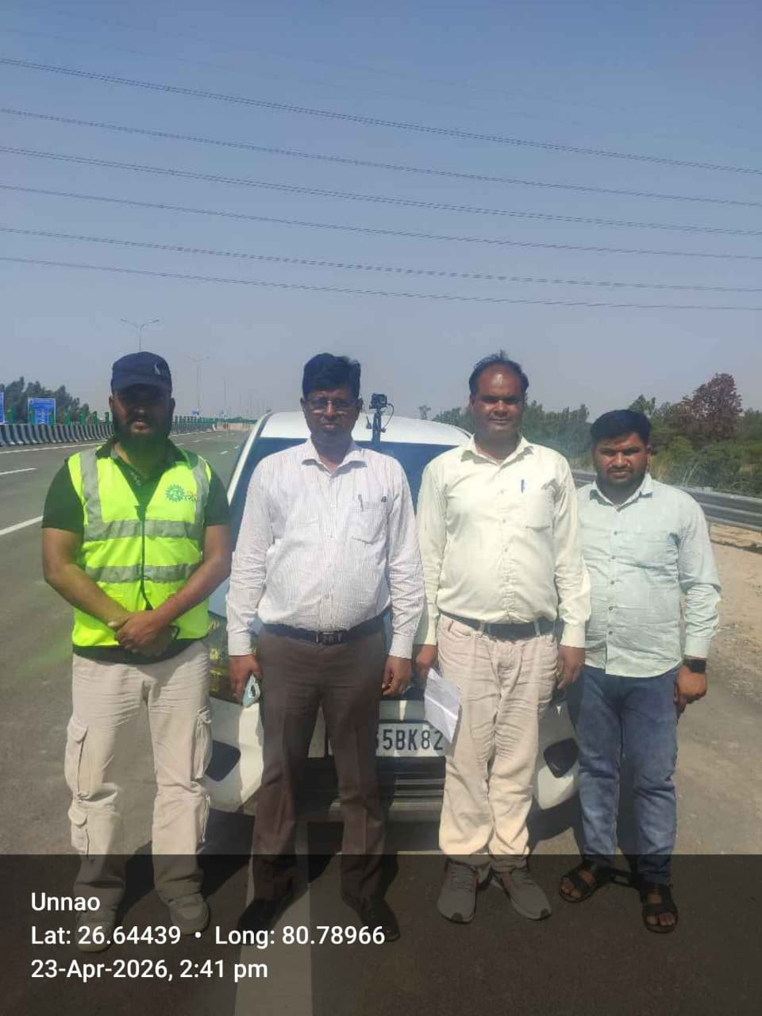

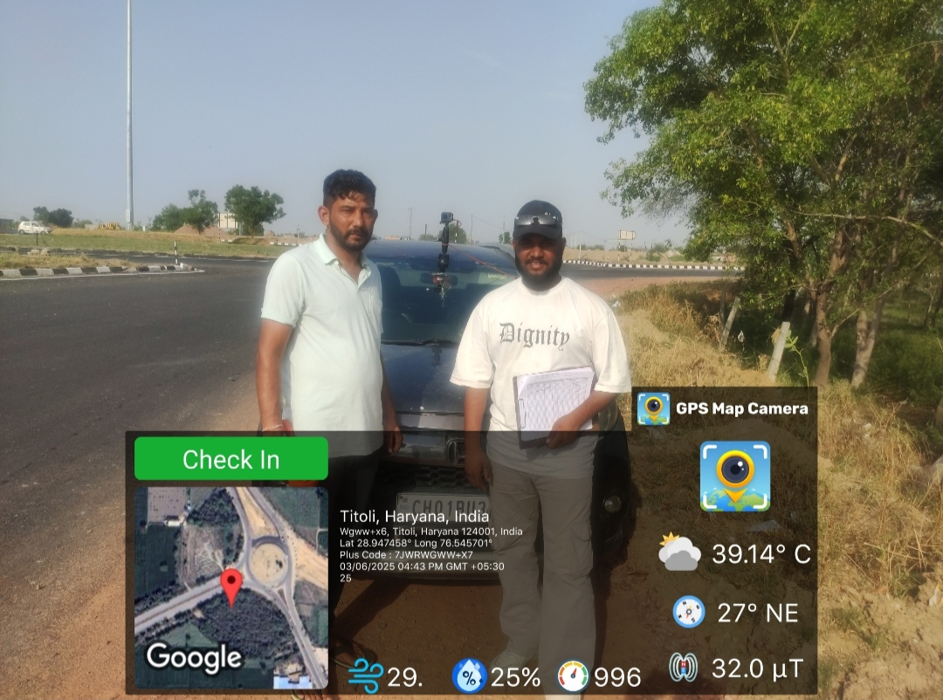
FIG:1.3 CAPTURING DURING NHAI SURVEY

5.2 PWD & Punjab Mandi Board

“Worked on road safety audit, pavement condition assessment, road inventory, GIS mapping, and infrastructure survey projects across multiple districts of Punjab including Ludhiana, Amritsar, Jalandhar, Patiala, Bathinda, Mohali, Moga, Sangrur, Hoshiarpur, Pathankot and other districts under Punjab Mandi Board (PMB), PWD, and various Market Committees under JE/SDO supervision.”

- My engagement with projects under the Public Works Department (PWD) and the Punjab Mandi Board (PMB) provided an entirely different perspective. Unlike the urban-centric and structured nature of NHAI roads, these surveys were conducted in rural and semi-rural locations, where challenges were significantly different and often more demanding.
- These areas frequently lacked proper mobile network coverage, which meant that GPS signal dropouts and navigation errors were common. In the absence of automated guidance, we had to depend heavily on manual navigation using printed maps and prior coordination with local authorities. Often, we relied on Junior Engineers (JE) from the departments to identify departmental road ownership—a necessary step for accurate administrative mapping.

- Photograph Captured During PMB &PWD Field Survey
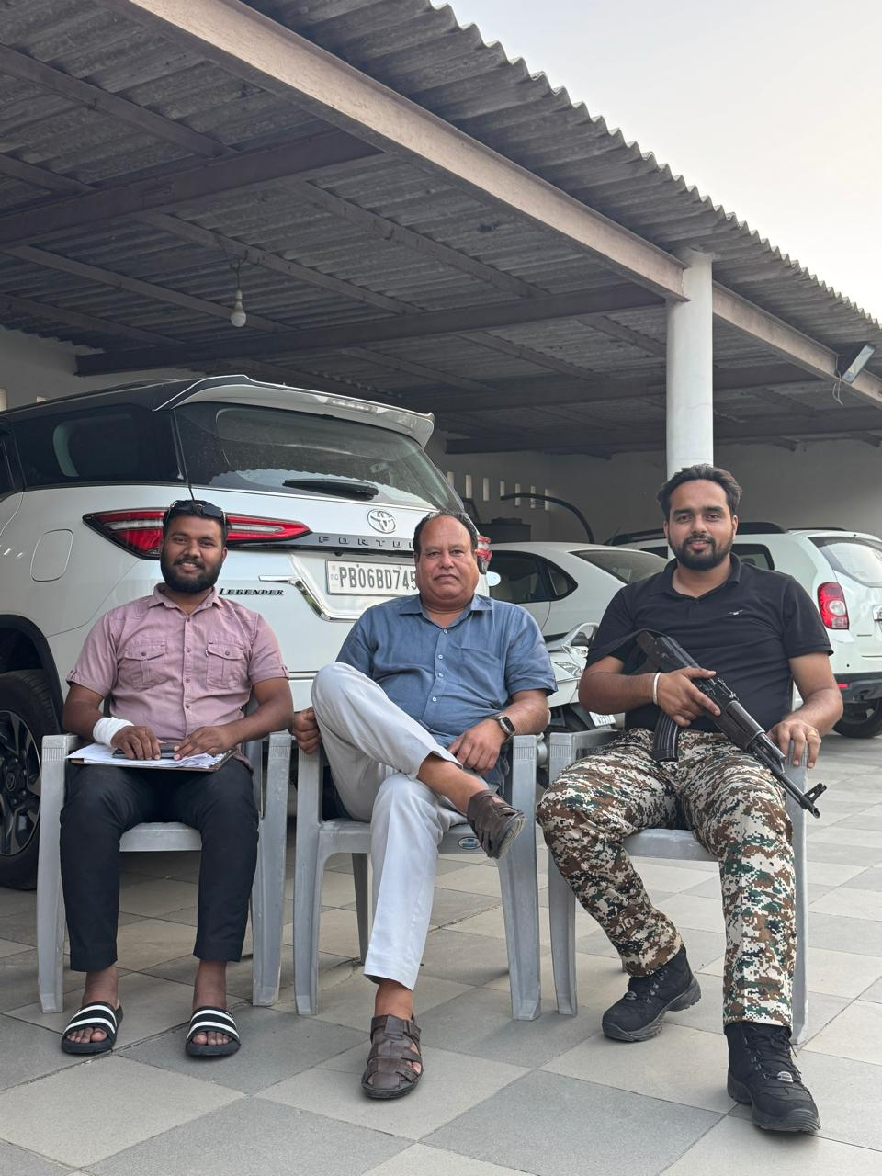

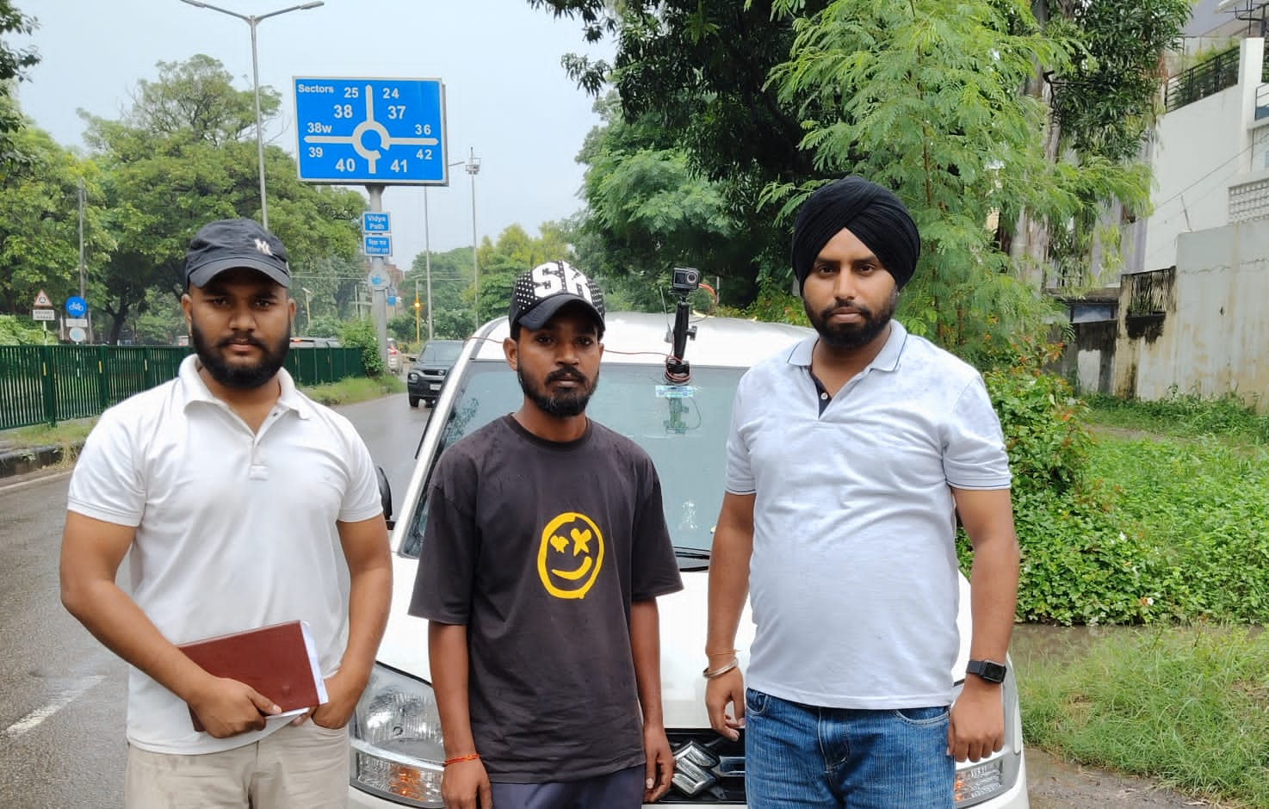

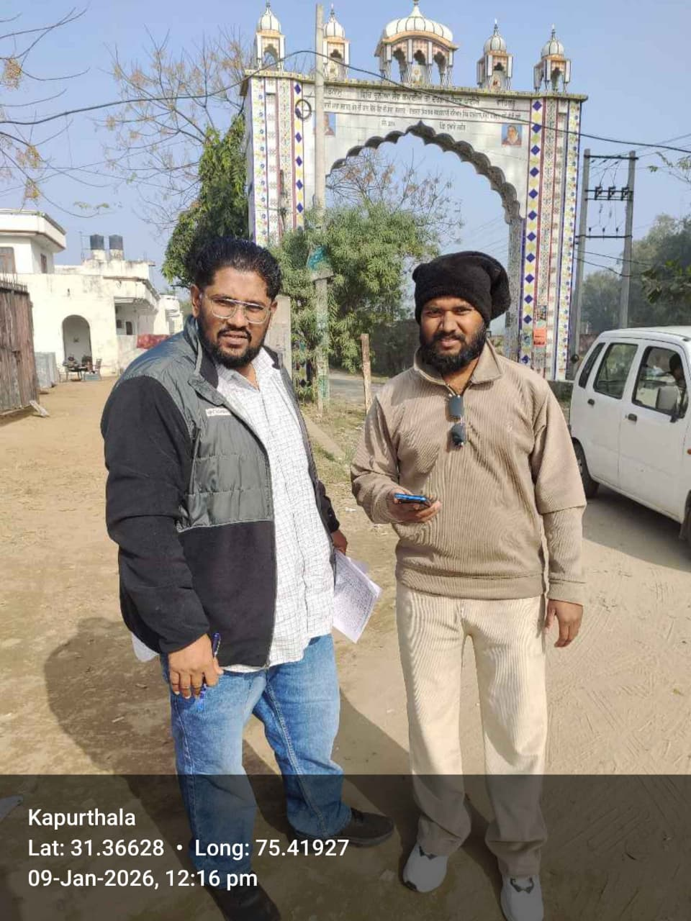

FIG:1.4 CAPTURING DURING PMB,PWD SURVEY

5.3 Gujarat Roads & Buildings (R&B) Department
Conducted road survey and road safety analysis on accident-prone and landslide-prone areas under the assistance and supervision of Executive Engineer (XEN). The work included field inspection, roadway condition assessment, identification of hazardous locations, data collection, safety observation, and reporting for road infrastructure improvement and safety enhancement

- Photograph Captured During gujrat R&B Field Survey

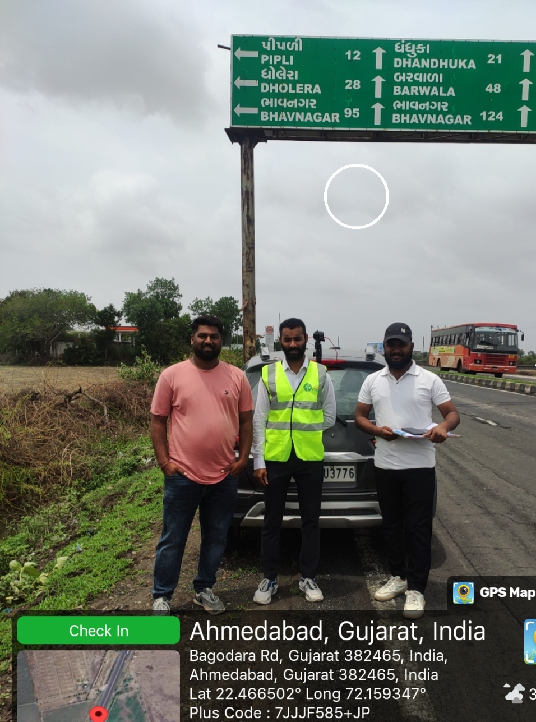

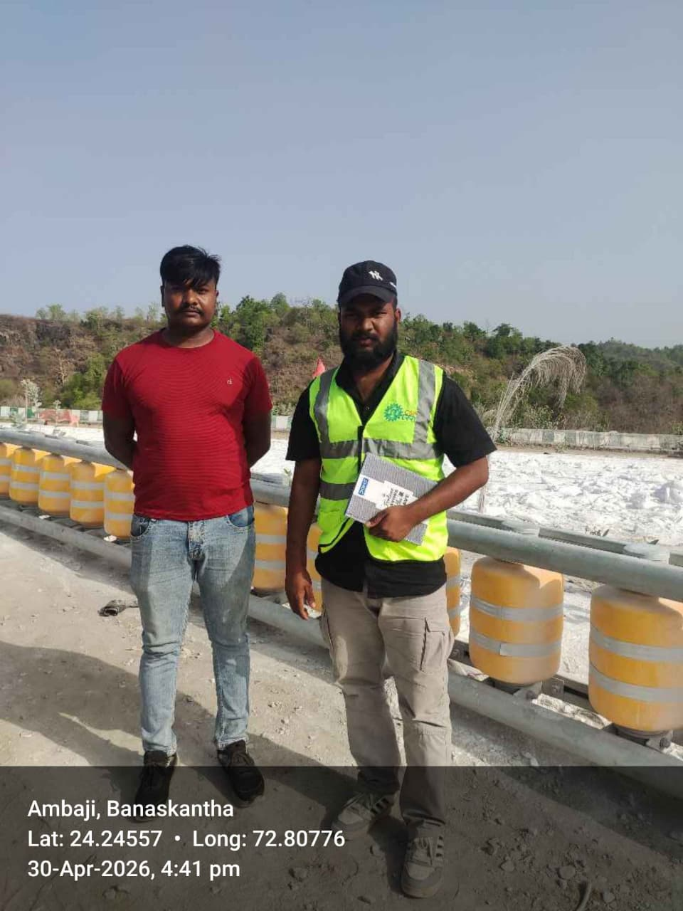
FIG:1.5 CAPTURING DURING GUJRAT SURVEY

5.4 Haryana Municipal Corporations
- Completed road condition survey, road mapping, and Road Safety Audit (RSA) works under the guidance of Junior Engineer (JE) and Executive Engineer (XEN) in various municipal areas of Haryana, including Gurugram, Kalanaur, and Karnal. The work involved roadway inspection, pavement condition assessment, geo-referenced data collection, mapping, identification of safety issues, and preparation of survey reports for urban road infrastructure improvement
- SURVEY SHEET
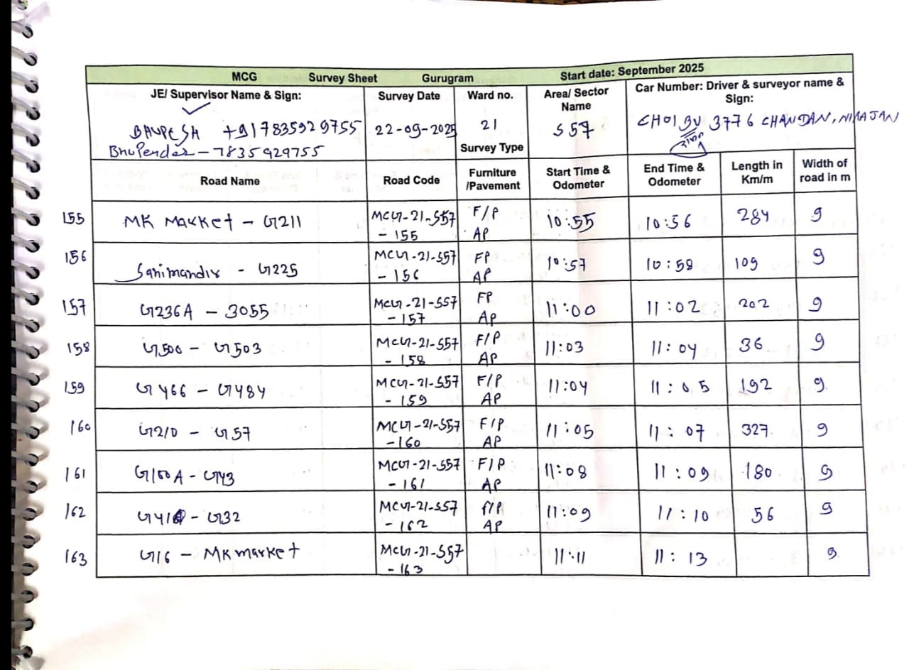

Photograph Captured During MUNICIPAL Field Survey
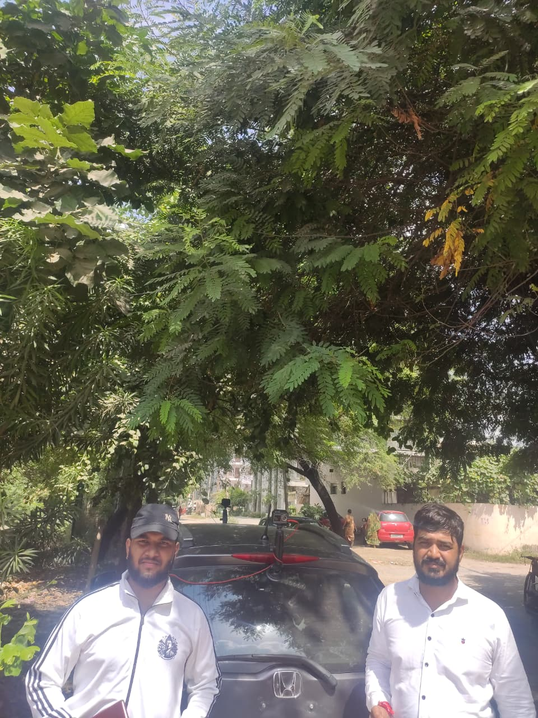
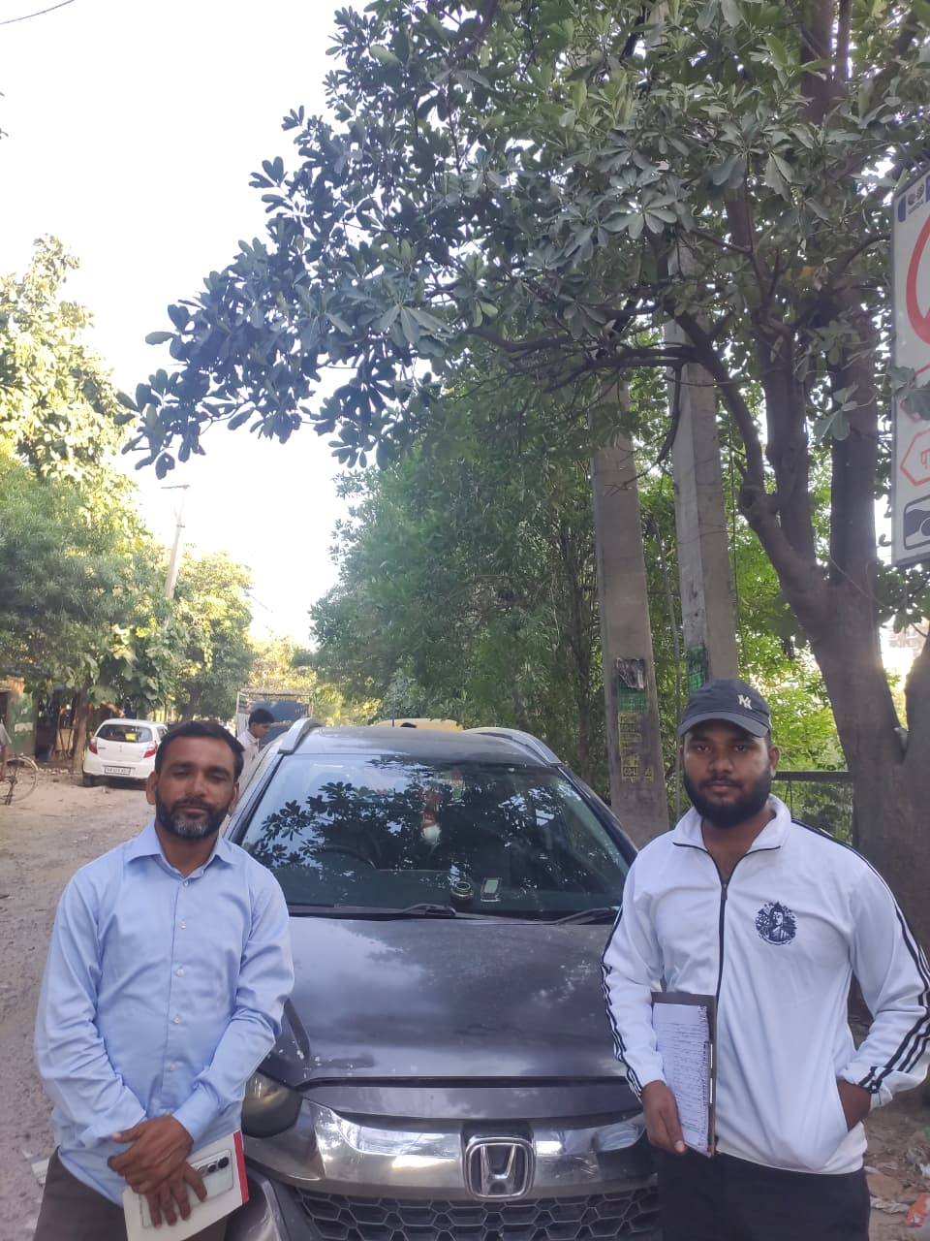
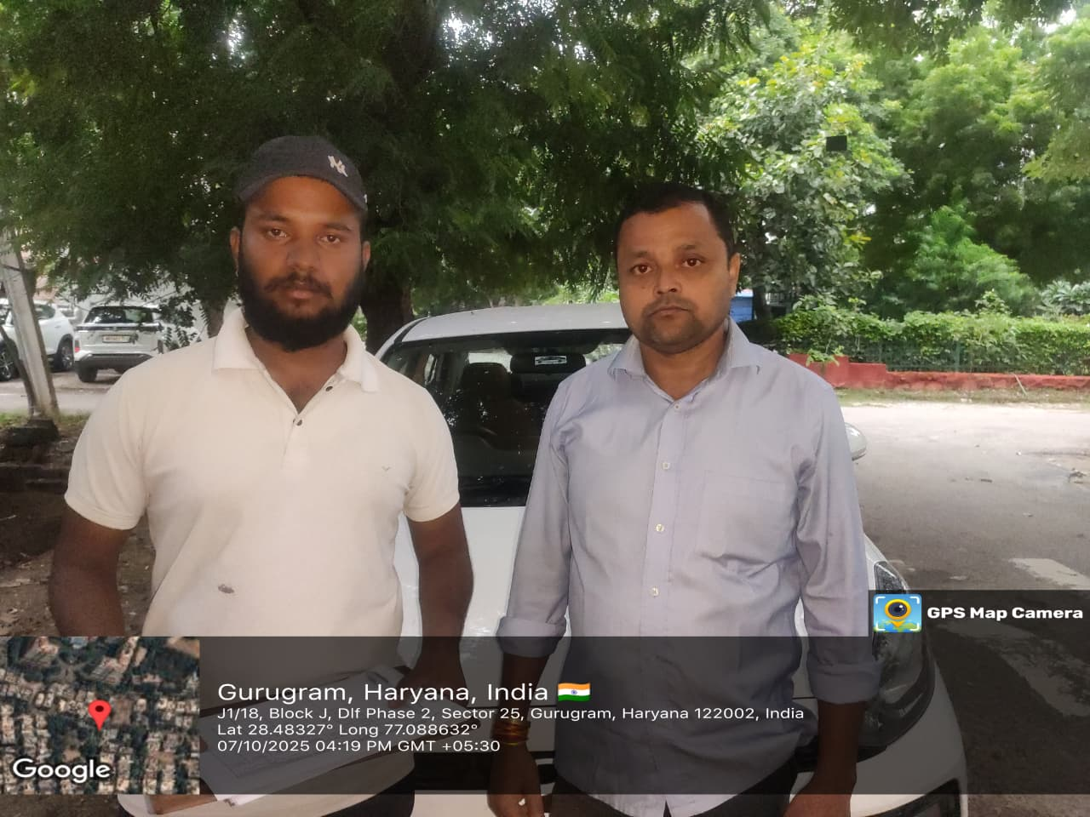

FIG:1.6 CAPTURED DURING HARYANA SURVEY

- Dashboard Presentation and Report submission Submission
  - Dash Board Presentation

- Home (GIS): Explained the hierarchy structure and GIS-based dashboard navigation.
- Statistics: Demonstrated pavement defect counts and road sign inventory statistics.
- RSA: Explained Road Safety Audit (RSA) features and analysis modules.
- Surveys: Demonstrated Excel report downloading, AI-processed video viewing, and linear plot analysis.
- Digital Twin: Provided an overview of Digital Twin functionality and visualization features.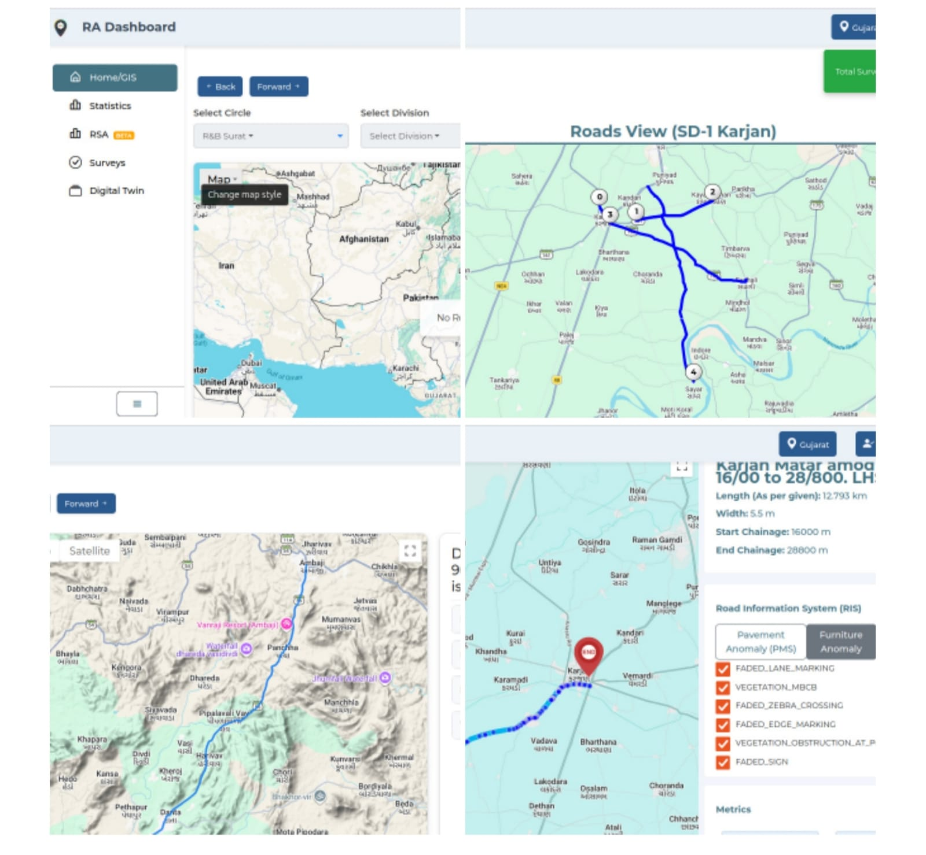

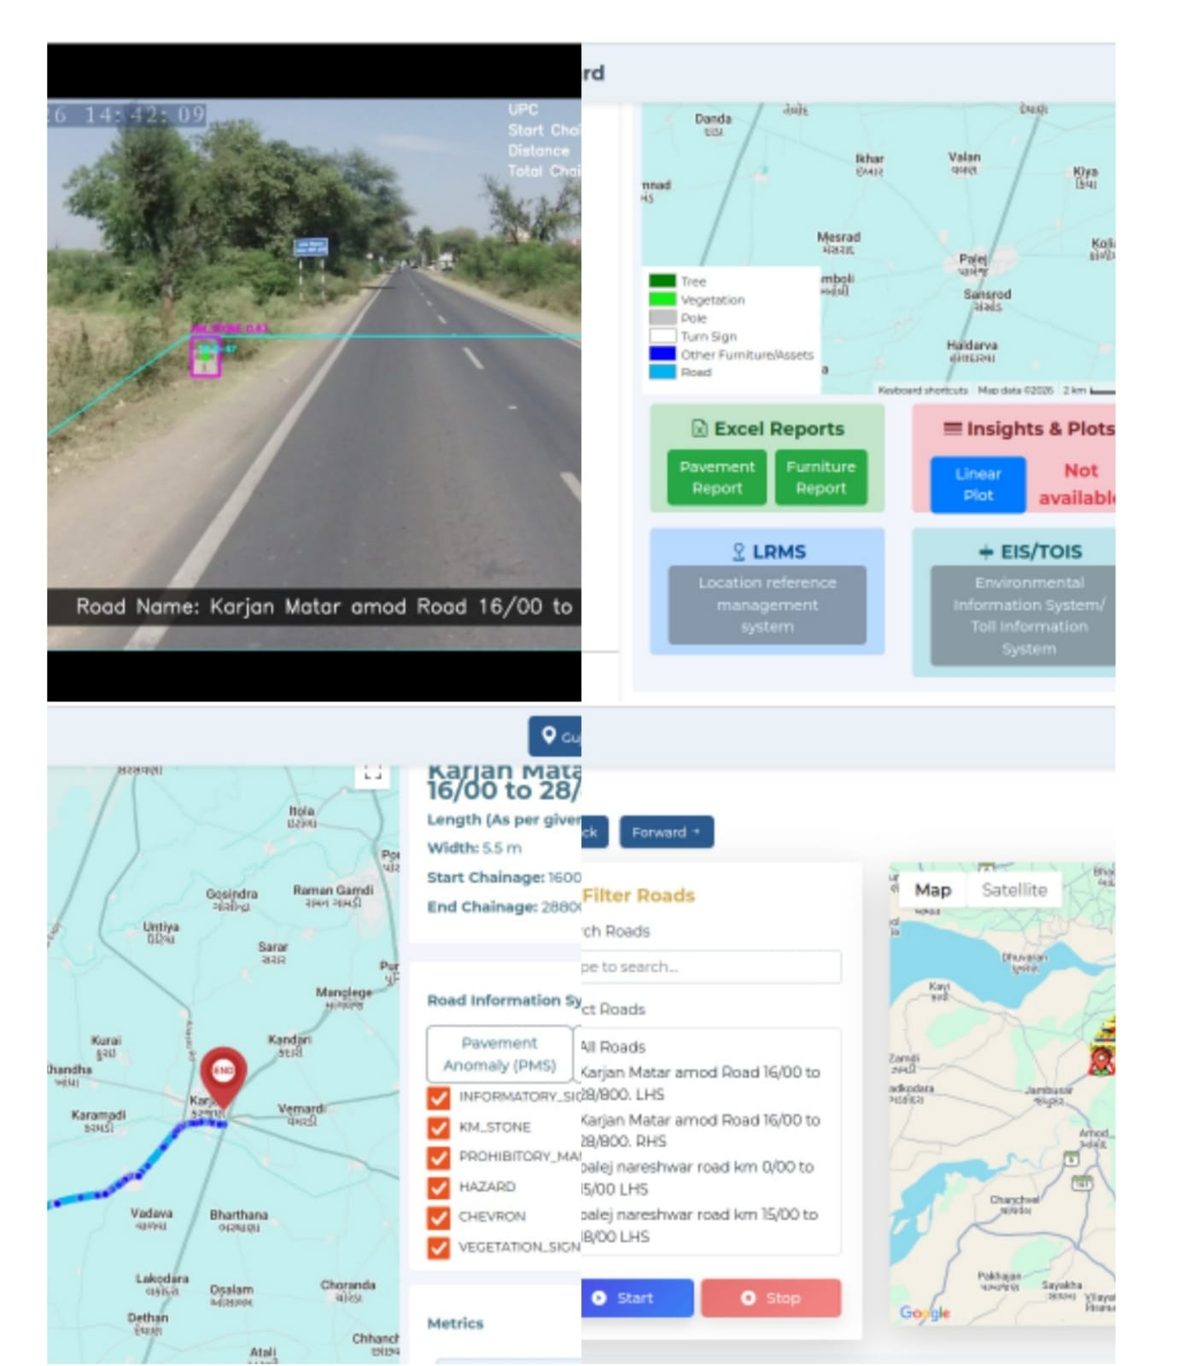
FIG:1.7 DASHBOARD PRESENTATION
6.2 Report submission Submission

1.Pavement Condition Report

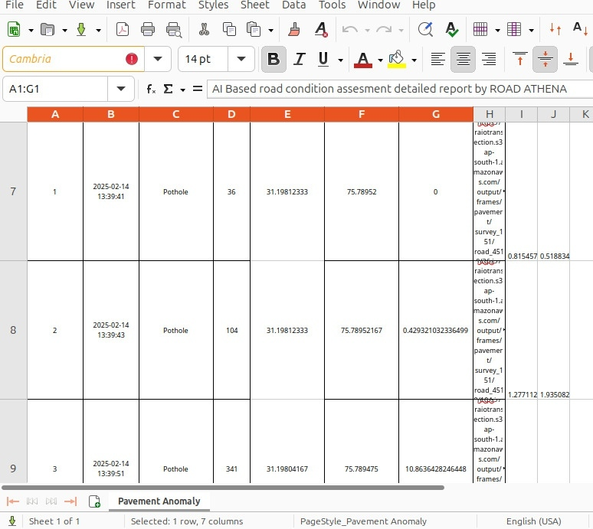
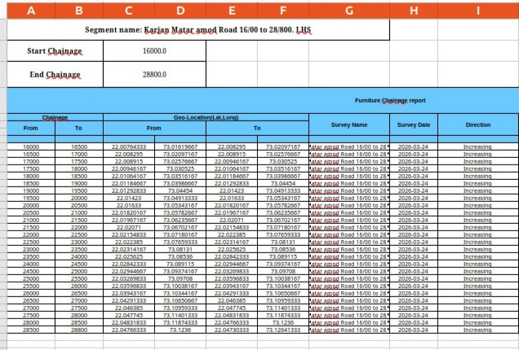

3 Road Safety Audit(RSA REPORT)
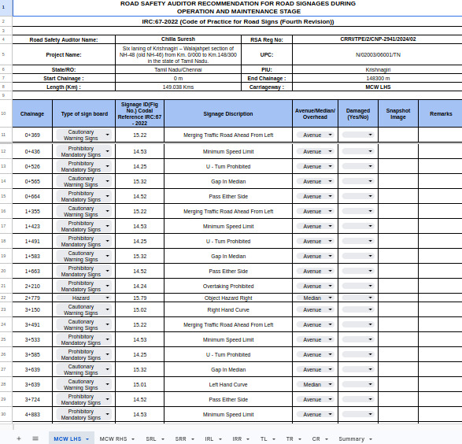
FIG:1.8REPORT SUBMISSION.

7.Learning Outcomes

7.1 Skills Acquired:

My industrial training experience at Hanu AI offered a dynamic and multidimensional learning environment that allowed me to acquire a robust set of technical, analytical, and professional skills. This section outlines the key competencies I developed over the training period and highlights how they contributed to my overall growth as a future civil engineer working in the domain of intelligent infrastructure systems.

7.2 Technical & Analytical Skills

- One of the most valuable technical competencies I gained was the ability to configure and operate advanced smart cameras such as AKASO and DDPAI for infrastructure monitoring. I learned to calibrate these cameras for optimal angles, lighting conditions, and frame rates, ensuring high-quality data capture essential for AI model processing. Additionally, I gained hands-on experience with GPS tracking tools and devices, including U-Blox modules and SW Maps applications, enabling me to synchronize geospatial data with recorded footage in real time.

- Beyond hardware operation, I was introduced to the foundational principles of computer vision and intelligent transport systems (ITS). I learned how image and video processing algorithms detect pavement distress, signage, and road features, which deepened my understanding of how AI interprets infrastructure conditions. This exposure strengthened my problem-solving abilities and helped me bridge the gap between fieldwork and backend model analysis.

7.3 Data Analysis & Visualization

- My role involved engaging with real-time data on a daily basis, which helped me gain proficiency in interpreting dashboard outputs and drawing insights from processed survey results.

- I understood the logic behind dashboard-based decision-making, where defect statistics and geospatial markers were visualized in user-friendly formats for stakeholders such as engineers and government officials.

- I also worked with Geographic Information System (GIS) tools and mapping platforms, learning to translate raw coordinates into road overlays, route trajectories, and structural defect maps.
- This practical application of GIS allowed me to contextualize data in spatial terms, a crucial skill in modern civil engineering projects. Furthermore, I became familiar with data validation protocols, learning to identify inconsistencies in large datasets and applying correction techniques to ensure data integrity.

7.4 Communication & Collaboration

- My training required frequent interaction with survey supervisors, government engineers, and the internal data processing team. This collaborative setting significantly improved my communication skills, both written and verbal.
- I documented technical reports, logged equipment usage and data uploads, and contributed to internal knowledge-sharing sessions.
- Through this, I learned the importance of clear, concise communication particularly when addressing discrepancies, requesting guidance, or reporting progress.
- The ability to translate complex observations into understandable reports was essential when collaborating with teams from both engineering and software backgrounds.

7.5 Project Management

- As part of my responsibilities, I managed survey timelines, coordinated data uploads, and maintained logs for project tracking. This helped me develop organizational skills essential for field and post-processing balance.

- I became accustomed to handling multiple tasks simultaneously—ranging from surveying to annotation correction—while meeting deadlines and reporting updates regularly to mentors and supervisors.

- This experience taught me the fundamentals of managing a technical project, including prioritization, resource allocation, and stakeholder reporting. It also made me aware of the importance of time management and workflow optimization in large-scale infrastructure surveys.

7.6 Adaptability and Problem Solving

- Perhaps one of the most critical skills sets I developed was adaptability in the face of unpredictable challenges. From hardware malfunctions to GPS signal loss and environmental disruptions such as heavy traffic or weather conditions,
- I learned to respond quickly and efficiently. I developed contingency plans and troubleshooting strategies, including rebooting equipment, resurveying

CHALLENGES & SOLUTIONS

8.1 CHALLENGES FACED WITH THERE SOLUTIONS: -

During the course of my industrial training, I encountered a wide range of challenges that were both technical and operational in nature. Each challenge tested our team’s problem-solving abilities and required innovative approaches to ensure the success of AI-based civil infrastructure monitoring. Below are some of the major challenges faced, along with the strategies implemented to resolve them effectively:

1. Data Collection & Accuracy Issues:

Challenge: One of the primary challenges we faced was ensuring the accuracy of collected data. In many instances, GPS data would be disrupted due to poor satellite visibility in densely built-up or remote areas. Sensor malfunctions, weather-related disruptions (such as rain or fog), and unstable internet connectivity also hindered the collection of high-fidelity video and geospatial data.

Solution: To overcome this, we employed a multi-pronged approach. Multiple data collection devices were used in parallel to ensure redundancy. Where GPS drift or data loss occurred, we used map-matching techniques and manual GPS corrections based on known landmarks. Additionally, automated data validation scripts were used to flag anomalies in time stamps, GPS trails, or video resolution for correction. This approach ensured that we maintained a high standard of data integrity even in challenging environments.

2. Traffic Congestion & Management

Challenge: Surveying in urban locations brought its own set of difficulties due to high vehicle density, narrow roads, and unpredictable traffic behaviour. Capturing uninterrupted and comprehensive video footage without obstruction was nearly impossible during peak hours, affecting the quality of the dataset.

Solution: To mitigate this, we scheduled surveys during off-peak hours and used route optimization tools to select survey paths with the least expected congestion. We also proposed traffic signal optimization at surveyed intersections, along with the deployment of dynamic routing strategies based on AI-predicted traffic flow patterns. These proposals were shared with municipal engineers and incorporated into subsequent survey plans to ensure more efficient data collection.

3. Integration of Smart Technologies

Challenge: While implementing AI-based monitoring systems, a significant hurdle was the integration of AI tools with existing infrastructure and legacy systems. Compatibility issues, lack of real-time processing capability, and insufficient cloud synchronization protocols caused frequent delays and processing errors.

Solution: We adopted a modular integration strategy—starting with critical intersections and gradually expanding as compatibility was tested. By focusing first on edge AI solutions that operate without relying on real-time cloud support, we ensured initial deployment success. Later, we promoted cloud-based scalability by designing workflows compatible with Amazon Web Services (AWS) and using APIs for smooth interaction between local and remote systems.

4. Public Compliance & Awareness

Challenge: A less technical but equally crucial challenge was public behaviour. Many citizens lacked awareness about road safety practices or misunderstood the role of survey vehicles, often interfering with survey operations or ignoring designated routes. This sometimes resulted in incomplete or unusable data.

Solution: We proposed and supported the launch of public awareness campaigns in collaboration with local authorities. These included placing temporary notices, social media advisories, and distributing pamphlets in survey areas. In parallel, AI-driven automated enforcement tools such as object detection systems were suggested to identify rule violations, which could later be integrated with city enforcement databases.

Conclusion
9.1 SUMMARY OF TRAINING AS A SURVEYOR AND PROJECT ASSOCIATE AT HANUAI:-
During my training at RoadAthena/Hanu AI Chandigarh as a Surveyor, I gained hands-on experience in traffic data collection, analysis, and reporting, contributing to intelligent transportation solutions. The training involved conducting on-site traffic surveys, monitoring road conditions, and assessing vehicle movement patterns to support AI-driven traffic management systems. I worked with various traffic monitoring tools and GIS-based mapping systems to analyze congestion points, road safety issues, and traffic flow optimization strategies.
A key aspect of my role was data accuracy and validation, ensuring that collected information was reliable for decision-making. I also had the opportunity to understand how ITS (Intelligent Transportation Systems) integrate real-time data to improve urban traffic efficiency. Despite facing challenges such as real-time data discrepancies, on-ground coordination, and external environmental factors, problem-solving strategies like cross-verification of data sources and adaptive survey methodologies helped in overcoming them.
Additionally, I observed areas where operational efficiency could be enhanced, such as streamlining survey methodologies, better team coordination, and structured reporting frameworks. The training provided a comprehensive understanding of smart mobility solutions, road safety assessments, and the impact of data-driven decision-making in traffic management. Overall, this experience significantly enriched my technical and analytical skills while offering valuable exposure to the practical challenges and innovations in the field of urban transportation planning.
This transformative experience profoundly enriched the entirety of my industrial training period. Unlike traditional surveyor responsibilities, which often emphasize data collection alone, my role evolved into one of multifaceted engagement across the entire data lifecycle. It allowed me to go beyond the immediate tasks of field documentation and annotation, empowering me to understand the larger system that powers intelligent infrastructure solutions in the real world.

By working closely with AI models, data engineers, survey supervisors, and government officials, I was exposed to a comprehensive ecosystem where every component—hardware, software, cloud systems, and human intelligence—must align seamlessly to deliver effective, real-time insights. This exposure helped me bridge the gap between theoretical knowledge gained in academic settings and practical, on-ground applications. It taught me how systems behave under varying real-world constraints such as inconsistent data signals, environmental noise, camera malfunctions, and the critical importance of real-time data integrity. I realized that even the most advanced AI systems still rely on human validation and intelligent feedback loops to function reliably and responsibly.

Throughout the training, I developed a systems-level perspective—one that appreciates not only the technical intricacies of data labelling and model evaluation but also the architectural design and maintenance of end-to-end pipelines. From edge devices capturing terabytes of raw video to cloud servers running model inference, and finally to front-end dashboards consumed by infrastructure authorities, I understood how each segment contributes to a unified, decision-making platform. Being part of such a framework made me realize that true innovation lies in how well we integrate our tools and processes, not just how advanced the tools are individually.

Furthermore, this experience instilled in me a deep appreciation for precision, accountability, and the ethical dimensions of AI in civil infrastructure. The roads we surveyed, the defects we captured, and the annotations we corrected are not just data points—they translate directly into funding decisions, public safety measures, and long-term planning strategies. Knowing that our work can influence such high-impact outcomes made me more conscientious and detail-oriented in every task, no matter how small.

It also sparked within me a lasting curiosity for intelligent systems—how they’re built, how they learn, and how they evolve. I found myself increasingly drawn to explore areas such as machine learning operations (MLOps), data governance, annotation scalability, and performance tuning of AI systems under constrained conditions. The collaborative nature of this training—with cross-disciplinary teams and iterative feedback cycles—taught me how to think critically, act responsibly, and communicate effectively in a tech-driven environment.
In conclusion, this hands-on exposure did not merely help me complete a training module—it shaped my professional identity. It prepared me to contribute meaningfully to the growing field of AI-assisted civil engineering by equipping me with not just technical knowledge but also the mindset, awareness, and foresight required to build intelligent, inclusive, and reliable infrastructure solutions for the future.
9.2 RECOMMENDATIONS:- My training experience at Hanu AI provided valuable insights into the field of intelligent traffic management and road safety solutions. The organization's commitment to technological innovation is evident in its use of AI-driven traffic monitoring, IoT-based surveillance, and data analytics to enhance urban mobility. However, there is potential for improvement in certain areas that could significantly boost overall efficiency and workplace dynamics. Introducing a more structured training and mentorship program. would ensure better skill development and knowledge transfer for trainees and employees alike. Additionally, enhancing interdepartmental collaboration and optimizing workflow management with clearer task delegation would lead to greater productivity and smoother project execution. A focus on employee engagement, motivation, and professional growth would further contribute to a more dynamic and innovative work environment. Moreover, incorporating a strong feedback mechanism where employees and trainees can share insights and suggestions could foster continuous improvement. While the company is making impressive strides in intelligent transportation solutions, refining organizational and management practices would unlock its full potential, creating a more structured and progressive workplace.

Annexures / Appendices

The annexures included in this report serve as supplementary material that validates and enhances the technical content discussed throughout the document. These additional resources provide visual references, code-based evidence, process clarity, and operational transparency—bridging the gap between descriptive explanation and real-world execution. They also serve as proof of active participation and technical contribution during the training period at Hanu AI (RoadAthena). Each annexure plays a critical role in contextualizing the training objectives and project implementation.

A. Sample Annotated Images (Before and After Manual Tagging)
This section includes screenshots of road survey videos showing AI-generated annotations alongside manually corrected versions. These images clearly demonstrate the importance of human involvement in AI verification. For example, in several cases, the AI failed to detect certain road signs or faint cracks due to low contrast or occlusion. The manual annotations show how these elements were accurately identified and patched. These visuals provide insight into the annotation tools and portals used during the training and help illustrate the concept of the triple-check QA system that ensures data quality.

B. Python Script Snippets (Used for Automation or File Handling)
Included here are code excerpts from Python scripts developed or used during the training for file uploads, GPS-data synchronization, video renaming, and batch processing. These scripts were essential in automating repetitive manual tasks and ensuring the smooth functioning of the data pipeline. The annexure highlights the logic and structure of the scripts, with comments for clarity, to showcase the level of technical understanding applied during script execution and troubleshooting.

C. GPS Route Maps and Survey Logs
This section contains exported GPX route maps generated using the SW Maps application. These maps display the precise trajectory of the survey vehicle during road inspections, along with time-stamped coordinates. The annexure also includes daily survey logs, which document surveyed segments, surveyor details, timings, hardware status, and remarks.

These artifacts are critical for traceability, verification, and reporting to government clients. They also demonstrate how field-level data was meticulously recorded and reviewed.

D. Camera Setup Photos
Images showing the mounting and calibration of AKASO and DDPAI cameras on the survey vehicle are included here. These visuals explain how camera angles, lens height, and vehicle position were optimized to achieve maximum visibility of road surfaces and roadside furniture. The annexure showcases the practical challenges faced during field deployment, such as stabilization, road vibration handling, and field adjustments, offering a real-world perspective into hardware setup and field readiness.

E. Company Dashboard Screenshots
Screenshots of the RA (RoadAthena) portal dashboard used during training are provided to demonstrate how video data and annotations were uploaded, verified, and reviewed. These images highlight various dashboard functionalities such as:
- Timeline-based video navigation
- Heatmap visualization of defects
- Signage layer selection
- Frame-by-frame verification
These visuals help readers understand how processed survey data was presented and interpreted by engineers and decision-makers.

F. Survey Schedule or Timeline Table
Included in this section is a detailed table of the training survey schedule, highlighting:
- Locations surveyed
- Dates and timings
- Road segments covered
- Assigned personnel
- Equipment used
- Issues encountered (if any)
This annexure provides a structured overview of the survey tasks undertaken during the training period and reflects effective time management, coordination, and field planning.

Glossary of Terms

This glossary provides definitions and contextual explanations for the key technical terms, abbreviations, and acronyms used throughout the training report. These terms are widely used in the fields of civil engineering, artificial intelligence, geospatial analysis, and intelligent transportation systems. The glossary is intended to help readers better understand the concepts, tools, and technologies applied during the training period at Hanu AI (RoadAthena).

AI – Artificial Intelligence
Artificial Intelligence refers to the simulation of human intelligence processes by machines, especially computer systems. In the context of this training, AI was used to detect road surface defects, identify traffic signage, and classify road assets from video footage through deep learning and computer vision models.

GIS – Geographic Information System
A Geographic Information System is a framework used to gather, manage, and analyze spatial and geographic data. During training, GIS tools were employed to map GPS data, visualize survey routes, and overlay defect locations on satellite imagery for reporting purposes.

GPX – GPS Exchange Format
GPX is a standard file format used to store GPS data including waypoints, tracks, and routes. The training involved recording vehicle movement using GPX format logs, which were later used to synchronize video frames with precise geographical locations.

ITS – Intelligent Transportation Systems
Intelligent Transportation Systems refer to the integration of communication and computing technologies into transportation infrastructure and vehicles. The training program contributed to this concept by leveraging AI and geospatial data to improve road quality monitoring, traffic planning, and safety assessments.

U-Blox – GPS Module
U-Blox is a brand of high-precision GPS modules used to track the geographic coordinates of survey vehicles. These modules were used in conjunction with software applications like SW Maps to collect real-time spatial data during road surveys.

RA Portal – RoadAthena Dashboard
RA Portal is the proprietary dashboard platform used by Hanu AI to review, annotate, and validate survey footage. It displays AI-processed videos, defect heatmaps, GPS trajectories, and manually corrected data for review by engineers and decision-makers.

Annotation – Data Labelling Process
Annotation is the process of labelling objects within images or videos to train machine learning models. In this training, annotation involved identifying road furniture (e.g., signboards, dividers) and defects (e.g., potholes) so that the AI models could learn to detect similar patterns in future datasets.

Edge AI – Edge-Based Artificial Intelligence
Edge AI refers to the deployment of AI algorithms directly on local devices (e.g., cameras or embedded systems) rather than on centralized cloud servers. This allows real-time processing with lower latency. Edge AI was explored during training for on-vehicle video preprocessing.

SW Maps – Survey and Mapping Application
SW Maps is an open-source mobile application used to record and visualize GPS tracks. It was used in the training to log and validate field survey routes in real-time, and to generate GPX files for later analysis and processing.

OneDrive – Cloud Storage Service
OneDrive is Microsoft’s cloud-based file hosting platform. It was used to upload and organize video footage and GPS data collected during surveys, making it accessible for AI processing and manual review by different teams.

Defect Detection – AI-Powered Fault Identification
Defect detection refers to the use of AI and computer vision to automatically identify flaws on road surfaces such as cracks, potholes, and rutting. This was a core objective of the training program, helping authorities prioritize repair and maintenance tasks.

Python Script – Automation Program
Python scripts are small programs written in the Python language to automate tasks. During the training, scripts were used to rename files, match GPS timestamps, upload footage, and execute defect detection pipelines more efficiently.

Manual Tagging – Human-Based Annotation
Manual tagging is the process of human reviewers labelling missed or misclassified elements that the AI did not detect correctly. This was essential to improve the accuracy of the final dataset and provide feedback for future model retraining.

This glossary supports a deeper understanding of the report and serves as a quick reference guide for readers unfamiliar with the technical jargon used in modern AI-integrated civil infrastructure systems.

References

The following references include technical documentation, learning resources, manuals, and organizational websites that were either directly consulted or implicitly applied throughout the course of the industrial training at Hanu AI (RoadAthena). These materials supported my understanding of the hardware and software systems, AI methodologies, survey protocols, and traffic engineering concepts relevant to the training.

1. Hanu AI / RoadAthena Official Website
URL: https://hanuai.com
The company’s official website provided an overview of its mission, services, and product architecture. It offered insight into Road Athena’s AI-based solutions for road infrastructure monitoring and outlined key features of its RA portal. I referred to this platform to better understand how my assigned field work aligned with the company’s broader operational framework and technological stack.

2. SW Maps – Survey and Mapping Tool Documentation
Source: [SW Maps Official Guide & Help Documentation]
SW Maps is the mobile application used during surveys to record GPS coordinates in real time. Its documentation provided detailed guidance on initializing GPS recording, generating GPX files, customizing base maps, and exporting data. This was instrumental in ensuring that the GPS trail captured during the survey was accurate, uninterrupted, and ready for synchronization with video footage.

3. Akaso Camera User Manual & Setup Guide
Source: Akaso EK7000 / Brave Series User Manual
This reference helped me understand the correct procedure for setting up and operating Akaso action cameras used for road surveys. It covered details about frame rate, resolution, battery life, mounting setup, Wi-Fi connectivity, and troubleshooting steps. This was crucial during field operations to maintain stable video quality and avoid data loss due to improper configuration.

4. DDPAI Camera Configuration Manual
Source: DDPAI App Setup Guide
For projects involving DDPAI cameras, this document offered detailed instructions on pairing the device with the mobile app, configuring angle alignment, saving video files locally, and calibrating wide-angle settings for vehicle-mounted surveys. It enabled me to switch between camera systems when required and ensure uniformity in output across hardware.

5. AI in Transportation: Overview and Application Guides
Source: White papers and technical articles from industry sources (e.g., McKinsey, Deloitte, NITI Aayog AI Strategy 2020)
These documents offered a high-level perspective on how AI is transforming intelligent transportation systems (ITS). They provided examples of global and Indian case studies in AI-powered traffic management, predictive maintenance, and smart infrastructure, helping me frame the relevance of my training in the broader context of future civil engineering innovations.

6. Road Defect Classification Guidelines
Source: Internal training documents and visual classification charts from Hanu AI
These materials helped me distinguish between different types of pavement distress such as potholes, cracks, ruts, and fatigue cracking. The guidelines also outlined the criteria for tagging road furniture and signage, ensuring consistency across manual annotation processes.

7. Government Manuals from MoRTH and NHAI
Sources:
- “Manual for Maintenance of Roads” – Ministry of Road Transport and Highways (MoRTH)
- “Highway Safety Manual” – National Highways Authority of India (NHAI)
These government-issued manuals provided formal definitions and classifications of road defects, standards for road safety audits, and protocols for infrastructure surveys. They were used as baseline references when validating survey data and understanding national-level expectations for road quality reporting.

8. Internal Software Training Materials – RoadAthena Dashboard & Annotation Tool
These included step-by-step guides shared by Hanu AI for using proprietary tools such as the RA portal and internal annotation platforms. These documents explained how to upload videos, assign GPS metadata, patch annotations, and conduct manual QA—essential components of the post-processing workflow.

By engaging with these resources, I developed a more comprehensive understanding of both the theoretical concepts and practical tools necessary for contributing meaningfully to an AI-driven infrastructure assessment project. These references were foundational in completing tasks accurately and understanding the larger scope of intelligent transportation systems.

Self-Reflection / Personal Growth

Participating in the industrial training program at Hanu AI (RoadAthena) was not just a technical experience—it was a defining period in my academic and professional journey. This training changed the way I approach engineering problems and exposed me to the incredible potential of artificial intelligence and automation in civil infrastructure. It provided me with an opportunity to move beyond textbooks and simulations into the real-world setting of high-impact road infrastructure management—an area that is both dynamic and socially relevant.
Before this training, I saw AI and data analytics as exciting but distant fields—primarily associated with computer science and tech giants. However, my experience during this program showed me that AI is very much at home in civil engineering too. From defect detection on rural roads to mapping road furniture in high-speed corridors, I witnessed first-hand how machine learning models, GPS integration, and real-time video processing are revolutionizing the way we plan, assess, and maintain public infrastructure. It was an eye-opening realization that engineering today is no longer confined to structural design alone—it must be data-driven, adaptive, and intelligent.
This shift in perspective played a key role in helping me clarify my career goals. I now see myself building a career at the intersection of civil engineering, AI, and smart infrastructure systems. I am particularly interested in contributing to data-driven infrastructure development, intelligent transportation systems (ITS), and digital twin technologies. The fusion of traditional engineering with modern digital tools has inspired me to explore roles where I can work on smart city projects, AI-enhanced planning, and infrastructure analytics platforms. I have already started identifying postgraduate opportunities and certification programs in these emerging domains.

The training also boosted my confidence in working within real-world technical environments. Managing survey equipment in challenging rural conditions, syncing GPS data with video footage, troubleshooting hardware malfunctions on-site, and later verifying and annotating model predictions—all these tasks gave me a deep understanding of the practical side of engineering. These were not tasks I had done in the classroom before.

Facing and solving unpredictable issues, especially those involving technical delays or network problems in remote locations, helped me develop a more resilient and resourceful mindset—an essential trait for any engineer working on field-based projects.

One particular incident stands out in shaping my outlook. During a field survey for the Punjab Mandi Board, the camera mount malfunctioned due to vibrations on an uneven rural road. We were at risk of losing an entire day’s worth of data. Instead of waiting for technical support, I worked with the team to secure an improvised mount using local materials, reconfigured the angle manually using the Akaso app, and re-synced the GPS tracker. The data we salvaged was later successfully processed, with minimal quality loss. This experience taught me that engineering is not just about technical knowledge—it is also about adaptability, quick thinking, and taking ownership.

More broadly, the training reinforced the importance of collaboration, accountability, and interdisciplinary teamwork. I worked alongside software developers, data analysts, field engineers, and government officials. These interactions improved my communication skills and helped me appreciate the value of clear documentation, timely reporting, and cross-functional coordination—skills that are just as vital as technical know-how in any professional environment.

In conclusion, this training was not just a requirement—it was a transformative experience. It reshaped my understanding of what it means to be an engineer in the 21st century and inspired me to pursue a career path where I can contribute to building smarter, more sustainable, and more connected infrastructure systems. The combination of technical exposure, fieldwork, problem-solving, and self-growth I experienced will remain a strong foundation as I move forward in my academic and professional life.

