Concepts of branching and merging

Branching in git is the folder view/git view… of all commits and changes pushed in the repository

So now you have branching… which is basically something like you start working on a code… you know some part of it is running… tested and passed… then you update your git repo. This is your master branch… you keep on working… you create more unstable code… don’t add it to master branch as of yet… you branch it out to separate temporary branches… look at the figure below for more reference

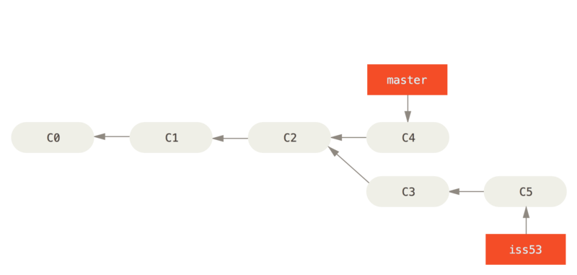here you work on some git branch master at c4… you get an issue at branch c5, then you can revert back to earlier branches…

Merging Is basically when you clear the issue 53 in the above branches, then you can add it to the master branch or “merge” them… this is merging…

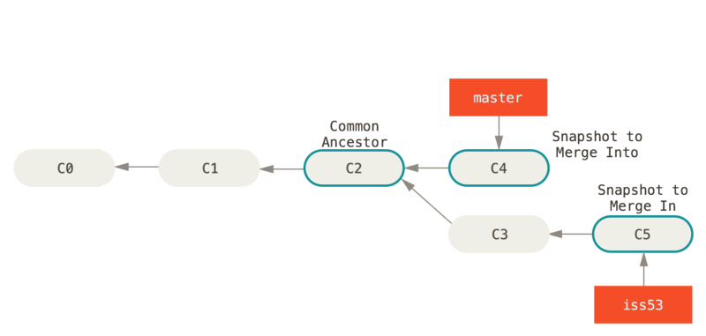

Elastic IP:

An *Elastic IP address* is a static IPv4 address designed for dynamic cloud computing. With an Elastic IP address, one can mask the failure of an instance or software by rapidly remapping the address to another instance in your account.

An Elastic IP address is a public IPv4 address, which is reachable from the internet. If an instance does not have a public IPv4 address, one can associate an Elastic IP address with your instance to enable communication with the internet. For example, this allows one to connect to one’s instance from one’s local computer.

Static IP on the other hand is related directly to you website address, and any and all changes made to webpages are final… they reflect instantly… and unlike cloud services like amazon AWS, do not allow you to switch to a different repository…

Client Server Model

The client-server model describes how a server provides resources and services to one or more clients. Examples of servers include web servers, mail servers, and file servers. Each of these servers provide resources to client devices, such as desktop computers, laptops, tablets, and smartphones. Most servers have a one-to-many relationship with clients, meaning a single server can provide resources to multiple clients at one time.

When a client requests a connection to a server, the server can either accept or reject the connection. If the connection is accepted, the server establishes and maintains a connection with the client over a specific protocol. For example, an email client may request an SMTP connection to a mail server in order to send a message. The SMTP application on the mail server will then request authentication from the client, such as the email address and password. If these credentials match an account on the mail server, the server will send the email to the intended recipient.