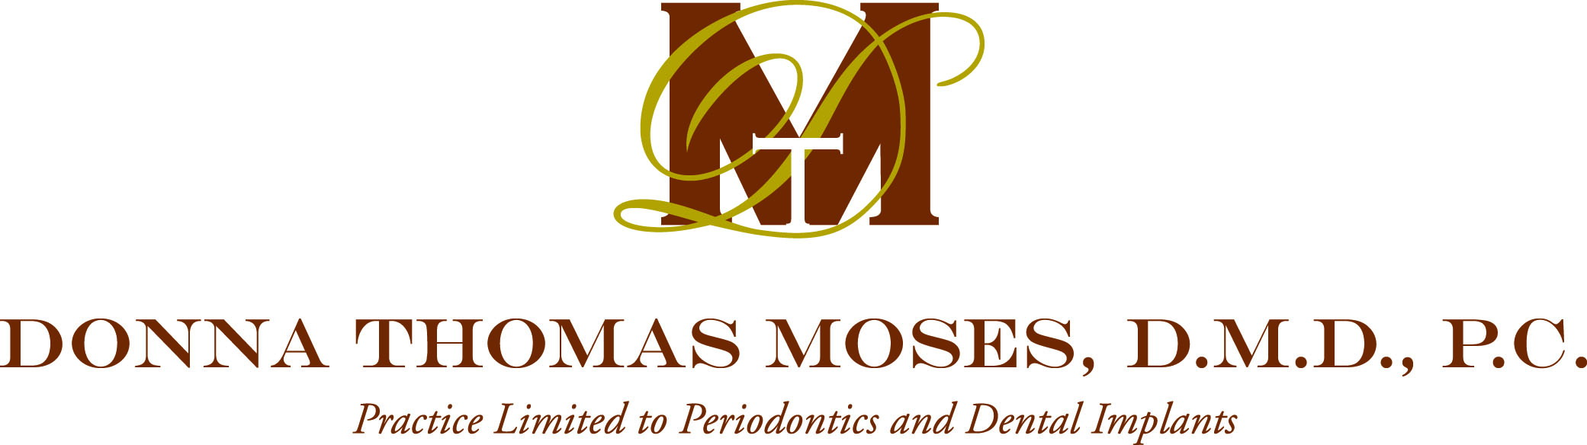

Authorization to Release Periodontal Status Information to Third Party
(Permission to speak to other individuals regarding your periodontal treatment
(example family member, friend, etc.)

On this date , I
Today’s Date Patient’s Printed Name

state that I am a patient of Dr. Donna T. Moses and authorize Dr. Moses and/or her staff to discuss my periodontal status, schedule appointments and discuss financial/insurance matters with the following individual/s:

Name of individual which Dr. Moses and/or staff may release information to Relationship to patient
(example family member, friend, etc.)

Name of individual which Dr. Moses and/or staff may release information to Relationship to patient
(example family member, friend, etc.)

I realize that I may revoke this authorization at any time in writing. I further understand that Dr. Moses and/or her staff will not condition treatment, payment, enrollment or eligibility for benefits on whether I sign this authorization, and there is potential for information disclosed pursuant to the authorization to be subject to re-disclosure by the recipient.

Patient or Guardian’s Signature Date

Witness’ Signature Date

11/16

