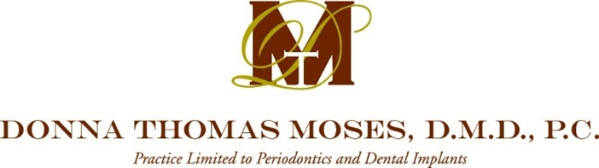

CONSENT FOR ELECTRONIC COMMUNICATION
PATIENT ACKNOWLEDGEMENT OF RISK ASSOCIATED WITH TRANSMISSION
OF PATIENT HEALTH INFORMATION VIA ELECTRONIC DEVICES

Date:

Patient Name: DOB:

Please indicate your personal preference/s for the Practice to contact you regarding appointments:
□ Text Cell Phone #:
□ E-Mail E-Mail Address:
□ Phone call Phone #:
□ None (I prefer no electronic form of appointment reminder)

The Health Insurance Portability and Accountability Act of 1996 (HIPAA) recommends that e-mail containing protected health information be encrypted*. Our Practice strives to ensure our patient’s health records are secure. In order to treatment plan a patient’s case, we must communicate with you (the patient), your dentist/s, lab, physician/s and/or any other party necessary to care for your periodontal needs. This may entail forwarding dental/health records to those involved with your dental needs via e-mail and/or text. Our standard is to send e-mail correspondence regarding your case to these individuals in an encrypted format. That being said, there are instances beyond our control in which we are unable to forward this information via encryption. In addition, please note that we are unable to send text messages in an encrypted format. Electronic records that are not in an encrypted format, could mean that the confidentiality of such records may be breached by a third party.

*Encrypted E-mail: Encryption of email messages protect the content from being read by entities other than the intended recipients. Email encryption may also include authentication.

PATIENT ACKNOWLEDGMENT AND AGREEMENT
I acknowledge that I have read and fully understand this consent form. I understand that in order to treatment plan my periodontal needs, my health records may be forwarded to interested parties through the use of E-mail/Text between the Practice, Lab, Physician and myself and the risks associated with this form of communication. I understand that if I do not consent to the Practice utilizing these forms of communication, that it may cause a delay in treating my dental/periodontal/health needs. I further understand that I am responsible for updating my personal contact information (i.e., e-mail address/cell phone number, etc.) should it change.

Patient/Parent/Legal Guardian Signature: Date:

Witness Signature: Date:

2/20

