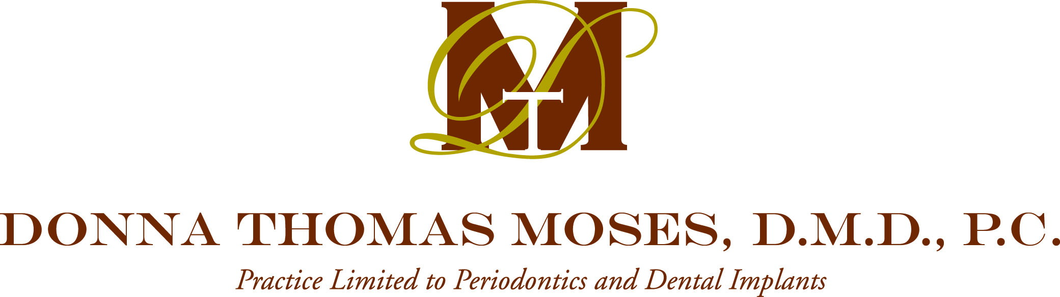

Patient’s Name:

Statement of Financial Policy for Professional Services

Welcome to our practice. We hope to make your visits as pleasant as possible. Unfortunately, aside from the emotional and physical impact of any treatment, there is all too often a degree of financial impact as well. Your review of our financial policies at this time greatly helps avoid any possible future misunderstanding(s) and thus allows everyone to be more efficient.

- Our relationship and our contract is with you. We do not provide dental services to your insurance company and have no responsibility to assure that the insurance company is pleased with your dental care. We will not short-change your dental care to satisfy any insurance company.

- Please note that we are considered an out-of-network provider. Therefore, payment for the visit is required at the time of service. That being said, WE WILL FILE YOUR INSURANCE TO YOUR PRIMARY DENTAL INSURANCE POLICY AND REQUEST THAT ALL REIMBURSEMENT CHECKS BE ENDORSED TO AND DIRECTLY FORWARDED TO THE SUBSCRIBER. IN ADDITION, PATIENTS DESIRING A DENTAL PRE-ESTIMATION OF BENEFITS MUST REQUEST SUCH. WE DO NOT AUTOMATICALLY FILE PRE-ESTIMATES. In the event this Practice is issued payment directly from an insurance company, it will be returned to the insurance carrier, directing payment to the subscriber. Please contact your insurance carrier directly if you have questions regarding your plan and coverage and to inquire if a pre-estimation of benefits must be filed prior to a procedure.

- Any agreement that exists between you and any third party (insurance company, employer, etc.) for dental, medical or surgical care reimbursement does not obligate us to comply with the provisions of your policy. Please contact your insurance carrier directly if you have questions regarding your plan and coverage. In general, we do not have contracts with insurance companies.

- Often insurance companies will use the term “Usual and Customary”, or similar such language when denying charges for dental care. The implication is that the Doctor charges too much for a given procedure. Universal “Usual and Customary” fee schedules Do Not Exist. The amount an insurance company reimburses for a procedure will vary with the company, the type and quality of policy, the zip code where charges were made and sometimes even the age or health of the patient. Our fee schedule is the same for everyone!

- CANCELLATION POLICY: We require you to inform our office of a cancellation or rescheduling of any appointments at least 1 (one) business day before the appointment. Due to the nature of our dental practice, and the advance planning of all major treatment (surgery), such notice is mandatory. Shorter notices prevent us from efficiently operating our practice and unfairly prevent other patients from receiving needed care. Without this 24-hour advanced notice, you will be charged $100.00 (one hundred dollars), which must be paid in full before another appointment is scheduled. This fee will be enforced and is similar to other industries which charge for space, commodities or time. _________ Patient’s initials

- The patient understands and agrees that he/she is responsible for all amounts due, and further agrees to pay any fees (including attorney’s fees and other costs) associated with the collections as well as interest in the amount of 1.5% per month on amounts due more than 90 days.

- Any person with financial responsibility for a patient, regardless of the patient’s age, will have access to information regarding treatment, health, finances, etc for the patient.

We are all too aware of the current nationwide crisis in healthcare financing. Despite the pressures to pass along increased costs to the patient, we work hard on your behalf to contain fees and other charges. We are here to serve you for your dental needs. If we have done well, please tell your family, your friends and your referring doctor. If we have not, please tell us!

By signing as the responsible party/guardian, I _________________________________________________________________
Printed name of patient or responsible party/guardian

state that I am financially responsible for the above-mentioned patient. I further understand and agree that I am responsible for all
amounts due, Nd agree to pay any fees (including attorney’s fees and other costs) associated with the collections. I have read and
understand the above. I understand that I may receive a copy of this form upon request. The Practice accepts Checks, Cash, Visa, MasterCard, American Express and offers 6 months no interest with CareCredit.

_________________________________________ __________________________________ ____________________
Signature of patient responsible party/guardian Witness’ Signature Date
5/19

