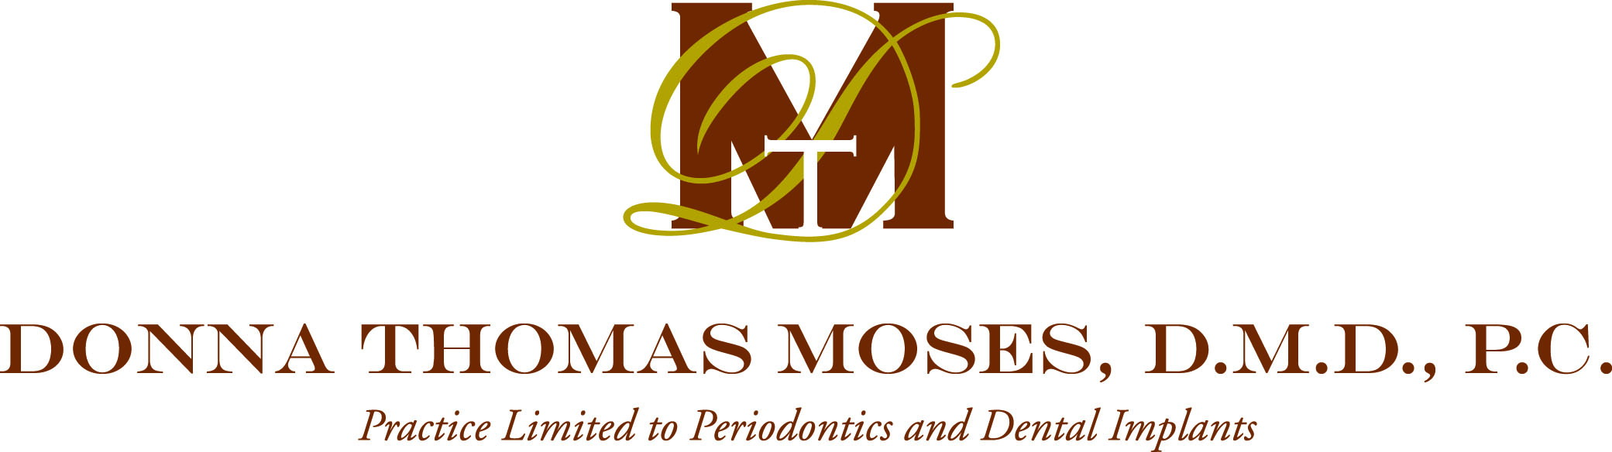

Release of Medical/Dental Records
Dear patient,

In the future, our office may need to request medical records from your physician/s. Please complete the highlighted areas of this form (sign & date) should this need arise. Thank you!
Dear

The following individual has asked us to request that his/her medical records be released and forwarded to the address listed below:

Patient’s Name Date of Birth

Forward records to: Dr. Donna Thomas Moses
530 Newnan Street
Carrollton, Georgia 30117
(770) 832-0089 Phone (770) 830-9531 Fax

Please be sure to include the following information:

Copy of complete medical record(s)

Copy of complete dental record(s)

Lab results:

Radiographs

Other:

I hereby authorize the release of all medial records indicated to the address listed above. I wish for them to be forwarded as soon as possible.

Patient or Guardian Signature Date

Physician’s Name Phone Number

Address (city, state, zip code) Fax Number
11/08

