Name:Anuj Panthri
Subject:Python Programming
Roll no. :190529014
Course: BCA Vth Sem

Ans 1.
s="thequickbrownfoxjumpsoverthelazydog"
allchars=set(s)
print("Character Frequency:")
for char in allchars:
if (s.count(char)>1):
print(char,":",s.count(char))

Output:
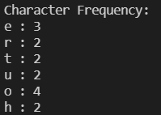

Ans 2.
l1=[[1,2,3],[4,5,6],[10,11,12],[7,8,9]]
max=0
for item in l1:
if sum(item)>max:
max=sum(item)
max_list=item
print("List:",l1)
print("Output:",max_list)

Output:

Ans 3.
s1={2,5,3,4,5,17,3}
s2={1,6,7,8,9}
#s2={1,3,5,2,6}

print('s1:',s1)
print('s2:',s2)

if len(s1.intersection(s2))==0:
print("no common elements found")
else:
print("common elements found")

Output:
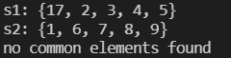

Ans 4.
d1={'item1': 45.50, 'item2':35, 'item3': 41.30, 'item4':55,'item5': 24}
sorted_dict=sorted(list(d1.items()),key=lambda x:x[1],reverse=True)
print("Top 3 items:")
for item in sorted_dict[:3]:
print(item[0],item[1])

Output:

