Game Design Document

Fill up the following document

1. Write the title of your project.

Walking Game

1. What is the goal of the game?

The man has to reach at the finish line

1. Write a brief story of your game.

There is a man ,he has to com at the finish line there are many levels.

This game is a Multiplayer Game. There is Leardboard Score and

Many things.

1. Which are the playing characters of this game?

* Playing characters are the ones who respond to the user based on the input from the user.
* Cars, monkeys, dinos, wizards, etc., are the playing characters in the game.

|  |  |  |
| --- | --- | --- |
| Number | Character Name | What can this character do? |
| 1 | 1st Man | He can walk |
| 2 | 2nd Man | He can walk |
| 3 |  |  |
| 4 |  |  |
| 5 |  |  |
| 6 |  |  |
| 7 |  |  |
| 8 |  |  |

1. Which are the Non-Playing Characters of this game?

* Non-Playing characters are the ones that don't have an action or behavior when the user interacts with the game.
* Hurdles, stones, bananas, coins, etc., are non-playing characters in the game.

|  |  |  |
| --- | --- | --- |
| Number | Character Name | What can this character do? |
| 1 | track | It is stable |
| 2 | railway | The train goes here and there. |
| 3 | footpath | It is going in y axis |
| 4 | stone | The stone is goes here and there |
| 5 | arrow | The arrow goes here and there |
| 6 | tile | It has place on the rivergoes here and there and helps the man to cross the river |
| 7 | river | It is stable and it floats |
| 8 | Finish line | It is stable and show the end |

Coin To increase the

score

Draw your imagination of this game. What does this game look like?

* Draw the game either on your computer or on paper.
* Add images of the game scenes to show each of the playing and non-playing characters at least once.

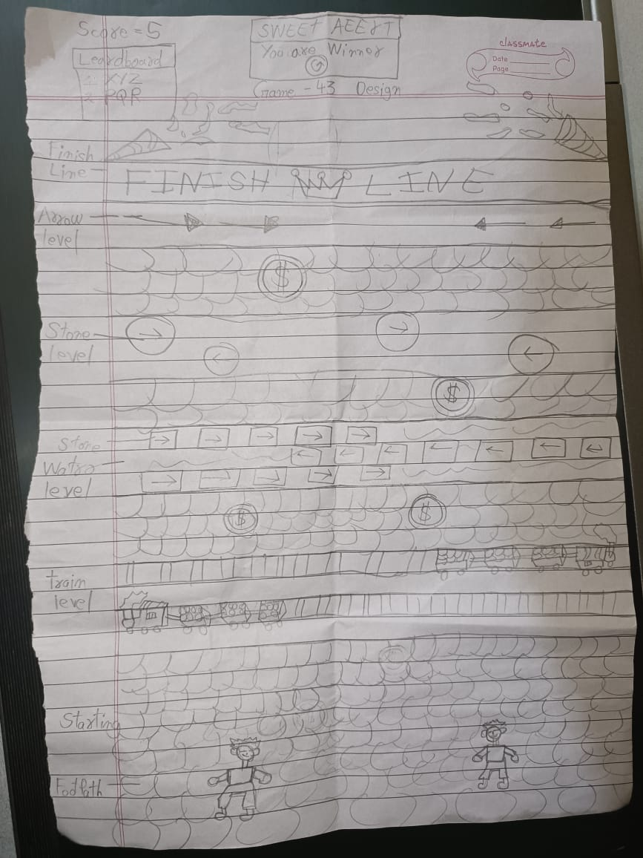  
There is a footpath ont that ther 2 mans standing on it. There are tracks,Railways, stone. river,

Tile,arrow .On the river ther are tiles moving here and there.

How do you plan to make your game engaging?

I have add many levels to it and made the game multiplayer.Ther is also score and leardboard.to make the game engaging.