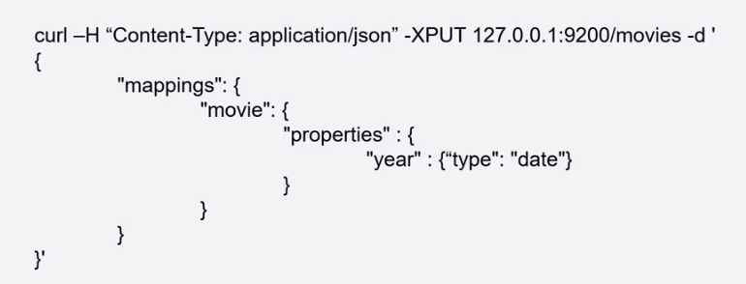

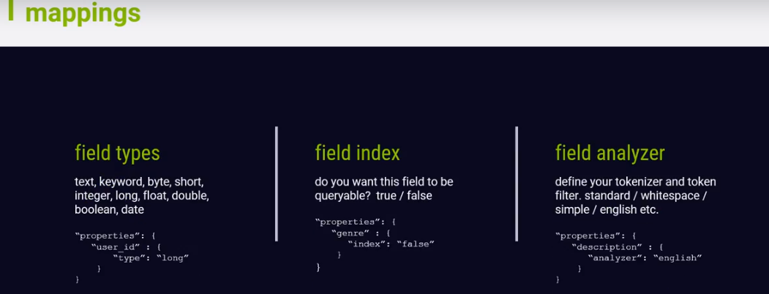

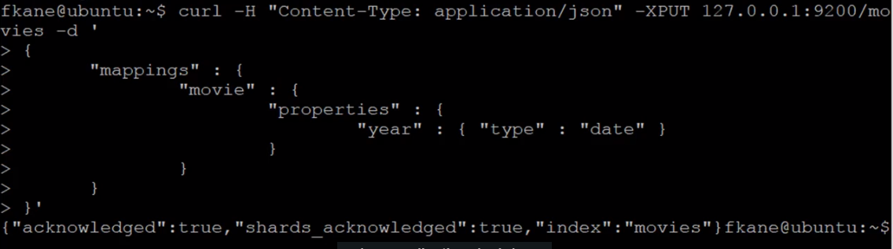

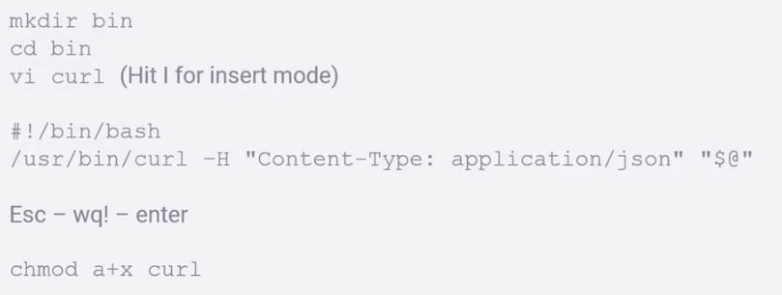



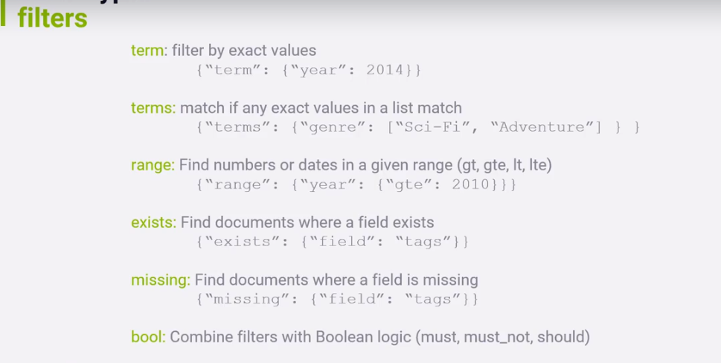

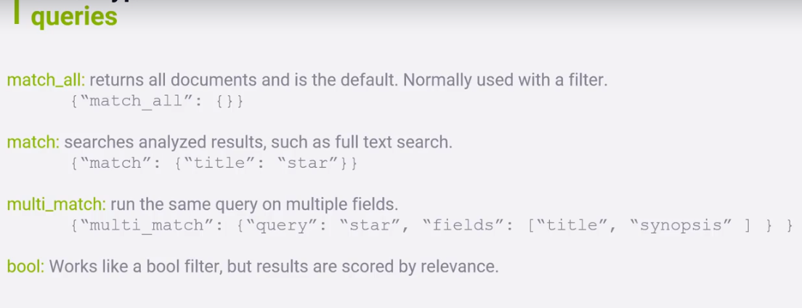

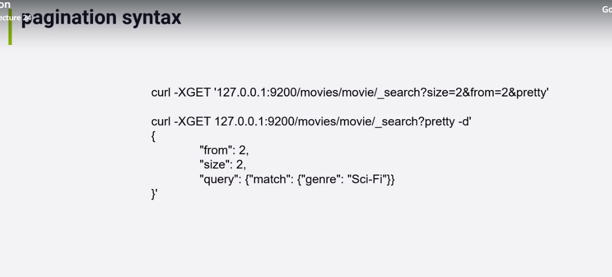



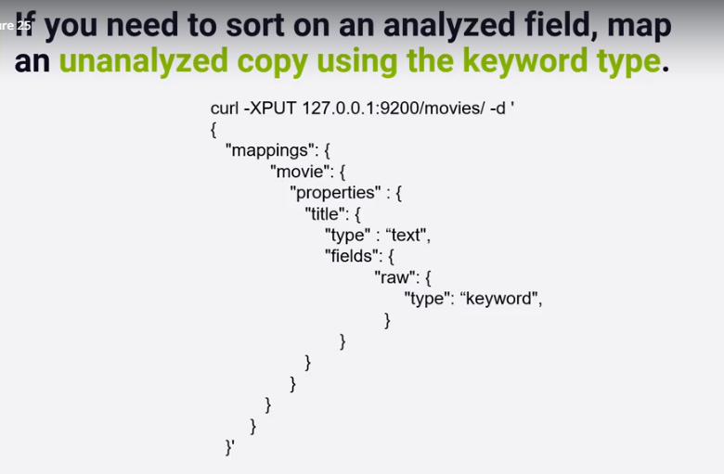

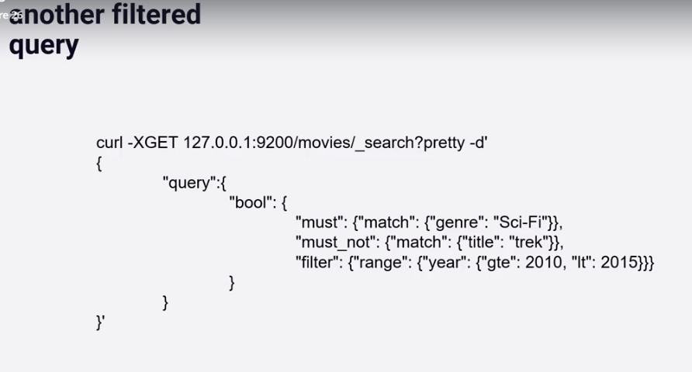

curl -XGET http://10.5.214.42:9200/logstash-btfy-*/_search?pretty

{

}

curl -H "Content-Type: application/json" <URL> -d '<BODY>'

curl -H "Content-Type: application/json" -XGET 'http://10.5.214.42:9200/logstash-btfy-*/_search?pretty' -d '/

{/

"query": {/

"match_phrase":{/

"text_entry":"c5ac2365-99aa-4109-a60e-700a07785dc7"/

}/

}/

}/

'

curl -H "Content-Type: application/json" -XGET 'http://10.5.214.36:9200/logstash-btfy-*/_search?pretty' -d '{"query": {"query_string": {"analyze_wildcard": true,"query": "*73db680b-b14b-401b-b01a-25e0db52e4de*"}}}'

curl -H "Content-Type: application/json" -XGET 'http://10.5.214.36:9200/logstash-btfy-2018.12.21/_search?pretty' -d'{"query":{"match_phrase":{"text_entry":"*93082e62-dfdb-44b5-af74-251d36e6e319*"}}}'

{

"index": "logstash-btfy*",

"query": {

"query_string": {

"analyze_wildcard": true,

"query": "*"

}

PUT /testindex

{

"settings":{

"number_of_shards": 3

,"number_of_replicas": 1

}

}

Above code will give 6 shards

--------------WHAT IS OPENSSH????

curl -H "Content-Type: Application/json" -XPUT 10.5.214.36:9200/test_data -d '{"mappings" : {"movie" : {"properties" : {"year" : { "type" : "date" }}}}}'

curl -H "Content-Type: Application/json" -XGET 10.5.214.36:9200/test_data/_mapping/movie?pretty

curl -XPUT 10.5.214.36:9200/test_data/movie/109487 -d '{"genre" : ["IMAX", "Sci-Fi"], "title" : "Interstellar", "year" : "2014"}'

curl -XGET 10.5.214.36:9200/test_data/movie/_search?pretty

curl -XGET 10.5.214.36:9200/test_data/movie/109487?pretty

curl -XPUT 10.5.214.36:9200/_bulk?pretty --data-binary @movies.json

curl -XGET 10.5.214.36:9200/test_data/movie/109487?pretty

curl -XPOST 10.5.214.36:9200/test_data/movie/109487/_update -d ' {"doc" : {"title" : "Interstellar Woo"}}'

curl -XPUT 10.5.214.36:9200/test_data/movie/109487 -d '{"genre" : ["IMAX", "Sci-Fi"], "title" : "Interstellar", "year" : "2014"}'

curl -XGET 10.5.214.36:9200/test_data/_search?q=DARK

curl -XDELETE 10.5.214.36:9200/test_data/movie/58559

curl -XPUT 10.5.214.36:9200/test_data/movie/109487?version=3 -d '{"genre" : ["IMAX", "Sci-Fi"], "title" : "Interstellar", "year" : "2014"}'

curl -XPOST 10.5.214.36:9200/test_data/movie/109487/_update?retry_on_conflict=5 -d '{"doc" :{"genre" : ["IMAX", "Sci-Fi"], "title" : "Interstellar", "year" : "2015"}}'

curl -XGET 10.5.214.36:9200/test_data/_search?pretty -d '{"query":{"match":{"title": "Star Trek"}}}}'

curl -XGET 10.5.214.36:9200/test_data/_search?pretty -d '{"query":{"match_phrase":{"genre": "sci"}}}}'

curl -XDELETE 10.5.214.36:9200/test_data

curl -XPUT 10.5.214.36:9200/test_data -d '{"mappings" : {"movie" : {"properties" : {"year" : { "type" : "date" },"id": {"type":"integer"},"genre":{"type":"keyword"},"title":{"type":"text","analyzer":"english"}}}}}'

curl -XPUT 10.5.214.36:9200/_bulk?pretty --data-binary @movies.json

curl -XGET 10.5.214.36:9200/test_data/_search?pretty -d '{"query":{"match_phrase":{"genre": "sci"}}}}'

curl -XGET 10.5.214.36:9200/test_data/_search?pretty -d '{"query":{"match_phrase":{"genre": "Sci-Fi"}}}}'

curl -XGET 10.5.214.36:9200/test_data/_search?pretty -d '{"query":{"match":{"title": "Star Trek"}}}}'

curl -XPUT 10.5.214.36:9200/series -d '{"mappings":{"movie":{"properties":{"film_to_franchise":{"type": "join","relations":{"franchise":"film"}}}}}}'

curl -XGET "10.5.214.36:9200/test_data/movie/_search?q=title=star&pretty"

curl -XGET "10.5.214.36:9200/test_data/movie/_search?q=+year:>2010&pretty"

curl -XGET "10.5.214.36:9200/test_data/movie/_search?q=+year:>2010+title:trek&pretty"

curl -XGET "10.5.214.36:9200/test_data/movie/_search?q=%2Byear%3A%3E2010+%2Btitle:trek&pretty"

------------------URI Search in ElasticSearch Documentation-----------------

curl -XGET 10.5.214.36:9200/test_data/movie/_search?pretty -d '

{

"query": {

"match": {

"title":"star"

}

}

}'

curl -XGET 10.5.214.36:9200/test_data/movie/_search?pretty -d '{"query": {"match": {"title":"star"}}}'

curl -XGET 10.5.214.36:9200/test_data/movie/_search?pretty -d '

{

"query": {

"bool": {

"must":{"term":{"title":"trek"}},

"filter":{"range":{"year":{"gte":2010}}}

}

}

}'

curl -XGET 10.5.214.36:9200/test_data/movie/_search?pretty -d '{"query": {"bool": {"must":{"term":{"title":"trek"}},"filter":{"range":{"year":{"gte":2010}}}}}}'

curl -XGET 10.5.214.36:9200/test_data/movie/_search?pretty -d '

{

"query": {

"match_phrase": {

"title":"star wars"

}

}

}'

curl -XGET 10.5.214.36:9200/test_data/movie/_search?pretty -d '{"query": {"match_phrase": {"title":"star wars"}}}'

curl -XGET 10.5.214.36:9200/test_data/movie/_search?pretty -d '

{

"query": {

"match_phrase": {

"title":{"query":"star beyond","slop": 10}

}

}

}'

Pagination

---------------------

curl -XGET "10.5.214.36:9200/test_data/movie/_search?size=2&pretty"

curl -XGET "10.5.214.36:9200/test_data/movie/_search?size=2&from=2&pretty"

Sorting

----------------------

curl -XGET "10.5.214.36:9200/test_data/movie/_search?sort=year&pretty"

curl -XGET "10.5.214.36:9200/test_data/movie/_search?sort=title&pretty"

curl -XDELETE 10.5.214.36:9200/test_data

curl -XPUT 10.5.214.36:9200/test_data -d '{"mappings" : {"movie" : {"properties" : {"year" : { "type" : "date" },"id": {"type":"integer"},"genre":{"type":"keyword"},"title":{"type":"text","fields":{"raw":{"type":"keyword"}}}}}}}'

curl -XPUT 10.5.214.36:9200/_bulk?pretty --data-binary @movies.json

curl -XGET "10.5.214.36:9200/test_data/movie/_search?sort=title.raw&pretty"

curl -XGET 10.5.214.36:9200/test_data/movie/_search?pretty -d '

{

"query" :{

"bool":{

"must":{"match":{"genre":"Sci-Fi"}},

"must_not":{"match":{"title":"trek"}},

"filter":{"range":{"year":{"gte":2010,"lt":2015}}}

}}}'

curl -XGET "10.5.214.36:9200/test_data/movie/_search?sort=title.raw&pretty" -d '

{ "query":{

"bool":{

"must": {"match":{"genre":"Sci-Fi"}},

"filter":{"range":{"year":{"lt":1960}}}

}}}'