**Notebook Screenshots 1 (Unit Testing): Distance**

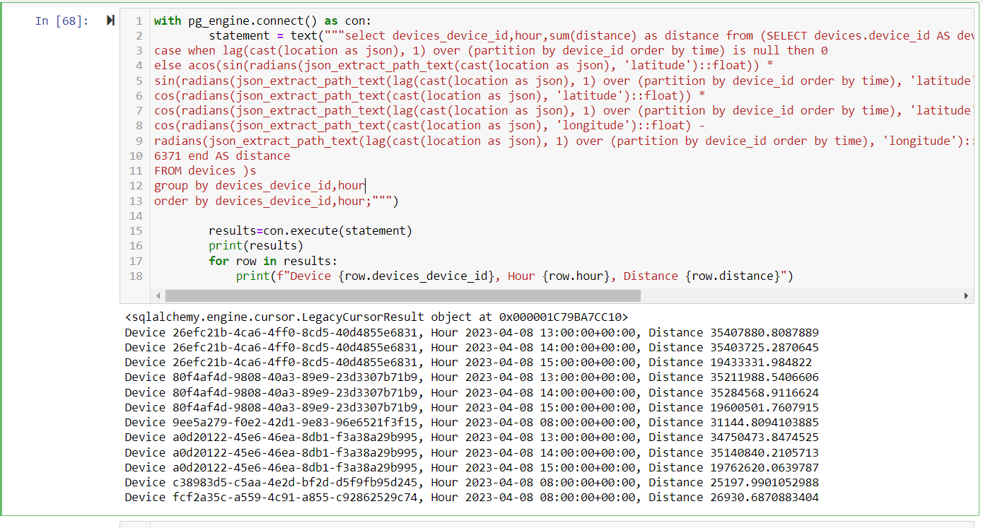

**Notebook Screenshots 1 (Unit Testing): Max Temperature and Count**

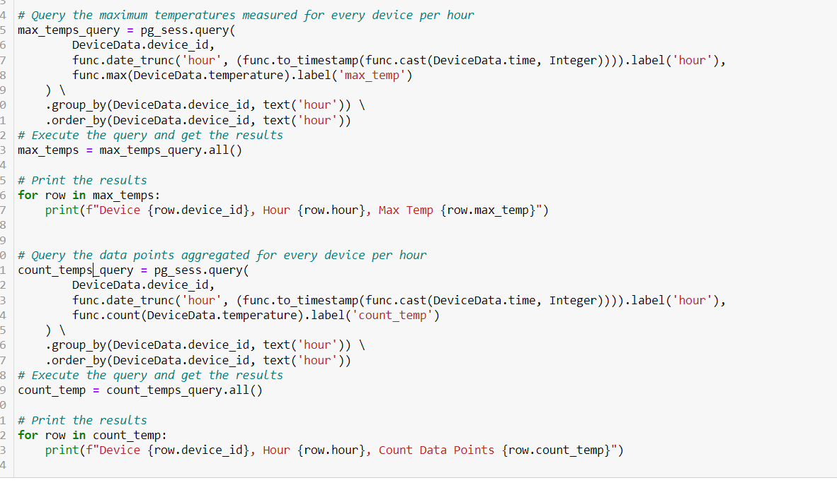

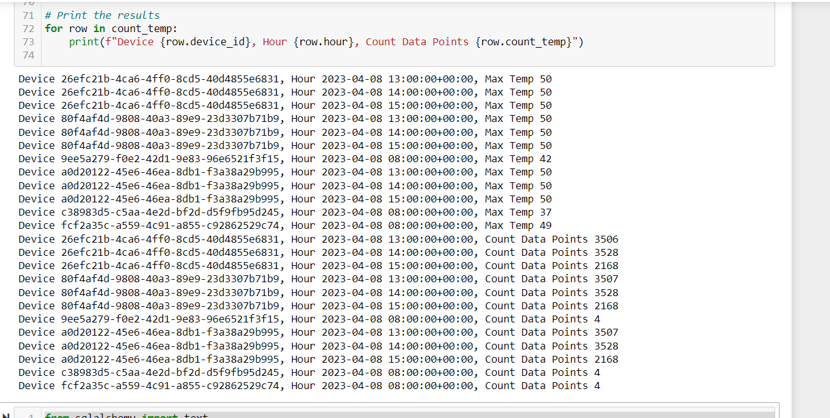

**Output on MYSQL table : Final Table “AGGREGATED_DATA”**

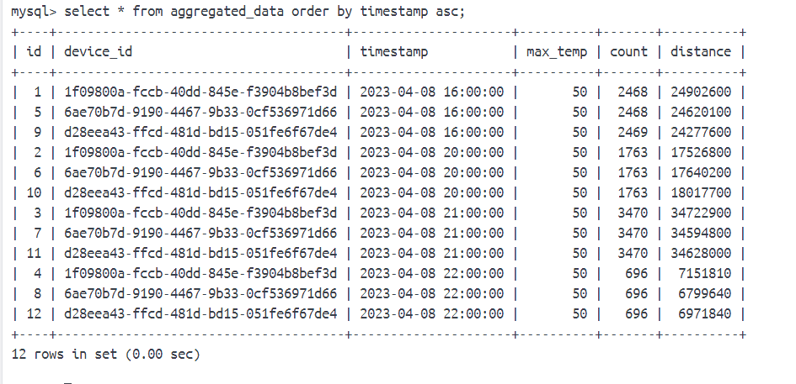

**Output on MYSQL table : Staging Table “TEMPERATURE_DATA”**

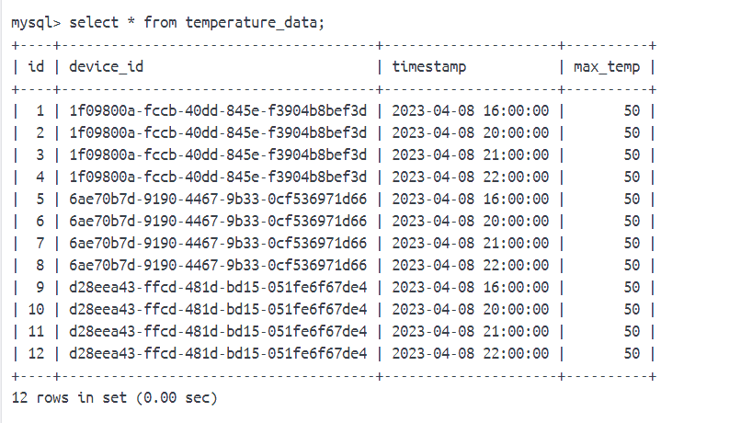

**Output on MYSQL table : Staging Table “DISTANCE_DATA”**

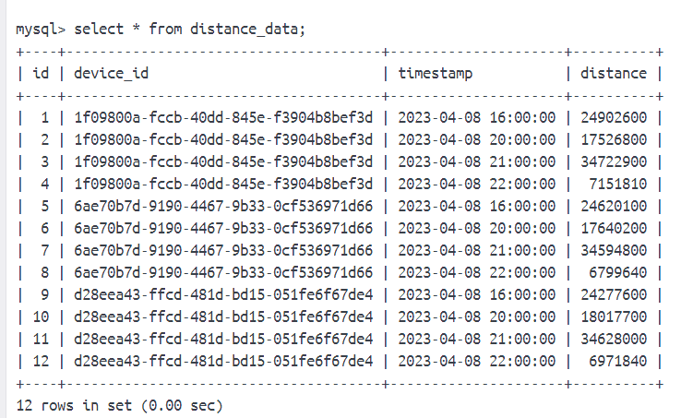

**Output on MYSQL table : Staging Table “COUNT_DATA”**

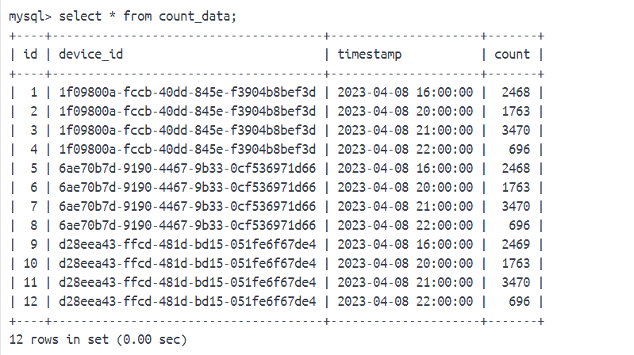

**CONTAINER SCREENSHOT for OUTPUT**



