SNJB's LS KBJ College of Engineering, Chandwad Department of Computer Engineering
Data Science & Big Data Analytics (310251) — 2025-26

Mini Project Title
Hackathon Participant Data Collection and Analysis using Google Forms and Microsoft Excel
PART 2 — Data Collection via Google Form
Data is collected using a Google Form shared among students and participants registering for the hackathon. Each response represents one team registration entry. The form is designed to be simple and user-friendly, taking less than 2 minutes to complete, ensuring quick and accurate data collection from all participants.
Google Form Fields & Settings:
# | Question / Field | Type | Validation / Notes
1 | Timestamp | DateTime | Auto-generated
2 | College Name | Short Answer | Required
3 | Team Name | Short Answer | Required
4 | Team Leader Name | Short Answer | Required
5 | Team Member 2 | Short Answer | Optional
6 | Team Member 3 | Short Answer | Optional
7 | Team Member 4 | Short Answer | Optional
8 | Leader Contact | Short Answer | 10-digit number
9 | Member 2 Contact | Short Answer | Optional
10 | Member 3 Contact | Short Answer | Optional
11 | Member 4 Contact | Short Answer | Optional
12 | Leader Email | Short Answer | Email validation
13 | Member 2 Email | Short Answer | Optional
14 | Member 3 Email | Short Answer | Optional
15 | Member 4 Email | Short Answer | Optional
16 | Track Chosen | Dropdown | AI / Web Dev / App Dev
17 | Idea Title | Short Answer | Required
18 | Idea Description | Paragraph | Required
19 | PPT Upload | File Upload | Drive link required
20 | WhatsApp Join | Multiple Choice | Yes / No
PART 3 — Raw Data Collected (Google Sheets Sample)
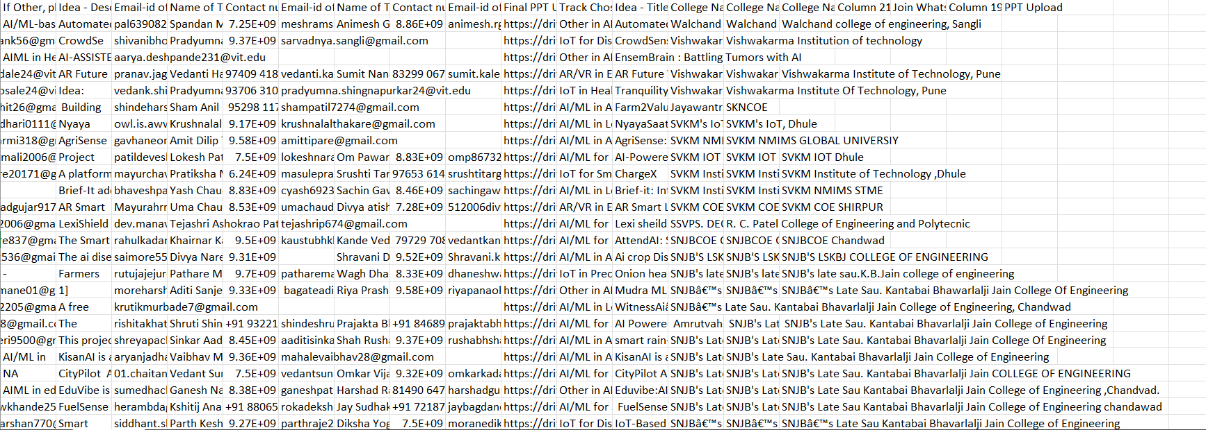

PART 4 — Data Cleaning & Preprocessing
Before analysis, we must clean the raw data. Data cleaning involves identifying and fixing three main types of issues: missing values, duplicate records, and outliers. We use Python (Pandas library) for this step.
Step 1 — Identify Missing Values
Run the following Python code to detect null values in the dataset:
import pandas as pd
import numpy as np
df = pd.read_csv("sales_data.csv")
# Check for missing values
print(df.isnull().sum())
print("Total missing:", df.isnull().sum().sum())
print("Shape:", df.shape)
Output:
Timestamp 0
College Name 0
Team Name 0
Team Leader Name 0
Team Members 0
Name of Team Member 2 0
Team Leader Contact no. 1
Contact number of Member 2 0
Email-id of Member 2 0
If Other, please provide details of the track 121
Idea - Description 0
Email-id of Team Leader 2
Name of Team Member 3 19
Contact number of Member 3 25
Email-id of Member 3 31
Name of Team Member 4 55
Contact number of Member 4 59
Email-id of Member 4 69
Final PPT Upload (reference) 5
Track Chosen 5
Idea - Title 5
College Name.1 10
College Name.2 30
College Name.3 62
Column 21 180
Join Whatsapp Group 180
Column 19 180
PPT Upload 180
dtype: int64
Total missing values: 1219

Step 2 — Handle Missing Values
Replace missing numeric values with the column mean; drop rows where critical fields are empty:
# Fill numeric missing values with mean
df["Sales_Amount"].fillna(df["Sales_Amount"].mean(), inplace=True)
df["Customer_Age"].fillna(df["Customer_Age"].median(), inplace=True)
df["Rating"].fillna(df["Rating"].mean(), inplace=True)
# Fill categorical missing values with mode
df["Returned"].fillna(df["Returned"].mode()[0], inplace=True)
Missing after fix: 0
Step 3 — Remove Duplicate Records
# Identify duplicates
print("Duplicates found:", df.duplicated().sum())
# Remove duplicates
df = df.drop_duplicates()
print("Rows after removing duplicates:", len(df))
Duplicates found: 0
Rows after removing duplicates: 180
Step 4 — Detect and Handle Outliers (IQR Method)
Outliers are values that are very different from the rest of the data. We use the IQR (Interquartile Range) method to find and remove them:
Q1 = df["Sales_Amount"].quantile(0.25)
Q3 = df["Sales_Amount"].quantile(0.75)
IQR = Q3 - Q1
lower_bound = Q1 - 1.5 * IQR
upper_bound = Q3 + 1.5 * IQR
# Remove rows outside the bounds
df = df[(df["Sales_Amount"] >= lower_bound) &
(df["Sales_Amount"] <= upper_bound)]
print(f"Rows after outlier removal: {len(df)}")
print(f"Sales range: ■{df.Sales_Amount.min():.0f} – ■{df.Sales_Amount.max():.0f}")
Rows after outlier removal: 179

Cleaning Summary
