1. In the below elements which of them are values or an expression? eg:- values can be integer or string and expressions will be mathematical operators.

* : Expressions

'hello' : String Value

-87.8 : Float Value

- : Expressions

/ : Expressions

6 : Integer value

2. What is the difference between string and variable?

**Variable** is container or identifier which can store any value it should be simple and descriptive

**String** is sequence of characters which is always wrap in single or double quotation mark.

(Eg : “Ineuron”)

3. Describe three different data types.

**Numeric datatype:** it represents numeric values which can be Integers, float, or complex numbers

**Text datatype**: is string in which text values can be store in quotation marks.

**Sequence datatype:** in which we can store any data in sequential manner list, tuple are the sequence datatype

4. What is an expression made up of? What do all expressions do?

**Expressions made up of Operator, constants & variable [Eg : a = 5*2 ]**

**Expressions are used to evaluate value**

5. This assignment statements, like spam = 10. What is the difference between an expression and a statement?

**Expressions is a combination of operators, constant and variables**

**Statement is just like comment which python interpret and execute**

6. After running the following code, what does the variable bacon contain?

bacon = 22

bacon + 1

**bacon contain: 23**

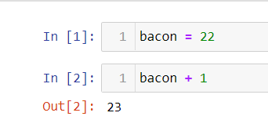

7. What should the values of the following two terms be?

'spam' + 'spamspam'

'spam' * 3

**Same output for both terms**

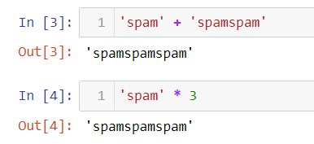

8. Why is eggs a valid variable name while 100 is invalid?

**Variable cannot start with integer should start with alphabets**

9. What three functions can be used to get the integer, floating-point number, or string version of a value?

**Int (), float(), Str()**

10. Why does this expression cause an error? How can you fix it?

'I have eaten ' + 99 + ' burritos.'

**99 is integer value which cannot concatenate with string value, to fix this error we have to wrap 99 in quotation to convert integer value to string datatype**

