1.What are the two values of the Boolean data type? How do you write them?

**True and False are the two values of the Boolean data type. In binary it is represented as 0 and 1**

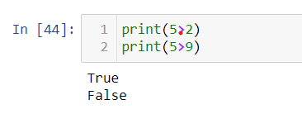

2. What are the three different types of Boolean operators?

**AND, OR and NOT these are three different types of Boolean operators.**

3. Make a list of each Boolean operator's truth tables (i.e., every possible combination of Boolean values for the operator and what it evaluates).

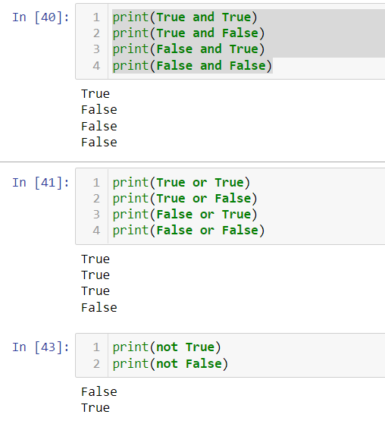

4. What are the values of the following expressions?

(5 > 4) and (3 == 5) : **False**

not (5 > 4) : **False**

(5 > 4) or (3 == 5) : **True**

not ((5 > 4) or (3 == 5)) : **False**

(True and True) and (True == False) : **False**

(not False) or (not True) : **True**

5. What are the six comparison operators?

**> : Grater than**

**>= : Grater than or equal to**

**< : Less than**

**<= : less than or equal to**

**== : Equal**

**!= : Not equal**

6. How do you tell the difference between the equal to and assignment operators? Describe a condition and when you would use one.

**Equal to operator is used for comparison between two values**.

**(e.g.**

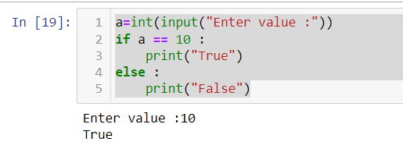

**Assignment operator is used to assign value.**

**(e.g.** 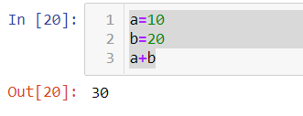

7. Identify the three blocks in this code:

spam = 0

if spam == 10:

print('eggs') : **expected an indented block**

if spam > 5:

print('bacon') : **expected an indented block**

else:

print('ham') : **expected an indented block**

print('spam')

print('spam')

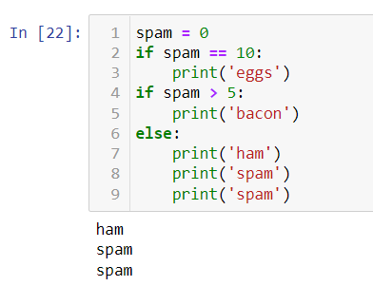

8. Write code that prints Hello if 1 is stored in spam, prints Howdy if 2 is stored in spam, and prints Greetings! if anything else is stored in spam.

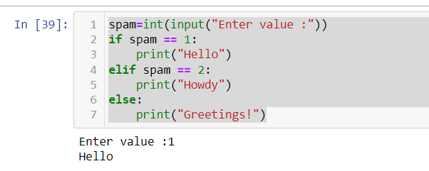

9.If your programme is stuck in an endless loop, what keys you’ll press?

**Ctrl+C**

10. How can you tell the difference between break and continue?

**Break: break is use to exit out of the loop and stop the flow execution or switch cases of the control statement.**

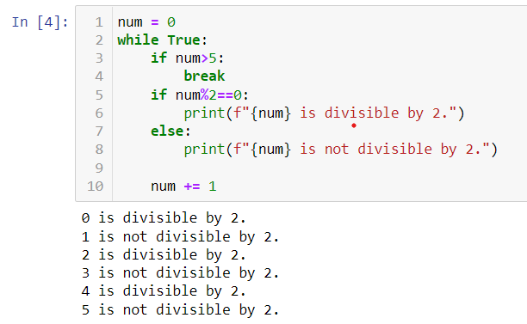

**Continue**: **Continue statement used to skip the code inside loop for the current iteration.**

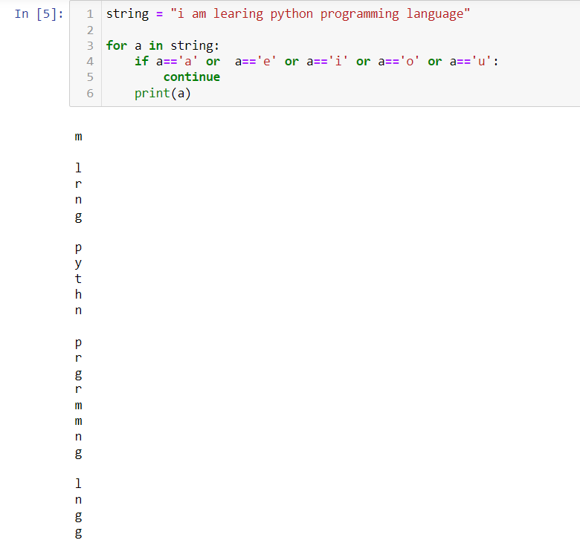

11. In a for loop, what is the difference between range(10), range(0, 10), and range(0, 10, 1)?

The output will be same for all 3

range(10) : here the start parameter is not defined it will execute till last index defined in range.

range(0,10) : here the start and end range is defined.

range(0,10,1) : here first is starting value second is end and third is jump

Example :

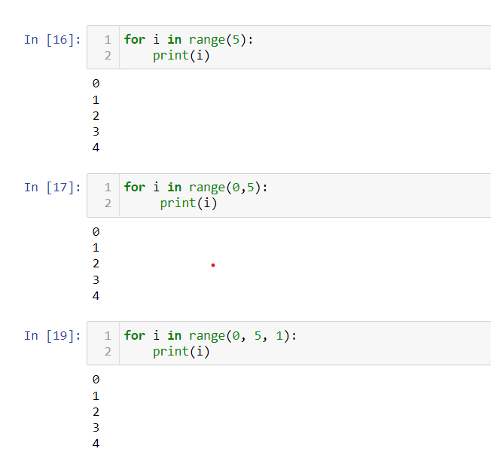

12. Write a short program that prints the numbers 1 to 10 using a for loop. Then write an equivalent program that prints the numbers 1 to 10 using a while loop.

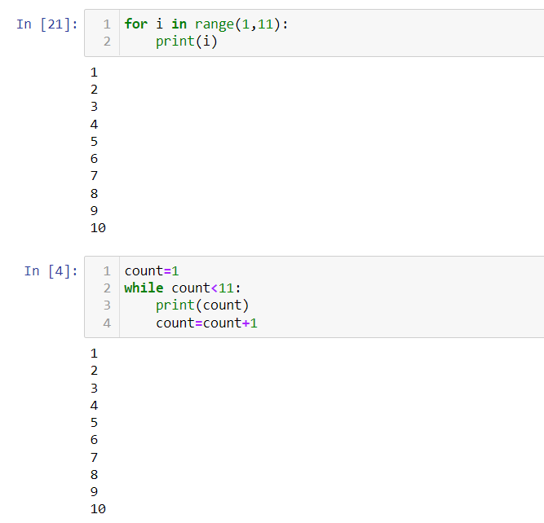

13. If you had a function named bacon() inside a module named spam, how would you call it after importing spam?

**spam.bacon()**