1. **Why are functions advantageous to have in your programs?**

-> Functions are reusable code that is use to perform single related action and for large programs functions make it more organised and manageable.

**2. When does the code in a function run: when it's specified or when it's called?**

-> eg. In below example the sum of two defined numbers is stored in variable a , when we call add function then only the code of the function run & return the output.

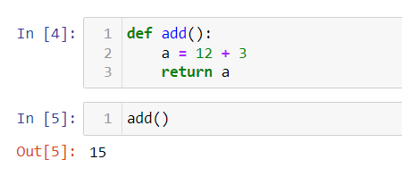

**3.** **What statement creates a function?**

-> Syntax : def <Function_name>(parameters):

Set of operation

Function name is to identify the function.

Parameters are the input to the function or it could use optional

Body of the function contains set of operation.

**4. What is the difference between a function and a function call?**

-> Functions are the set of instructions. We can write the functions, but it will execute only when we call the function, until we call the function it won’t execute.

**5. How many global scopes are there in a Python program? How many local scopes?**

-> There are four variable scopes in python.

1) Local : The variables which are defined inside the function.

2) Global : The variables which are defined outside the function or defined by the keyword global.

3) Built-in : The built-in scope has all the names that are loaded into python.

4) Enclosed : a python variable scope that isn’t global or local is enclosing scope.

One global scope and we can have many local scope variables as per the number of functions we have defined.

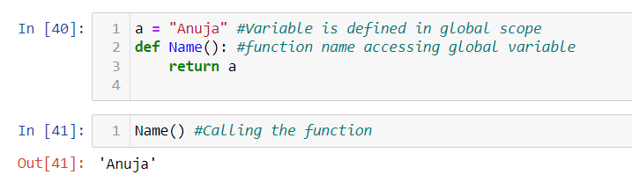

**6. What happens to variables in a local scope when the function call returns?**

-> A local variable become undefined after the function call completes.

**7. What is the concept of a return value? Is it possible to have a return value in an expression?**

-> The return statement is used to end the execution of the function call and ‘return’ the result to the caller. The statement after the return statement are not executed.

**8. If a function does not have a return statement, what is the return value of a call to that function?**

-> If function doesn’t specify a return value, it return None.

In conditional statements none evaluates to False

**9. How do you make a function variable refer to the global variable?**

-> We can use Global keyword before variable to defined as global variable.

**10. What is the data type of None?**

-> NoneType

**11. What does the sentence import areallyourpetsnamederic do?**

-> There is no module named areallyourpetsnamedericinpython.

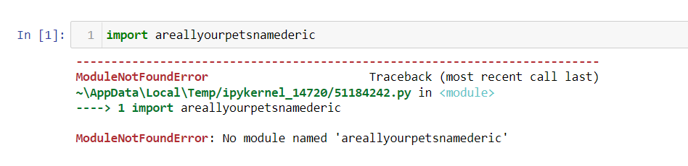

**12. If you had a bacon() feature in a spam module, what would you call it after importing spam?**

-> Any function in spam module can be call with below,

Spam.<function-name>()

bacon feature can be called using,

spam.bacon()

**13. What can you do to save a programme from crashing if it encounters an error?**

-> with the use of **try** statement test a code block and if it encounters error an **except** statement handles the error & save program from crashing.

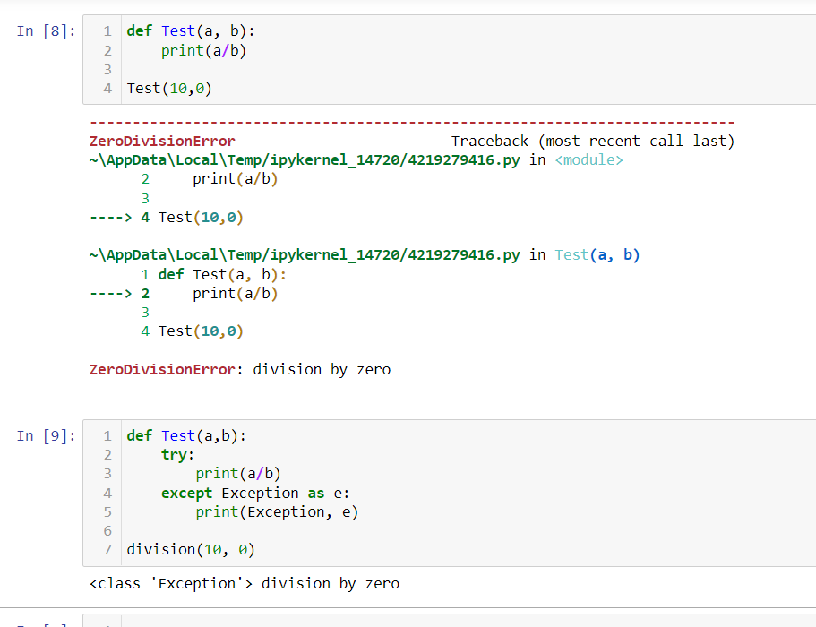

**14. What is the purpose of the try clause? What is the purpose of the except clause?**

-> Try and Except statement is used to handle errors within our code in Python. The try block is used to check some code for errors i.e the code inside the try block will execute when there is no error in the program. Whereas the code inside the except block will execute whenever the program encounters some error in the preceding try block.