1. **What exactly is []?**

-> Square brackets represent empty list in python.

The data wrap in square brackets is consider as list in python

eg

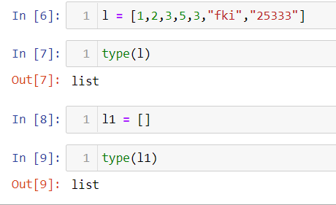

**2. In a list of values stored in a variable called spam, how would you assign the value 'hello' as the third value? (Assume [2, 4, 6, 8, 10] are in spam.)**

->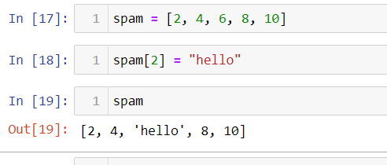

**Let's pretend the spam includes the list ['a', 'b', 'c', 'd'] for the next three queries.**

**3. What is the value of spam[int(int('3' * 2) / 11)]?**

**4. What is the value of spam[-1]?**

**5. What is the value of spam[:2]?**

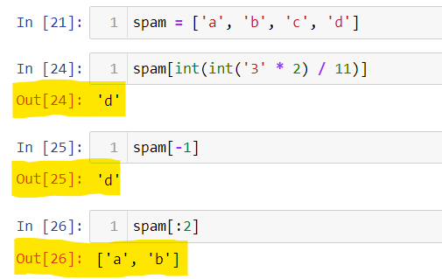

**Let's pretend bacon has the list [3.14, 'cat,' 11, 'cat,' True] for the next three questions.**

**6. What is the value of bacon.index('cat')?**

**7. How does bacon.append(99) change the look of the list value in bacon?**

**8. How does bacon.remove('cat') change the look of the list in bacon?**

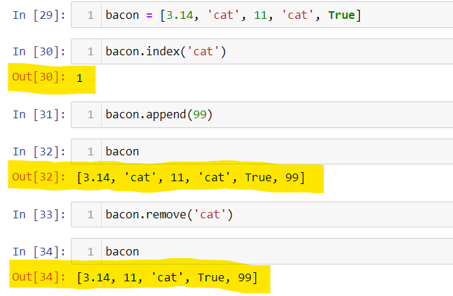

9. What are the list concatenation and list replication operators?

-> we use “+” operator for concatenation and “*” operator for replication

e.g.:

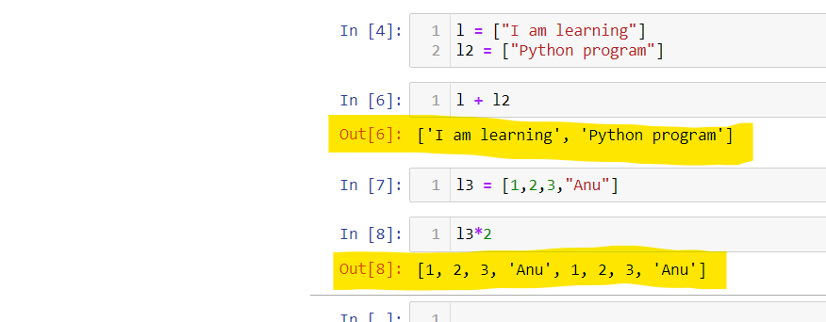

10. What is difference between the list methods append() and insert()?

-> append() will add the element at the end of the list whereas insert() will insert the element at the defined index place in the list.

Eg:

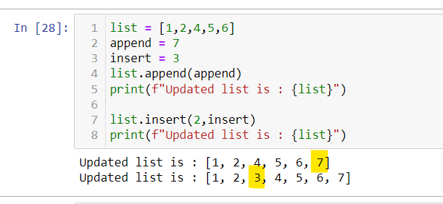

11. What are the two methods for removing items from a list?

-> **pop()** will remove an item at index and **remove()** will remove the first occurrence value. E.g

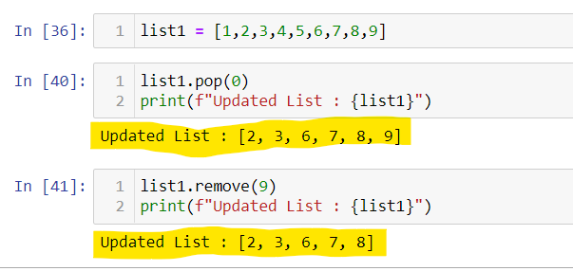

12. Describe how list values and string values are identical.

-> We can concatenate, slice, replication and loop on both string and list.

Eg.

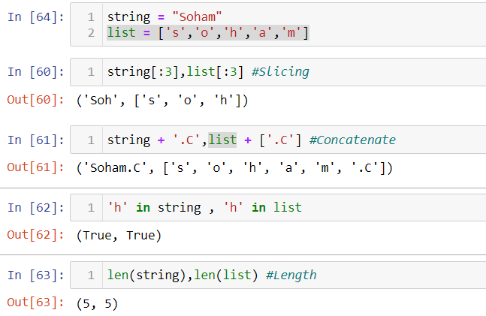

13. What's the difference between tuples and lists?

**Tuples**: Tuple is similar to a list but contains immutable objects and processing is faster than the list.

t = (1,2,3,’a’,’l’)

**Lists**: A list is a container to contains different types of objects and is used to iterate objects. List is mutable

L = [1,2,3,’a’,’l’)

14. How do you type a tuple value that only contains the integer 42?

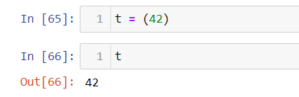

15. How do you get a list value's tuple form? How do you get a tuple value's list form?

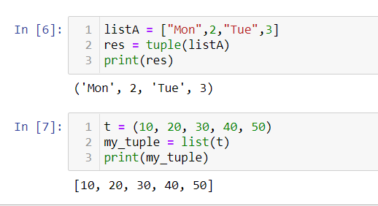

16. Variables that "contain" list values are not necessarily lists themselves. Instead, what do they contain?

-> variables do not store values directly.

Python variables work with references to objects representing the values.

For example, we have

N = [25,36,85]

Python creates a new reference for a to point at the object representing the value [25,36,85] in the memory.

17. How do you distinguish between copy.copy() and copy.deepcopy()?

-> the copy() returns a shallow copy of list and deepcopy() return a deep copy of list.

Eg 