1. What does an empty dictionary's code look like?

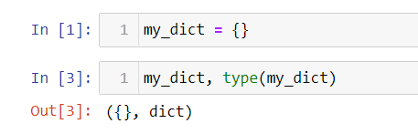

1. What is the value of a dictionary value with the key 'foo' and the value 42?

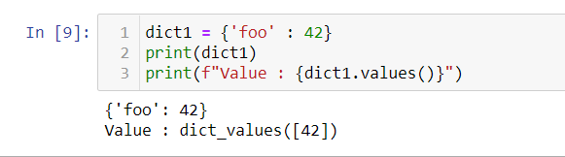

1. What is the most significant distinction between a dictionary and a list?

**List** contains order items and **dictionary** includes a collection of data points in key, value structure to store values.

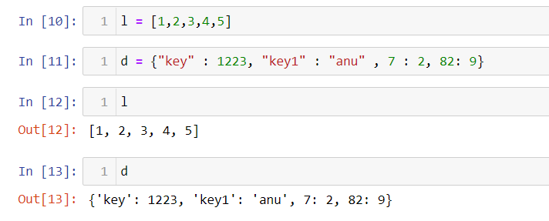

1. What happens if you try to access spam['foo'] if spam is {'bar': 100}?

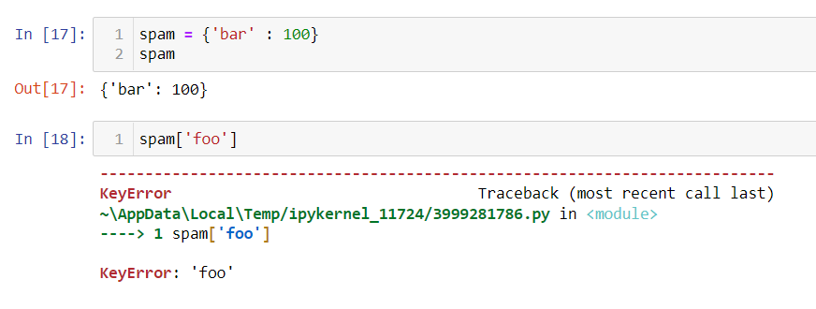

1. If a dictionary is stored in spam, what is the difference between the expressions 'cat' in spam and 'cat' in spam.keys()?

**There is no difference. The in operator checks whether a value exists as a key in the dictionary.**

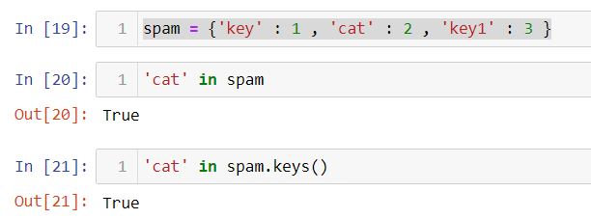

1. If a dictionary is stored in spam, what is the difference between the expressions 'cat' in spam and 'cat' in spam.values()?

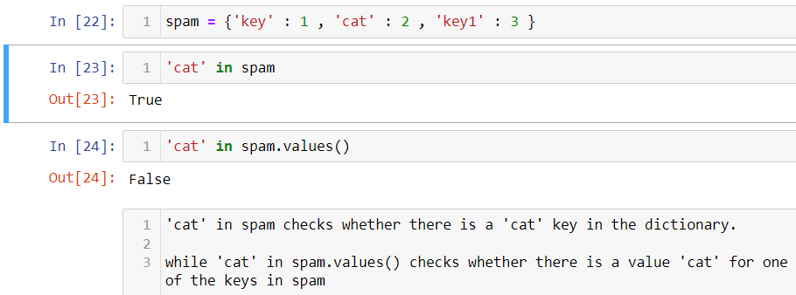

7. What is a shortcut for the following code?

if 'color' not in spam:

spam['color'] = 'black'

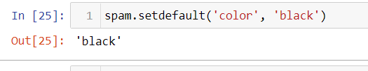

1. How do you "pretty print" dictionary values using which module and function?
2. 