1. What are escape characters, and how do you use them?

An escape character is a backslash \ followed by the character you want to insert.

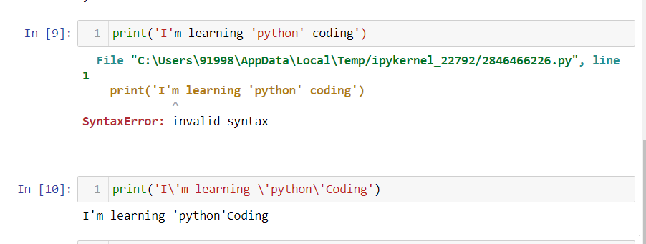

1. What do the escape characters n and t stand for?

\n stands for next line or enter

\t stands for space

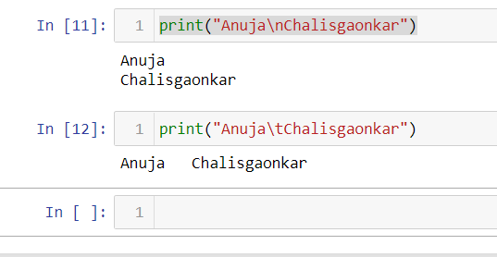

1. What is the way to include backslash characters in a string?

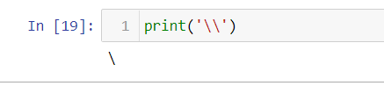

1. The string "Howl's Moving Castle" is a correct value. Why isn't the single quote character in the word Howl's not escaped a problem?

* The complete string is enclosed in double quotes

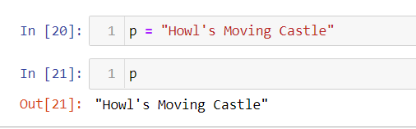

1. How do you write a string of newlines if you don't want to use the n character?

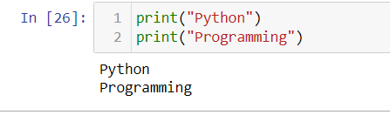

6. What are the values of the given expressions?

'Hello, world!'[1]

'Hello, world!'[0:5]

'Hello, world!'[:5]

'Hello, world!'[3:]

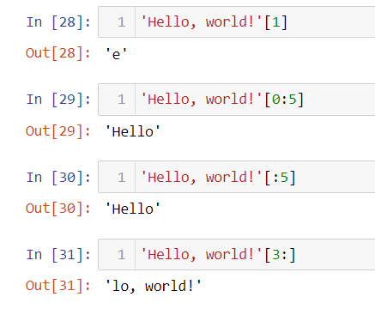

7. What are the values of the following expressions?

'Hello'.upper()

'Hello'.upper().isupper()

'Hello'.upper().lower()

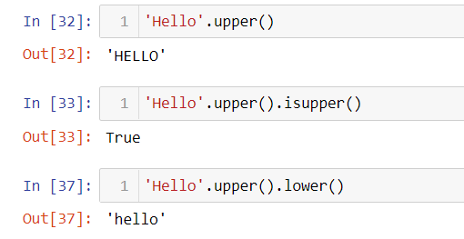

8. What are the values of the following expressions?

'Remember, remember, the fifth of July.'.split()

'-'.join('There can only one.'.split())

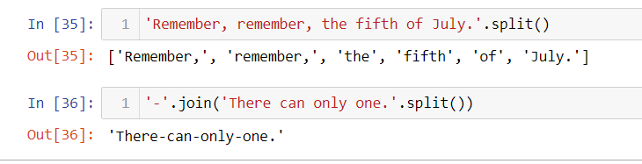

9. What are the methods for right-justifying, left-justifying, and centering a string?

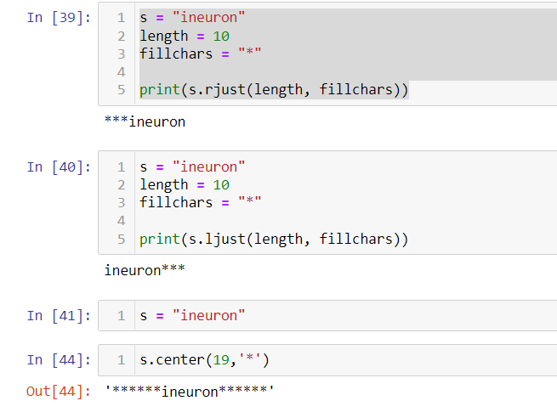

10. What is the best way to remove whitespace characters from the start or end?

**->** Strip() is the best way to remove whitespace.

