

**5COSC009C.2**

**Software Development**

**Group Project**

**Final System Requirement Specification**

Module Leader

**Mr. Banuka Athuraliya**

TeamName

**DEBUG PIRATES**

|  |  |
| --- | --- |
| **Team Member** | **Registration ID** |
| H. Thiwanki Dias Hettiarachchi | 2019741 / w1790191 |
| Srimali Udayangani | 20191114/ w1790361 |
| Ahmed Isthaffa | 2018497 / w1761936 |
| K.N. Kumar | 2018432 / w1761759 |
| Akthab Bifaz | 2018060 / w1761866 |
| H.M.A.D. Herath | 20191180 / w1790023 |

# Abstract

In recent years the connection between dogs and humans getting close but not so close because humans couldn’t identify their emotions. So, automatic emotion recognition has been an active research topic. Humans’ emotions are reflected through their speech, gesture of the body, their attitudes, and their facial expressions. The problem is dogs can’t show them like humans do and also if they show we might not understand. There are few applications to recognize the emotions of dogs, so humans get an understanding of their own dogs. Ooggy doggy is to recognize the emotions of dogs and their owners much closer.

## Acknowledgement

We want to thank our domain expert in making this project a success and giving us instructions to make our application. And, we want to thank all our IIT lecturers and all the academic staff who are involved in the SDGP (Software Development Group Project) who has been giving us feedbacks of the work we have done week in and week out. They constantly gave us positive feedbacks and as well as where we must improve our work. We are new to some of the technologies that we are using in the application and our lecturers helped each one of us to adopt to the new technologies to be used in making the application.

We would like to acknowledge all colleagues and the people who has supported us by filling the questionnaire we sent out to them.

Table of Contents

Abstract ii

Acknowledgement ii

List of Figures vi

List of tables vii

List of Abbreviations viii

Chapter 1 – Introduction 1

1.1 Problem Background 1

1.1.1 Problem Definition 2

1.2 Research Question 2

1.2.2 Research Areas 2

1.2.3 Limitations 3

1.3 Aim of the Project 3

1.4 Project Scope 4

1.5 Features of the prototype 4

1.5.5 The technologies we’re going to use in the app 6

1.6 Feature Comparison Chart 7

Chapter 2 – Literature Review 10

2.1 Chapter Overview 10

2.2 Research 10

2.2.1 Review of related researches on domain 10

2.2.2 Research Gap 13

2.3 Research on approaches and techniques 14

2.3.1 Algorithms and Technologies 14

2.3.2 Advantages and disadvantages of algorithms and technologies 19

2.3.3 Methods, steps and technologies 20

2.4 Chapter Summary 24

Chapter 3 – Project Management 25

3.1 Chapter Overview 25

3.2 Methodologies 25

3.3 Constraint 30

3.4 Communicational Plans 31

3.5 Risks and Mitigations 31

3.6 Drivers of the Project 32

3.7 Activity Schedule 33

3.8 Gantt chart Diagram 33

3.9 Work break down structure 34

3.10 Chapter Summary 34

Chapter 4 – System Requirement specification 35

4.1 Chapter Overview 35

4.2 Stakeholder analysis 35

4.2.1 Stakeholders 35

4.2.2 Onion model diagram 36

4.2.3 Stakeholders view Points 37

4.3 Requirements gathering 38

4.3.1 Techniques for requirements gathering 38

4.3.2 Questionnaire design 40

4.3.3 Formal interviews with domain experts 40

4.4 Analysis gathered data 41

4.5 Models 44

4.6 Functional Requirements 51

4.7 Non-Functional Requirements 52

4.8 Chapter Summary 52

Chapter 5 – Design 53

5.1 Chapter Overview 53

5.2 High-Level architecture Diagram 53

5.3 Class Diagram 55

5.4 Sequence Diagram 56

5.5 Activity Diagram 57

5.6 Wireframes 58

5.7 Chapter summary 58

Chapter 6 – Conclusion 59

6.1 Chapter Overview 59

6.2 Dataset 59

6.3 Legal, ethical, social and professional issues 60

6.4 Plans for implementation 61

*Numpy* 62

*Keras* 62

*Scikit-Learn* 62

*TensorFlow* 63

*OpenCV* 63

*Flutter* 63

*Jupiter Notebook* 63

6.5 Chapter Summary 63

References 64

Bibliography 66

Appendix – A (Work breakdown diagram) A

A

Appendix – B Questionnaire Pictures B

Appendix – C data set’s privacy policy C

Appendix D – Gannt Chart Diagram D

Appendix E – Wireframes E

Participation List F

# List of Figures

Figure 1:What is Data Science Source:(Edureka, 2017) 11

Figure 2: Overall Procedure of Emotion Detection. Source (Kim, Joo and Park, 2005) 12

Figure 3: Convolutional formula 15

Figure 4: Visual Explanation of convolution 16

Figure 5: Step by step of convolutional Nueral network (Deep learning) 16

Figure 6: facial recognition of dogs 18

Figure 7: facial recognition of dogs 18

Figure 8: Cross validation explanation 23

Figure 9: RAD methodoloy 26

Figure 10: RAD methodology steps 27

Figure 11:Gantt chart 33

Figure 12: Onion model of the Oggy Doggy product 36

Figure 13:Expression explanation of a dog by domain expert 41

Figure 14:Question 1 of questionnaire 42

Figure 15: Question 2 of questionnaire 42

Figure 16: Question 3 of questionnnaire 43

Figure 17: Question 4 of questionnaire 43

Figure 18: question 5 of questionnaire 44

Figure 19: Domain model 45

Figure 20 : High level Architecture Diagram 54

Figure 21: class diagram 55

Figure 22: sequence diagram 56

Figure 23: Activity diagram 57

Figure 24: wireframe 1 58

Figure 25: Happy 59

Figure 26: Angry 60

Figure 27:Sad 60

Figure 28:Fear 60

Figure 29:work break down structure A

Figure 31:Questionnaire page 01 B

Figure 30:Questionnaire page 02 B

Figure 32:Gantt chart Diagram D

Figure 33: wireframe-3 E

Figure 34: wireframe-2 E

Figure 35: wireframe-4 E

# List of tables

Table 1: Feature comparison chart to compare features of our product with other products features 8

Table 2: why other methodologies not used 28

Table 3: Risks and mitigations 32

Table 4: Activity schedule and project deliversbles 33

Table 5: Stakeholder view point 37

Table 6: About literature review method to requirement gathering 38

Table 7: about online questionnaire method to requirement gathering 38

Table 8: Interview with domain expert as requirements gathering method 39

Table 9: Brainstroming method as requirements gathering technique 39

Table 10: Observation method as requirements gathering technique 39

Table 11: Prototyping as requirements gathering technique 40

Table 12: Questionnaire design 40

Table 13: Inserting Image 45

Table 14: Face detection 46

Table 15: View Results 47

Table 16: Subscribe 48

Table 17: Receive notification 49

Table 18: Domain model 50

Table 19: Functional requeirement 51

Table 20: Non functional requirements 52

Table 21: classes and responsibilities in class diagram 56

# List of Abbreviations

|  |  |
| --- | --- |
| Abbreviation | Explanation |
| AI | Artificial Intelligent |
| SVM | Support Vector Machine |
| LSTM | Long Short-Term Memory |
| DBN | Deep Belief Network |
| RNN | Recurrent Neural Network |
| HRV | Heart Rate Variability |
| CNN | Convolutional Neural Network |
| ML | Machine Learning |
| DCNN | Deep Convolutional Neural Network |
| SCR | Silicon Controlled Rectifie |
| BVP | Boundary Value Problems |
| ICM | Independent Chip Model |
| NLP | Neural Language Processing |
| MAN | Metropolitan Area Network |
| Map | Mean Arterial Pressure |
| QRS | Quick Reaction Section |
| GSR | General Statutory Rules |
| DEAP | Diagnostic Evaluation of Articulation and Phonology |

# Chapter 1 – Introduction

## Problem Background

Humans are valuable to dogs. Dogs have evolved to have a close relationship with us. Researchers have found that they show sensitive behaviors similar to those seen in human infants when dogs communicate with their owners. When stressed, dogs will approach their owners, use them as a safe base for exploration, and reunite with them joyfully after separation. These findings support the theory that dogs develop real relationships with their individuals. This is quite unique given that two separate groups are dogs and humans. We will assess what dogs have gained from interacting with humans and what capacities they have for complicated communication, intelligence and emotion by exploring this relationship.

Dogs have feelings similar to human beings, and they understand us instead of words by facial expressions and body language. To increase the quality of life they spend with their furr-end, it’s important for dog owners to understand dog emotions. Some animal owners bring dogs home to overcome isolation, loneliness and stress. Some buy it for their children’s happiness. But did you ever think of the dog or puppy introduced to your family and looking at you as his only savior, from the viewpoint of him? The relational understanding of dogs has the advantages here:

* It will help you get a balanced sensitive dog up.
* This will help you manipulate the right moods and form the negative emotions on the spot.
* It stops the dog from being sad, stressful or disturbed.
* You may have a smart emotional puppy.

Dogs also capture your thoughts. So, by remaining conscious of your attitudes to your dog, you can understand your responses and feelings better. As the problem of less understand of dogs Emotions we will go to make app to detect dogs emotions using image recognition of machine learning. In order to tell you what your dog is thinking, this new application uses machine learning to help you to understand dogs emotions.

### Problem Definition

The issue that we are trying to address is mainly directed at a specific group of individuals. Although all the lovers of the Dogs will become this system's main target audience, it will not be limited to that. The system will be constructed accordingly to make it suitable for any individual who is interested in understanding the emotions of dogs. The main reason for developing such a system is to enhance or raise the level of people's awareness of dog feelings due to the fact that people are having less chances to recognize the emotions of dogs.

## Research Question

RQ1: Does the owners of the pet has interest in knowing the emotions of their pet?

RQ2: How can we use machine learning to interpret live emotions of the dog?

RQ3: Is there any previous study for such development in the industry?

RQ4: what are the technologies and algorithms used to detect the emotions using images?

### 1.2.2 Research Areas

Humans have been evolving with domestic animals such as dogs and cats as pets for a long time. But with the developing technology and evolving of human mind and emotions the time and care that is given to the pet has reduced. As humans even pets have emotions that without proper interaction and care cannot be understood. Generally, a pet is a companion for a human where they interact with their pet with all those emotions. But, as stated above with the decreasing interaction with the pets it has been difficult for owners to understand their pet in times of need, thus creating a vast distance between each other which lead to loss of relationship. So, here we are focusing on developing a relationship with the help of technology to understand the emotions of a pet for the owner to understand their emotions.

There are software and platform which are used to identify and classify different dog breeds using AI. It is also evident that human emotions are identified with different AI software in a very effective way. Hence, there is a gap of identifying emotions of a pet (in this case a dog) in any software. Learning the emotions of a pet has been a dire need for many owners in this evolving world.

This research however is primarily focused on developing the data set needed for the platform. A machine learning application to read AI based content, there should be a data set feed to recognize the needed data to train the model and to gather the requirements need to this project.

#### 1.2.2.1 So, the areas that we are going to conduct our research in

1) Related works and related researches to our project.

2) Research on the Data set.

3) Research on the techniques that we are going to use in this project.

4) Research on the machine learning algorithms that used to detect the emotions.

### 1.2.3 Limitations

This research is limited to study only about the dog as pet. As dog has been considered the most domestic pet which most of the humans like interacting with. Dogs are considered a life companion by some, and some value their relationship with their pet dog something more than they value.

## Aim of the Project

Aim of this project is to show the emotion of the dog through an mobile application and we make use image processing to develop this application and make this a platform where the owner of the pet or anybody who has a pet can easily or efficiently recognize the some basic emotion of their pet dog whether they are happy or sad or neutral. Normally people are not able to recognize emotions of the pet dog. Dog is the most domestic pet animal in the world. The owner of the pet dog should take a picture of it and upload it into our application and the application will process the input of the user and it will output the emotion of the dog.

Initially we are making an android application where the user can easily use. And to make this project a success our team is trying the best to find the best solution. We are also doing some research on some algorithms that have been used in the past how it worked out and also why it did not work out and can we improve that solution and also we do researches on how to process images using Artificial Intelligence and we must meet people who knows how to detect and what are the techniques they use to detect them, and we need more and more datasets on dogs’ images to find out the emotions of the dog and we got some of the data sets from Kaggle.com. And we must train our data and make use of Artificial Intelligence to detect the image of the dogs. Through this mobile application the user will be able to recognize the emotions of a dog just through a picture of it.

## Project Scope

1. **In scope**

* Gathering data of images – Collecting the required data from Kaggle and Google.
* Using Machine Learning– Gather all the above datasets and by using Machine learning produce a summary.
* Using image processing – Based on the user uploads the image it will show what are the emotions that his / her dog having right now.
* A mobile application with a set of features – A mobile application where you what are the emotions of your dog and when it’s a negative emotion it will show a warning.

1. **Out of Scope**

* Application which supports to find emotions for different breeds of dogs.

## Features of the prototype

Analyses an animal’s facial features, tells you what breed it is and indicates which of the five most common animal emotions — happy, angry, neutral, sad and scared — it is feeling. We are going to uses AI, or machine learning. It’s technology that’s used for vision in robotics and self-driving cars and it works by taking in images and assigning importance to them.

One common use for AI is in facial recognition technology. Many of us can unlock our mobile phones with an image of our part of face and it’s an important security processes in, for instance, airports.

But this type of technology already used in an app called happy pets. The researchers had to teach the technology to recognize that an image was an animal — instead of, for instance, a blueberry muffin. It then had to learn to recognize facial features. This is complicated because photos can be taken in so many different ways: from the side, above, below, in bright light. And different animals can have such different facial features. Think about how different the snouts of a border collie and a bulldog are, for instance.

Once the AI behind this learned, it then had to be able to detect emotions based on specific facial features that are associated with each emotion, which it has learnt from thousands of examples. For instance, if a dog tightens its eyes and mouth while changing the position of its ears in a particular way, it’s a sign of being scared.

Human faces tell us a lot about what someone is feeling or thinking – so, could the same facial recognition technology be used to interpret the emotions of animals? The face is responsible for communicating not only thoughts or ideas, but also emotions. First is classifying the specific types of animals we’re talking about – in this case, pets. Secondly, we then needed to identify the key features and patterns that represent the underlying emotions. And AI can help us achieve this.

The current state-of-the-art technology for image recognition in general is Convolutional Neural Networks. These are Deep Learning algorithms which can take in images and assign importance to them. This kind of technology is widely used, from vision in robotics to self-driving cars.

Neural Networks are based on the way our brains work, using a mechanism called supervised learning. Through supervised learning, we learn what output (or label) should go with what input (an image). In the same way you would teach a child to differentiate between an apple and a pear, for the algorithm, we adjust the weights and parameters of functions that transform inputs into outputs.

We do this until we have optimal results on training data – that is, if given a picture of an apple, the algorithm gives a high score that it thinks it is looking at an apple. Convolutional Neural Networks are optimized for image recognition. They work like normal neural networks but, in addition, they have the ability to extract and identify features from images, though a technique known as convolution.

The issue with facial features – like an arched eyebrow or a smirking mouth – isn’t so much what they look like, but the fact that they can appear ‘anywhere’ on an image. This is because photos can be taken at infinite angles, in different lighting and zooms.

A filtering mechanism is used to correct for this and transform images into feature maps.

This can then be repeated to create feature maps of feature maps until huge volumes of data, involving millions of pixels, are reduced to succinct features. Labels for these images (or features) can then be learnt by the AI.

For our mobile app, we used images extracted from online resources for the AI to learn what breed a pet is. But we also wanted it to interpret what emotion the animal was expressing at the time. Key to getting our app to work were well curated and labelled training data that covers many, many examples, with lots and lots of parameter tweaking to optimize the performance of the neural nets.

The AI detects emotions based on specific facial features that are associated with each emotion, which it has learnt from thousands of examples. For instance, if a dog tightens its eyes and mouth while changing the position of its ears in a characteristic way, it’s a sign of being scared. How accurate are the results? Well, we think they are pretty solid, having extensively tested the app, but you should judge for yourself.

At the moment, we only have a limited number of breeds available, so if yours isn’t there, it might get approximated to the nearest one.

### 1.5.5 The technologies we’re going to use in the app

The technologies were going to use is machine learning, Artificial intelligence, and mobile app features for this app. For machine learning we’re going to use Microsoft azure, for artificial intelligence using python and for the mobile app we’ll use flutter. And we can use dlib, OpenCV and deep learning also for the face emotion recognition. he development of machine learning algorithms for the detection of activity and emotion is very important.

## Feature Comparison Chart

In this feature comparison chart, we added three products as our competitors. They designed IT based products to detect dog’s emotions. So, in this chart compare these IT solutions’ features with our product’s features.

|  |  |  |  |  |  |
| --- | --- | --- | --- | --- | --- |
| F  E  A  T  U  R  E  S |  | **Our product**  **Ooggy doggy**-mobile application  using machine learning) | Product2  (**Happy Pets** mobile application) | Product3  (DogStar app - **TailTalk**) | Product4  (**Inupathy**-communication device – IOS application) |
| Detect happy expression of dogs | **✔** | **✔** | **✔** | **✔** |
| Detect anxious/stressed expression of dogs | **✔** | **✔** | **__** | **✔** |
| Detect Neutral expression of dogs | **✔** | **✔** | **__** | **__** |
| Detect sad expression of dog | **✔** | **✔** | **___** | **__** |
| Detect some other expressions | **✔** |  |  | **✔** |
| Non-torture to your dogs by without using sensor belts or sensor rubber bands | **✔** | **✔** | **__** | **__** |
| Detect cat’s emotions | **__** | **✔** | **__** | **__** |
| Print the application’s data | **✔** | **__** | **__** | **__** |
| Creative icons / logos/best colors to get attraction of viewers and users | **✔** | **__** | **__** | **✔** |
| There is no charge | **✔** | **✔** | **__** | **__** |
| When dog has negative expressions, it will show warning message | **✔** | **__** | **__** | **__** |

Table 1: Feature comparison chart to compare features of our product with other products features

**Then in below we explained shortly how those competitors’ product’s solutions actually work**

The “*Inupathy”* communication device use a wearable belt for detecting dog’s five emotions like “relaxed, excited, happy, interested, and stressed”. And also, they installed a heart rated sensors for that belt, then it will analyze the data from heart beat speed then it identifies the expression of dog and represent different colors for their unique expression and the data will goes to IOS app.

And the Happy Pets mobile application is worked when I get a picture or select a picture from gallery of the dogs or a cat. Then it will identify percentage of their expressions. But it can’t print or store the data.

The DogStar TailTalk application is also worked using sensors. It uses wearable band for the tail. It detects happy expression with percentage. Sensor uses tail movement behaviors to identify dog’s happiness. Then the data will go to app and it will show happiness overview, emotional events in a simple graph and track our dog’s busy schedule.

**Then we talk about our application’s features- Ooggy doggy**

First when we enter our dog’s picture. Then this Ooggy doggy application is analyzed our picture of doggie and it will identify our dog’s expressions like fear, happy, stresses, sad, neutral etc. When it identified expressions then it will show a unique colour for different expressions. Then anyone who uses this app can get their attraction. And if the dog has any negative expression like fear, stress or sad then it will show a warning message to owner. And also another feature of our app is, can print our data.

# Chapter 2 – Literature Review

## 2.1 Chapter Overview

This chapter is the chapter of the Literature Review and the main aim of this chapter is to analyze the existing knowledge of our product. Our product is mainly focused on to doggy lovers because using this Ooggy doggy product they can identify their puppy or a dog’s emotions easily and fast. For these purposes, we will look at the latest ideas, the rules on the topic we have Chosen, get an idea of the current technologies we are using in order to implement our emotion recognition system for dogs. Then it will discuss the improvements of previous works and current structures, advantages and disadvantages of our technologies and Also, this chapter explains our product's new features.

## 2.2 Research

### 2.2.1 Review of related researches on domain

This part discusses the literature review of the research topic that is being addressed. This part is aligned in a way that it focuses on the important aspects of the research to be understood with regard to previous studies. There are limited number of research on the based topic, therefore referring to similar studies.

#### 2.2.1.1 What is emotion?

Emotion is the key for judgments in the human world. As Solomon, (2019) stated in his article emotion is the gateway of a complex conscious experience which is the reflection of a personal significance of an event or a state. Further clarifying that emotions are those which create the sense of judgment in men with varied expressions such as “Anger, Pity, Happy, Fear and so on”. But emotions are not always expressed and physically visible through facial expression, they can also be invisible.

#### 2.2.1.2 Humans emotion vs dog’s emotion

Humans have been evolving with lot of emotions expressed or unexpressed but duly configured by other humans. It is not easy but possible for most of the humans to read another humans emotion. However, an emotion of a pet (dog) companion domestically grown with human interaction can be misread by its owner itself. A dog’s emotion is mostly misinterpreted by their owner in certain conditions where they confuse with dog’s inability to express itself (Correia-Caeiro, Guo and Mills, 2020).

Similar to human’s facial expression, dog’s expression is also fixated mostly on internal facial expressions that is mostly dealt with facial elements. In various studies by Somppi et al., (2013) dogs’ expressions are limited as they deliver negative expression through eyes and mouth while positive expressions are exposed by forehead, while in some other studies he has stated that negative expressions are mostly cheeks and sidelines while positive expressions come from eyes and mouth muscles.

#### 2.2.1.3 What is data science?

This is the science behind the use of complex tools in the information technology. Using various tools, machine learning principles and algorithms to interpret hidden patterns from huge pile of raw data. This can also be used as tool to discover and create new patterns to emerge new discoveries (Hemant Sharma, 2017).

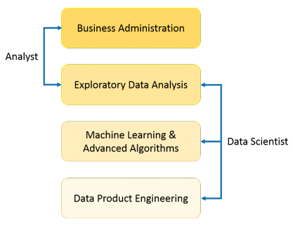

Figure 1:What is Data Science Source:(Edureka, 2017)

#### 2.2.1.4 What is Machine learning

Machine learning is the way of predicting patterns and links between a group of data. That process helps us understand, extract and learn useful patterns. Thus, helping us to create new discoveries from the emerged patterns (Srihari Sasikumar, 2017).

#### 2.2.1.5 Facial image emotion detection using machine learning

In a previous study done by Maglogiannis, Vouyioukas and Aggelopoulos, (2007) using humans facial emotions, they have stated that human emotions are widely expressed with eyes and cheeks muscles. Their detection algorithm uses skin muscles as a base to detect facial changes that eventually categorizes the patterns and match them with previously input data set which contains basic emotions. This process multiplies the accuracy and tendency for various human emotions with machine learning approach.

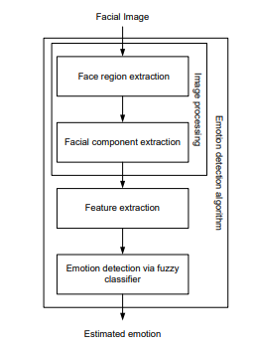

Figure 2: Overall Procedure of Emotion Detection. Source (Kim, Joo and Park, 2005)

The algorithm “is composed of three main stages as shown in figure 2. Image processing stage and facial feature extraction stage, and emotion detection stage. In image processing stage, the face region and facial component is extracted by using fuzzy color filter, virtual face model, and histogram analysis method. The features for emotion detection are extracted from facial component in facial feature extraction stage. In emotion detection stage, the fuzzy classifier is adopted to recognize emotion from extracted features. It is shown by experiment results that the proposed algorithm can detect emotion” well (Kim, Joo and Park, 2005).

### 2.2.2 Research Gap

Humans and dogs have been in domestic relation for centuries and even more. Understanding them and their patterns are an important thing in today’s world. It is “very important for human beings to understand the activity pattern of the dog, and its emotional behavior. A wearable, sensor-based system is suitable for such ends, as it will be able to monitor the dogs in real-time. However, the question remains unanswered as to what kind of data should be used to detect the activity patterns and emotional” patterns (Aich et al., 2019).

Past studies have been done on detecting emotions from humans using machine learning approach. Need for such method to understand dog’s emotion is also very crucial as learning human emotions. Generally, a pet is a companion for a human where they interact with their pet with all those emotions. But, as stated above with the decreasing interaction with the pets it has been difficult for owners to understand their pet in times of need, thus creating a vast distance between each other which lead to loss of relationship. So, here we are focusing on developing a relationship with the help of technology to understand the emotions of a pet for the owner to understand their emotions.

Therefore, we propose a system which is based on the data collected from dogs, including varied breeds of various sizes and ages, and both genders an using machine learning classification techniques to automate the detection of various emotional expressions of dogs.

## 2.3 Research on approaches and techniques

### 2.3.1 Algorithms and Technologies

There are two main strategies for emotion detection: facial recognition and semantic analysis. Facial detection analyzes facial expressions in video and photos, detecting micro expressions which determine common emotions such as surprise, joy, anger, sadness, disgust and more. These powerful algorithms can detect expressions by plotting points on a face and reading their relationships to one to another, with the help of facial databases. The second type of machine learning-based sentiment analysis-and one likely encountered online is semantic analysis includes algorithms that detect emotion in language, whether keywords in a text are positive or negative in connotation, through which an overall tone emerges. Algorithms may detect multiple examples of tone in a single statement, offering a comprehensive look into what the speaker or writer is thinking. The algorithm is composed of three main stages: image processing stage and facial feature extraction stage, and emotion detection stage. In image processing stage, the face region and facial component is extracted by using fuzzy color filter, virtual face model, and histogram analysis method. The features for emotion detection are extracted from facial component in facial feature extraction stage. In emotion detection stage, the fuzzy classifier is adopted to recognize emotion from extracted features. It is shown by experiment results that the proposed algorithm can detect emotion well.

Some studies for the affect recognition of have implemented supervised classification approaches such as k-Nearest Neighbor, and Support Vector Machine (SVM). The researchers defined keyword to valid the user’s emotional response through the valence and excitation model. On the other hand, Deep learning approach applies non-linear transformation to physiological signs for the detections of features of dog’s emotional behavior. In this context, CNN techniques have been used for the automatic extraction of SCR and BVP features and 70 to 75% accuracy results have been obtained in the prediction of emotion (relaxation, anxiety, excitement, and fun). Other investigations validated the performance of affection models with deep learning using the multimodal DEAP database and adopted a multiple-fusion-layer-based ensemble classifier of stacked autoencoder (MESAE) framework, to extract the physiological features that were merged into an SAE network. The accuracy results in arousal and valence were 0.83 and 0.84 respectively. Regarding to semi-supervised learning methodologies SAE was integrated with Deep Belief Network (DBN) using a Bayesian inference classification based decision fusion method, results of arousal were obtained in 73.1% and valence in 78.8%. In they defined a hybrid model composed of a CNN and a Recurrent Neural Network (RNN). As a requirement for the sequential processing in the CNN, the features were extracted and the prediction was made in the Long Short-Term Memory (LSTM) unit of the RNN. This model obtained an accuracy of 74.1% for arousal and 72.1% for valence. The models based on CCN and DNN showed better results in the affective classification when using the image domain of the EEG signals .

. In this case, the set of convolution formula is given by following Figure 3,

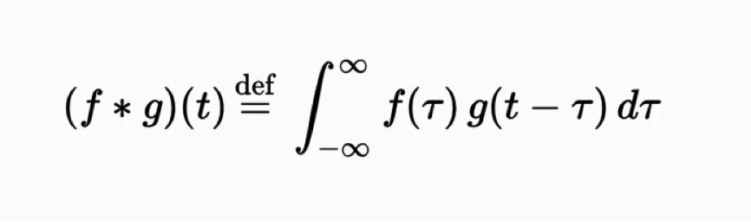

Figure : Convolutional formula

(f *g)(t) = functions that are being convoluted

t = real number variable of functions f and g

g (T) = convolution of the function f(t)

T’ =first derivative of g (tau) function

**Convolution** is a mathematical operation on two functions (*f* and *g*) that produces a third function ({\displaystyle f*g}f*g) that expresses how the shape of one is modified by the other. The term convolution refers to both the result function and to the process of computing it. It is defined as the integral of the product of the two functions after one is reversed and shifted. And the integral is evaluated for all values of shift, producing the convolution function.

Some features of convolution are similar to cross-correlation for real-valued functions, of a continuous or discrete variable, it differs from cross-correlation ({\displaystyle f\star g}f*g) only in that either *f*(*x*) or *g*(*x*) is reflected about the y-axis; thus it is a cross-correlation of  *f* (*x*) and *g* (−*x*), or *f*(−*x*) and *g*(*x*).  For complex-valued functions, the cross-correlation operator is the adjoint of the convolution operator.

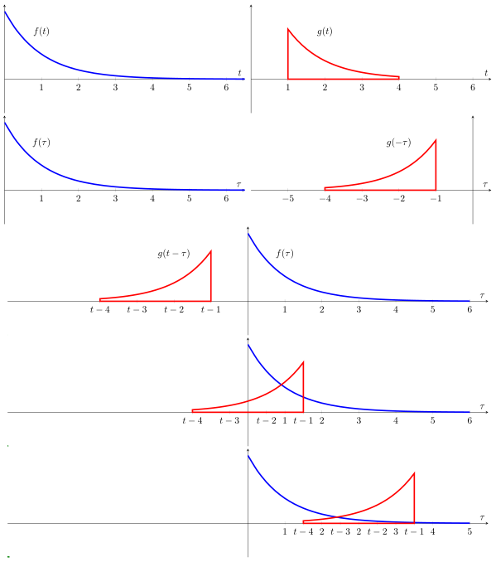

Figure 4: Visual Explanation of convolution

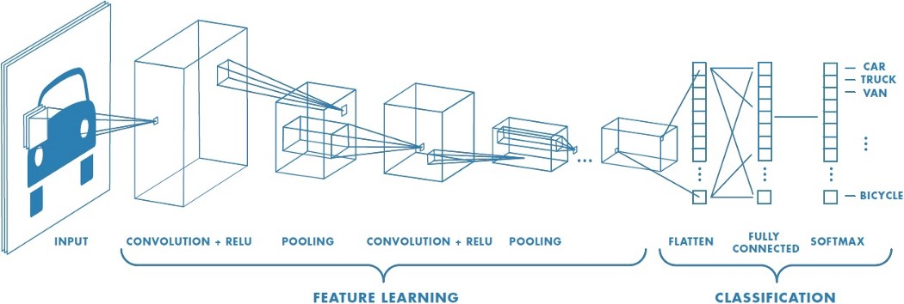

Figure 5: Step by step of convolutional Nueral network (Deep learning)

1. Machine learning

As a previous step to the features extraction of the physiological signals, the detection of peaks of the ECG and GSR signals is performed, because the emotions generate significant changes in these segments. The Heart Rate Variability (HRV) analysis is an affective diagnostic tool to determine the beat to beat interval (RR interval) . The values between a RR interval correspond to the time between two peaks R, which is calculated through a standard wave of the QRS complex. The ECG signal is transformed with the PanTomkins QRS detection algorithm proposed in . The signal is filtered to reduce the noise with cutoff frequencies of 0.5 and 15 Hz and uses an adaptive threshold for the detection of the QRS complex . Similarly, the GSR signal is preprocessed using bandpass filters to reduce noise with cutoff frequencies of 0.05 and 19 Hz . Then it is resampled with a digital phase filter of 10 Hz. During SCR peak detection a standard method is used that identifies the max, min and offset indexes of the signal GSR . So, the threshold of the amplitude is determined and the features between SCR peaks are calculated.

1. Deep convolutional neural network

Deep learning is an area of machine learning based on algorithms and techniques for modeling high-level abstractions in datasets , such as the patterns recognition in images, text or emotions. The learning levels take as input the results of the previous levels, which are transformed into insights, to train and validate the classification model. The DCNN architecture proposed for the emotion detection system was adapted from the work of Pyakillya et al, with the Keras framework . The DCNN involves a sequence of CNN layers and pooling layers to automatically extract features from the physiological signals. Fully connected layers are located in front of CNN, operate on all nodes and are used to predict the affective state.

1. Proposed face detection algorithm

The proposed face detection algorithm contains two major modules: (1) face localization for finding face candidates; and (2) facial feature detection for verifying detected face candidates. The algorithm first detects skin regions that possibly contain a human face. The skin detection algorithm is a segmentation technique that first transforms the image from the RGB to YCbCr color space.

The skin detection algorithm is based on statistical imageprocessing model using Bayesian estimation [2]. A segmentation technique has to be adopted to track the skin regions. We used a Markov Random Field and MAP image segmentation [5], for assuming an image which contains a skin region that can be divided into two classes (skin vs. non-skin). The discrete steps are depicted in Fig. 1. An MRF is used for skin detection because it is a non casual model, it is strongly attached to an isotropic behavior and MRFs use only local dependencies. This feature makes them very flexible, while in conjunction with MAP, this approach may be more accurate than many other estimation techniques and statistic models.

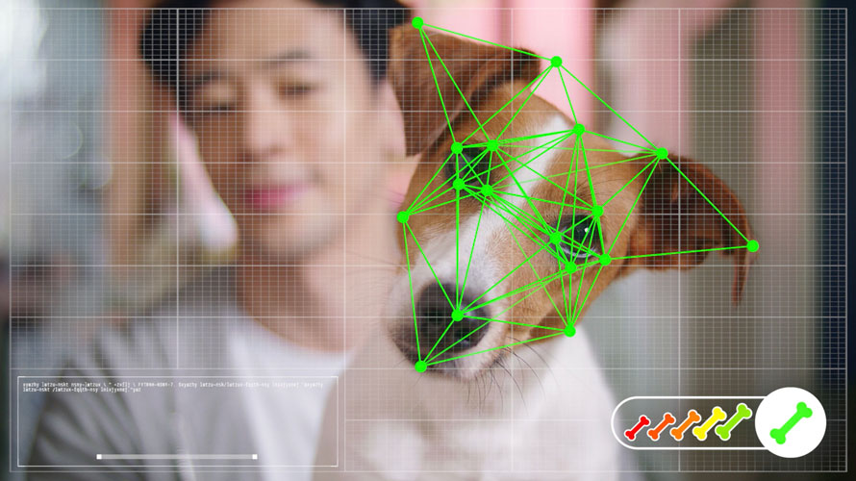

Figure : facial recognition of dogs

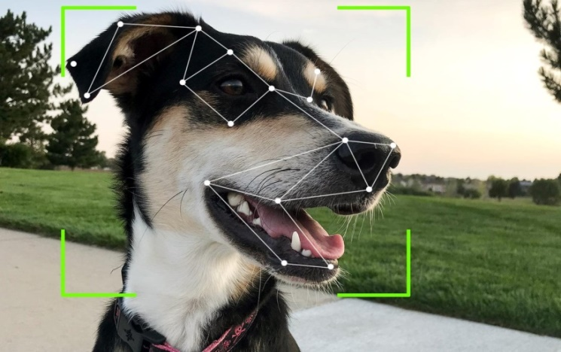

Figure : facial recognition of dogs

Past studies have been done on detecting emotions from humans using machine learning approach. Need for such method to understand dog’s emotion is also very crucial as learning human emotions. Generally, a pet is a companion for a human where they interact with their pet with all those emotions. But, as stated above with the decreasing interaction with the pets it has been difficult for owners to understand their pet in times of need, thus creating a vast distance between each other which lead to loss of relationship. So, here we are focusing on developing a relationship with the help of technology to understand the emotions of a pet for the owner to understand their emotions.

Therefore, we propose a system which is based on the data collected from dogs, including varied breeds of various sizes and ages, and both genders an using machine learning classification techniques to automate the detection of various emotional expressions of dogs.

### 2.3.2 Advantages and disadvantages of algorithms and technologies

Advantages of the technologies used

* CNNs provide better performance in image resolution as compared to traditional sparse representation because it possesses higher representation capability [21]. So there is no need of feature extraction it automatically detects the important features without any human supervision.
* Moreover, if CNN is trained once, it's weights can be learned by another network by transfer learning [25].
* K- nearest neighbor algorithm requires no training before making prediction new data can be added seamlessly.
* An advantage of the decision tree over other methodologies, such as neural networks, is that it can provide understandable English-like rules or logic statements. For instance, if the gray level of a given pixel ranges between 180 and 240 and its entropy is greater than 0.5, then it is a pixel of interest.

Disadvantages of technologies used

* K nearest neighbor need feature scaling (standardization) and normalization before applying KNN algorithm to any dataset . If we don’t do so, KNN may generate wrong predictions.
* Does not work well with large dataset. In large dataset the cost of calculating the distance between the new point and each existing point is huge which degrades the performance of the algorithm.
* One of the main disadvantage of using CNN is that it may take longer to train data.
* Another important disadvantage is the need for large data sets (i.e. hundreds or thousands of images), and their proper annotation, which is sometimes a delicate procedure that must be performed by domain experts.
* A small change in the data can cause a large change in the structure of the decision tree causing instability.
* Decision tree often involves higher time to train the model.

### 2.3.3 Methods, steps and technologies

There is no lot of direct researches for detecting dogs’ emotions using machine learning. But in the approaches and technical side world has more researches for machine learning, deep learning, artificial intelligent and convolutional neural networks etc. As mentioned before this product is basically focused on to dog lovers to identify their dogs’ emotions. So this chapter explains this Ooggy doggy product’s methods and techniques with other researches.

* Data preparation and preprocessing
  + **Data collection**

Data is the foundation of any machine learning project. Data collection is a major bottleneck in machine learning and an active research topic in multiple communities. (Roh, Heo and Whang, 2019). This “*Ooggy doggy*” project is used kaggle’s data set to Machine Learning part.

* + **Data visualization**

The large amount of data represent in graphical ways is easier to understand and analyze. “Data visualization plays a crucial role in identifying interesting patterns in exploratory data analysis.” (Leban et al., 2006).

* + **Labeling**

What is data labeling in machine learning? Let’s say as example this “*Ooggy doggy*” project is image recognition system and has already collected thousands of photos of dogs. Label would be telling the AI, that dog is in happy mood, dog is in angry mood and that dog is in neutral and so on. The main challenge of data labeling is labeling approaches, techniques and tools.

* + - Acquiring domain expertise- veterinary doctors/dog’s trainers
    - CAPTCHA challenge
    - Transfer learning

Transfer learning is a strategy where we use a model for one task as the starting model point for a model on a second task. Transfer learning is mostly applied for training neural network- models used for image recognition, image segmentation and human motion modeling etc.

* **Data selection**-

After getting data, subgrouping them to solve the problem of detecting dog’s emotions

* **Data preprocessing**

The value of preprocessing is to convert raw data into a form that fits machine learning. In other words “Data Preprocessing is a technique that is used to convert the raw data into a clean data set.” (Data Preprocessing for Machine learning in Python, 2017)

* Data formatting – Data formatting is like changing images name, their services and formats etc.
  + Data cleaning - This technique remove useless and incomplete data
  + Data Anonymization
  + Data sampling-big data get more time and more computational power. This technique helps to build and run models much faster.
* **Data transformation**

Data transformation can identify outcome of the machine learning project.

* + Scaling
  + Data decomposition
  + Aggregation
* Dataset splitting

Train and test

Dataset used in machine learning partitioned in to three subsets.

* + **Training set** - “The sample of data used to fit the model” (Brownlee, 2017).Model will train over and over from the training set.
  + **Test set**- Test data is the set of data that is used to test the model actually model is already trained. This test set already separate from both the test set and validation set. And also test set is unlabeled.
  + **Validation set**-validation set is the set of data separate from the training set. That is used to validate our model during training.
* Modeling
  + **Model training**

The purpose of model training is to develop a model. There are common two model training styles called supervised learning and unsupervised learning.

* Supervised learning

“Supervised learning entails learning a mapping between a set of input variables X and an output variable Y and applying this mapping to predict the outputs for unseen data” (Cunningham, Cord and Delany, 2008).With supervised learning , can solve classification and regression problems.

* Unsupervised learning

In Unsupervised learning training style, an algorithm can analyze unlabeled data. The goal of model training is to find hidden interconnection between data objects and structure objects by similarities and or differences. Unsupervised learning aims at solving such problems as clustering, association rule learning, and dimensionality reduction.

* Model Evaluation and Testing

The goal of this step is to develop the simplest model. This task can do by model tuning. So one of the method to model evaluation and tuning is cross validation.

* + - Cross validation

Cross validation entail splitting a training dataset. It can shuffle the data and split into k partitions called folds. As an example if k is 5, then each time cross validation takes 4 folds as the training set and the remaining one as the validation set. This cross validation can do by keras deep learning frame work and this can run by Tensorflow and numpy.

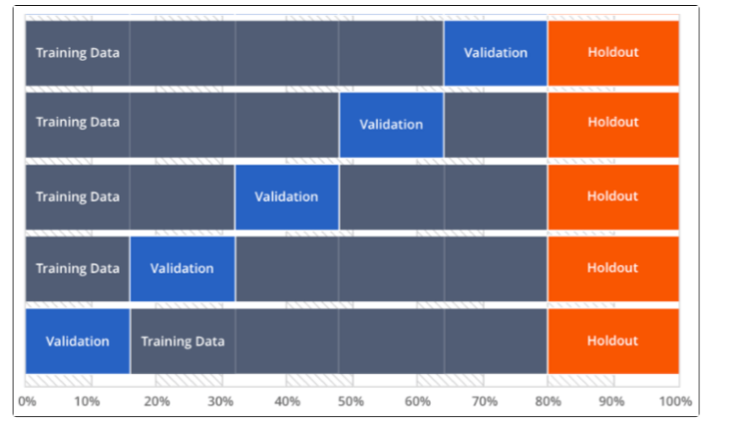

Figure : Cross validation explanation

* Improving prediction with ensemble method

The ensemble methods produce more accurate solutions than single model would. “Ensemble methods aim at improving the predictive performance of a given statistical learning or model fitting technique” (Bühlmann, 2012). The common ensemble methods are,

* + - Stacking –This stacked generalization approach suggests developing a meta-model or higher level learner by combining multiple base models. The purpose of this technique is to reduce generalization error.
    - Bagging – This sequential model ensemble method first slit the training data into subsets then model are trained on each of these subsets. This bagging helps to avoid model overfitting and reduce the variance error.
    - Boosting – In this technique first use subset of original data set and to develop several averagely performing models and then combines them to increase their performance using majority votes.
* Model Deployment

Deployment is the method by which you merge a machine learning model into an existing production environment to make practical business decisions based on data. This Ooggy doggy product is deploy from mobile application.

## 2.4 Chapter Summary

This chapter gives a clear idea about the current approaches, technologies, methods which are used to implement our product and will get a good idea about our products advantages and disadvantages as well as recognizing the main features that we have to emphasis on in order to have a better product. The existing products have also been thoroughly explored in depth. The next section will cover the project management process of the project and explain the methodologies used in this project.

# Chapter 3 – Project Management

## 3.1 Chapter Overview

As a part of this research project this chapter will cover project management methodologies. And also the most appropriate software development methodologies, plan for this Ooggy doggy system, work break down structure and Gantt chart are also explain in this chapter. As well as this chapter will explain about risks for project management and what are the actions for those risks and activity schedule and project deliverables are in detailed**.**

## 3.2 Methodologies

Apart from the actual research work involved, one of the main components of this project involves developing a prototype that would showcase the viability of the author’s proposed solution. In order to achieve the required functionality within the limited time allocated, a Development Methodology needs to be followed. To select a one that is best suited for this Oggy Doggy project, the author picked several established methodologies and compared them based on the requirements needed for this project. Firstly, the development methodologies will be individually considered briefly relative to how their features relate to the author’s project. Thereafter the methodologies will be compared, and a suitable selection performed based on with more merit.

Research approach

Research approach was a plan and the producers for research. There are two types of research approaches, deductive approach and inductive approach. The deductive approach is concerned with “developing a hypothesis based on existing theory, and the designing a research strategy to test the hypothesis. The inductive approach is focused with the generation of a new theory emerging from the data.

This project, Oggy Doggy will be done using deductive approach as the aim of the project is detecting the dog’s emotions by using an app.

Rapid Application Development model (RAD)

From the available software process models, RAD model will be used for this project. The RAD model is based on prototyping and iterative development with no specific planning involved. The process of writing the software itself involves the planning required developing the product. Rapid application development focuses on gathering customer requirements through workshops or focus groups, reuse of the existing prototypes (components), continuous integration and rapid delivery.

Changing requirements can be accommodated, progress can be measured, iteration time can be short with use of powerful RAD tools, productivity with fewer people in a short time, reduced development time, Increases reusability of components, quick initial reviews occur, integration from very beginning solves a lot of integration issues these are the advantages of this rapid application development model.

Below Figure_9  shows the RAD model.

Figure : RAD methodoloy

Figure : RAD methodology steps

|  |  |
| --- | --- |
| Model | Reason for not choosing the model |
| Waterfall | Not suitable for the projects where requirements are at a moderate to high risk of changing. So risk and uncertainty is high with this process model. Unknown technologies and unclear requirements are not accommodated. |
| Spiral | Management is more complex. Process is complex. End of the project may not be known early. More suitable for long-term projects. |
| Agile | Not suitable for handling complex dependencies. More risk of sustainability, maintainability and extensibility. Minimal emphasis on documentation and difficulty to make additions with an iteration. Depends heavily on customer interaction, so if customer is not clear, team can be driven in the wrong direction. |
| kanban | The boards must be constantly monitored and there is a potential of the boards being complex. |
| V-model | High risk and uncertainty. Not a good model for complex and object-oriented projects. Lacks adaptability and possibility for restrictions in the timeline. Not suitable for the projects where requirements are at a moderate to high risk of changing. Poor model for long and ongoing model. |
| Prototyping | Users may got confused in the prototypes and actual systems. It could be expensive if proper monitoring isn’t done. This methodology may increase the complexity of the system. |
| Iterative | End of the project may not be known which is a risk. Highly skilled resources are required for risk analysis. |

Table : why other methodologies not used

**Analysis and design approach**

Selection of procedure analysis approach and the tools to be used are, The Object - oriented analysis and design is selected for the analysis and design approach. The OOD approach decreases the complication of the system and increases the readability of the code. This approach also adds in the flexibility of reusing components using the object - oriented techniques. New features regard to the mailing list of summarizer could be added as part of further improvements. UML is known as the standard modeling approach for an OOAD approach.

Object- oriented design methodology is used for this research project. The objective of using this methodology is that OOD identifies the natural modularity of the software and manages its complexity. Objects have very clear rules of communicating with one another.

Testing methodology

Some of the testing methodologies that will be used are, unit testing, performance testing, integration testing, usability testing, compatibility testing and bug testing will be done for this Oggy doggy project.

Project management method

Proper project management is important because it guarantees genuine expectations are set around the deliverables of a project. Choosing a suitable project management approach aides in dealing with constraints such as time, cost and scope.

Data gathering method

Gathering and organization of data is a fundamental and expository of a research. There are different gathering methods available and listed below are some of the data gathering methods that will be used for this Ooggy Doggy project.

* Brain storming- Brain storming sessions helps to discuss the technical aspects involved in this project with the domain experts and helps to get there ideas as how to identify the dog’s emotion to solve the problem.
* Questionnaire – By sending a questionnaire to the target audience, it will be possible to gather a lot of necessary data which will be important for the project.
* Interviews- Interviews will be conducted to gather more information from a domain expert(Pet doctor).
* Observation- Observation will be made on the dog’s and domain experts (pet doctors) to gather necessary data.
* Literature review – Summarizing a mailing list is a new field of research. So gaining an in depth knowledge into previous researches and previous work carried out is essential. This aides in gaining the domain expert (pet doctor) knowledge of the part of the project.
* Existing documents – Existing documents on web, books , articles ,papers and other resources about the dog’s emotion detection and pet domain expert will be used.
* Prototyping – Wireframes will be designed to get ideas from the end users in order to ideatify how the system design can be enhanced.

## 3.3 Constraint

There are constraints and challenges that need to be taken into consideration and resolved with any project to ensure the ultimate performance of the project. Project constraints are restricting factors that can affect efficiency, implementation, and overall project performance of the project. Project constraints must be managed well to avoid issues with the project in the future. Time, cost and scope are the three main constraints that programmers should be comfortable with. This are also referred to as functional constraints or the triangle of project management. Each constraint is related to the other two; For the example, expanding the project's scope is likely to take additional time and resources, while increasing up the project schedule will save costs, but also reduce the scope. Constraints recognised in our project are,

1.Time Constraint: The time constraint applies to the delivery timeline of the project, including the deadlines for each project process, as well as the date of the final deliverable roll-out. Because of the short time given to complete the project, the timelines could be impossible to reach in order to study and execute them.

2.Resources: Resources are closely associated with the expense of the project. The amount of money required to obtain the expected results would reduce the usage and development of resources, producing an unique constraints.

3. Lack of skills and experience: The quality of the product can be affected by the lack of previous knowledge and skills, especially in research areas such as machine learning and programming knowledge.

## 3.4 Communicational Plans

Efficient project management requires breaking down high-level targets into smaller projects that eventually adhere to a fixed timetable, a genuinely brilliant programmer understands that without a project management communication plan no project, large or small, would be efficient. A communication plan for project management determines how necessary information can be conveyed during the project to stakeholders. It also defines who will receive the communication, how it will be handled by certain persons, when they will receive it, and how much they can expect the information to be received.

Weekly meetings were arranged with the supervisors, Mr. Banuka Athuraliya , Mr. John Sriskandarajah, Mr. Nuwan Jayawardene, Mrs. Krishnakripa Jayakumar, to discuss the project's progress, to check the reach, to overcome the challenge and to develop solutions. In addition to the weekly sessions, there was e-mail communication with the supervisors.

## 3.5 Risks and Mitigations

The list of project risks that were identified during the course of this project as well as relevant mitigation procedures for each is detailed in below Table 3.

|  |  |  |  |  |
| --- | --- | --- | --- | --- |
| No | Description | Probability | Impact | Mitigation action |
| 01 | Lack of knowledge in technologies and techniques | High | High | Take advice from experts and self -studying on the related research domain. |
| 02 | Failing to stay updated with the technologies associated with the field | High | High | Converse with experts in the field and get through feedback on the state of technologies. |
| 03 | Losing data due to unforeseen hardware or software failures and issues | Medium | High | Make a cloud backup of everything related to the project including the documentation and prototype daily to avoid data lose. Have a backup computer if the primary system breaks. |
| 04 | Missing deadlines due to complexity of the project | High | High | Having a clear plan as to which components of the research have the highest priority so those can be completed at the earliest. |
| 05 | Being unable to achieve the required level of functionality to showcase the performance of the architecture | High | High | Doing research beforehand to fine alternative methods to achieve a problematic area |
| 06 | Getting stuck on a certain component during prototype development | High | High | Fine alternative methods to complete the task as hand. |
| 07 | Problems with implementations | High | High | Prioritize the requirements and implement what is most important first. |

Table 3: Risks and mitigations

## 3.6 Drivers of the Project

A person or team who is responsible for setting the path for the project is the project driver. For any major series in the project, the driver can set targets, agree problem targeting, or set backporting.

1. Strong Leader: Each project has undertaken several aspects, such as team management, objectives to accomplish and completing work on schedule, so good leadership is required to efficiently, effectively and seamlessly manage all these goals in order to achieve a successful project. To make a project successful, the Debug Pirates group leader directs all members of the group.

2. Supervisors: They guide the our team and encourage all of us to do best. They also guide us by setting production goals and providing them with instruction and guidance to meet those goals.

3. Stakeholders: Feedback from veterinary doctors to improve the solution,

## 3.7 Activity Schedule

The activity schedule along with the project deliverables are detailed in the below Table 4.

|  |  |  |  |
| --- | --- | --- | --- |
| Activity | Start Date | End Date | Time Frame |
| Finalizing project idea | 29 Sep 2020 | 13 Oct 2020 | 2 weeks |
| Submission of project topic selection form | 29 Sep 2020 | 13 Oct 2020 | 2 weeks |
| Submission of draft proposal document | 13 Oct 2020 | 20 Oct 2020 | 1 week |
| Data set for dog’s emotions | 13 Oct 2020 | 20 Oct 2020 | 1 week |
| Submission of the final project proposal document | 13 Oct 2020 | 30 Oct 2020 | 3 weeks |
| Submission of draft literature review | 20 Oct 2020 | 22 Nov 2020 | 1 month |
| Submission of final literature review | 22 Nov 2020 | 30 Nov 2020 | 1 week |
| Submission of draft SRS | 01 Dec 2020 | 07 Dec 2020 | 1 week |
| Submission of draft project management | 01 Dec 2020 | 07 Dec 2020 | 1 week |
| Submission of the final SRS | 17 Nov 2020 | 04 Jan 2021 | 2 months |

Table 4: Activity schedule and project deliversbles

## 3.8 Gantt chart Diagram

Similar to how a WBS chart helps maintain an arrangement of how a project is structured, a Gantt chart allows a clear view of the timeline for a time period that project should be accomplished within. This is mostly created at the very onset of a project so as to have a clear idea about which stage the project should be in at any given time. This is especially true for research projects where too much time languishing on one aspect would take away from the time allocated for a later phase. Thus, a Gantt chart is a valuable tool to have for time management purposes.

You can see the Gannt chart diagram by the following link Appendix D

Figure :Gantt chart

## 3.9 Work break down structure

A Work Breakdown Structure (WBS) helps a project manager clearly understand what phases a certain project comprises of and decompose each to its bare essentials. The finalized Work Breakdown Structure has been moved to Appendix A – Work Breakdown Chart

## 3.10 Chapter Summary

This project management chapter explained about all the project management methods and process model of Ooggy doggy product. And also this chapter included about work break down structures and the activity schedule and project deliverables. The next chapter is System Requirements Specification (SRS), This will explain all the requirements, models and stakeholders of the project etc.

# Chapter 4 – System Requirement specification

## 4.1 Chapter Overview

This “chapter focuses on gathering the system requirements and the analysis of the gathered requirements. First the stakeholders who are associated with the system are identified and their roles are specified. “The requirement gathering techniques like how they were executed and the outcome from different methods will be discussed and along with it, the use case diagram, use case description and the domain model for ooggy doggy”. Finally, the functional and nonfunctional requirements of the system are defined with a clear scope.

## 4.2 Stakeholder analysis

### 4.2.1 Stakeholders

Stakeholders are the category that in several ways, has an interest in our product. Maybe they might be our competitors, supporters or well-wishers. They can be either external or internal. Internal stakeholders, such as developers, designers, etc have a close interaction with the product. Competitors, the media, domain specialists etc will be external stakeholders. The stakeholder diagram (Onion model) of the proposed structure is seen in the below figure .  We can easily imagine the relationships between each and every stakeholder by examining the onion model, and also find out about stakeholders that have very little influence over the direction of the project, which would be of significant importance to the project's progress. Through this we can also concentrate on the project target, which is the product that shows in the middle.

### 4.2.2 Onion model diagram

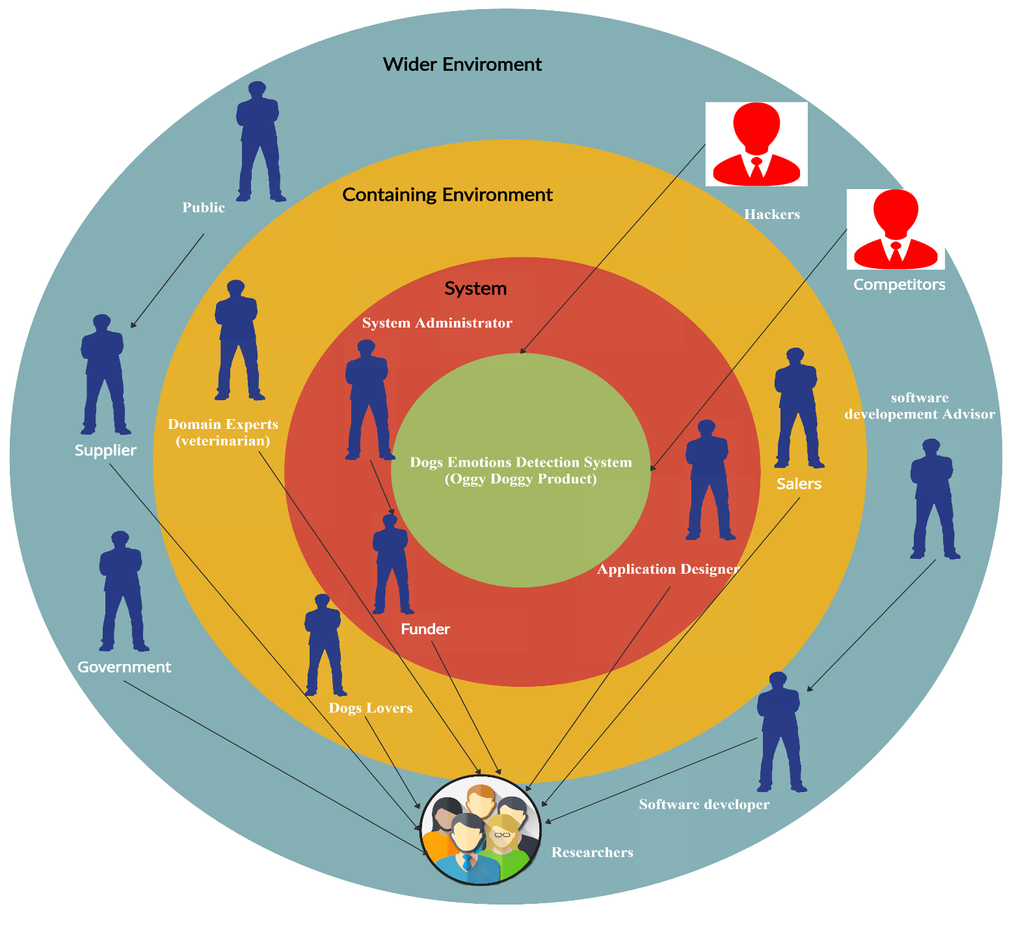

Figure : Onion model of the Oggy Doggy product

### 4.2.3 Stakeholders view Points

|  |  |  |
| --- | --- | --- |
| Stakeholder | Role | View Point |
| Application Designer | **Operational role** | **Develop an application which is user-friendly.** |
| System Administrator | **Operational role** | **Manages the whole device for every**  **Failings.** |
| Funder | **Investing role** | **Provide money to develop the project** |
| Domain Experts(veterinarian) | **Expert** | **Provides guidance to professionals on better**  **Technology and software solutions in**  **The system's creation.** |
| Dogs Lovers | **Users** | **Implement the application for their dogs** |
| Salers | **Sale Role** | **Building trust and confidence between the customer and the product.** |
| Public | **Negative role** | **In the system, point out faults and leave**  **Comments negative.** |
| Researchers | **Owners of the system (Oggy Doggy)** | **Research to develop the system** |
| Software Development Advisor | **Advisory** | **Provide instructions on finishing the**  **System.** |
| Software Developer | **Developer** | **Develop the software of the system** |
| Supplier | **Business Role** | **Providing a development team with high-quality goods from a supplier at a reasonable price** |
| Government | **Business Role** | **Collect taxes from the product.** |
| Hackers | **Negative Role** | **Hacks the software and puts it improperly**  **Stuff.** |
| Competitors | **Negative Role** | **Still search to identify faults and weaknesses,**  **Implement a model that is better than our**  **Framework.** |

Table 5: Stakeholder view point

Requirements are one of the most important parts of a system or a product. This topic will explain about requirement gathering methods and techniques.

## 4.3 Requirements gathering

### 4.3.1 Techniques for requirements gathering

|  |  |
| --- | --- |
| Method 1 | Literature Review |
| Literature review techniques are used to compare similar systems and products that come under detecting dogs’ emotions. Using valid digital libraries such as ACM, IEEE and other valid online resources like research gate and google scholar, project can gather data to compare similar products’ features, technologies, their researches, weaknesses and strengths etc. This will helps to understand what are the features need to add and what are the features no need to add to this Ooggy doggy product. | |

Table 6: About literature review method to requirement gathering

|  |  |
| --- | --- |
| Method 2 | Online questionnaire |
| Using online questionnaire can gather the valuable data to understand the percentage of people who are interested to detect doggys’ emotions, how much percentage of people love this type of products and to check what kind of knowledge they have about dogs’ emotions etc. And also this online questionnaire helped to gather many suggestions from dog lovers to improve this Ooggy doggy product. | |

Table 7: about online questionnaire method to requirement gathering

|  |  |
| --- | --- |
| Method 3 | Interview with domain experts |
| Face to face interviews with Domain experts is a very important technique to gather requirements and validate the requirements. And also this method is helped to clarify doubts of projects. | |

Table 8: Interview with domain expert as requirements gathering method

|  |  |
| --- | --- |
| Method 4 | Brainstorming |
| “Brainstorming is an individual or group method for generating ideas increasing creative efficacy, or finding solutions to problem” (Wilson, 2013b). This session can conduct with friends and colleagues to gather ideas and requirements. And also brainstorming can conduct individually from talk to our own brain to gather ideas and data. This requirement gathering is very important technique to collect lot of ideas and requirements for this “Ooggy doggy” product. | |

Table 9: Brainstroming method as requirements gathering technique

|  |  |
| --- | --- |
| Method 5 | Observation |
| Observation is a method to understand user in the current work environment. This method is fully helpful to gather requirements for projects. Because using this observation can get a better idea about how user interact with the system. | |

Table 10: Observation method as requirements gathering technique

|  |  |
| --- | --- |
| Method 6 | Prototyping |
| Prototyping is a modern technique to requirements gathering. A prototype is there the give your stakeholders a chance to see what the final output will feel like. After doing prototyping, can understand what the unnecessary things in a project are, what points are missed and what doesn’t make sense in a project etc. So this will help to out high quality result. | |

Table 11: Prototyping as requirements gathering technique

### 4.3.2 Questionnaire design

Oggy doggy product got one questionnaire to gather data.

|  |  |
| --- | --- |
| **Goal** | **Question** |
| To get an idea about how many knowledge they have about dogs’ emotions | Are you have a good Idea about dogs' emotions? |
| To get an idea about how many people willing to know about dogs’ emotions using mobile application | What do you think, if you can identify dogs' emotions using mobile application? |

Table 12: Questionnaire design

### 4.3.3 Formal interviews with domain experts

#### 4.3.3.1 Aim of the interview

* To get a better knowledge about how they are learn about dogs’ emotions.
* To get an idea about what are the main benefits can get from understanding dogs emotions.
* To know are they satisfy about this type of product to get dogs’ emotions.

#### 4.3.3.2 Interviewer’s names degree and occupation

* Name: Dr. Dasanayaka
* Degree: Bachelor of Veterinary Science
* Occupation: Veterinarian

#### 4.3.3.3 Interview type

* Face to face interview

#### 4.3.3.4 Findings from interview

* Show a picture of a dog and get a short description of that dog’s expression

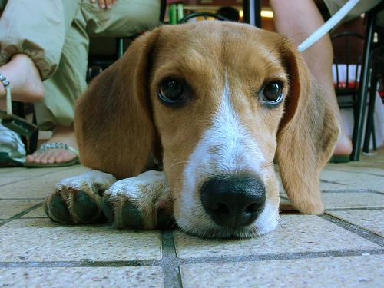

Eyes are bright so he is not in neutral mood

When he put his head on his hands without closing eyes he is try to stay comfortable

Figure :Expression explanation of a dog by domain expert

* Findings from asking what are benefits of detecting dogs’ emotions
  + By identifying dogs’ emotions is helped to communicate with them and easy to train them.
* Get a domain expert’s review and idea about Ooggy doggy mobile application
  + Dr. Dasanayaka said “I think this type of product will help to communicate with dogs for us and all the dogs’ owners in future.”

## 4.4 Analysis gathered data

The questionnaire was sent out on 1 st December 2020. This questionnaire asked six questions from users .Given below is explained all the detailed analysis of the questionnaire of Ooggy doggy product.

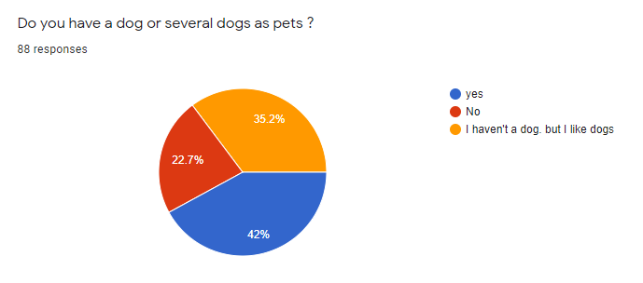

Figure :Question 1 of questionnaire

42% of persons have one or several dogs and 35.2% persons love dogs but they haven’t dogs. As for this circle graph majority of persons are dog lovers and dog owners.

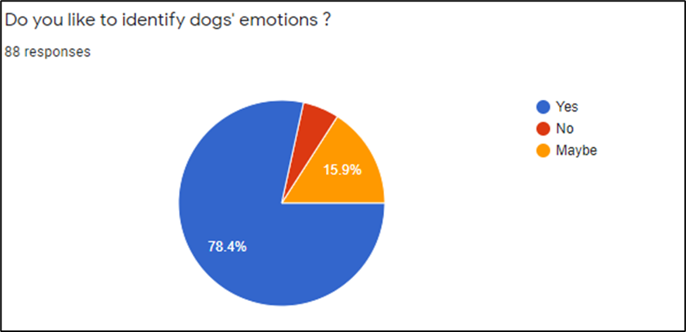

Figure 15: Question 2 of questionnaire

As for this circle diagram majority of people like 78.4% of persons like to identify dogs’ emotions.

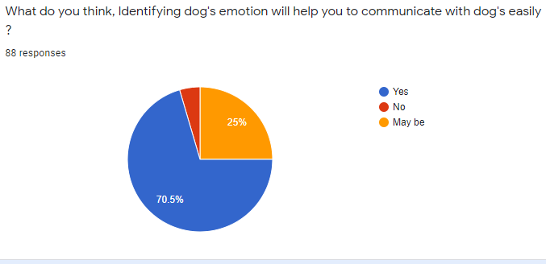

Figure 16: Question 3 of questionnnaire

This question is checking and validating of Ooggy doggy product’s benefit. It shows 70.5 % of persons agree with this product’s usage.

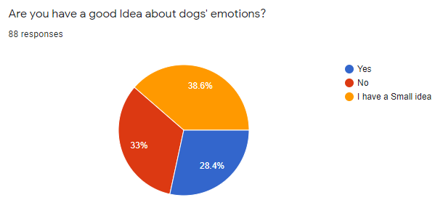

Figure 17: Question 4 of questionnaire

This Circle diagram shows 33% of persons haven’t any idea of dog’s emotions and 38.6% of persons have only small idea about dog’s emotions.

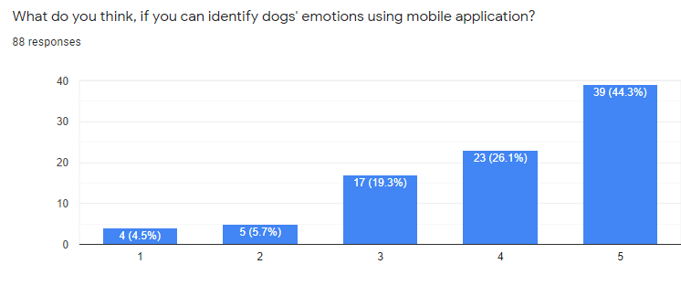

Figure 18: question 5 of questionnaire

This bar chart shows majority of persons are willing to use mobile application to detect dogs’ emotions. The questionnaire pictures were shown in the Appendix **B**

## 4.5 Models

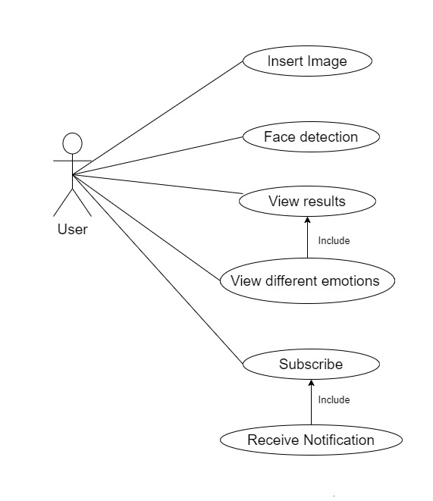

Figure 19: Domain model

|  |  |
| --- | --- |
| **Use Case ID** | **UC1** |
| **Use Case Name** | **Inserting Image** |
| Description | User Insert the image of the dog that he needs by selecting an image from a file |
| Participating actors | Public Users |
| Preconditions | * Only the dog image should be inserted * The dog face should be clear in the image |
| Extended use cases | None |
| Included use cases | None |
| Main flow | 1. Insert the dog image 2. Click enter |
| Alternative flow | None |
| Exceptional flow | E1- when dog image is not inserted  E2- when the face of the dog in the image is not visible   1. Displays error message |
| Post conditions | Generate and display the results |

Table 13: Inserting Image

|  |  |
| --- | --- |
| **Use Case ID** | **UC2** |
| **Use Case Name** | **Face Detection** |
| Description | After user insert the clear image of the dog face from a file and analyze it using face detect app |
| Participating actors | Public Users |
| Preconditions | * Only the clear dog image should be inserted and face should be visible |
| Extended use cases | None |
| Included use cases | None |
| Main flow | 1. Insert the dog image 2. Click enter |
| Alternative flow | None |
| Exceptional flow | E1- when the dog image is not clear   1. Displays error message |
| Post conditions | Generate and display the summary |

Table 14: Face detection

|  |  |
| --- | --- |
| **Use Case ID** | **UC3** |
| **Use Case Name** | **View Results** |
| Description | User can view the results of the image that he inserted |
| Participating actors | Public Users |
| Preconditions | * Only the dog image should be inserted * The dog face should be clear in the image |
| Extended use cases | None |
| Included use cases | 1. View percentage of different emotions |
| Main flow | 1. Insert the dog image 2. Click enter 3. Click on the image |
| Alternative flow | * Click on the image |
| Exceptional flow | E1- connection failure   1. Displays error message |
| Post conditions | Generate and display the summary with the percentage of different emotions |

Table : View Results

|  |  |
| --- | --- |
| **Use Case ID** | **UC4** |
| **Use Case Name** | **Subscribe** |
| Description | User can subscribe to get news and new features about the app |
| Participating actors | Public Users |
| Preconditions | None |
| Extended use cases | None |
| Included use cases | 1. Receive notification |
| Main flow | 1. Enter the Email 2. Validates the email by confirming the message sent to the user 3. Click on subscribe |
| Alternative flow | None |
| Exceptional flow | E1- Invalid Email  E2- Connection failure   * Displays error message |
| Post conditions | Subscription will be successfully added to the Database. |

Table 16: Subscribe

|  |  |
| --- | --- |
| **Use Case ID** | **UC5** |
| **Use Case Name** | **Receive notification** |
| Description | User can receive email notification of new features about the app |
| Participating actors | Public Users |
| Preconditions | * User must be subscribed to this |
| Extended use cases | None |
| Included use cases | None |
| Main flow | None |
| Alternative flow | None |
| Exceptional flow | E1- When there are no new updates, nothing will be sent |
| Post conditions | User receive email notification |

Table 17: Receive notification

**Domain model**

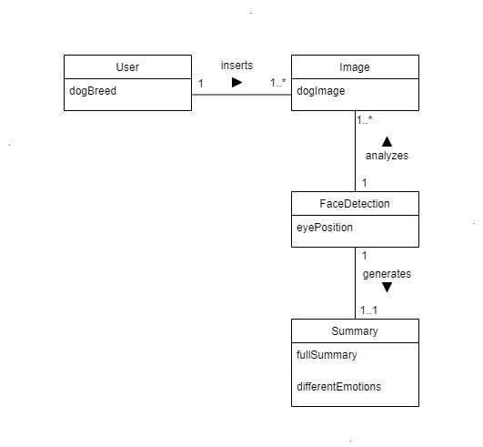

Table 18: Domain model

## 4.6 Functional Requirements

|  |  |  |  |
| --- | --- | --- | --- |
| Requirements list | | Priority Level | Description |
| FR1 | Processing the image | Critical | Application should be able to process the image the user uploaded |
| FR2 | Identifying the emotion | Critical | By processing the image, the user uploaded the application should be able to accurately output the emotion of the dog |
| FR3 | Identify other images | Desirable | The application should be able to detect images other than dogs and display a message |
| FR4 | Receive notifications | Luxury | The user should be able to turn on notifications using a email address about the new features of the application |

The table below shows the functional and non-functional requirements of the oggy-dogyy application along with a description for each functional and non-functional requirement.

Table 19: Functional requeirement

## 4.7 Non-Functional Requirements

The non-functional requirements of the oggy-doggy application are listed below in the table

|  |  |  |  |
| --- | --- | --- | --- |
| Requirements list | | Priority Level | Description |
| NF1 | Accuracy | Critical | Application should be able to correctly identify the emotion |
| NF2 | Performance | Critical | Application should work well without any considerable lag or take time to process the output |
| NF3 | Usability | Desirable | The application should be very user friendly where anybody can easily use it |
| NF4 | Scalability | Desirable | The application should maintainable in the future and the code should be stored in a repository |

Table 20: Non functional requirements

## 4.8 Chapter Summary

This “chapter looked at the appropriate stakeholders, the different requirement gathering techniques”, use case , use case description, domain model for Ooggy doggy and the functional and nonfunctional requirements for the system.

# Chapter 5 – Design

## 5.1 Chapter Overview

The previous chapter was focused on the System Requirement Specifications. The current chapter will discuss the Design of Ooggy Doggy. This design chapter will discuss High-level architecture diagram, class diagram, sequence diagram, activity diagram, and the wireframes for Ooggy Doggy.

## 5.2 High-Level architecture Diagram

Figure 20 illustrates the high-level architecture diagram for Ooggy Doggy. The architecture of the system is illustrated in the presentation tier, domain logic tier and data storage tier. The dataset used in this project shown in the data storage layer. The domain logic layer contains the modular approach of the backend logic of Ooggy Doggy in order to identify the face recognisation. The presentation layer illustrates the mobile application.

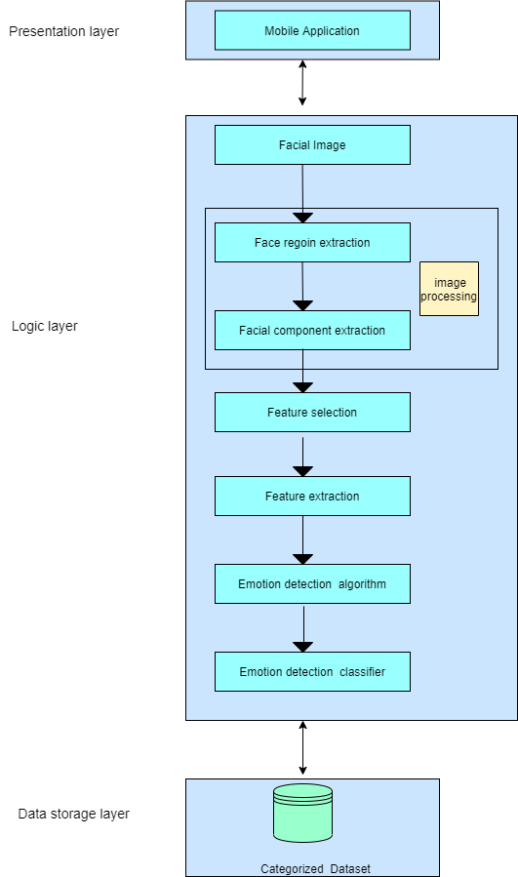

Figure 20 : High level Architecture Diagram

## 5.3 Class Diagram

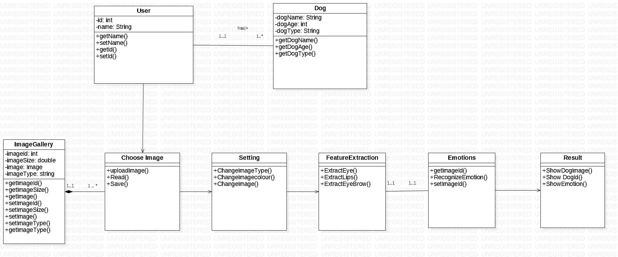

Figure 21: class diagram

Above diagram illustrates the class diagram for the Oggy Doggy system. The classes are explained briefly below.

|  |  |
| --- | --- |
| **Class** | **Responsibility** |
| User | Contain the user details |
| Dog | Contain dogs details |
| ImageGallery | Contain all added dogs photos to the application |
| ChooseImage | It will choose the image from gallery , read it and save |
| Setting | Change before added Image |
| FeatureExtraction | Extract features from the image. |
| Emotions | Get image and recognize the emotions of the image |
| Result | Display dog emotions with its details to the user |

Table 21: classes and responsibilities in class diagram

## 5.4 Sequence Diagram

Figure 22: sequence diagram

The above figure illustrates the sequence diagram for the main function of the oggy-doggy which is uploading an image. The user can upload an image to the application and the application will process the image. The application will process the image and it will the display the emotion of the particular image of the dog.

## 5.5 Activity Diagram

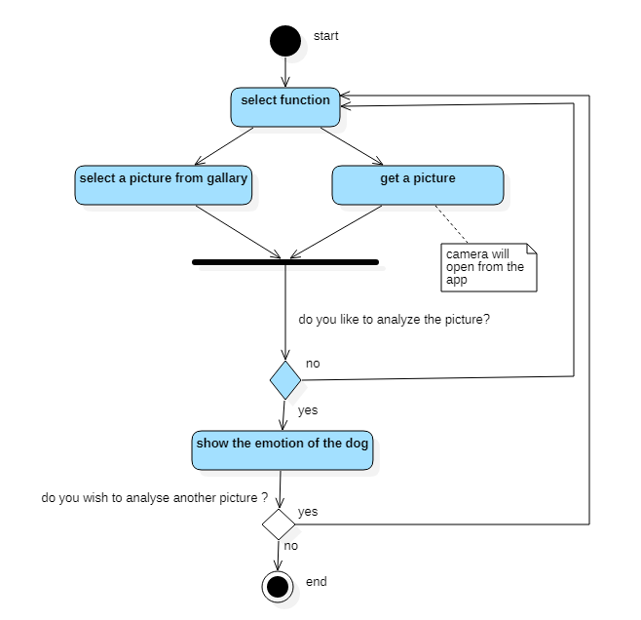

Figure 23: Activity diagram

This figure shows the Activity diagram of Ooggy doggy product. The activity diagram captures the dynamic behavior of the product and it helps to model the control flow from one activity to another.

## 5.6 Wireframes

Figure 22 below shows the wireframe of the home page for the Ooggy Doggy mobile application. All the other wireframes can be found under Appendix **E**.

Figure 24: wireframe 1

## 5.7 Chapter summary

This chapter covers the design of Ooggy Doggy with the High-level architecture diagram, class diagram, sequence diagrams, activity diagrams, and wireframes for Ooggy Doggy. The class diagram will aid in developing the Ooggy Doggy. The next chapter will be our last chapter where we will be concluding our report

# Chapter 6 – Conclusion

## 6.1 Chapter Overview

This is the part where we conclude the research tackled by Ooggy doggy. This chapter also addresses how the aim and objectives were achieved, also achievements obtained and challenges and difficulties that we face while doing this project and how we are overcome. Also, how we planning to do the implementation. The learning outcomes of the project and further enchantments will be done in near future to improve the Ooggy doggy

## 6.2 Dataset

The current data set used for identification of dog breeds has been taken from, Kaggle.com. The link is provided below for further information.

Context of the data

“The Stanford Dogs dataset contains images of 120 breeds of dogs from around the world. This dataset has been built using images and annotation from ImageNet for the task of fine-grained image categorization. It was originally collected for fine-grain image categorization, a challenging problem as certain dog breeds have near identical features or differ in color and age”.

**Content of the data**

Number of categories: 120

Number of images: 20,580

Annotations: Class labels, Bounding boxes

So, we planned to use this data for our project to detect the emotion of the dogs

**Data labeling**

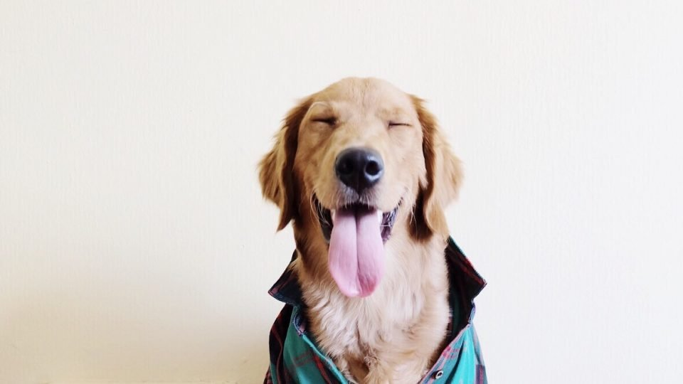

Figure : Happy

Figure : Angry

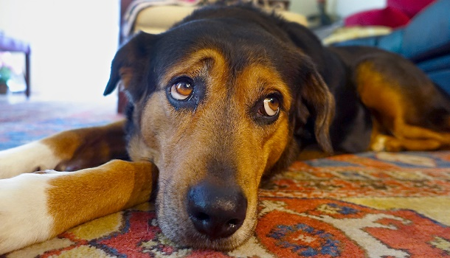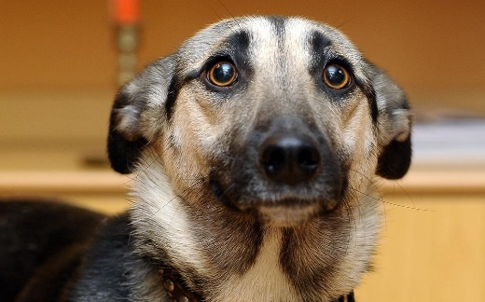

Figure :Sad

Figure :Fear

**Link:** [**https://www.kaggle.com/c/dog-breed-identification/data**](https://www.kaggle.com/c/dog-breed-identification/data)

## 6.3 Legal, ethical, social and professional issues

**Legal issues**

Data privacy laws were given high respect when designing the Oggy Doggy Product. The terms of use and conditions reported on Kaggle were closely checked before using the freely accessible Kaggle.com Stanford Dogs Dataset for Dogs. During the question evaluation point, the questionnaires sent out did not obtain any personal information from the users. The collected data was handled confidentially and the users' privacy was covered. The details of users who replied to the questionnaire was kept private. The instructions given in the handbook of the module was specifically Followed .

**Ethical issues**

The Ooggy doggy product faced some ethical issues since beginner time. So there is an explanation of those ethical issues and how this product handles those issues fairly. As one of ethical issues is privacy. As an example, when collecting data from domain experts, needed to get permission to use or add his or her data for this product.

The next thing is to protect privacy concerns of the data set. So this Ooggy doggy project is used Kaggle’s data set. The publisher of the dataset in kaggle has provided this data set to use for any activity, but in an agreement, says when in publications, need to add cite of original source’s creators and some secondary papers. The screenshot of the privacy concerns and description of the data set is available on an appendix C. So the citation of the original source’s creators and cite of some secondary papers is available on in references page and bibliography page.

As well as when getting data from questionnaire, this product doesn’t get any personal data like name, age or email etc.

**Social issues**

The Oggy Doggy project should have a very low social impact. The prototype of the project was introduced in English only and may impact persons who do not understand the English language.

**Professional issues**

In the professional environment The Ooggy doggy product’s stakeholders (developers) got whole responsibilities of the product and work honestly by respecting others. The good group working will help to submit or finish the products successfully.

For the future developing usage of the product always draft documents and draft projects put in drive or in git hub organization groups will help to get a recovery of accidently missing valuable documents or project’s codes. As well as the usage of anti-virus software is a valuable thing to protect product’s data privacy.

## 6.4 Plans for implementation

Implementation Overview

Following the choice of mobile product made the author will now be attempting to deconstruct the contents of the Entgra mobile sever product in order to go about implementing the proposed architecture.

Language selection

After evaluating the programming languages available, Python was selected as the main programming language for the implementation of the project. Python was selected mainly due to the following reasons,

* Availability of libraries and tools.
* Heavy use in open source development.
* High community support to overcome issues during implementation.
* Availability of tutorials and support with Machine learning related tasks with python.
* Author being comfortable with the language and interest in improving the knowledge in the area.

Library/ Framework selection

### Numpy

Numpy supports a wide range of hardware and computing platforms, and plays well with distributed, GPU, and sparse array libraries. Numpy offers comprehensive mathematical functions, random number generators, linear algebra routines, Fourier transforms and more.

### Keras

Keras is a powerful and easy to use free open source python library for developing and evaluating deep learning models. It wraps the efficient numerical computation libraries Theano and TensorFlow and allows you to define and train neural network models in just a few lines of code. Keras mostly used for deep learning.

### Scikit-Learn

Scikit-learn is probably the most useful library for machine learning in python. The scikit learn library contains a lot of efficient tools for machine learning and statistical modeling including classification, regression, clustering and dimensionality reduction. Scikit Learn neural network (NN) model offers a few NN classifiers that can be used for the implementation of the Ooggy Doggy project, therefore the Multi-layer perceptron(MLP) classifier trains iteratively.

### TensorFlow

TensorFlow is an open source library for numerical computation and large scale machine learning. TensorFlow bundles together a slew of machine learning and deep learning models and algorithms and makes them useful by way of common metaphor. TensorFlow is a python library for fast numerical computing. It is a foundation library that can be used to create deep learning models directly or by using wrapper libraries that simplify the process built on top of TensorFlow.

### OpenCV

OpenCV is a library of python bindings designed to solve computer vision problems. OpenCV makes use of numpy, which is a highly optimized library for numerical operations with a MATLAB style syntax. All the OpenCV array structures are converted to and from numpy arrays. OpenCV is a cross-platform library using which we can develop real-time computer vision applications. It mainly focus on image processing, video capture and analysis including features like face detection and object detection.

### Flutter

Flutter is an open source UI software development kit this will be used for Ooggy Doggy project’s mobile application. Flutter works with existing code, is used by developers and organizations around the world.

### Jupiter Notebook

The Jupiter notebook is an open source web application that allows you to create and share documents that contain live code, equations, visualizations and explanatory text.

## 6.5 Chapter Summary

This chapter we discussed about the functional and non-functional requirements of the application with a small description about each description and priority level of each functional and non-functional requirements. This chapter also included about the use diagrams that are designed for the application along with the stakeholders.

# References

* Young Hoon Joo, Kim, Jin Bae Park, 2015 July, Research Gate,<https://www.researchgate.net/publication/228870902_Emotion_Detection_Algorithm_Using_Frontal_Face_Image>
* <https://www.researchgate.net/publication/301335563_Real_Time_Facial_Emotion_Recognition_based_on_Image_Processing_and_Machine_Learning>
* Poh, M.Z., McDuff, D., Picard, R.: A medical for non-contact health monitoring. In: Special Interest Group on Computer Graphics and Interactive Techniques Conference, Vancouver, BC, Canada (2011). Article No. 2[Google Scholar](https://scholar.google.com/scholar?q=Poh%2C%20M.Z.%2C%20McDuff%2C%20D.%2C%20Picard%2C%20R.%3A%20A%20medical%20for%20non-contact%20health%20monitoring.%20In%3A%20Special%20Interest%20Group%20on%20Computer%20Graphics%20and%20Interactive%20Techniques%20Conference%2C%20Vancouver%2C%20BC%2C%20Canada%20%282011%29.%20Article%20No.%202)
* Rakthanmanon, T., Campana, B., Mueen, A., Batista, G., Westover, B., Zhu, Q., Zakaria, J., Keogh, E.: Searching and mining trillions of time series subsequences under dynamic time warping. In: Proceedings of the 18th ACM SIGKDD International Conference on Knowledge Discovery and Data Mining, Beijing, China, pp. 262–270 (2012)[Google Schola](https://scholar.google.com/scholar?q=Rakthanmanon%2C%20T.%2C%20Campana%2C%20B.%2C%20Mueen%2C%20A.%2C%20Batista%2C%20G.%2C%20Westover%2C%20B.%2C%20Zhu%2C%20Q.%2C%20Zakaria%2C%20J.%2C%20Keogh%2C%20E.%3A%20Searching%20and%20mining%20trillions%20of%20time%20series%20subsequences%20under%20dynamic%20time%20warping.%20In%3A%20Proceedings%20of%20the%2018th%20ACM%20SIGKDD%20International%20Conference%20on%20Knowledge%20Discovery%20and%20Data%20Mining%2C%20Beijing%2C%20China%2C%20pp.%20262%E2%80%93270%20%282012%29)r.
* Leban, G. et al. (2006). VizRank: Data Visualization Guided by Machine Learning. *Data Mining and Knowledge Discovery*, 13 (2), 119–136. Available from <https://doi.org/10.1007/s10618-005-0031-5>.
* Milicevic, M. et al. (2019). Application of Transfer Learning for Fine-Grained Vessel Classification Using a Limited Dataset. In: Ntalianis, K. Vachtsevanos, G. Borne, P. et al. (eds.). *Applied Physics, System Science and Computers III*. Lecture Notes in Electrical Engineering. 2019. Cham: Springer International Publishing, 125–131. Available from <https://doi.org/10.1007/978-3-030-21507-1_19>.
* Wilson, C. (2013a). *Brainstorming and Beyond: A User-Centered Design Method*. Newnes.
* Khosla, A. et al. (2011). *First Workshop on Fine-Grained Visual Categorization, IEEE Conference on Computer Vision and Pattern Recognition*. Colorado Springs, CO: Aditya.
* [25] Yosinski, J., Clune, J., Bengio, Y., et al.: ‘How transferable are features indeep neural networks?’. Proc. Advances in Neural Information ProcessingSystems, Montréal, Canada, 2014, pp. 3320–3328
* [21] Dong, C., Loy, C., He, K., et al.: ‘Image super-resolution using deepconvolutional networks’, IEEE Trans. Pattern Anal. Mach. Intell., 2016, 38,(2), pp. 295–307
* [26] Sarma, Mani & Abate, Yoseph. (2014). A New Decision Tree Approach to Image Data Mining and Segmentation.
* [28] [A. Kamilaris](https://www.cambridge.org/core/search?filters%5BauthorTerms%5D=A.%20Kamilaris&eventCode=SE-AU) (a1)[F. X. Prenafeta-Boldú](https://www.cambridge.org/core/search?filters%5BauthorTerms%5D=F.%20X.%20Prenafeta-Boldú&eventCode=SE-AU) (a2) The Journal of Agricultural Science, [Volume 156](https://www.cambridge.org/core/journals/journal-of-agricultural-science/volume/74C468BE208A3E98DD1D879A9F719B66), [Issue 3](https://www.cambridge.org/core/journals/journal-of-agricultural-science/issue/18F7ECDAEB1DE992C49621D1274376A2)  April 2018 , pp. 312-322
* Aich, S., Chakraborty, S., Sim, J.-S., Jang, D.-J. and Kim, H.-C. (2019). The Design of an Automated System for the Analysis of the Activity and Emotional Patterns of Dogs with Wearable Sensors Using Machine Learning. *Applied Sciences*, 9(22), p.4938.
* Correia-Caeiro, C., Guo, K. and Mills, D.S. (2020). Perception of dynamic facial expressions of emotion between dogs and humans. *Animal Cognition*, 23(3), pp.465–476.
* Hemant Sharma (2017). *What Is Data Science? A Beginner’s Guide To Data Science*. [online] Edureka. Available at: https://www.edureka.co/blog/what-is-data-science/.
* Kim, M., Joo, Y. and Park, J. (2005). *Emotion Detection Algorithm Using Frontal Face Image*.
* Maglogiannis, I., Vouyioukas, D. and Aggelopoulos, C. (2007). Face detection and recognition of natural human emotion using Markov random fields. *Personal and Ubiquitous Computing*, 13(1), pp.95–101.
* Solomon, R.C. (2019). emotion | Definition, Scope, Variety, & Structures. In: *Encyclopædia Britannica*. [online] Available at: https://www.britannica.com/science/emotion.
* Somppi, S., Törnqvist, H., Hänninen, L., Krause, C.M. and Vainio, O. (2013). How dogs scan familiar and inverted faces: an eye movement study. *Animal Cognition*, 17(3), pp.793–803.
* Srihari Sasikumar (2017). *Expert Talk: Data Science vs. Data Analytics vs. Machine Learning*. [online] Simplilearn.com. Available at: <https://www.simplilearn.com/data-science-vs-data-analytics-vs-machine-learning-article>.
* ProjectManager.com. 2020. 10 Project Constraints That Endanger Your Project’s Success. [ONLINE] Available at: <https://www.projectmanager.com/blog/10-project-constraints-that-endanger-your-projects-success>. [Accessed 14 December 2020].
* course Hero. 2020. Six key drivers of successful project management.docx - Q1.... [ONLINE] Available at: <https://www.coursehero.com/file/46175136/Six-key-drivers-of-successful-project-managementdocx/>. [Accessed 14 December 2020].
* “Which Emotions Do Dogs Actually Experience?” *Modern Dog Magazine*, [https://moderndogmagazine.com/articles/which-emotions-do-dogs-actually-experience/32883. Accessed 2 Jan. 2021](https://moderndogmagazine.com/articles/which-emotions-do-dogs-actually-experience/32883.%20Accessed%202%20Jan.%202021)
* “Core Emotions of Dogs.” *Fairfield Beach Access*, [https://www.fairfieldbeachaccess.org/core-emotions-of-dogs. Accessed 2 Jan. 2021](https://www.fairfieldbeachaccess.org/core-emotions-of-dogs.%20Accessed%202%20Jan.%202021).
* Donaldson, Tammy M., et al. “Understanding Your Dog’s Mind and Emotions.” *Animal Wellness Magazine*, 13 July 2018, <https://animalwellnessmagazine.com/understanding-dogs-mind-emotions/>.
* Sehlhorst, Scott. “How To Visualize Stakeholder Analysis.” *Tyner Blain*, 14 Mar. 2007, <http://tynerblain.com/blog/2007/03/13/visualize-stakeholder-analysis/>.

# Bibliography

* Shin, et al. “Detection of Emotion Using Multi-Block Deep Learning in a Self-Management Interview App.” *Applied Sciences*, no. 22, MDPI AG, Nov. 2019, p. 4830. *Crossref*, doi:10.3390/app9224830.
* Anbarjafari, Gholamreza, et al. “Machine Learning for Face, Emotion, and Pain Recognition.” *Machine Learning for Face, Emotion, and Pain Recognition*, SPIE, <http://dx.doi.org/10.1117/3.2322572.ch1>.
* Halder, Rituparna, et al. “Real Time Facial Emotion Recognition Based on Image Processing and Machine Learning.” *International Journal of Computer Applications*, no. 11, Foundation of Computer Science, Apr. 2016, pp. 16–19. *Crossref*, doi:10.5120/ijca2016908707.
* Singh, Himanshu. “Image Processing Using Machine Learning.” *Practical Machine Learning and Image Processing*, Apress, 2019, pp. 89–132, http://dx.doi.org/10.1007/978-1-4842-4149-3_5.
* Amjad, A., et al. “Multiple Face Detection Algorithm Using Colour Skin Modelling.” *IET Image Processing*, no. 8, Institution of Engineering and Technology (IET), Nov. 2012, pp. 1093–101. *Crossref*, doi:10.1049/iet-ipr.2012.0167.
* Suzuki, Yasufumi, and Tadashi Shibat. “A Directional-Edge-Based Face Detection Algorithm Adapted to the VLSI Image Recognition System.” *Image Fusion and Its Applications*, InTech, 2011, <http://dx.doi.org/10.5772/18983>.
* IBM - United States. (2015). Available from https://www.ibm.com/us-en/ [Accessed 21 October 2020].
* イヌパシー | 愛犬の気持ちを心拍から読み解く | INUPATHY | ラングレス. (no date). Available from https://www.inupathy.com/en/ [Accessed 21 October 2020].
* Brown, S. (2020). Want to know how Fido feels? This harness apparently can tell you. *CNET*. Available from https://www.cnet.com/news/this-dog-harness-wants-you-to-know-how-your-pup-is-feeling/ [Accessed 21 October 2020]
* How to Structure a Data Science Team: Key Models and Roles to Consider. (no date). *AltexSoft*. Available from https://www.altexsoft.com/blog/datascience/how-to-structure-data-science-team-key-models-and-roles/ [Accessed 20 November 2020].
* Deng, J. et al. (2009). ImageNet: A Large-Scale Hierarchical Image Database. *CVPR09*. 2009.
* Stanford Dogs Dataset. (no date). Available from https://kaggle.com/jessicali9530/stanford-dogs-dataset [Accessed 12 December 2020].

# Appendix – A (Work breakdown diagram)

# 

Figure 29:work break down structure

# Appendix – B Questionnaire Pictures

First page of questionnaire Second page of questionnaire

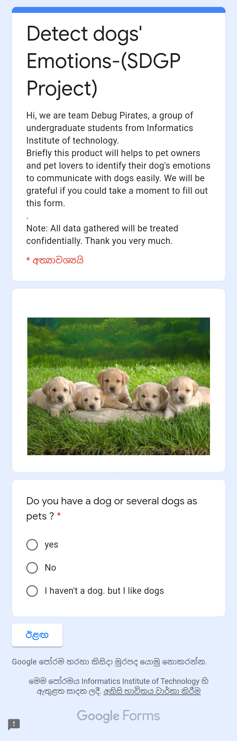



Figure :Questionnaire page 01

Figure :Questionnaire page 02

# Appendix – C data set’s privacy policy

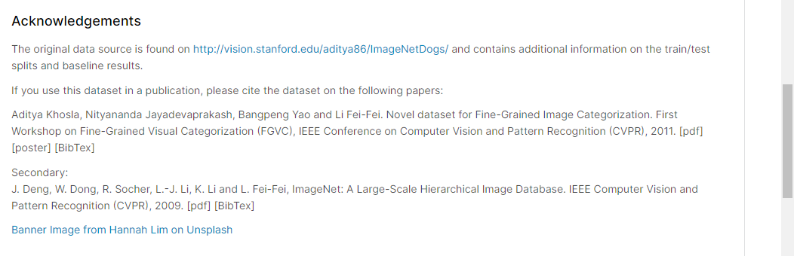

# Appendix D – Gannt Chart Diagram

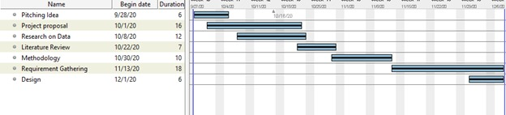

Figure 32:Gantt chart Diagram

# Appendix E – Wireframes

Figure : wireframe-3

Figure : wireframe-2

Figure : wireframe-4

# Participation List

|  |  |  |
| --- | --- | --- |
| **Name** | **UoW id** | **Works** |
| H. Thiwanki Dias Hettiarachchi | w1790191 | **1)Chapter 1- Introduction**   * Feature comparison chart part   **2) Chapter 2- Literature Review**   * **Research on approaches and techniques** * Methods, Steps and Techniques part   **3)Chapter 3 – Project management**   * Chapter Overview * Chapter summary   **4)Chapter 4- SRS**   * Requirements gathering part * Face to Face interview with domain experts * Made questionnaire form * Detailed explanation * Analyzing gathered data part.   **5) Chapter 5 – Design and model**   * Activity diagram   **6)Chapter 6 - conclusion**   * Ethical and Professional Issues   **7)Made Participation list**  **8)Merge all the parts for the report and add modifications, list of figures and list of tables** |
| Srimali Udayangani | w1790361 | **1)Chapter 1- Introduction**   * Problem background part   **2)Chapter 2- Literature Review**   * Chapter overview * Chapter summary   **Chapter 3- Project management**   * Constraint * Communication plan * Drivers of the project   **3)Chapter 4-SRS**   * Stakeholders part   **4)Chapter 5- Design and model**   * Class diagram   **5)Chapter 6- conclusion**   * Legal and social issues |
| Ahmed Isthaffa | w1761936 | **1)Chapter 1- Introduction**   * Research question   **2)Chapter 2- Literature Review**   * Review of related researches on domain * what is emotions * Humans emotion * What is data science   **3)Chapter 3- Project management**   * Gantt chart diagram   **4)Chapter 4- SRS**   * Chapter Overview * Chapter summary   **5) Chapter 5- Design and model**   * Wireframes and sequence diagram   **6)chapter 6- conclusion**   * dataset |
| K.N. Kumar | w1761759 | **1)Chapter 1- Introduction**   * Scope part   **2)Chapter 2- Literature Review**   * Review of related researches on domain * What is machine learning * Facial image emotion detection using machine learning   **3)Chapter 4- SRS**   * Models   **4) Chapter 5- Design and model**   * Chapter Overview * Chapter summary   **5) Chapter 6-Conclusion**   * Chapter summary   **6) Helps to make first page**  **7)Abstract of the report** |
| Akthab Bifaz | w1761866 | **1)Chapter 1- Introduction**   * Aim part   **2)Chapter 2- Literature Review**   * Advantages and disadvantages of algorithms and technologies   **3)Chapter 4- SRS**   * Functional requirements * Non-Functional requirements   **4) Chapter 5-Design and model**   * Sequence diagram   **5)Chapter 6-Conclusion**   * Chapter summary   **6) Acknowledgment of the report** |
| H.M.A.D. Herath | w1790023 | **1)Chapter 1- Introduction**   * Feature of the prototype part   **2)Chapter 2- Literature Review**   * **Research approaches and techniques** * Algorithms and technologies part   **3)Chapter 3- Project management**   * Methodologies * Work break down chart * Work break down structure * Risks and mitigation part * Activity schedule * Gantt chart description   **4)Chapter 4- SRS**   * Help to make questions to questionnaire   **5)Chapter 5- Design and model**   * High level architecture diagram * Helps to draw wireframes   **6)Chapter 6- Conclusion**   * Plans for implementation   **7)List of abbreviations**  **8) Help to modify the report** |
| All group members |  | 1. **When problem arises help to other persons** 2. **Read many Research papers and many Thesis.** 3. **Search data set as a team**   **Etc.** |