

GITHUB EXERCISE

Submitted to,

Prof. Christelle Scharff



November 21, 2016

Anuja More

Pace University

Q.1. What is GitHub? When was it created? Why? By who? What similar platforms exist? Why would you use such a platform?

Answer:

* Github is basically a Hub, i.e GitHub.com, where coders can save their projects and network with people with similar interests.
* Github is a web based graphical interface.
* It also provides access control and several collaboration features, such as a wikis and basic task management tools for every project.
* GitHub was originally founded by Thomas Preston-Werner, Chris Wanstrath and PJ Hyett.
* There are few reasons why we should GitHub:

1. It is an open source.
2. Networking can help improving the skills.

**Tutorial steps:**

Step 1:

Initializing Git

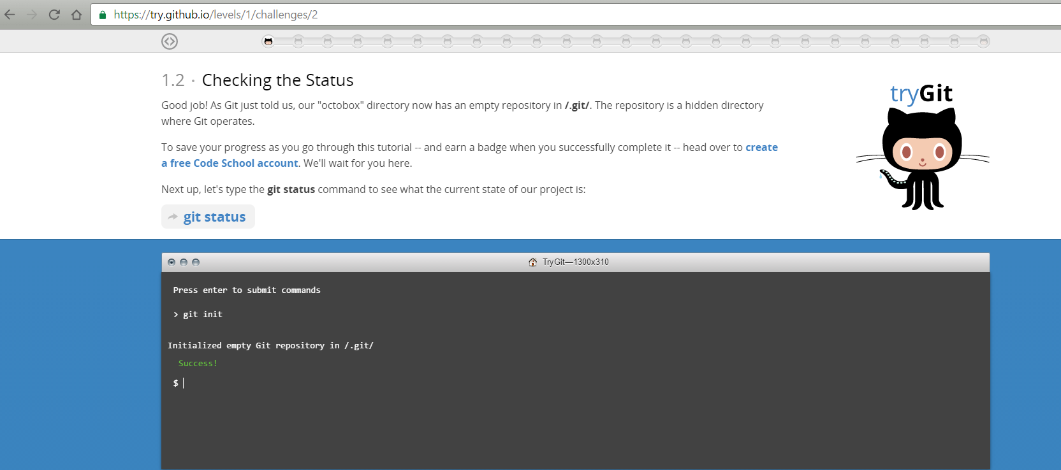

Step 2:

Checking the status

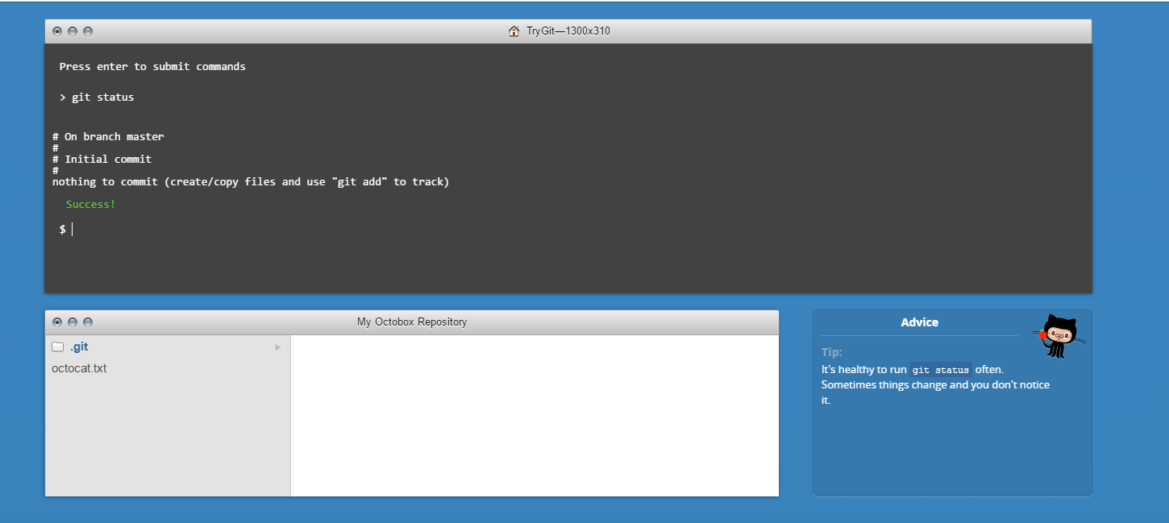

Step 3:

Adding and committing

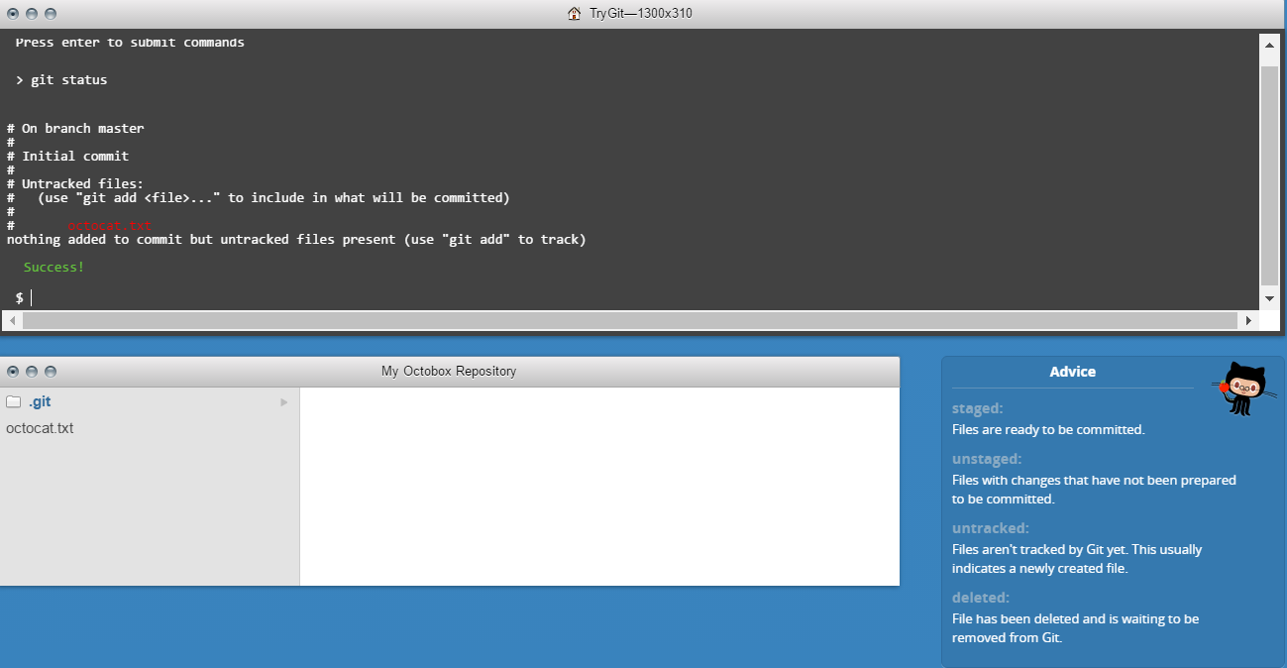

Step 4:

Adding Changes

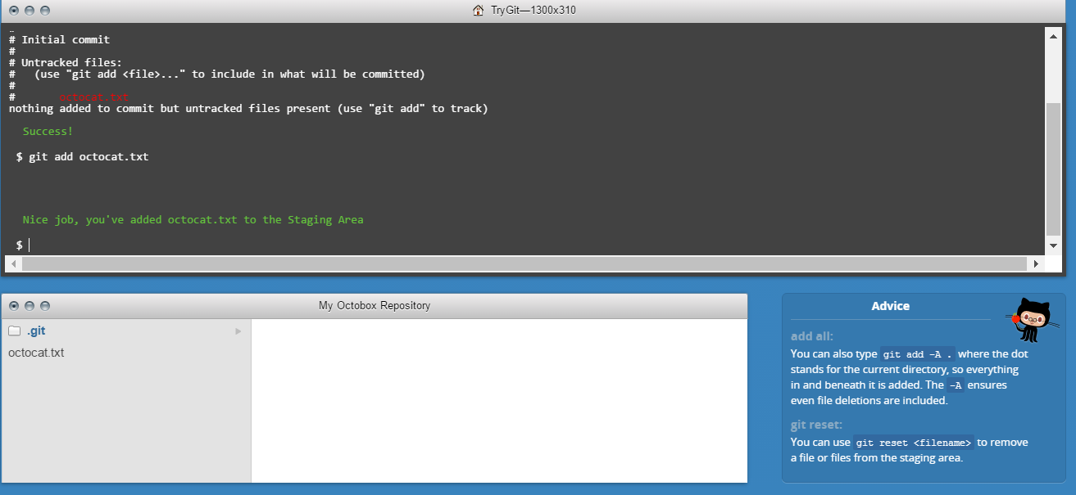

Step 5:

Checking for changes

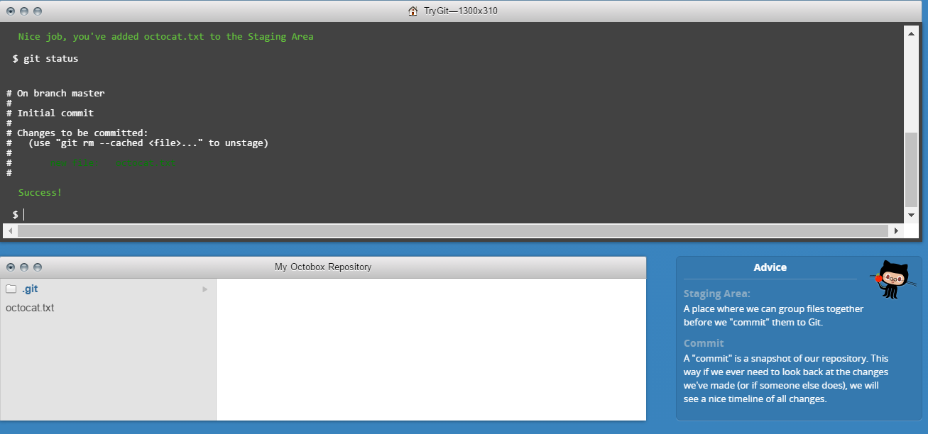

Step 6:

Committing

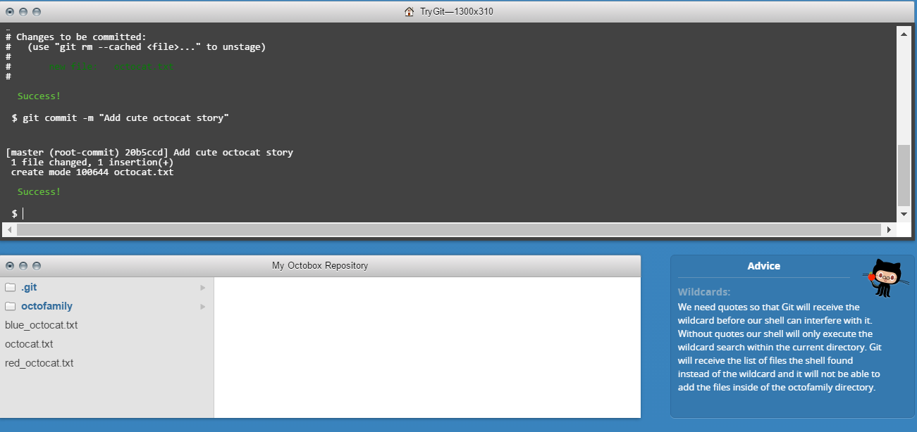

Step 7:

Adding all changes

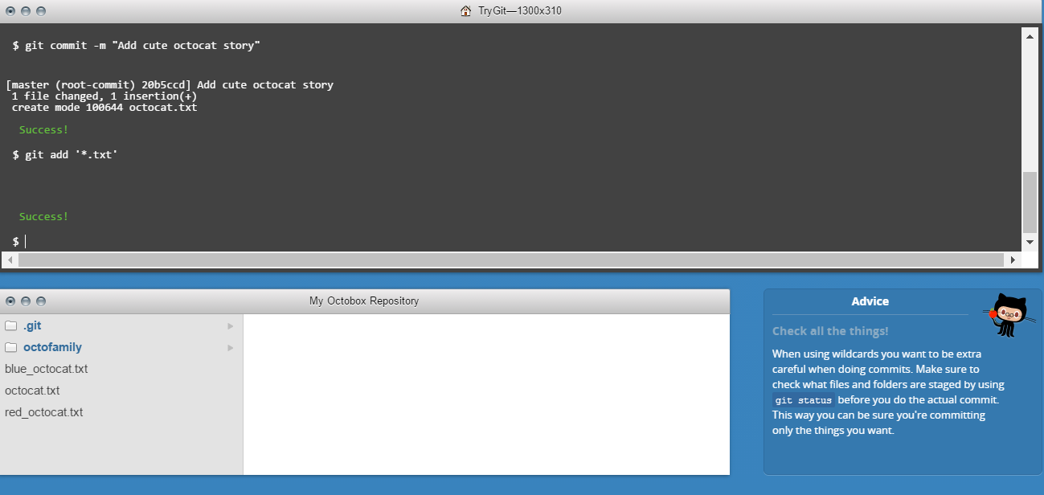

Step 8:

Committing all changes

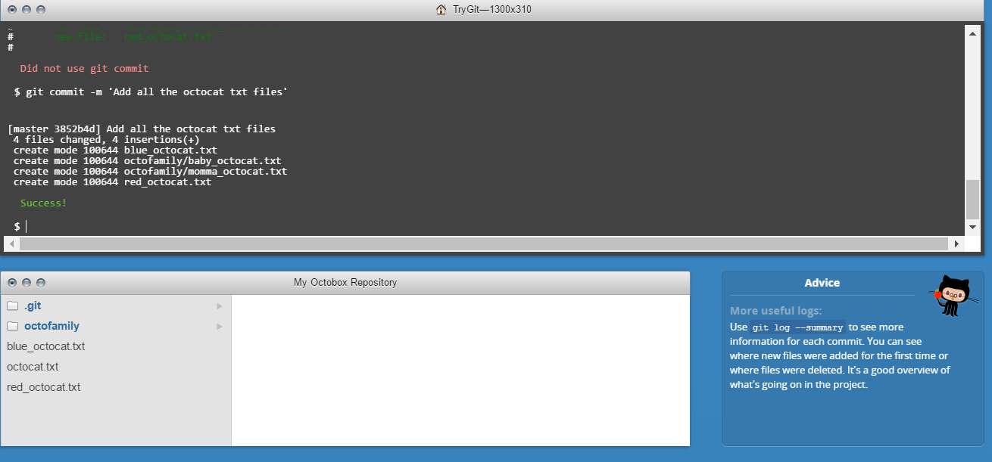

Step 9:

History

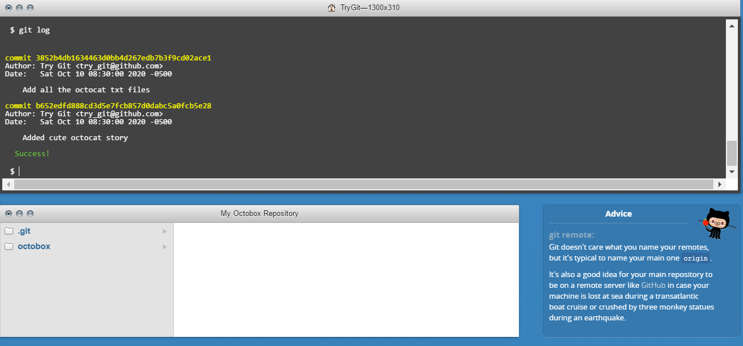

Step 10:

Remote Repositories

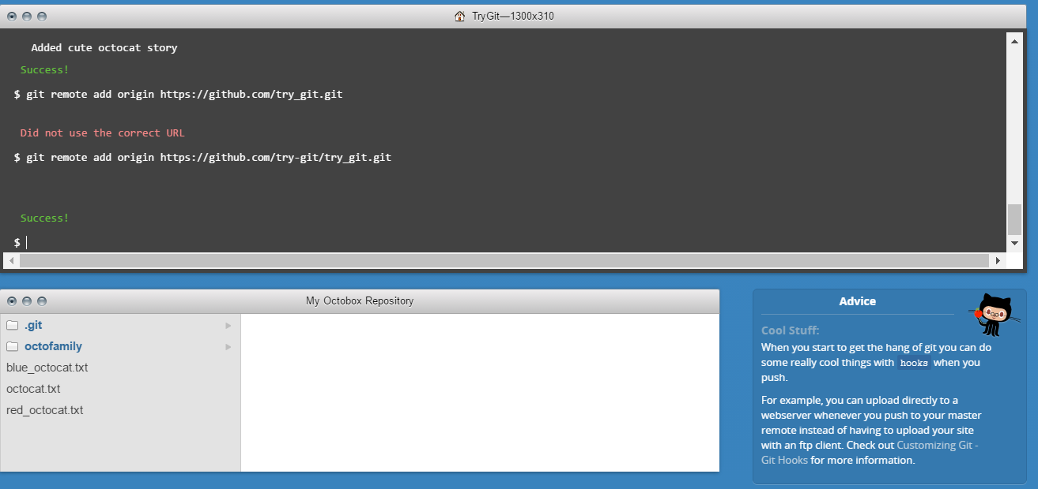

Step 11:

Pushing Remotely

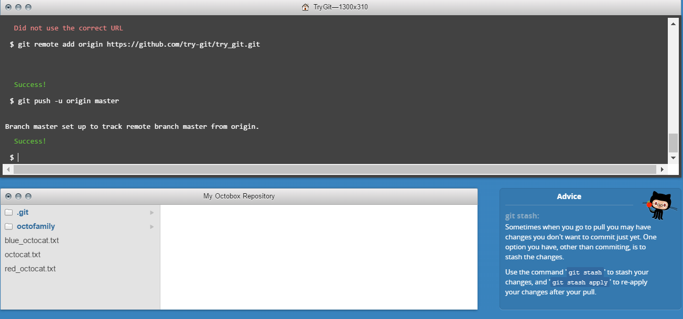

Step 12:

Pulling Remotely

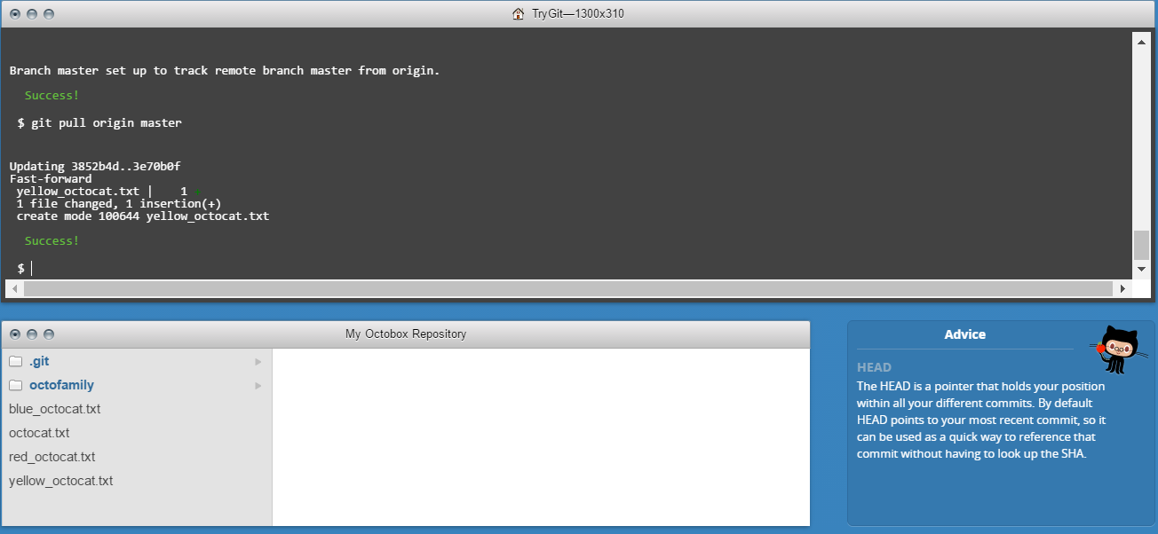

Step 13:

Differences

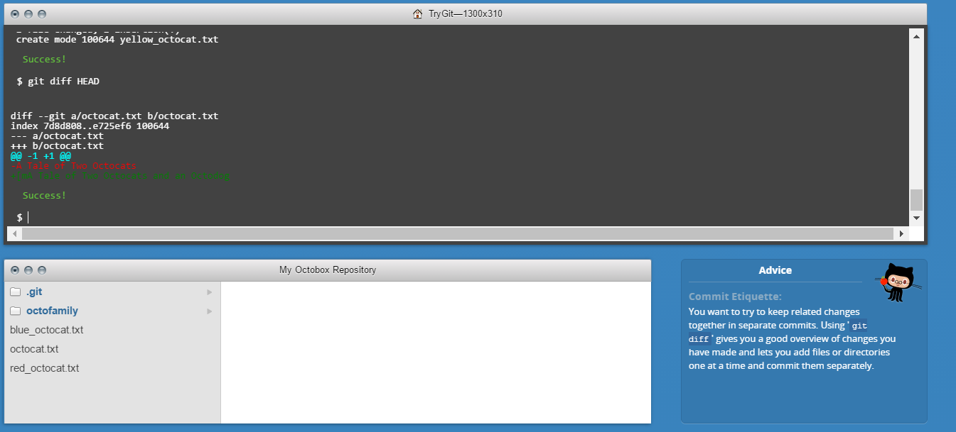

Step 14:

Staged Difference

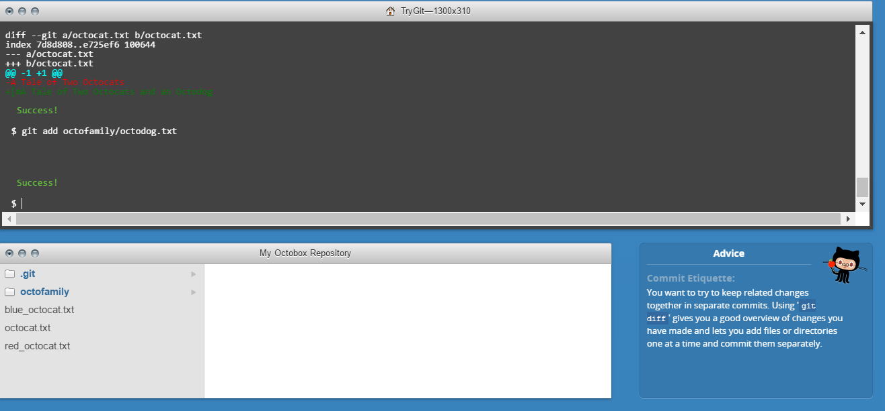

Step 15:

Staged Difference (Cont’d)

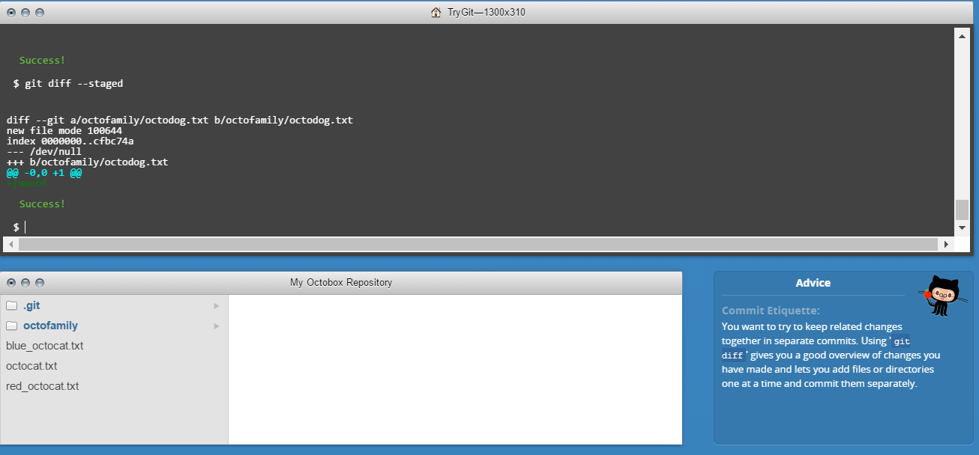

Step 16:

Resetting the stage

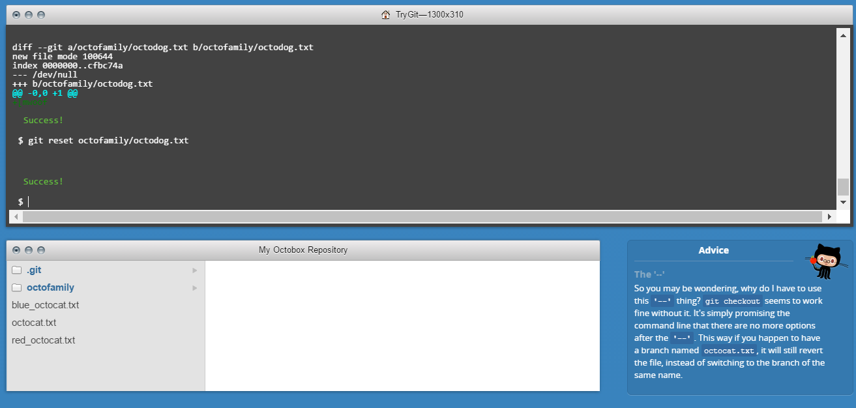

Step 17:

Undo

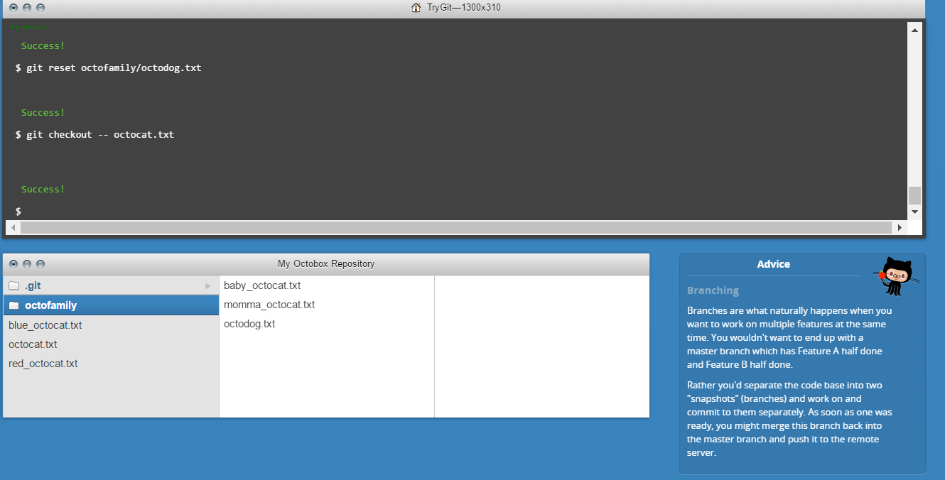

Step 18:

Branching out

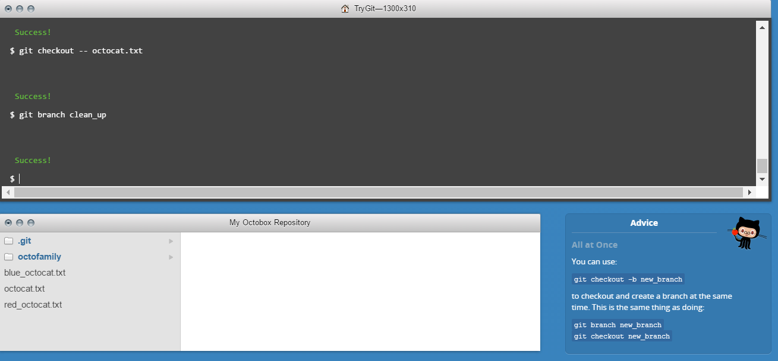

Step 19:

Switching Branches

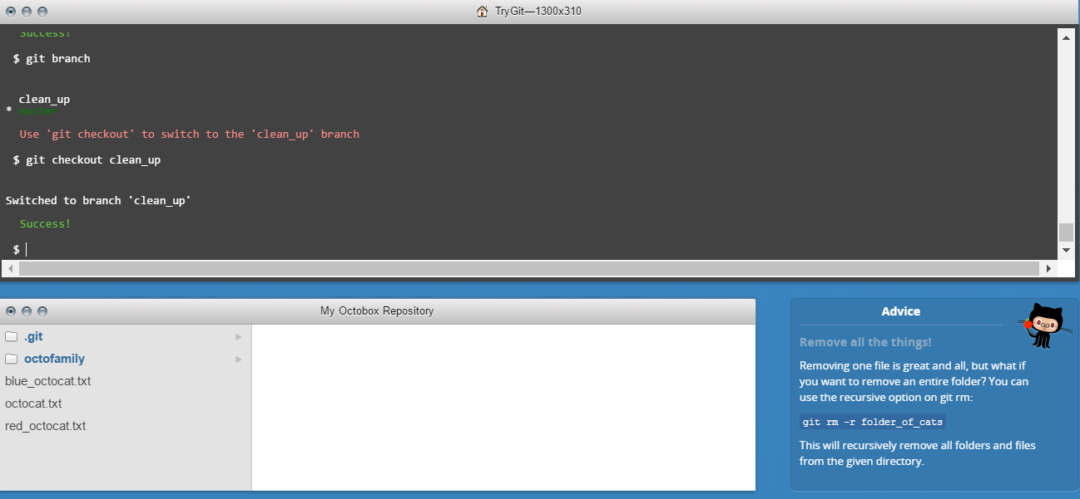

Step 20:

Removing all things

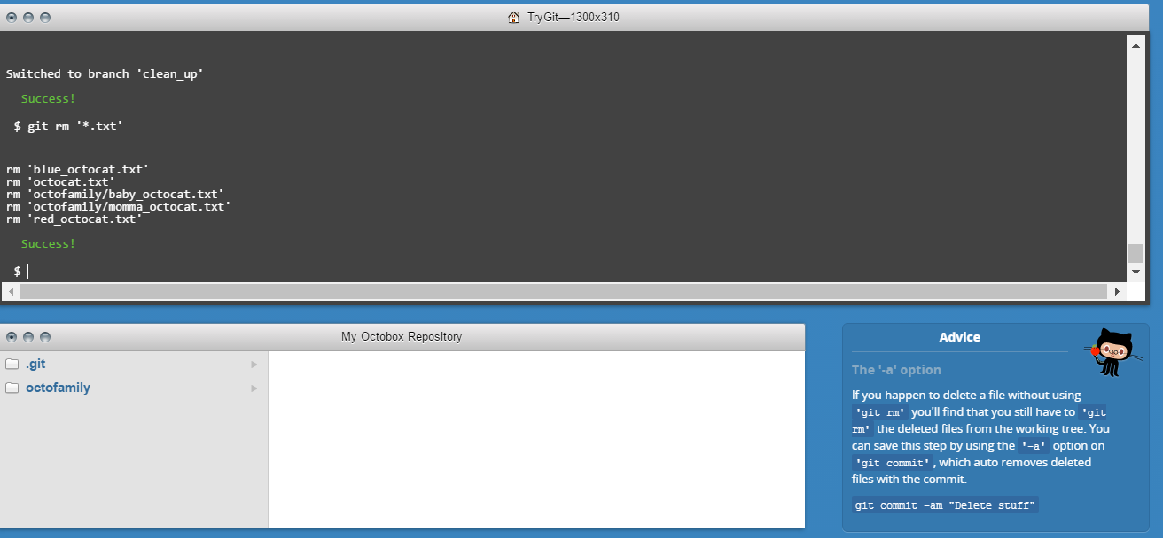

Step 21:

Committing Branch Changes

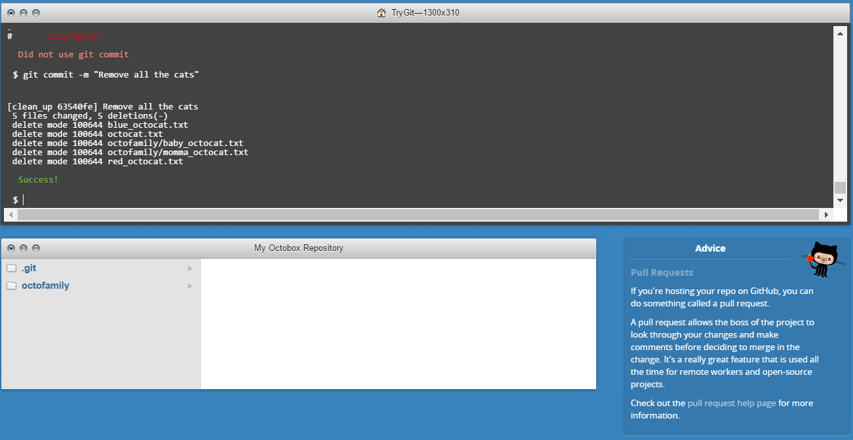

Step 22:

Switching back to master

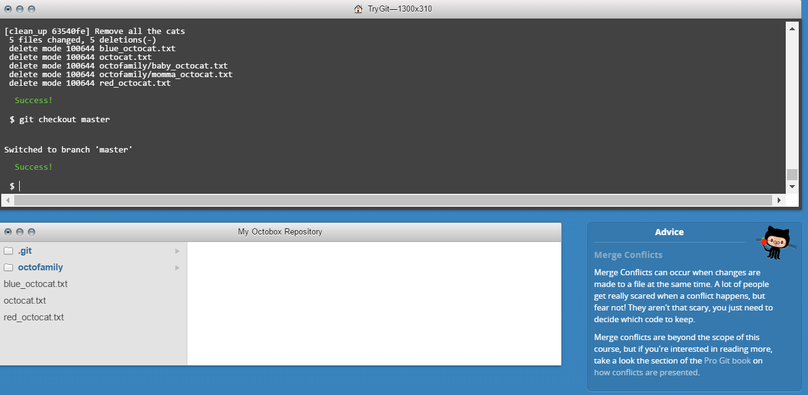

Step 23:

Preparing to merge

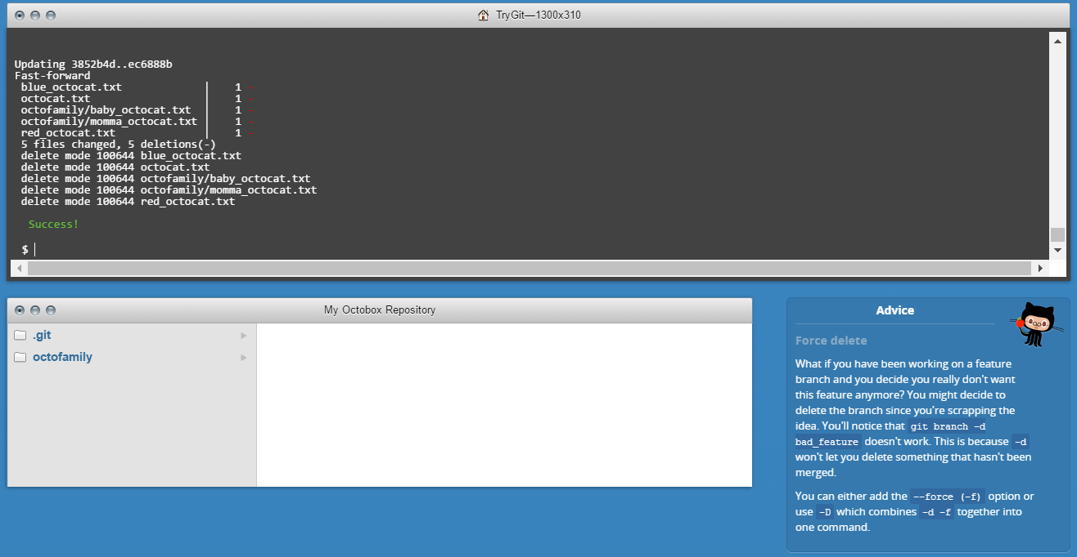

Step 24:

Keeping things clean

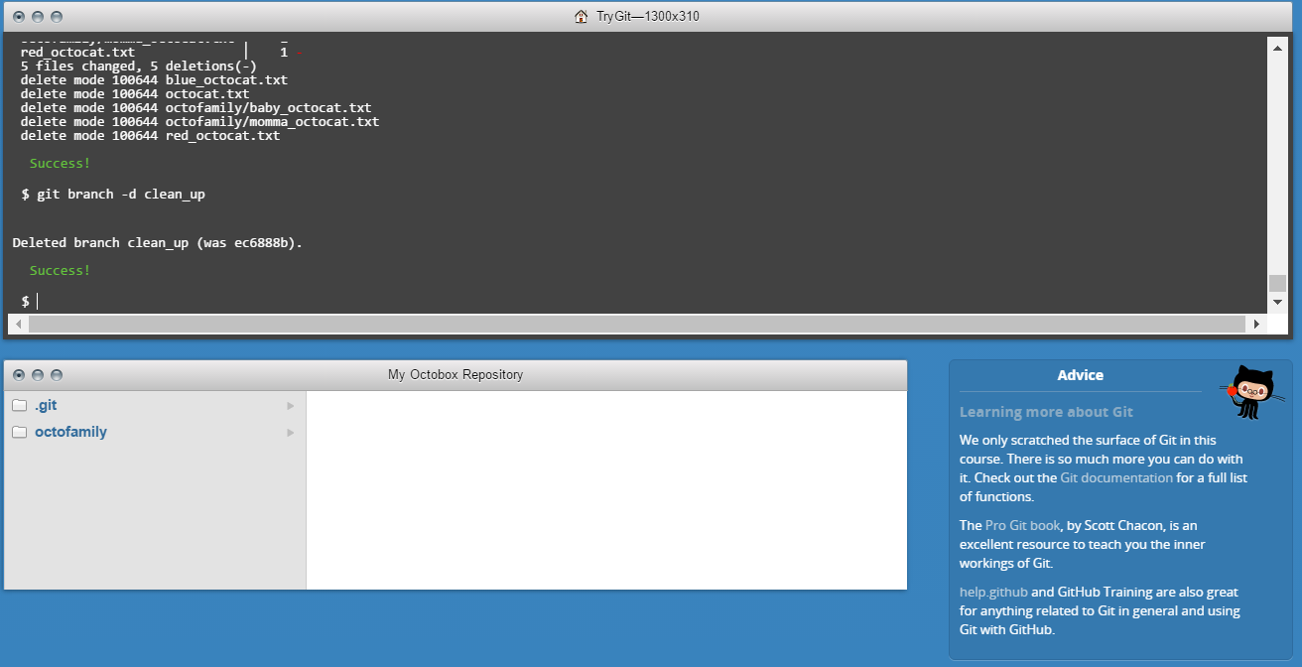

Step 25:

The final push

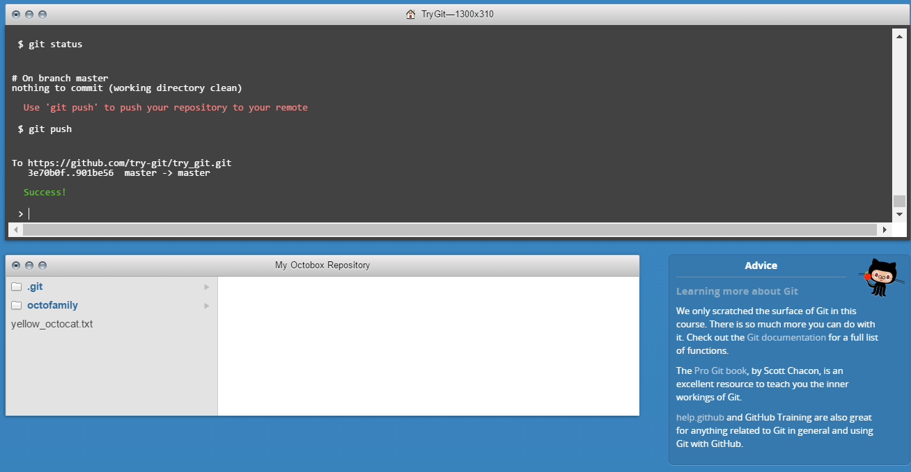

Q.2 Define the following terms in the context of Git (2 lines maximum):

Answer:

1. Repository:A repository contains all of the project files (including documentation), and stores each file's revision history.
2. Commit: A commit is an individual change to a file (or set of files). It creates an unique ID that allows you to keep record of what changes were made when and by who.
3. Branch: A branch is a similar version of a repository. It is contained within the repository, but does not affect the primary or master branch allowing you to work freely without disrupting the "live" version.
4. Fork: Forks allow you to freely make changes to a project without affecting the original. Forks remain attached to the original, allowing you to update the author with your changes.
5. Merge: Merging takes the changes from one branch (in the same repository or from a fork), and applies them into another.
6. Clone: Cloning a repo in simple words, “Creating a copy of a repo”. By this, developers/coders can make changes on the clone repo and check for different outputs.
7. Pull: Pull refers to fetching in changes and merging them. In its default mode, git pull is short hand for *git fetch*.
8. Pull request: Pull request contains the information about the changes made to a GitHub repo. A revision history can be checked by a Pull request.