#####
When we click on any relaxation service it should play song
Concern, availability, location based therapist searching in patient dashboard
From sidebar remove notifications, bookings
Make therapist profile mandatory

DEMO button:
After clicking demo it should show the above referred page (try anhat for free)and song should be played
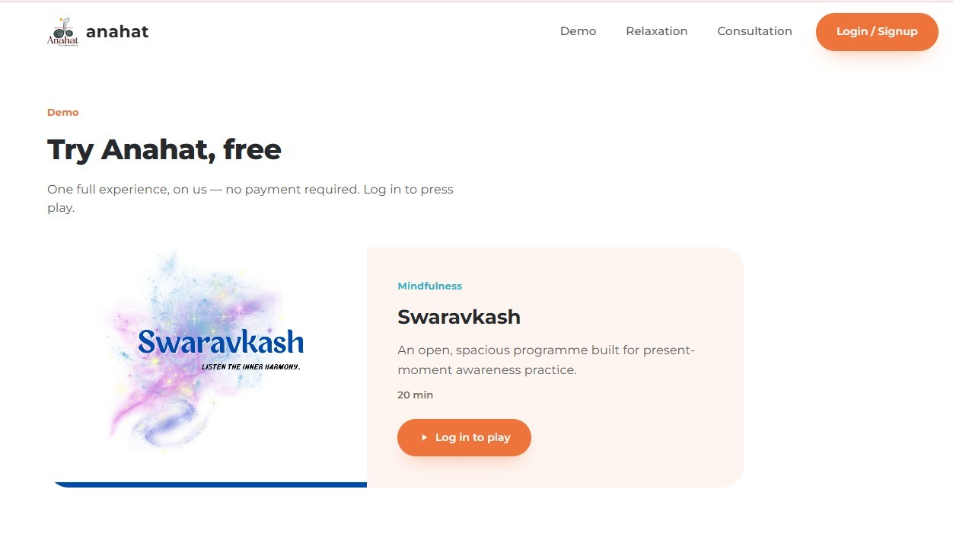
After clicking on consultation redirect to siun up page and then their respective demographic forms for patient and therapist and after that redirect them to their respective dashboards
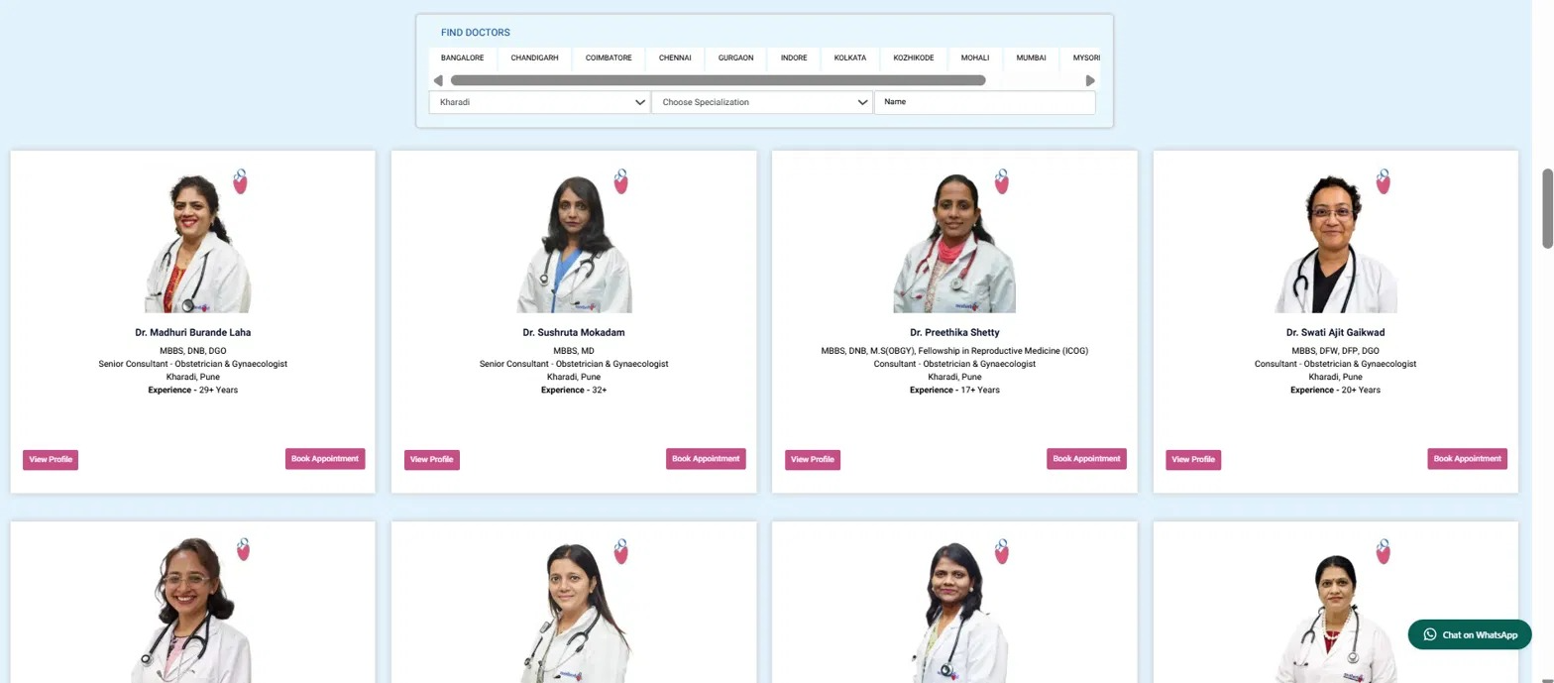

When we go to patient dashboard add nav bar which consists of find your therapist(refer image after clicking find your therapist like the image therapist should appear along with the buttons view profile and book appointment) , notifications bell icon (all notifications should be popped here patient should also see prevois notifications as well and when patient reads notifications it should be removed from the bell icon) profile image and when we click on profile in dropdown settings and logout (in drop down of profile after clicking profile ) and side panel as is just remove notifications and booking tab from it
After clicking view profile it should show info like the above referred image
NOTE: you don’t need to add therapist on your own we have therapist dashboard from there the therapist who have registered should be shown here
NOTE: if possible while signing up for first tie guide the user as well as therapist to go to next steps the way it is done in professional websites only do it while signig up pop up texts like try this click here to book like this based on your own judgement do this same with therapist guide him or her while signing up and taking session for first time guide therapist to click here writer your answers here tell therapist which questions are completed etc in professional manner also keep skip otion like skip steps mimic professional websites for this gyidance steps

