Final Project: Minesweeper

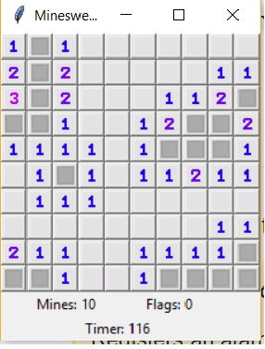

Priya Baskaran

Anuja Dinesh Vaidya

Minesweeper:

Approach towards it:

Lessons learnt:

Source Code:

Screen Shots:

Difficulties faced:

Reference:

1. <https://github.com/flntzr/Java-Minesweeper/blob/master/leCode/Minesweeper.java>
2. <http://www.progressivejava.net/2012/10/How-to-make-a-Minesweeper-game-in-Java.html>