**Screenshots:**

I have made two files csv and txt. The screenshots are based on the entries there.

1. For a CSV file:

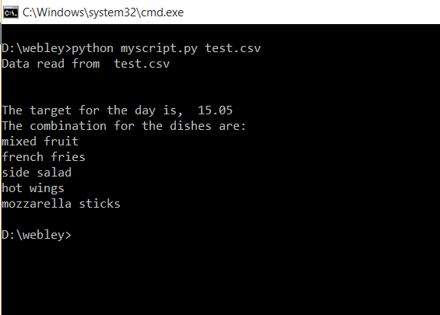

1. The txt file:

