Table of Contents – YARA Rules Report
- Introduction
1.1 Background on Malware Detection
1.2 What is YARA?
1.3 Importance of YARA in Cybersecurity
- Fundamentals of YARA
2.1 Structure of YARA Rules
2.2 Key Components: Strings, Conditions, Identifiers
2.3 Syntax and Rule Examples
- Types of YARA Rules
3.1 Basic Rules
3.2 String Matching Rules
3.3 File and Binary Pattern Rules
3.4 Metadata Usage
- Working of YARA
4.1 How YARA Scans Files and Processes
4.2 Rule Matching Process
4.3 Integration with Security Tools
- Practical Applications
5.1 Malware Detection and Analysis
5.2 Threat Hunting in Enterprises
5.3 Incident Response and Forensics
5.4 Integration with SIEM, IDS/IPS, and EDR
- Writing Effective YARA Rules
6.1 Best Practices in Rule Creation
6.2 Avoiding False Positives and Negatives
6.3 Reusable and Modular Rules
- Case Studies and Examples
7.1 Example Rule for Ransomware Detection
7.2 YARA Rules for Detecting APT Malware
7.3 Community-Sharing of Rules (e.g., GitHub, VirusTotal, MalwareBazaar)
- Advanced YARA Features
8.1 Modules (PE, ELF, Cuckoo, Hash, Math, etc.)
8.2 Performance Optimization in Large-Scale Environments
8.3 Combining YARA with Machine Learning/AI
- Challenges and Limitations
9.1 Evasion Techniques by Malware Authors
9.2 Maintenance of Rule Repositories
9.3 Performance and Resource Constraints
- Future of YARA in Cybersecurity
10.1 Evolving Threat Landscape
10.2 Automation and AI Integration
10.3 Community Collaboration and Open Source Growth
- Conclusion
- References

1. Introduction

1.1 Background on Malware Detection
Cybersecurity threats have grown significantly in recent years. Malware authors use techniques such as encryption, obfuscation, and polymorphism to bypass traditional antivirus software. Signature-based detection methods are often insufficient because they rely on exact matches with known malware.
To overcome these challenges, analysts and researchers require more flexible, pattern-based detection tools that can identify not only exact signatures but also similarities and families of malware. This is where YARA plays a critical role.
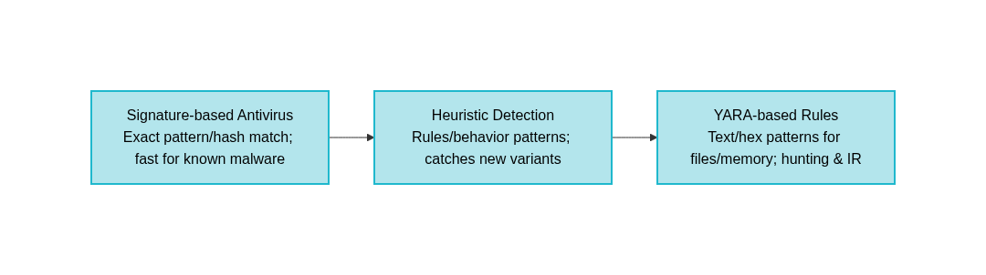

1.2 What is YARA?
YARA stands for "Yet Another Recursive Acronym". It was developed by Victor Alvarez at VirusTotal (later acquired by Google). YARA provides a rule-based framework that helps researchers identify and classify malware samples.
It is widely used for:
- Malware research
- Threat hunting
- Incident response
- Digital forensics
- Integrating detection into SIEM, IDS/IPS, and endpoint protection solutions

1.3 Importance of YARA in Cybersecurity
- Custom Detection: Organizations can create their own rules to detect targeted attacks.
- Flexibility: Detects both simple strings and complex binary patterns.
- Integration: Works with tools like Security Onion, MISP, Suricata, Zeek, and VirusTotal.
- Open Source & Community Support: Thousands of shared rules are available in public repositories.

2. Fundamentals of YARA
YARA rules form the backbone of its detection capability. To understand how YARA works, it is important to break down the structure of a rule, its components, and the role of identifiers, strings, and conditions.

2.1 Structure of YARA Rules
A YARA rule typically consists of four key sections:
- Rule Name
  - This is the unique identifier for the rule.
  - Every rule must have a name, and it should describe what the rule is detecting (e.g., Ransomware_Detector or Detect_TrojanX).
  - Naming conventions should be meaningful, consistent, and descriptive, as rule sets can become large in enterprise environments.
  - Example:
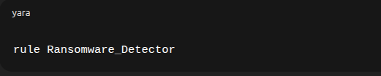
  - If a rule name contains spaces, underscores _ are usually used instead.
- Meta Section
  - The meta section is optional but highly recommended.
  - It provides metadata about the rule, which helps other analysts understand its purpose and origin.
  - Typical meta fields include:
    - author: Person who wrote the rule.
    - description: Short explanation of what the rule detects.
    - date: Date of creation or update.
    - reference: Links to reports, CVEs, or articles related to the malware.
  - Example:
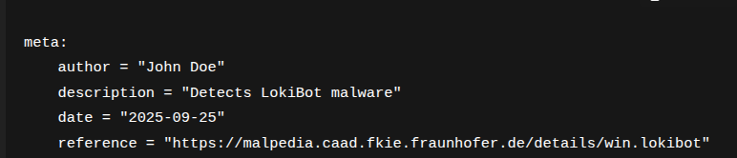
- Strings Section
  - The strings section defines the data patterns YARA will search for in files, memory, or processes.
  - Strings are the heart of YARA rules because they describe what to look for.
  - Each string must be given a label/identifier (e.g., $a, $b1, $config).
  - Strings can be of different types: ASCII, Unicode, regex, or hexadecimal patterns.
  - Example:
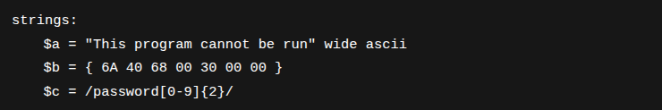
- Condition Section
  - The condition section defines the logic for when the rule should match.
  - It is a mandatory section in every rule.
  - Conditions can be simple (e.g., “string $a must be present”) or complex (“file size < 1MB AND at least 2 strings must match”).
  - Example:
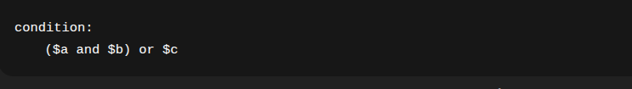
👉 Image suggestion: A labeled diagram showing the 4 main sections of a YARA rule (Rule Name → Meta → Strings → Condition).

2.2 Key Components in Detail

2.2.1 Identifiers
- Definition: An identifier is a label used to name rules, strings, or variables.
- Identifiers must start with a letter or underscore and may include letters, numbers, or underscores.
- They are case sensitive (e.g., $a is not the same as $A).
- Identifiers are used to:
  - Name a rule (rule MyRule { ... })
  - Name strings ($a, $config1)
  - Reference conditions (#a > 3)
👉 Example:
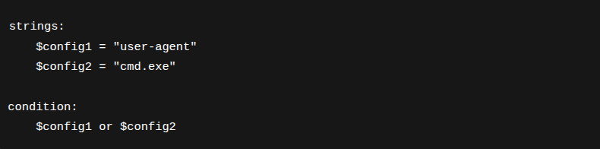

2.2.2 Strings
Strings define what patterns YARA looks for inside a file or process. There are four major types:
- Text (ASCII) Strings
  - Basic strings in plain ASCII format.
  - Example:
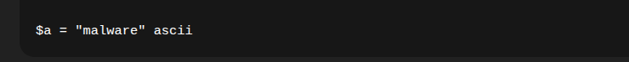
- Wide (Unicode) Strings
  - Strings encoded in 2-byte Unicode (UTF-16 LE), commonly used in Windows executables.
  - Example:
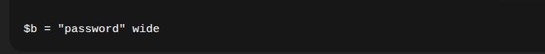
- Regular Expressions (Regex)
  - Regex allows for pattern-based matching, useful for detecting obfuscated or variable strings.
  - Example:
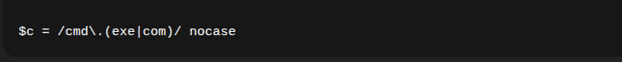
- Hexadecimal Strings
  - Defines byte patterns (with wildcards allowed).
  - Used to detect binary-level patterns inside executables.
  - Example:
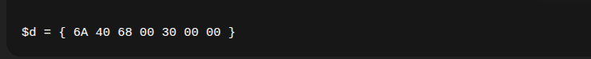

2.2.3 Conditions

The condition section is where analysts define how many and which strings must match for the rule to trigger. It uses boolean logic, arithmetic, and counters.
Types of conditions include:
- Boolean Operators
  - and, or, not
  - Example:
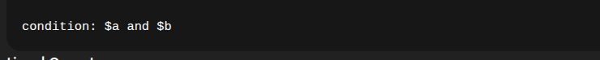
- Relational Operators
  - <, >, ==, !=
  - Example:
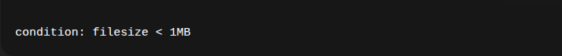
- String Occurrence Counters
  - # counts the number of times a string appears.
  - Example:
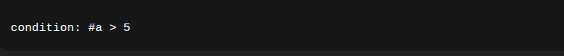
- Offset & At Operators
  - at ensures a string appears at a specific offset.
  - Example:
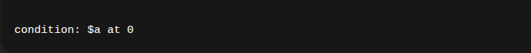
- Combination of Conditions
  - Example:
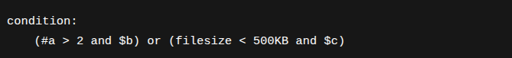

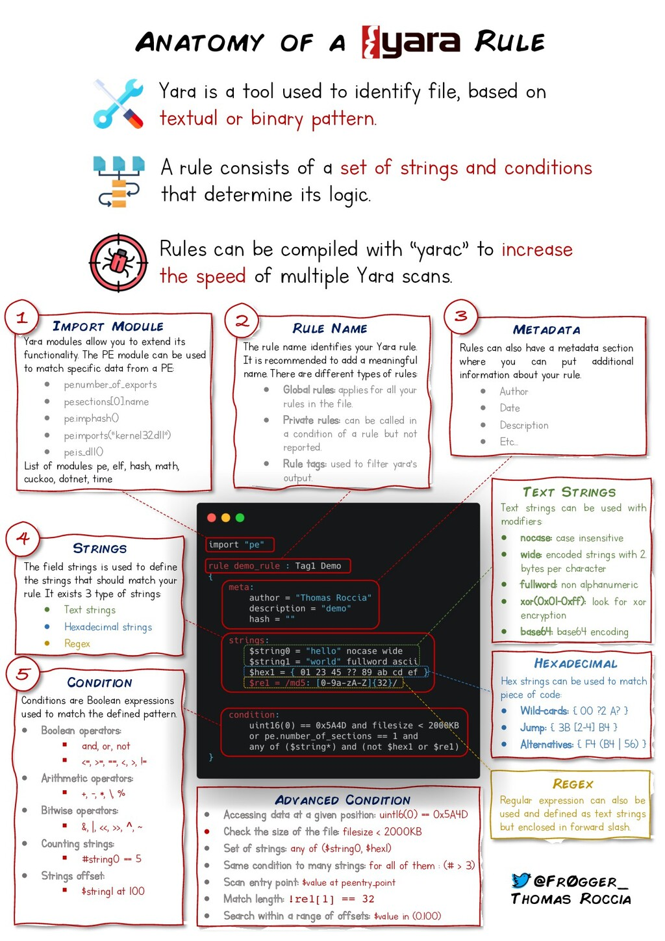

3. Types of YARA Rules
YARA rules can be written at different levels of complexity depending on the detection needs. They may be as simple as a single string match, or as complex as multi-condition rules with metadata, file attributes, and modular integrations.

3.1 Basic Rules
- Definition:
Basic rules are the simplest form of YARA rules. They detect the presence of one or more static strings in a file or process.
- Usage:
  - Detecting malware families that contain unique keywords like "ransom", "trojan", "keylogger".
  - Useful in cases where malware leaves behind recognizable plain-text artifacts.
- Advantages:
  - Easy to write and understand.
  - Quick scanning with minimal resource usage.
- Limitations:
  - High chance of false positives if strings are common.
  - Not effective against obfuscated or encrypted malware.

Example:
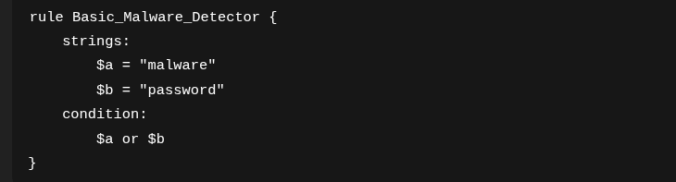

3.2 String Matching Rules
- Definition:
String matching rules use ASCII, Unicode, regex, and complex expressions to detect malware-specific strings.
- Usage:
  - Detecting hardcoded commands (e.g., "cmd.exe", "powershell")
  - Detecting C2 (Command and Control) server URLs embedded in malware.
  - Catching malware configuration patterns stored in binaries.
- Techniques:
  - ASCII Strings: For simple readable text.
  - Wide/Unicode Strings: For Windows malware executables.
  - Regex Matching: For flexible detection, e.g., /http[s]?:\/\/[a-z0-9\.]+/.
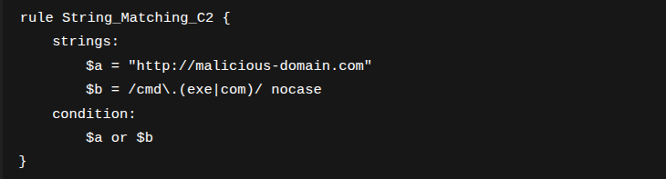
- Example:

- Advantages:
  - More precise detection compared to basic rules.
  - Reduces false positives by matching patterns.
- Limitations:
  - Regex can slow down performance in large-scale scanning.
👉 Image suggestion: Table of different string types (ASCII, wide, regex) with side-by-side examples.

3.3 File and Binary Pattern Rules
- Definition:
These rules detect specific byte sequences or file attributes commonly found in malware binaries.
- Usage:
  - Identifying PE (Portable Executable) files on Windows.
  - Identifying ELF (Executable and Linkable Format) files on Linux.
  - Identifying Mach-O binaries on macOS.
  - Detecting shellcode or binary instructions used in exploits.
- Hexadecimal Patterns:
  - Strings can be defined in hex format with wildcards.
  - Example:
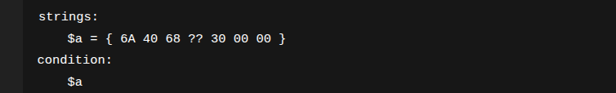
- File Characteristics:
  - With the PE module, analysts can check headers, imports, and version info.
  - Example:
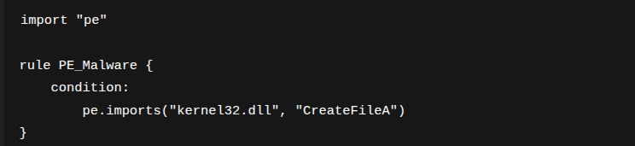
- Advantages:
  - Very effective against packed malware.
  - Detects low-level traits that are difficult to obfuscate.
- Limitations:
  - More complex to write.
  - Requires knowledge of file formats and assembly instructions.
👉 Image suggestion: Diagram of a PE file header, with YARA scanning for specific imports.

3.4 Metadata Usage
- Definition:
Metadata provides contextual information about the rule. While it does not affect detection, it helps in documentation, maintenance, and collaboration.
- Typical Metadata Fields:
  - author: Name of the rule creator.
  - date: Date of rule creation.
  - description: Summary of what the rule does.
  - reference: External links (CVE IDs, malware reports, blogs).
  - hash: Sample hash used for testing.
- Example:
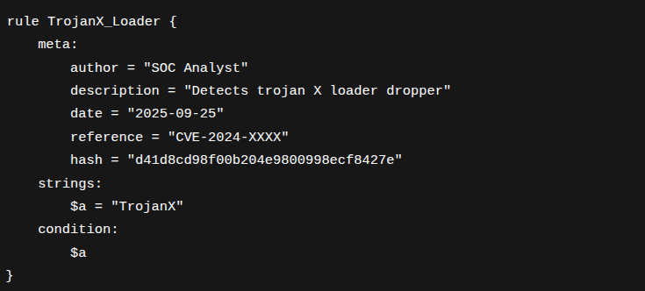
- Advantages:
  - Enhances collaboration between teams.
  - Helps in auditing and compliance.
  - Provides traceability of rule origins.
👉 Image suggestion: Example screenshot of a YARA rule repository (e.g., GitHub) where metadata helps organize rules.

4. Working of YARA
YARA operates as a pattern-matching engine. Its primary function is to scan files, directories, or processes against a set of user-defined rules, returning matches if the specified conditions are satisfied.

4.1 How YARA Scans Files and Processes
The general workflow of YARA scanning is as follows:
- Loading Rules into Memory
  - YARA first parses and compiles the user-defined rule set.
  - Invalid or conflicting rules are rejected at this stage.
- Target Selection
  - YARA scans the chosen file, process, or directory.
  - Files are read in chunks to optimize memory usage.
- Pattern Matching
  - YARA compares the file contents against the strings and conditions defined in the rules.
  - Both textual and binary patterns are checked.
- Condition Evaluation
  - The condition section decides if the rule should trigger.
  - Example: a string must appear at least 5 times or the file must be under 1 MB.
- Result Generation
  - If conditions are satisfied, YARA reports a match.
  - Matches can be logged, exported, or sent to external systems for further analysis.
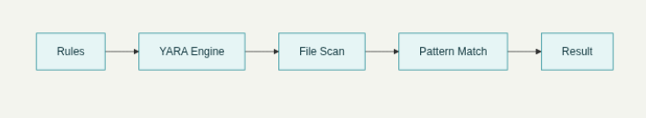

4.2 Rule Matching Process
- Rule Compilation
Before execution, YARA rules are compiled into an internal representation to speed up matching.
- File Iteration
Each target file is scanned byte by byte against all defined rules.
- Parallel Rule Application
YARA applies all rules to a file rather than scanning for one rule at a time, making the process efficient.
- Condition Checking
If multiple strings match, YARA evaluates the logical expressions in the condition section.
- Match Output
  - The output includes rule name, matched strings, offsets, and file path.
  - Results can be exported in JSON, text, or custom formats.
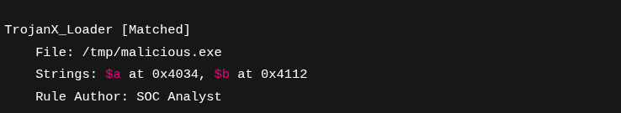

4.3 Integration with Security Tools
YARA is widely integrated into enterprise cybersecurity ecosystems. It can serve as a detection layer in multiple tools:

1. SIEM Integration (Security Information and Event Management)
- Platforms: Splunk, ELK Stack (Elasticsearch, Logstash, Kibana).
- YARA rules can be run as automated scans on suspicious files uploaded to SIEMs.
- Matches are correlated with logs and alerts.
Example Use Case: Splunk runs a YARA scan on files extracted from suspicious emails, alerting SOC analysts if malware patterns are detected.

2. IDS/IPS Integration (Intrusion Detection/Prevention Systems)
- Platforms: Snort, Suricata.
- YARA can complement signature-based detection by analyzing file payloads.
- Rules can detect malware hidden in traffic captures (PCAPs).
Example Use Case: Suricata sends extracted attachments from network traffic to YARA, which identifies malicious droppers.

3. Forensics and Incident Response
- Tools: Volatility (memory forensics), Autopsy (disk forensics).
- YARA scans can run against memory dumps to identify injected malware.
- Analysts can detect in-memory implants even if files are deleted.
Example Use Case: Volatility plugin uses YARA rules to scan memory for Cobalt Strike beacon signatures.

4. Threat Intelligence Platforms
- Platforms: MISP (Malware Information Sharing Platform), YETI, ThreatConnect.
- YARA rules are shared as part of threat intelligence feeds.
- SOC teams deploy these rules to detect newly emerging threats.
Example Use Case: A MISP feed pushes a new YARA rule for a ransomware variant; the SOC deploys it across endpoints to detect infections.

5. Other Integrations
- EDR/XDR Tools: CrowdStrike, SentinelOne, Elastic Defend integrate YARA for detection.
- Cloud Platforms: VirusTotal allows users to submit YARA rules for searching its sample database.
- Custom Automation: Python scripts using the yara-python library for batch scanning

4.4 Advantages of YARA Integration
- Cross-platform: Works on Linux, Windows, macOS.
- Scalable: Can scan single files or entire enterprise networks.
- Flexible: Rules can detect both known and unknown malware.
- Community-driven: Thousands of YARA rules are shared openly.
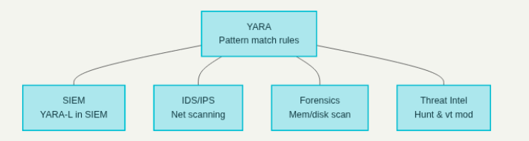

5. Practical Applications

5.1 Malware Detection and Analysis
- Detect ransomware, trojans, worms, keyloggers.
- Used in sandbox analysis and reverse engineering labs.

5.2 Threat Hunting in Enterprises
- Search for Indicators of Compromise (IOCs) across endpoints.
- Automates proactive defense.

5.3 Incident Response and Forensics
- Scan memory dumps, logs, and compromised files.
- Helps analysts quickly identify malicious activity.

5.4 Integration with SIEM, IDS/IPS, and EDR
- Custom YARA rules extend commercial security products.
- Example: Using YARA in Security Onion to detect malware traces in network packets.

6. Writing Effective YARA Rules

6.1 Best Practices
- Use unique strings instead of common ones (avoid "http").
- Combine multiple strings with logical conditions.
- Add metadata for documentation.

6.2 Avoiding False Positives/Negatives
- Test rules across clean datasets.
- Use regex carefully (they can cause performance issues).

6.3 Reusable and Modular Rules
- Use imports and modules for common detection logic.
- Maintain a central repository of rules for teams.

7. Installing YARA
YARA can be installed and used on multiple operating systems, primarily Linux and Windows. Below are the steps for installing YARA on both platforms.

7.1 Installing YARA on Linux
There are two common ways: via package manager or building from source.

Method 1: Install via Package Manager (Quickest Way)
For Ubuntu/Debian-based systems:
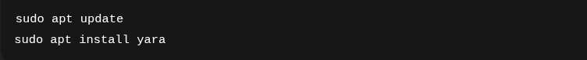
For CentOS/RHEL-based systems:
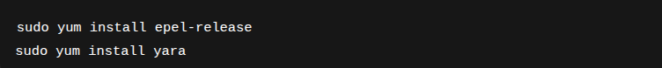
For Fedora:
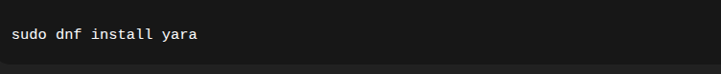
After installation, verify with:
yara --version

7.2 Installing YARA on Windows

Method 1: Precompiled Binaries (Recommended)
- Download precompiled binaries from the official YARA GitHub releases page.
👉 URL: https://github.com/VirusTotal/yara/releases
- Extract the .zip file.
- Add the bin folder (where yara64.exe is located) to your system PATH.
- Open Command Prompt or PowerShell and run:
yara64.exe --version

7.3 Installing yara-python (Optional for Automation)
YARA can also be used in Python scripts via the yara-python library.
pip install yara-python

8. Advanced YARA Features

8.1 Modules
- PE Module: Extracts metadata from PE headers.
- ELF Module: Detects Linux ELF malware.
- Cuckoo Module: Uses sandbox results.
- Hash Module: Matches based on hashes.
- Math Module: Statistical operations.

8.2 Performance Optimization
- Minimize regex usage.
- Use fast string matching.
- Limit large rulesets.

8.3 Combining YARA with Machine Learning
- ML can detect new malware variants.
- YARA rules can enforce detection on known families.
- Hybrid approach enhances threat intelligence.

9. Challenges and Limitations

9.1 Evasion Techniques
- Malware authors obfuscate strings.
- Packers/encryptors hide patterns.

9.2 Rule Maintenance
- Rules must be updated continuously.
- Old rules may become obsolete.

9.3 Performance Constraints
- Large rule sets slow down scans.
- Requires tuning for enterprise-scale deployment.

10. Future of YARA in Cybersecurity

10.1 Evolving Threat Landscape
- Rise of AI-powered malware.
- YARA will adapt with smarter modules.

10.2 Automation & AI Integration
- Integration with SOAR platforms.
- AI-assisted rule generation.

10.3 Community Collaboration
- Growth of open-source repositories.
- Shared intelligence across organizations.

