**Issue No. : Business Continuity Management Date of Issue : System Revision No :**

**Date of Revision :**

Document Number: **Page :**

**SLT PROPRIETARY**

UNAUTHORIZED REPRODUCTION, REFERENCE & POSSESSION OF THIS DOCUMENT IS NOT PERMITTED



Voucher Management System

# FUNCTIONAL REQUIREMENT DOCUMENT

Document Number :

Issue No : Issue Date : Issued By :

**Document Control Sheet**

**Contact for Inquiries & Proposed Changes**

Name : Uyani Panagoda

Designation : Trainee IT business analyst

E-mail : [uyaninpanagoda@gmail.com](mailto:uyaninpanagoda@gmail.com)

Prepared By

|  |  |  |  |
| --- | --- | --- | --- |
| Name | Designation | Date | Signature |
| Uyani Panagoda | Trainee IT business analyst |  | panagoda |
| Sithumi Vindy | Trainee IT business analyst |  | sithumi |
| Navoda Prabashini | Trainee IT business analyst |  | navoda |

Checked By

|  |  |  |  |
| --- | --- | --- | --- |
| Name | Designation | Date | Signature |
| Nishantha Alwis | Manager(S/D)/Digital Platforms |  |  |
|  |  |  |  |
|  |  |  |  |
|  |  |  |  |
|  |  |  |  |
|  |  |  |  |
|  |  |  |  |
|  |  |  |  |
|  |  |  |  |
|  |  |  |  |

Approved By

|  |  |  |  |
| --- | --- | --- | --- |
| Name | Designation | Date | Signature |
| Nishantha Alwis | Manager(S/D)/Digital Platforms |  |  |
|  |  |  |  |

Revision History

|  |  |  |  |  |
| --- | --- | --- | --- | --- |
| **Issue Number** | **Issued Date** | **Issued By** | **Summary of Changes** | **Document Section** |
|  |  |  |  |  |
|  |  |  |  |  |

# Table of Content

* 1. Introduction 5
  2. Background 5
  3. Overview 6
  4. Proposal 6
  5. Objectives 7
  6. Scope 7

2.0 High level Flow diagram 8

* 1. Functional Requirements 9
  2. List of Functions 9
  3. System Wireframes 14
  4. Non-Functional Requirements 20
  5. Privileges 20
  6. User Characteristics 23

## Introduction

## Background

The purpose of this document is to define the procedure for developing a Voucher Management System to promote SLT services to customers, including FTTH services. This system is designed to streamline the creation, approval, printing, distribution, activation, and tracking of vouchers within the organization. This process involves various stakeholders, including project managers, operational and batch-level approvers, procurement staff, store staff, agents, and customers.

Currently, the whole process is handled manually, resulting in a lot of paperwork. As the volume of vouchers increases, managing the process manually has become difficult. Human errors often occur during the process, especially in data entry operations and calculations, causing the entire employee team to double-check tasks, leading to a huge waste of time. To view the sales history, staff must keep physical logs. This process also poses security risks as documents and reports can be easily lost, damaged, or destroyed, leading to potential financial issues. Moreover, generating reports manually can result in inconsistencies and inaccuracies, and it is very labor-intensive. Approval delays often happen because vouchers get stuck in the approval process due to the need for physical signatures and manual checks. Furthermore, the department has to bear extra costs related to paper, printing, storage, and many other expenses.

The purpose of this Software Requirement Specification (SRS) report is to present a detailed description of the Voucher Management System application. This contains an overview of the overall SRS, including the purpose, project scope, overall description, functional features, non-functional requirement references, and external interface requirements. The features were proposed after thoroughly understanding client requirements. The document will give an understanding of how this application will help to improve the customer and client base and make business operations more efficient and accurate.

## Overview

The Voucher Management System is designed to streamline the entire process of voucher handling within the organization. This system will manage the creation, approval, distribution, activation, and redemption of vouchers. Each voucher will contain four coupons and the vouchers will be grouped into batches for efficient processing. The system will support various roles including project managers, approvers, procurement staff, store persons, agents, and customers each with specific responsibilities to ensure smooth operation. The tracking of the vouchers is also done by updating the status of the coupons to VMS until the voucher expires.



**Admin**

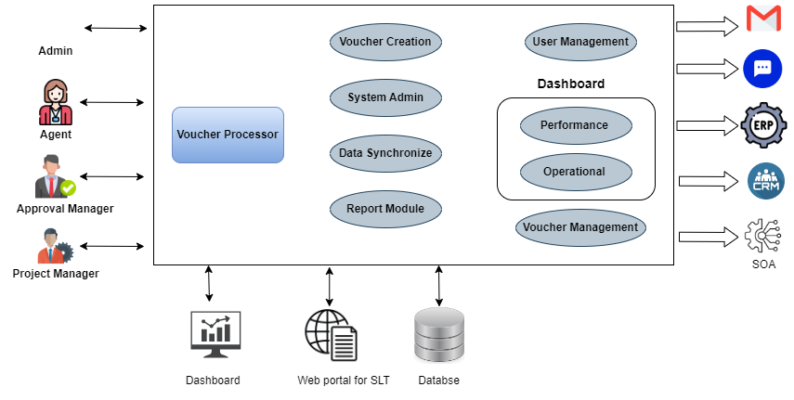

*Figure: Low-level architecture diagram of VMS*

## Proposal

The proposed BCMS will comprise several key components:

* + - Risk Assessment and Business Impact Analysis - Identify potential risks and assess their impact on our business operations. Prioritize critical functions and resources based on their importance and dependencies.
    - Business Continuity Planning - Develop and document detailed plans for responding to disruptions. These plans will outline the necessary steps, roles, and responsibilities for ensuring the continuity of critical business processes.
    - Emergency Response and Incident Management - Establish procedures for activating and managing emergency response efforts. Coordinate response efforts and communicate with relevant stakeholders during an incident.
    - Backup and Recovery - Implement mechanisms for backing up critical data and systems. Ensure timely recovery of data and systems in the event of a disruption.
    - Training and Awareness - Provide training to employees on business continuity procedures and their roles/responsibilities during an emergency. Raise awareness about the importance of business continuity across the organization.
    - Continuous Improvement - Conduct regular reviews and evaluations of the BCMS to identify areas for improvement. Update and revise business continuity plans based on lessons learned from incidents.

## Objectives

The primary objective of the proposed VMS is to streamline several key processes from voucher creating until to voucher redeeming. By establishing a structured approach, we aim to:

* + - Enable project managers to efficiently create vouchers and batches.
    - Implement a multi-level approval process to ensure compliance and accuracy.
    - Facilitate the distribution of approved voucher batches to stores and agents, simplifying the activation process for agents upon sale.
    - Provide an admin portal for managing agent registrations and overseeing system operations.
    - Enhance tracking and reporting capabilities by updating the status of vouchers such as inactive, reserved, active, etc.
    - Develop and document accurate, user-friendly, reliable and efficient working software.
    - Train and prepare end users.
    - Continuously monitor, identify and mitigate risks and implement a proper risk management strategy.

## Scope

The Voucher Management System aims to develop a fully functional, automated solution to the manual voucher management process and wishes to integrate with other SLT systems later. Project managers could create vouchers, each containing four coupons. These vouchers then undergo approval at both operational and batch levels before being sent to procurement for printing. Once printed, the vouchers are distributed to stores and then to agents for sale. Upon sale, agents are responsible for activating the vouchers, making them usable by customers. Throughout this process, the system tracks the status of the vouchers, from creation to redemption, at SLT workshops, ensuring that all coupons are used. The admin portal plays a crucial role in this process, as admins manage agent registrations and oversee the system's operation to ensure smooth functionality. This involves creating a user-friendly web application with advanced features to facilitate voucher management.

## 2.0 High level Flow diagram

## 

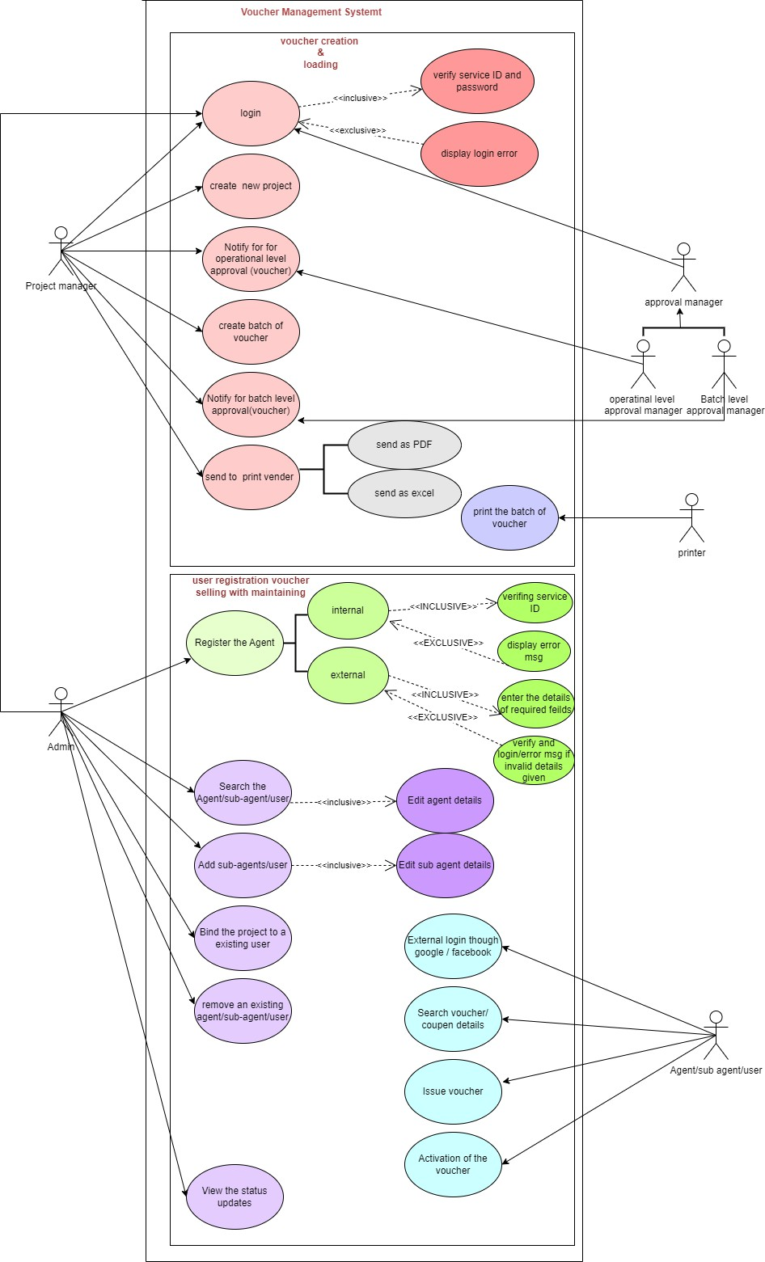

*Figure : high level use-case of the proposed VMS system.*

## Functional Requirements

## List of Functions

* + 1. **Internal user login.**

|  |  |  |
| --- | --- | --- |
| **User case ID** | UC01 | |
| **Use case name** | Internal user login | |
| **Actors** | System Admin, Project Manager, Approval Manager | |
| **Description** | This use case describes the process for an internal user (a SLT employee) to log into the system. | |
| **Pre-conditions** | * There should be a user who needs to do a task in voucher creation and managing process. * Should be a SLT employee and use service number as username and password use in slt systems. * The user should be registered. | |
| **Post-conditions** | * User should be logged into the system. | |
| **Pre status** | User – ***not allocated*** | |
| **Post status** | User – ***not allocated*** | |
|  | **Action** | **System Response** |
| **Success path** | **1**. User directed to the login page.  **3.** User enters and submits  the login details. | **2.** System request for login details.  **3.** System validates the details.  **4.** Redirects to the relevant page based on role. |
| **Alternate path** | If user credentials are wrong, should display an error  massage. | |

* + 1. **External user login.**

|  |  |  |
| --- | --- | --- |
| **User case ID** | UC02 | |
| **Use case name** | External user login | |
| **Actors** | Agent, Sub-agent , User | |
| **Description** | This use case describes the process for an external user to log into the system using Google or Facebook authentication | |
| **Pre-conditions** | * There should be a user who needs to sell and verify a voucher and see the sales history. * The external user should be registered. | |
| **Post-conditions** | * The external user should be logged into the system. | |
| **Pre status** | User – ***not allocated*** | |
| **Post status** | User – ***not allocated*** | |
|  | **Action** | **System Response** |
| **Success path** | **1.** The external user clicks “Sign up with Google” or “Sign up with Facebook”.  **3.** The external user clicks “Sign up with Google” or “Sign up with Facebook”. | **2.** System redirects to Google or Facebook login page.  **4.** System authenticates and logs in the user. |
| **Alternate path** | The external user cancels the login process on Google/Facebook. | |
| **Exceptional path** | The external user enters incorrect credentials. | The system displays an error message. |
| **Special requirements** | Secure authentication integration with Google and Facebook | |

* + 1. **Create a new project.**

|  |  |  |
| --- | --- | --- |
| **User case ID** | UC03 | |
| **Use case name** | Create a new project | |
| **Actors** | Project Manager | |
| **Description** | This use case describes the process for a project manager to create a new project in the system. | |
| **Pre-conditions** | * The user needs to create a new project. * The user is logged in. * The user should be registered and active. * The user has project manager privileges. * The status of the batch and project should be “pending”. | |
| **Post-conditions** | * A new project should be created. | |
| **Pre status** | Project – ***not allocated***, User – ***active*** | |
| **Post status** | Project – ***inactive*** , User – ***active*** | |
|  | **Action** | **System Response** |
| **Success path** | **1.** User navigates to the “Project” page and clicks “Create Project”.  **3.** The user fills out project details and clicks "Save". | **2.** The system displays the "Create New Project" form.  **4.** The system saves and displays the new project in the list. |
| **Alternate path** | The user clicks "Cancel" while creating a project. | |
| **Exceptional path** | The user enters invalid data. | The system displays an error  message and prompts for correction. |
| **Special requirements** | The project code should be an alphanumeric value. | |

* + 1. **Approve the newly created project.**

|  |  |  |
| --- | --- | --- |
| User case ID | UC04 | |
| **Use case name** | Approve the created project | |
| **Actors** | Operational-level approval manager | |
| **Description** | This use case describes the process for an approval manager to approve a created project in the system. If the user decides to reject the project or does not have the necessary privileges, the system handles these scenarios accordingly. | |
| **Pre-conditions** | * The project has been created and is pending approval. * The user should be registered and active. * The user is logged in. * The user has approval manager privileges | |
| **Post-conditions** | * The project's status should be updated to "approved". | |
| **Pre status** | Project – ***inactive*** , User – ***active*** | |
| **Post status** | Project – ***active*** , User – ***active*** | |
|  | **Action** | **System Response** |
| **Success path** | **1** User navigates to the “new project” page and clicks “Create project”.  **3.** The user clicks the “Details” icon.  **5.** The user fills o u t t h e form and clicks the “Approve” button. | **2.** The system displays the created project.  **4.** System redirects the user to the “Approve project” form.  **6.** The system updates the project status to "approved" |
| **Alternate path** | The user decides to reject the project instead of approving it | |
| **Exceptional path** | The user fills f o r m and c l i c k s “Reject” button. | The system returns to the “created project”. |
| **Special requirements** | The approval action should be logged for auditing purposes | |

* + 1. **Create a new batch.**

|  |  |  |
| --- | --- | --- |
| **User case ID** | UC05 | |
| **Use case name** | Create a batch. | |
| **Actors** | Project Manager | |
| **Description** | This use case describes the process for a project manager to create a new batch of vouchers in the system. **“Batch” is a collection of vouchers**. | |
| **Pre-conditions** | * The user needs to create a new batch. * The user is logged in. * The user should be registered and active. * The user has project manager privileges | |
| **Post-conditions** | * A new batch of vouchers should be created. * The status of the created batch should be “pending”. | |
| **Pre status** | Batch – ***not allocated*** , User – ***active*** , Project – ***active*** | |
| **Post status** | Batch – ***pending*** , User – ***active*** , Project – ***active*** | |
|  | **Action** | **System Response** |
| **Success path** | **1.** User navigates to the “Create Batch” page and clicks “Create Batch”.  **3.** The user fills out batch details and clicks "CREATE BATCH". | **2.** The system displays the "Create Batch" form.  **4.** The system saves the new batch and displays it in the  list. |
| **Exceptional path** | The user enters an invalid voucher count. | The system displays an error. |
| **Special requirements** | The voucher count should be less than the existing count. | |

* + 1. **Approve a newly created batch.**

|  |  |  |
| --- | --- | --- |
| **User case ID** | UC06 | |
| **Use case name** | Approve the created batch. | |
| **Actors** | Approval manager | |
| **Description** | This use case describes the process for an approval manager to approve a batch created by a project manager. | |
| **Pre-conditions** | * User needs to approve a batch created by project manager. * User is logged in. * User is registered and active. * User has approval manager permissions. | |
| **Post-conditions** | * A task should be created in the back-end accordingly. * Status of the batch changes into “Approved”. * Redirects the user to the “Create Print” form. | |
| **Pre status** | Batch – ***pending*** , User – ***active*** , Project – ***active*** | |
| **Post status** | Batch – ***approved*** , User – ***active*** , Project – ***active*** | |
|  | **Action** | **System Response** |
| **Success path** | **1.** User navigates to the “List of Batch” page and clicks “Create Batch”.  **3.** User clicks “Details” icon.  **5.** User fills form and click “Approve” button.  **7.** User enters data and submits. | **2.** System displays the all the batch lists created for different projects.  **4.** System redirects user to “Approve Batch” form.  **6.** System redirects user to “Create Print” form.  **8.** System changes the status to “Approve” and the “**Voucher Creation**” task will be created. |
| **Exceptional path** | The user fills form and c l i c k s  “Reject” button. | The system returns to t h e “List of  Batch” without changing  the batch status. |

* + 1. **View project details.**

|  |  |  |
| --- | --- | --- |
| **User case ID** | UC08 | |
| **Use case name** | View project details. | |
| **Actors** | Project Manager, approval managers, admin | |
| **Description** | This use case describes the process for a user to view the details of a specific project. The user must be logged in, registered, and have the necessary privileges to view project details. The user navigates to the projects page, selects a project from the list, and the system displays the project details. If the user does not have the required permissions, an error message is displayed. | |
| **Pre-conditions** | * The user is logged in. * The user I registered. * The user has the necessary privileges to view project details | |
| **Post-conditions** | * Project details are displayed to the user | |
| **Pre status** | – | |
| **Post status** | – | |
|  | **Action** | **System** **Response** |
| **Success path** | **1.** User navigates to the “Project List” page  **3.** User selects a project from the list. | **2.** The system displays the list of projects.  **4.** The system displays the details of the selected project. |
| **Exceptional path** | If the user does not have the necessary privileges. | The system displays an error message indicating insufficient permissions. |

* + 1. **Search coupon number.**

|  |  |  |
| --- | --- | --- |
| **User case ID** | UC09 | |
| **Use case name** | Search coupon Number. | |
| **Actors** | Project manager, Agent | |
| **Description** | This use case describes the process for a user (project manager and agent) to search for and view details of a specific voucher or coupon. The user must be logged in and have the appropriate permissions. The user navigates to the search page, enters the voucher or coupon number, and the system retrieves and displays the relevant details. If the entered number is invalid or not found, the system will display an error message. **Please note that the Agent has not sold the voucher to customer yet.** | |
| **Pre-conditions** | * User needs to find the details about a particular voucher/coupon. * User has Project Manager Permissions or Agent Permissions. | |
| **Post-conditions** | * User is logged in. | |
| **Pre status** | – | |
| **Post status** | – | |
|  | **Action** | **System Response** |
| **Success path** | **1.** User navigates to the “Search Coupon/Voucher Number” page and clicks “Create Batch”.  **3.** User enters voucher/coupon number. | **2.** System displays a search box.  **4.** System displays the voucher/coupon details. |

* + 1. **Register an External User (Agent and Sub-agent).**

|  |  |  |
| --- | --- | --- |
| **User case ID** | UC10 | |
| **Use case name** | Register an external user. | |
| **Actors** | Admin. | |
| **Description** | This use case describes the process for an admin to register a new agent and a sub-agent. | |
| **Pre-conditions** | * Admin needs to register a new user. | |
| **Post-conditions** | * The user is logged in. * The user has Admin permissions. | |
| **Pre status** | External user – ***not allocated*** , Admin - ***active*** | |
| **Post status** | External user – ***not allocated*** , Admin - ***active*** | |
|  | **Action** | **System Response** |
| **Success path** | **1.** The user navigates to the “User List” and clicks the “Register User” button.  **3.** User selects the “User Type” as external.  **5.** The user enters valid inputs for agent and sub-agent and clicks the “Register” button.  . | **2.** The system navigates the user to the “User Registration” page and displays a drop-down field.  **4.** The system redirects the user to the user registration form.  **6.** System validates the input data and adds to the new users to the database. |

* + 1. **Register an Internal User (SLT Employee)**

|  |  |  |
| --- | --- | --- |
| **User case ID** | UC12 | |
| **Use case name** | Register an internal user. | |
| **Actors** | Admin. | |
| **Description** | This use case describes the admin register a SLT employee into the system as an internal user. | |
| **Pre-conditions** | * Admin needs to register a new internal user. | |
| **Post-conditions** | * The user is logged in. * The user has Admin permissions. | |
| **Pre status** | External user – ***not allocated*** , Admin - ***active*** | |
| **Post status** | External user – ***not allocated*** , Admin - ***active*** | |
|  | **Action** | **System Response** |
| **Success path** | **1.** User navigates to the “User Registration”.  **3.** User selects internal.  **5.** The user enters the Service ID and clicks the “Search” button.  **7.** User selects the “Role” from the drop-down list and clicks “Register”. | **2.** The system navigates the user to the “User Registration” page and displays a drop-down field.  .  **4.** The system displays a search field.  **6.** System displays the information of the employee whose service ID matches the service ID.  **8.** System validates the input data and adds to the new user to the database. |

* + 1. **Issue a batch to print**

|  |  |  |
| --- | --- | --- |
| **User case ID** | UC07 | |
| **Use case name** | Issues a batch to print. | |
| **Actors** | Project Manager | |
| **Description** | This use case describes the process for a project manager to issue an approved batch of vouchers for printing. The user selects the batch to print, and proceeds with the batch operation. After entering the necessary data and submitting the form, the system sends a read protected Excel file and to open it a key will be sent via SMS.  The details (email, contact details) should be sent in read mode.  If there is any *delivery failure* the system should allow user to reattempt and a log for reattempts should be maintain accordingly. | |
| **Pre-conditions** | * The user needs to send the approved batch of vouchers to print. * The user is logged in. * The user should be registered. * The user has project manager privileges and should be active. | |
| **Post-conditions** | * The batch status should be updated to " ready to print " | |
| **Pre status** | Batch – ***approved*** , User – ***active*** , Project – ***active*** ,  Voucher – ***inactive*** , Coupon – ***inactive*** | |
| **Post status** | Batch – ***ready to print*** , voucher - ***inactive*** , coupon- ***inactive*** | |
|  | **Action** | **System Response** |
| **Success path** | **1.** User navigates to the “Batch list” page and clicks “Create Batch”.  **3.** User selects the batch to be printed and clicks the “Batch Operation”  **5.** The user clicks the “Update” button.  **7.** User enters data and submits. | **2.** The system displays the batch list created for different projects.  **4.** System redirects the user to the “Batch Operation” page.  **6.** System redirects the user to the “Create Print” form.  **8.** System sends an Excel  file to the procurement with the voucher numbers. |
| **Alternate path** | The user cancels the operation before submitting the form | |
| **Exceptional path** | The system fails to send the Excel file or alert message. | The system displays an error message and prompts  the user to retry. |

* + 1. **Loading printed vouchers to stores.**

|  |  |  |
| --- | --- | --- |
| **User case ID** | UC14 | |
| **Use case name** | Loading printed vouchers to stores | |
| **Actors** | Print vendor, Procurement Officer, Store Manager | |
| **Description** | This use case describes the process of loading the printed vouchers into the store. The store manager receives the printed vouchers. The store manager accepts the printed vouchers and updates the status of the vouchers “**inactive**”.  The printed voucher sets will be received in iterations, not as a single bulk delivery. To identify which list has been received, the vendor should send the voucher codes in a printed list along with the printed voucher sets. A back-end task should be created to this process accordingly.  When agent requested vouchers, the store releases existing vouchers which are in “active” status. | |
| **Pre-conditions** | * Printed vouchers are received from the print vendor. * The batch status should be "Print-ready" before send the batch to print vendors. | |
| **Post-conditions** | * The voucher status of the printed batch should be updated to "inactive". * A back-end task should be created to the iterations and voucher codes. * The store inventory is updated with the received vouchers. | |
| **Pre – voucher status** | Batch – ***ready to print*** , Voucher – ***inactive*** ,  Coupon – ***inactive***, Project – ***active*** | |
| **Post –voucher status** | Batch – ***goods received*** , Voucher – ***active*** , Coupon - ,  Project - ***active*** | |
|  | **Action** | **System Response** |
| **Success path** | **1.** User (Approval manager) approved the batch.  **3.** User (print vendor) sends the printed list of vouchers and voucher codes to the store. | **2.** System changes the status of batch as “**Approved**” and the “ready to print”.  **4.** Status of the vouchers change to “**Inactive**” and a backend task will be created accordingly. |
| **Exceptional path** | The print vendor cancels the receipt operation before confirming. | The system fails to reflect the vouchers in the store inventory. |
| **Special requirements** | Partial deliveries must be handled, with the system allowing for partial status updates. | |

* + 1. **Issue an voucher**

|  |  |  |
| --- | --- | --- |
| **User case ID** | UC010 | |
| **Use case name** | Log an issued voucher. | |
| **Actors** | Agent | |
| **Description** | This use case describes the process for an agent to log an issued voucher when a sale is made. The agent must be logged in and have the necessary permissions. The agent navigates to the  “Issue Voucher” page, enters the sold voucher number, and submits it. The system logs the voucher issuance and confirms the action. If the entered voucher number is invalid, an error message is displayed. | |
| **Pre-conditions** | * The user needs to issue a voucher when sells. * The user has Agent permissions. | |
| **Post-conditions** | * The user is logged in. | |
| **Pre status** | Voucher - ***active*** , Coupon – ***active*** , User – ***active*** , Project - ***active*** | |
| **Post status** | Voucher - ***reserved*** , Coupon – ***reserved*** , User – ***active*** ,  Project – ***active*** | |
|  | **Action** | **System Response** |
| **Success path** | **1.** The user navigates to the “Issue Voucher”.  **3.** The user views the details and clicks the “Issue Voucher” button and enter the issued date.  . | **2.** The system displays the details of the voucher searched.  **4.** System counts the validity period will be calculated using expire date and issued date.  **5.** The status of the voucher should be change from “Active” to “Issued”.  **6.** When agent submits the voucher number, it will be tracked by the system. |

* + 1. **Redeem coupon.**

|  |  |  |  |
| --- | --- | --- | --- |
| **User case ID** | UC13 | | |
| **Use case name** | Redeem coupon | | |
| **Actors** | Agent, cashier, Customer | | |
| **Description** | This use case describes the process for an agent to redeem a sold voucher. If already redeemed, an error message is displayed. Updates the voucher status and confirms the redemption. If the voucher number is invalid or expired, an error message is displayed. | | |
| **Pre-conditions** | * The customer must have purchased a voucher. * Status of coupon should be “**Active**”. * The validity period should **not be expired**. * The agent must be registered and logged into the system. | | |
| **Post-conditions** | * The voucher is marked as redeemed in the system. * The customer receives confirmation of redemption. * The redeemed voucher is recorded in the system for tracking and reporting. * The user has Admin permissions. | | |
| **Pre status** | Coupon – ***active*** , Voucher – ***active*** , Project - ***active*** | | |
| **Post status** | Coupon – ***redeemed*** , Voucher – ***active***  (if all coupons are redeemed then Voucher = “ ***redeemed***” )  , Project – ***active*** | | |
|  | **Action** | **System Response.** | |
| **Success path** | **1.** The user navigates to the “Redeem Voucher” page.  **3.** The user enters the voucher number and clicks the “Submit” button. | **2.** The system displays an input field for entering the voucher number.  .  **4.** The system validates the voucher number and updates the voucher status. | |
| **Alternate path** | The user cancels the redemption process before submitting the voucher number | | |
| **Exceptional path** | The voucher number is invalid or expired | | System displays an error message and prompts the user to correct the input. |
| **Special requirements** | Ensure that the redemption process is secure, and the data is correctly validated and updated in real-time. | | |

## System Wireframes

1. Internal user login



*Figure: internal login interface of VMS*

Internal users (SLT employees) who are project manager, approval manager and admin can login to their account using the login page where they enter service number as username and password to authenticate their login. After they logged in, users will be redirected to relevant pages based on their roles.

1. External user login



*Figure: external login interface of diagram of VMS*

External users, who are agents, sub –agents can login to their account via sign in through there Google or Facebook account login. After they logged in, users will be redirected to relevant page.

1. Create project

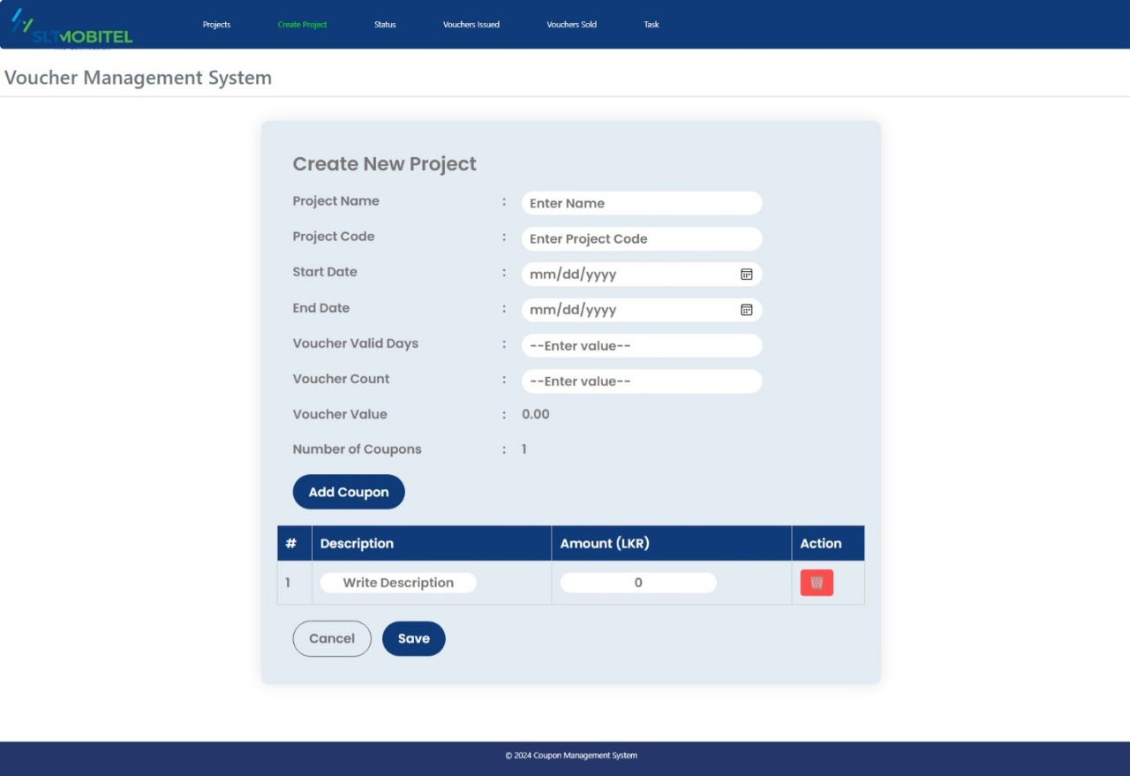

*Figure: Create new project interface of VMS*

The user (project manager) will be able to create a new voucher by including four customized coupons name of the project, a unique project code, the create date of the voucher, and expiration date value of the voucher is auto-filled.

1. Approve project

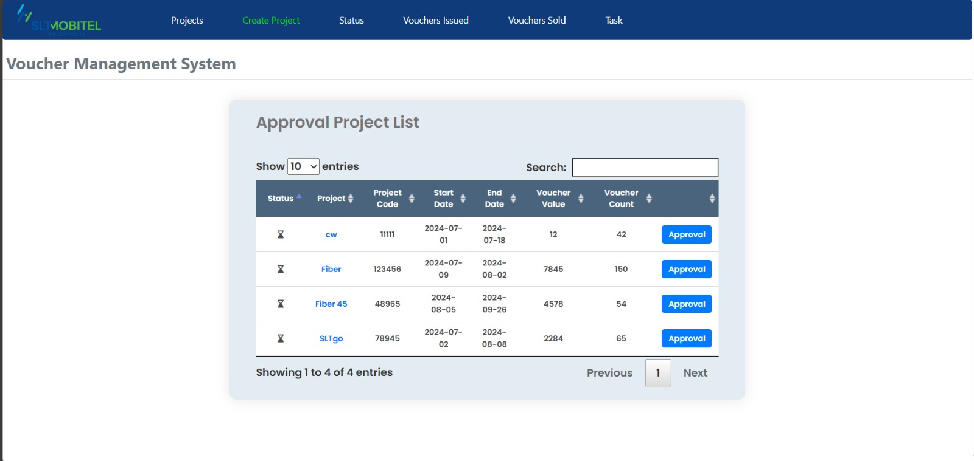

*Figure: Approve project list interface of VMS*

This interface allows users to approve or reject a batch of vouchers. The user ( approval manager ) can give approval to a created batch (a list of vouchers) by visiting the page “Approve Batch” and user can fill the “Remark” field and can approve the particular batch. Users can enter remarks in a provided text field and then click either the "Approve" or "Reject" button to finalize the decision.

1. Create batch

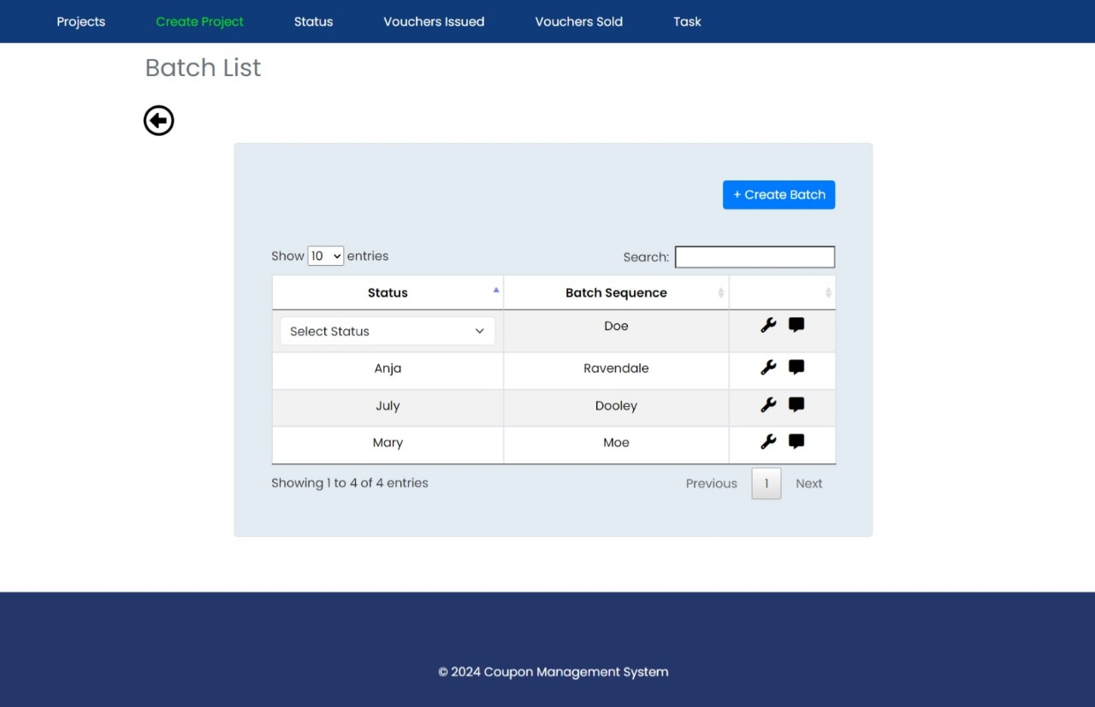

*Figure: Create new batch interface of VMS*

This interface is a "Batch List" screen from a Voucher Management System. It features a table listing batches with columns for "Status" and "Batch Sequence." The table includes options to select a status and edit or delete entries. There are navigation controls to show entries and search functionality. A "Create Batch" button allows user to create new batches. The navigation bar at the top includes links to "Projects," "Create Project," "Status," "Vouchers Issued," "Vouchers Sold," and "Task."

1. Approve batch

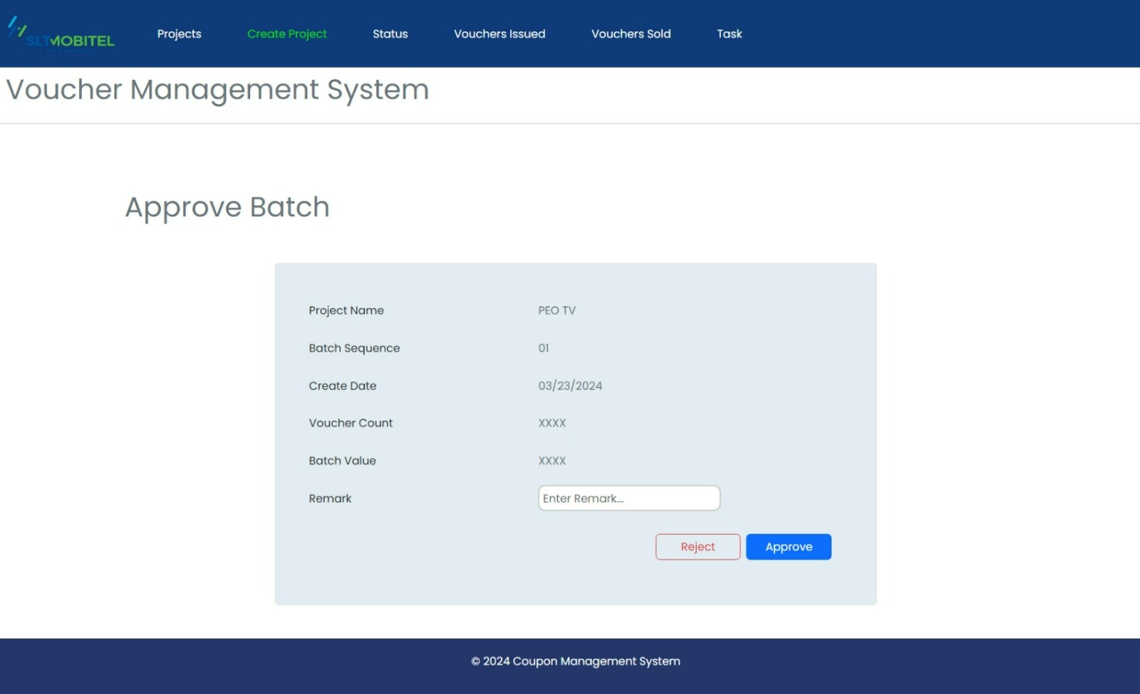

*Figure: Approve batch interface of VMS*

This interface is an "Approve Batch" screen from the Voucher Management System. It displays details of a batch including "Project Name," "Batch Sequence," "Create Date," "Voucher Count," and "Batch Value." There is a field to enter remarks. The screen has two buttons, "Reject" and "Approve," for *decision-making on the batch*. The navigation bar at the top includes links to "Projects," "Create Project," "Status," "Vouchers Issued," "Vouchers Sold," and "Task."

1. Create print

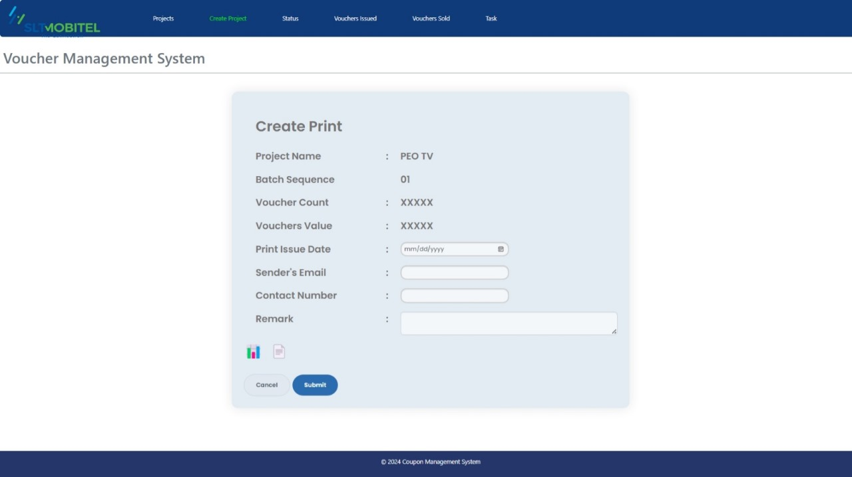

*Figure: Create print interface of VMS*

"Create Print" screen allows users to input details for printing vouchers, including "Project Name," "Batch Sequence," "Voucher Count," "Vouchers Value," "Print Issue Date," "Sender's Email," "Contact Number," and "Remark." The "Cancel" and "Submit," buttons are for managing the print creation process. The navigation bar at the top includes links to "Projects," "Create Project," "Status," "Vouchers Issued," "Vouchers Sold," and "Task." The User can send the created batch to print as Excel or PDF form after entering the remark.

Top of Form

Bottom of Form

1. View project details

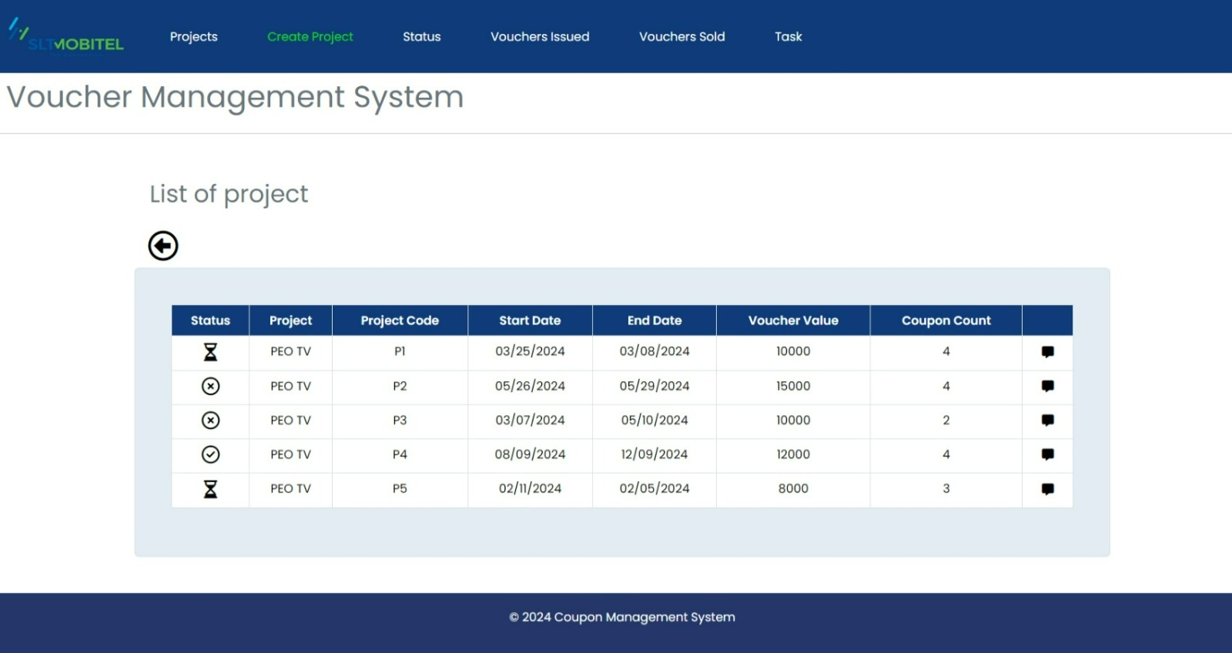

*Figure: View project details interface of VMS*

The interface is a Voucher Management System displaying a table of projects where user can view the project details. The table includes columns for Status, Project, Project Code, Start Date, End Date, Voucher Value, and Coupon Count. The top menu has options for Projects, Create Project, Status, Vouchers Issued, Vouchers Sold, and Task.

1. Register an internal user

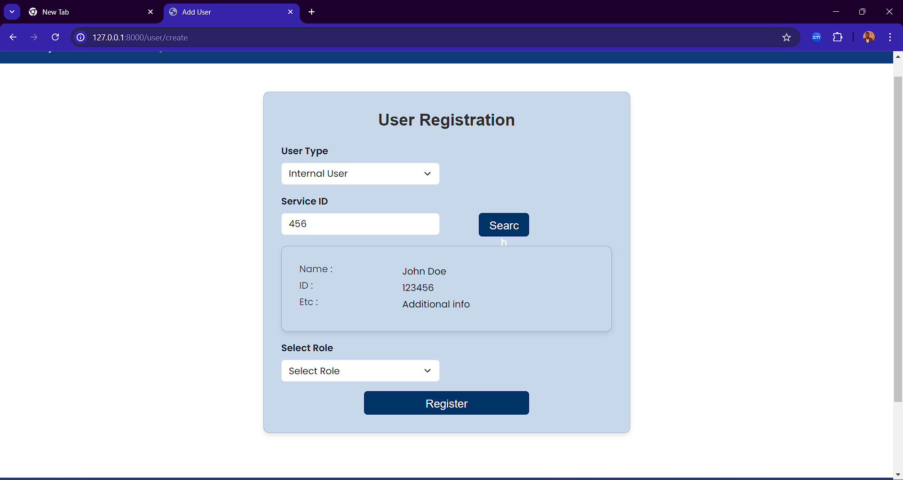

*Figure: User registration interface for internal users of VMS*

In this user registration interface user can fill necessary information regarding to internal users and can register them to the system to complete their registration.

1. Register external user

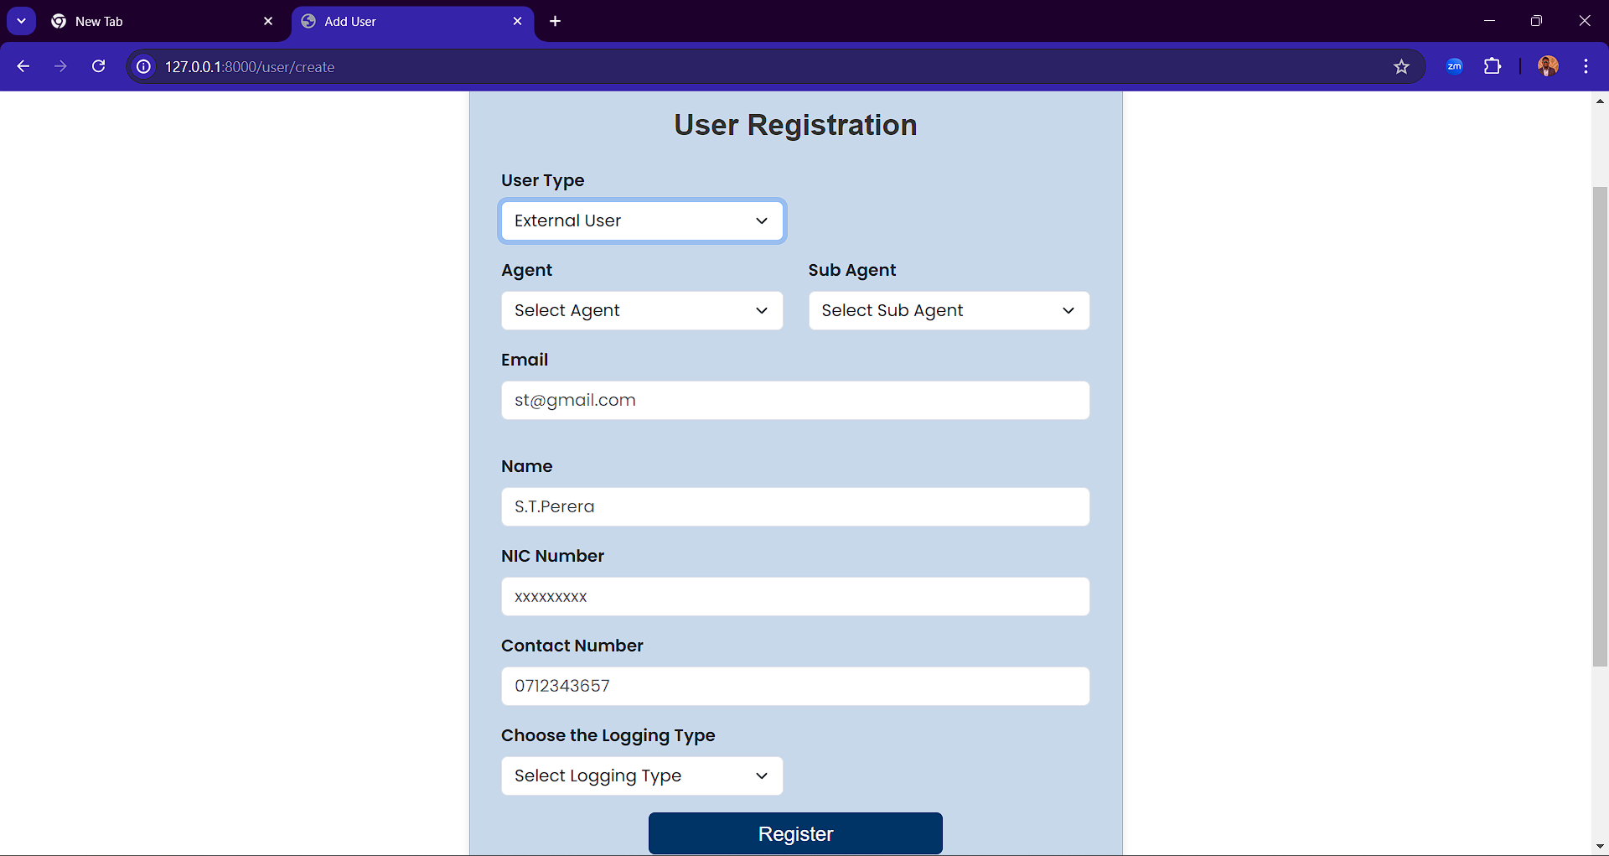

*Figure: User registration interface for external users of VMS*

In this user registration interface user can fill necessary information regarding to external users and can register them to the system to complete their registration.

1. Issue a voucher

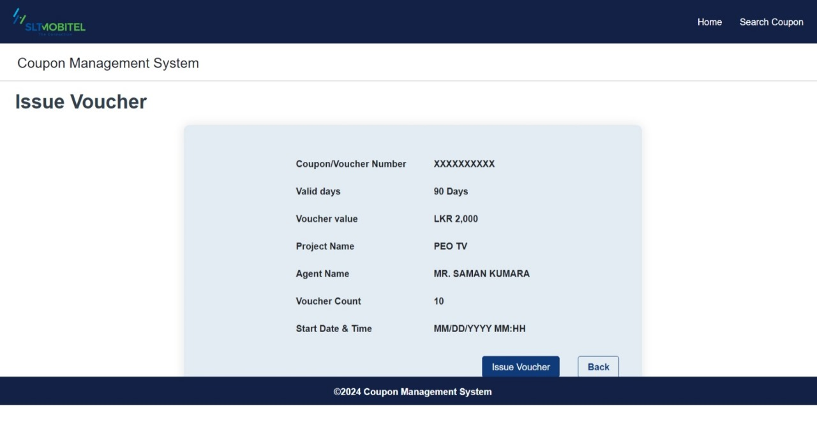

*Figure: Issue voucher interface of VMS*

It includes fields for entering the voucher number, coupon/voucher number, valid days, voucher value, project name, agent name, voucher count, and start date/time. Users can fill in the required information and then either submit the form to issue the voucher or reset the form to clear all fields.

## Non-Functional Requirements

## Privileges

The proposed system has seven types of access modes:

* 1. Admin
     + Logging in to the system.
     + Adding users to the system.
     + Adding privileges to the project manager and approval managers.
     + Viewing, editing, and commenting (remark) on all documents.
     + Adding user roles and responsibilities.
     + Distributing meeting responsibilities.
     + Searching for important details.
  2. Project Manager
     + Logging in to the system.
     + Creating projects.
     + Creating batches.
     + View project details.
     + View coupon details.
  3. Batch Level Approval Manager
     + Logging in to the system.
     + Approving the batches created by project manager.
     + Searching voucher details.
  4. Operational Level Approval Manager
     + Logging in to the system.
     + Viewing and commenting on documents.
     + Approving the documents.
  5. Agent / sub – agent /user
     + Logging in to the system.
     + Issuing voucher.
     + Log issued voucher to system.
     + Searching voucher details.
  6. **User Characteristics**

1. Project Manager- Create vouchers and batches and initiate the approval process.
2. Operational Level Approvers- Review and approve vouchers at the operational level.
3. Batch Level Approvers- Review and approve voucher batches for procurement.
4. The Procurement Department- Print approves voucher batches and sends them to stores.
5. Stores Department- Receive printed voucher batches and distribute them to agents.
6. Admin- Register and manage agents, oversee the system operations, and generate reports.
7. Agents- Sell vouchers, activate them upon sale, and ensure customers can use them.
8. Customers- Purchase and use activated vouchers at SLT workshops.

|  |  |  |
| --- | --- | --- |
| **User** | **User Type (Internal/ External)** | **Access Privileges** |
| Admin | Internal | View/Edit/Approve |
| Project Manager | Internal | View/Comment |
| Batch Level Approval Manager | Internal | View/ Approve |
| Operational Level Approval  Manager | Internal | View/Approve |
| Agent | External | View |
| Sub agent | External | View |
| User | External | View |

## Business Continuity Management

**System**

Document Number:

**Issue No. :**

**Date of Issue :**

**Revision No : Date of Revision : Page :**