**CSS BASICS**

* CSS Stands for Cascading Style Sheet.
* It is a Style sheet language.
* Used to style the HTML contents on a webpage.
* CSS can be added to HTML documents in 3 ways:
  1. **Inline -** by using the style attribute inside HTML elements.
  2. **Internal -** by using a <style> element in the <head> section.
  3. **External -** by using a <link> element to link to an external CSS file.

**Module 1: Syntax and Selectors**

* **Selectors** – Used to style HTML elements according to their type or attributes.
* **Universal Selectors (*)** – Used to style all HTML elements.
* **Classes Selectors (.)** - Classes are HTML attributes used to select one or more elements for CSS styling.
* **Id Selectors (#) -** If an HTML element needs to be styled uniquely, we can give it an ID using the id attribute.
* **Attribute Selectors (tag[attribute]) –** Used to style HTML elements with the help of attributes like href, src, etc.
* **Pseudo-Classes -** A pseudo-class is used to define a special state of an element. For example, it can be used to:
  + Style an element when a user mouses over it.
  + Style visited and unvisited links differently
  + Style an element when it gets focus
* **Specificity** - Used to style specific HTML elements using their ID.
* **Chaining** - it’s possible to require an HTML element to have two or more CSS selectors at the same time.
* **Descendant Combinator** - CSS also supports selecting elements that are nested within other HTML elements, also known as descendants.

**Module 2: Visual Rules**

* **Font Family** – It is used to specifies the font for an element.
* **Font Size -** The font-size property sets the size of the text.
* **Font Weight –** The font-weight property controls how bold or thin text appears.
* **Text Align –** The text-align property will align text to the element that holds it, otherwise known as its parent (Commonly used values – left, right, center, justify).
* **color –** This property styles an element’s foreground color.
* **background-color –** this property styles an element’s background color.
* **Opacity –** It’s measured from 0 to 1, with 1 representing 100%(fully visible) and 0 representing 0%(fully invisible).
* **Background Image –** This property is making the background of an element an image.
* **!important –** It can be applied to specific declarations, instead of full rules.

**Module 3: The Box Model**

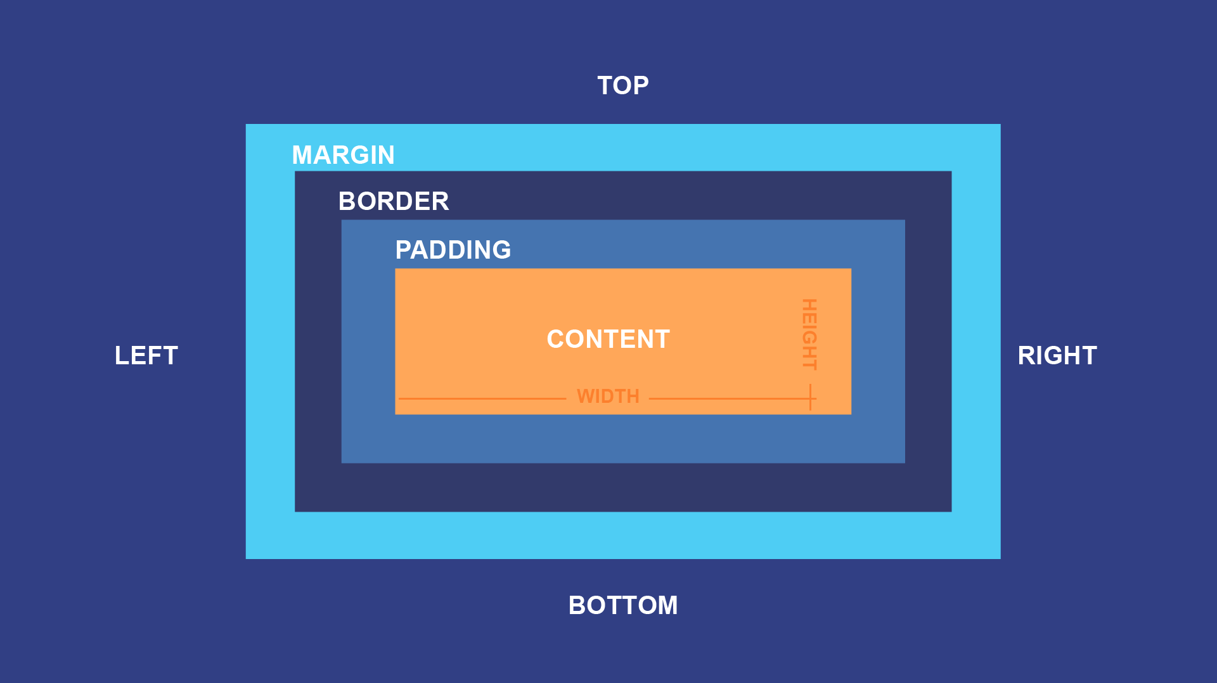

* **Padding –** The amount of space between the content area and the border.
* **Border –** The thickness and style of the border surrounding the content area and padding.
* **Margin –** The amount of space between the border and the outside edge of the element.
* **Height and Width –** This properties can be used to modify default dimensions.
* **Borders –** A border is a line that surrounds an element, like a frame around a painting. It can be set with specific width, style and color.
* **Border Radius –** You can modify the corners of an element’s border box with the border-radius property.
* **Overflow –** This property controls what happens content that overflow, outside its box. The most commonly used values are: hidden, scroll, visible.
* **Visibility –** Elements can be hidden from the view with the visibility property. Commonly used values are: hidden, visible, collapse.

**Module 4: Display and Positioning**

* **Position –** This property can take one of five values: static(bydefault), relative, absolute, fixed, sticky.
  + **Relative –** This value allows you to relative to its default static position on the webpage.
  + **Absolute –** Its defines the position of a given bounding box from the top and left side margins of the webpage.
  + **Fixed –** we can fix an element to a specific position on the page by setting its position to fixed.
  + **Sticky –** It keeps an element in the document flow as the user scrolls, but sticks to a specified position as the page is scrolled further.
* **Z-index –** This property that defines the order of overlapping HTML elements.
* **Display inline –** Its display list items horizontally instead of vertically.
* **Display block –** The display CSS property sets whether an element is treated as a block or inline element.
* **Display inline-block –** This combines the features of both inline & block.

**Module 5: Introduction to Color**

* **Foreground –** usually refer to the text color.
* **Background –** usually refer to the page color.
* **Hexadecimal –** A hex color begins with a hash character (#) which followed by three or six characters. The characters represent values for red, blue and green.
* **RGB (Red, Green, Blue) Colors –** It uses decimal numbers rather than hexadecimal numbers. (rgb(23, 45, 23))
* **HSL (Hue, Saturation, Lightness) Color –** Hue is a degree on the color wheel (from 0 to 360) – 0 or 360 is red, 120 is green, 240 is blue. Saturation is a percentage value; 0% means a shade of gray and 100% is the full color. Lightness is also a percentage; 0% is black, 100% is white.