KNOWLEDGE TRANSFER
PDF PII Masking — Micro Improvement Plans & Guest Discussions
Prepared by: Anuj Kumar
Purpose: hand over how the PDF masking works and how we should build it into our product.

TL;DR
We needed to hide the person's name and organisation name in our generated PDFs before sharing them, while keeping the location visible. We evaluated Microsoft Presidio for this. It works, but on its own it was unreliable on our documents. The approach that actually works well is a small deterministic script that reads our fixed PDF template and blacks out the name/org, leaving the location. It handled all 10 sample files, including a Hindi one.
The recommendation for the codebase: mask at generation time (we already have the fields), and keep the post-processing script only for old PDFs where we no longer have the source data.

What we were trying to do
Each PDF (a Micro Improvement Plan or a Guest Discussion) is generated for one person at one location. Before we share these outside, we want to remove who the person is and which organisation they belong to — but the location is fine to show, because that's not sensitive for us and it's useful context.
- Mask: person name, organisation / school name
- Keep: location (village, district, state, etc.)

What we tried first — Microsoft Presidio
Presidio uses an NLP model (spaCy) to spot names and organisations in free text. It's the industry-standard tool for this, so it was the natural first choice. Two problems showed up on our real documents:
- Noisy organisation detection. On the story paragraphs it tagged random phrases as organisations — things like “noticed that her school” or “positive change in the school.” That meant it either missed the real org or blacked out the wrong text.
- No support for Indian-language names. The English model simply doesn't recognise a name written in Hindi (Devanagari), so those would leak through completely.
So Presidio is useful, but not trustworthy by itself for our specific documents.

What actually works — read the template, don't guess
The key insight: our PDFs are machine-generated from a fixed template, so we don't need to “guess” with AI. The layout is always the same, so we can just read it structurally:
- The cover/header always follows the same order: title → name → (optional organisation) → location.
- The name is the first line that isn't a heading word and isn't a place.
- The organisation comes from the header, plus the story text (we look for school names like “Government Primary School” and phrases like “worker at Mantra”).
- The location is anything containing a place word (village, district, Bihar, and the Hindi equivalents) — and we deliberately never touch it.
Once we know the name and org, we search for them across every page and draw a black box over each match. So a name that appears on page 3 also gets covered on the cover page automatically.
For the Hindi file, text search doesn't work (the characters get mangled on extraction), so we fall back to blacking out the name line by its position on the page — which is reliable because we know where the name sits in the template.

What it looks like (real output)
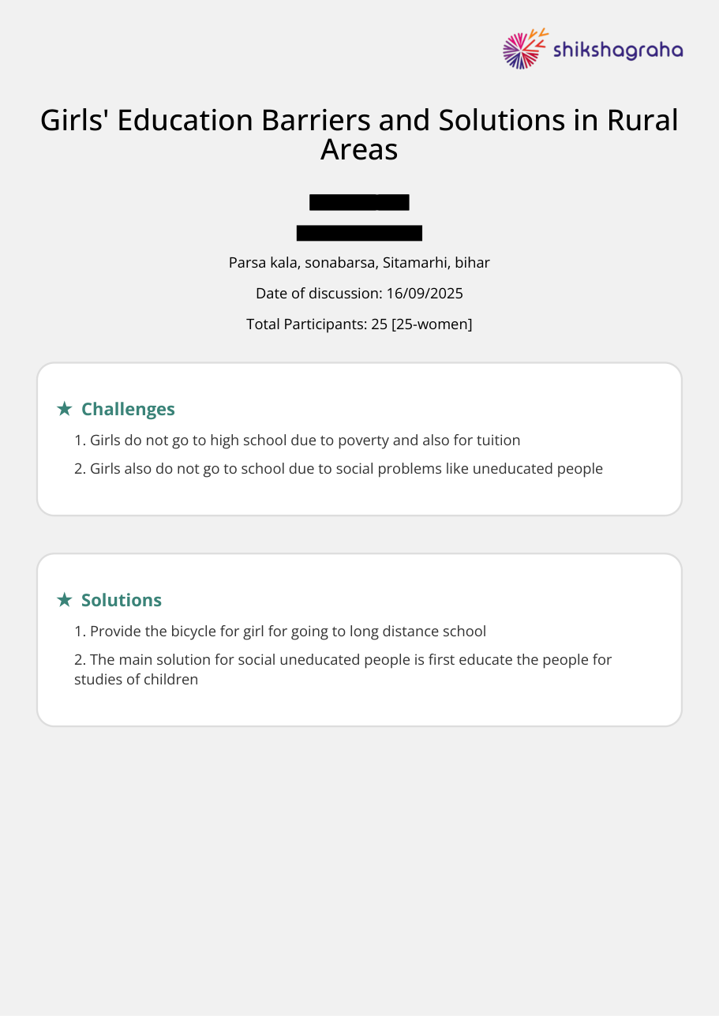
Guest Discussion cover: name and organisation are boxed out; the location and everything else stay readable.
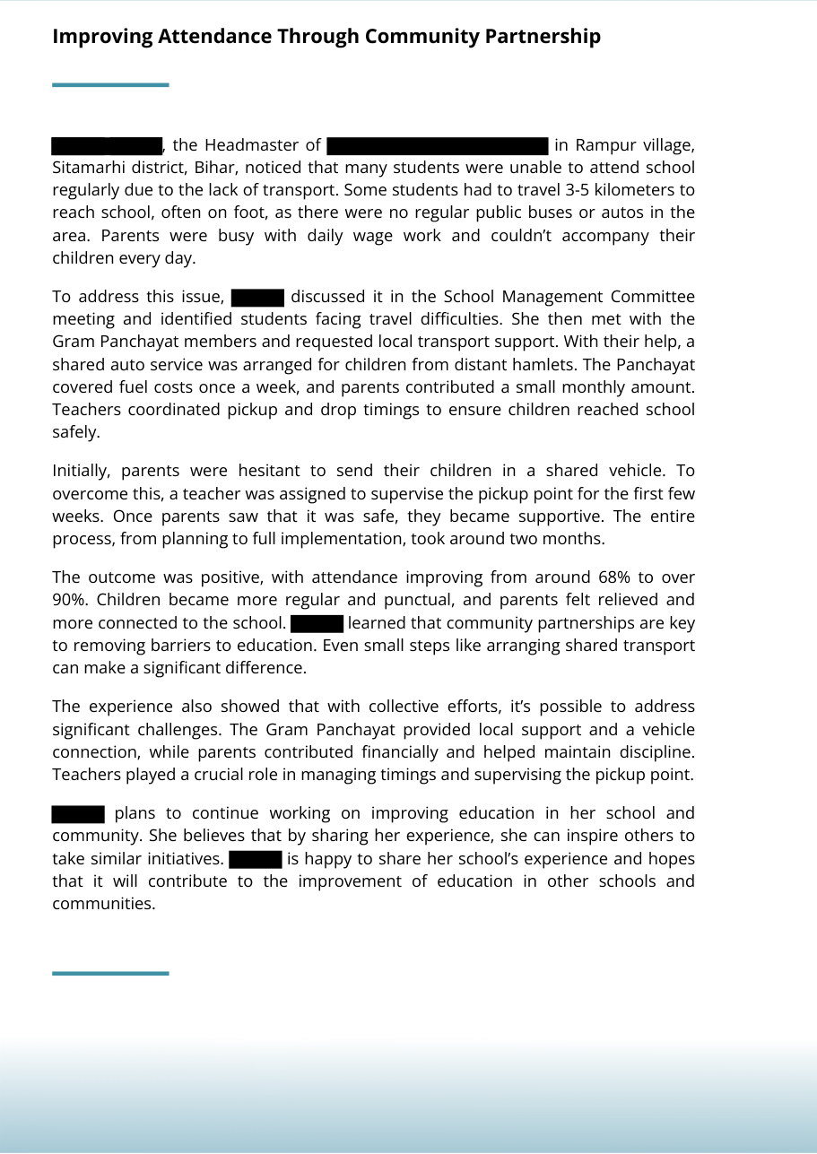
MIP story page: the name (every mention) and the school name are removed; village / district / state remain visible.

Results on the 10 sample files
Every file was checked two ways: we re-read the text out of the masked PDF to confirm the name/org were gone and the location survived, and we eyeballed the rendered pages.
File | Person masked | Organisation masked | Location kept (visible)
MIP1 | Ramya Kumar | Government Primary School | Rampur village, Sitamarhi, Bihar
MIP2 | Ramya Kumar | Government Primary School | Rampur village, Sitamarhi, Bihar
MIP3 | Anupriya | Government Primary School | Rampur village, Sitamarhi, Bihar
MIP4 | Puspa Kumari | — (none in doc) | Gaou Baya Panchayat, Sitamarhi
MIP5 | Rizvana | Mantra | Sherghatti Village, Gaya, Bihar
Guest_Discussion1 | Ramesh | — (none) | Patna, Bihar
Guest_Discussion2 | Astha Sahay | — (none) | Patna, Bihar
Guest_Discussion3 | अर्चना कुमारी (Hindi) | — (none) | हनुमान नगर … सीतामढ़
Guest_Discussion4 | Shubham Kumar Singh | — (none) | Chakand, Gaya, Bihar
Guest_Discussion5 | Saraswati Devi | Pragati ek prayash | Parsa kala, Sitamarhi, Bihar

Outcome: all 10 masked correctly. Names and organisations removed, locations preserved, including the Hindi document.

How to run it
The script is mask_pii_batch.py. Point it at the PDFs and it writes a _masked.pdf next to each one:
python mask_pii_batch.py # all MIP*/Guest_Discussion* in the folder
python mask_pii_batch.py file1.pdf ... # specific files
It needs pdfplumber (to read text) and pymupdf / fitz (to draw the boxes). No AI model download required.

Recommendation for our codebase
Best option — mask at generation time. When we generate the PDF we already have the name, organisation and location as separate fields. So for a shareable copy we just swap the name/org fields for blanks (or don't render them). No detection, no AI, no false positives, fully deterministic. This is the cleanest and safest path.
Fallback option — post-process existing PDFs. Use this script for PDFs that already exist and whose source data we no longer have. If we go this way, we can add Presidio back as a second safety-net layer over free-text sections to catch anything unusual.
Concretely: add a redact=True flag to the PDF generator that blanks the name/org fields, and keep mask_pii_batch.py as a batch tool for the legacy backlog.

Things to keep in mind
- It relies on the template staying consistent. If the layout changes, the structural rules need a quick update. (Another reason masking at generation time is safer long-term.)
- Black boxes are permanent. The redaction removes the underlying text, so masked PDFs can't be “un-masked” — which is what we want for sharing.
- Presidio couldn't be run in this test sandbox (the model download was network-blocked), so the head-to-head Presidio comparison should be re-run on a dev machine before we finalise the decision.

Files
- mask_pii_batch.py — the masking script
- masked_pdfs/ — the 10 masked output PDFs
- poc_presidio_pii.py — the earlier Presidio proof-of-concept (single file)

