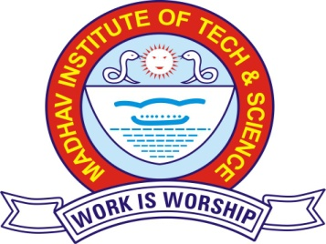
Anuj Pahariya
B.E. –Electronics & Communication
DOB: 29/03/1998
S/o: Dr. Pawan Kumar Pahariya
Add: 489, Mohan Nagar,
Thatipur, Gwalior-474011
Email Id: anujpahariya36@gmail.com , Mob: +91- 7049232349

Career Objectives
To pursue a challenging career and be part of a progressive organization that gives scope to enhance my knowledge, skills and to reach the pinnacle in the computing and research field with sheer determination, dedication and hard work.

Academic Credentials:
Examination | Year | Percentage | Institution | Board/University
B.E.(Electronics & Communication) | 2019 | 76.1%  (Upto 5th Sem) | Madhav Institute Of Technology & Science, Gwalior, M.P. | RGPV University Bhopal
Class XII | 2015 | 88.6% | Model Higher Secondary School, Gwalior, M.P. | State Board
Class X | 2013 | 76.6% | Model Higher Secondary School, Gwalior, M.P. | State Board

Projects & Trainings:
- Project –“LCRV 1”(//June-August, 2016)
Project Description- Light Chaser Robo Version 1 using Arduino, which is a car runs guided accordimg to the light.
- Project –“TVRC 1738”
Project Description- TV remote control car using Arduino and IR receiver 1738, guided using TV remote.
- Minor Project –“Automatic Street Light Light Control System”
Project Description- This system is meant for controlling street light automatically.
.
- Major training on J2EE from Numeric Infosystem Pvt. Ltd., Gwalior (5April-16May, 2017).
- Training on Integrated Circuit from Home Care Panasonic Authorised Service Centre, Gwalior(11June-25June, 2016)
- Internship on Web Development through Crooked Computing Inc. (June 2017 – July, 2017).

Skills:
- MS Office,
- Basics in C, C++, Android ,
- Arduino Embedded system designing,

Rewards & Recognitions:
- Participated in Science Quiz competition, Boston College Gwalior.
- Won 1st prize in chess, debate and G.K. competition.
- Participated in many school level cultural competitions.
- Received appreciation certificate from Vivekanand Kendra Kanya Kumari which creates a Guinness World Records for doing SURYA NAMASKAR.
Co-Curricular:
- Participated in Internet Of Things workshop conducted in Technocruise'16 (IIT Kanpur & Juniper ) Gwalior
- Course on Signal and System offered by IIT BombayX (07January- 30April, 2016).
- Actively participated in Self Development Program of U-CONNECT in association with heartfulness.
- Member- Literacy Club QURENCIA, MITS Gwalior.

Interests & Hobbies:
- Drawing.
- Content Writing.
- Reading Random Novels.

