Solutions of all 10 question given in the assignment along with output screenshots.

1.write a function that prints the number from 1 to 100 . but for multiples of three ,print "Fizz" instead of number , and for the multiples for the 5 print"Buzz" . for numbers that are multiple of both print "FizzBuzz".

Solution—

<!DOCTYPE html>

<html lang="en">

<head>

<meta charset="UTF-8">

<meta name="viewport" content="width=device-width, initial-scale=1.0">

<title>fizzbuzz</title>

</head>

<body>

<!-- write a function that prints the number from 1 to 100 . but for multiples

of three ,print "Fizz" instead of number , and for the multiples for the 5 print

"Buzz" . for numbers that are multiple of both print "FizzBuzz". -->

<div id="result"></div>

<script>

function fizzBuzz(){

let output = "";

for (let i=1; i<=100; i++){

if(i % 3 === 0 && i % 5 === 0){

output += "FizzBuzz<br>";

}

else if (i % 3 === 0){

output += "Fizz<br>";

}

else if (i % 5 === 0){

output += "Buzz<br>";

}

else{

output += i + "<br>";

}

}

let result = document.getElementById("result");

result.innerHTML = output ;

}

fizzBuzz();

</script>

</body>

</HTML>

Output-

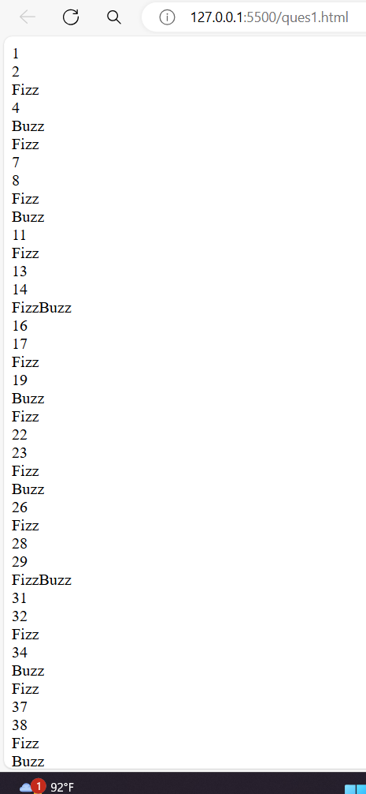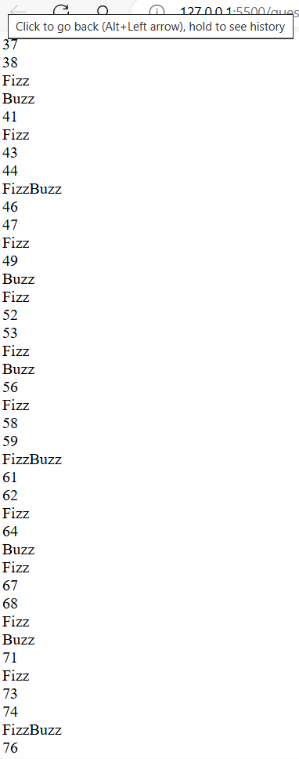

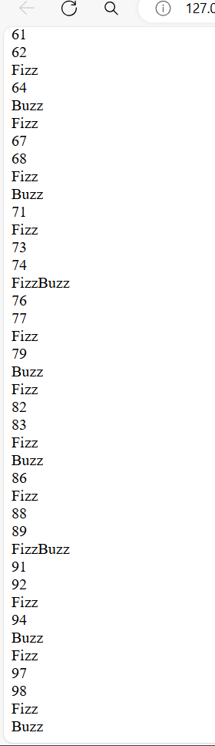

2.. write a function that takes a string input representing a simple arithmetic expression (only addition and subraction) and returns the result.

<!DOCTYPE html>

<html lang="en">

<head>

<meta charset="UTF-8">

<meta name="viewport" content="width=device-width, initial-scale=1.0">

<title>string</title>

</head>

<body>

<!-- write a function that takes a string input representing a simple arithmetic expression

(only addition and subraction) and returns the result

-->

<div id="exp"></div>

<div id="result"></div>

<script>

function evalExpression(expression){

return eval(expression);

}

let expression = "10 + 5 - 3 + 8 ";

document.getElementById("exp").innerHTML = expression ;

document.getElementById("result").innerHTML = "Result = " + evalExpression(expression);

</script>

</body>

</html>

Output--

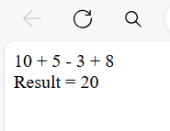

3..

Write a function that takes a nested array additionreturns a flattened array.

<!DOCTYPE html>

<html lang="en">

<head>

<meta charset="UTF-8">

<meta name="viewport" content="width=device-width, initial-scale=1.0">

<title>converting_array</title>

</head>

<body>

<!-- Write a function that takes a nested array additionreturns

a flattened array. -->

<div id="f_array"></div>

<p id="demo"></p>

<script>

function flattenNestedArray(arr) {

let flattenedArray = [];

arr.forEach(element => {

if (Array.isArray(element)) {

flattenedArray = flattenedArray.concat(flattenNestedArray(element));

} else {

flattenedArray.push(element);

}

});

return flattenedArray;

}

// Example nested array

const nestedArray = [['Hello', 'World'], ['JavaScript', ['is', 'awesome']]];

// Flatten the nested array

const flattenedArray = flattenNestedArray(nestedArray);

// Display the flattened array in the HTML element with the id "demo"

document.getElementById("demo").innerHTML = flattenedArray.join(', ');

// Print the flattened array to the console

console.log(flattenedArray);

</script>

</body>

</html>

Output-

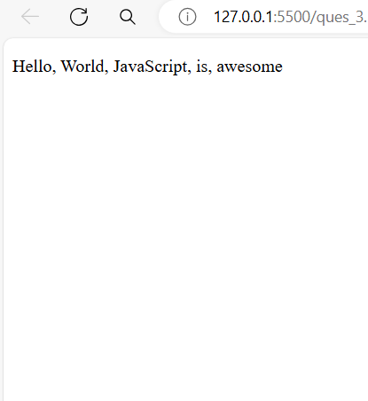  
4..

Write a function that checks if two given strings are anagrams opf each other.

<!DOCTYPE html>

<html lang="en">

<head>

<meta charset="UTF-8">

<meta name="viewport" content="width=device-width, initial-scale=1.0">

<title>Document</title>

</head>

<body>

Write a function that checks if two given strings

are anagrams opf each other.

<div id="demo1"> </div>

<div id="demo2"> </div>

<script>

function areAnagrams(str1, str2) {

// Helper function to clean and sort the string

function cleanString(str) {

return str

.replace(/[^\w]/g, '').toLowerCase()

.split('')

.sort()

.join('');

}

const cleanedStr1 = cleanString(str1);

const cleanedStr2 = cleanString(str2);

return cleanedStr1 === cleanedStr2;

}

const string1 = "Listen";

const string2 = "Silent";

console.log(areAnagrams(string1, string2)); // Output: true

const string3 = "Hello";

const string4 = "World";

console.log(areAnagrams(string3, string4));

</script>

</body>

</html>

Output-

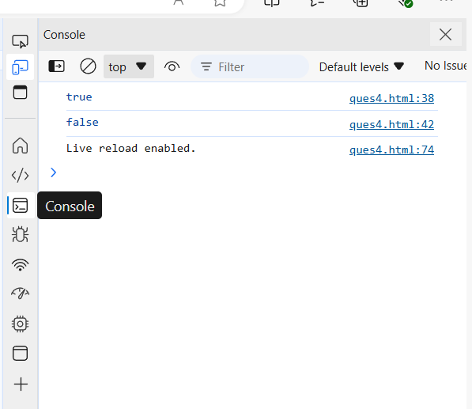

5..

write a function that takes an array and returns a new array with duplicates removed .

<!DOCTYPE html>

<html lang="en">

<head>

<meta charset="UTF-8" />

<meta name="viewport" content="width=device-width, initial-scale=1.0" />

<title>Duplicates</title>

</head>

<body>

<!-- write a function that takes an array and returns

a new array with duplicates removed -->

<h1>Remove Duplicates from Array</h1>

<script>

function removeDuplicates(array) {

let uniqueArray = [];

for (let i = 0; i < array.length; i++) {

if (!uniqueArray.includes(array[i])) {

uniqueArray.push(array[i]);

}

}

return uniqueArray;

}

const numbers = [1, 2, 3, 1, 4, 2, 5];

const uniqueNumbers = removeDuplicates(numbers);

console.log(uniqueNumbers);

</script>

</body>

</html>

Output-

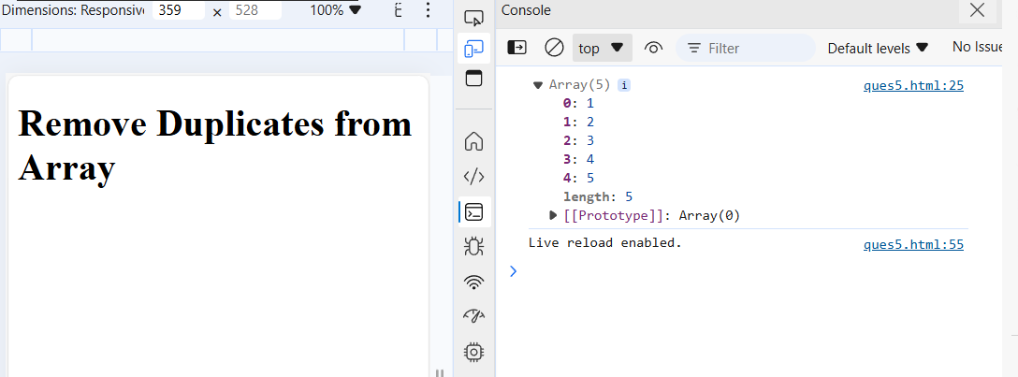

6..

write a function that takes a string and capitalizes the first letter of each word in string.

<!DOCTYPE html>

<html lang="en">

<head>

<meta charset="UTF-8" />

<meta name="viewport" content="width=device-width, initial-scale=1.0" />

<title>Capitalize</title>

</head>

<body>

<!-- write a function that takes a string and capitalizes the first letter -->

<!-- of each word in string. -->

<script>

function capitalize(str) {

return str

.split(" ")

.map((word) => {

return word.charAt(0).toUpperCase() + word.slice(1);

})

.join(" ");

}

let exampleString = "hello world! this is a test.";

let capitalizedString = capitalize(exampleString);

console.log(capitalizedString);

</script>

</body>

</html>

output-

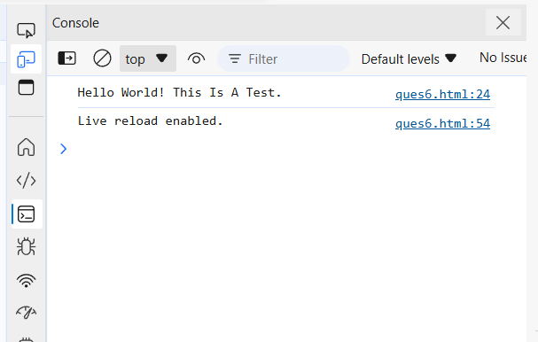

7..

write the function that generates the first n numbers of the fibonacci sequence.

<!DOCTYPE html>

<html lang="en">

<head>

<meta charset="UTF-8" />

<meta name="viewport" content="width=device-width, initial-scale=1.0" />

<title>Document</title>

</head>

<body>

<!-- write the function that generates the first n numbers

of the fibonacci sequence. -->

<script>

function fibonacci(n) {

if (n <= 0) {

return [];

} else if (n === 1) {

return [0];

} else if (n === 2) {

return [0, 1];

}

let fibSequence = [0, 1];

while (fibSequence.length < n) {

let nextNumber =

fibSequence[fibSequence.length - 1] +

fibSequence[fibSequence.length - 2];

fibSequence.push(nextNumber);

}

return fibSequence;

}

// Example usage:

let n = 10;

console.log(fibonacci(n));

</script>

</body>

</html>

Output-

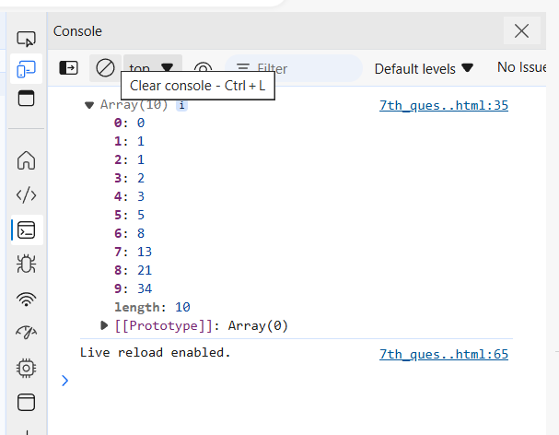

8..

Implement a simple HashMap class with put, get and removed methods.

<!DOCTYPE html>

<html lang="en">

<head>

<meta charset="UTF-8" />

<meta name="viewport" content="width=device-width, initial-scale=1.0" />

<title>Hashmap</title>

</head>

<body>

<!-- Implement a simple HashMap class with put,

get and removed methods -->

<script>

class HashMap {

constructor() {

this.map = {};

}

put(key, value) {

this.map[key] = value;

}

get(key) {

return this.map.hasOwnProperty(key) ? this.map[key] : undefined;

}

remove(key) {

if (this.map.hasOwnProperty(key)) {

delete this.map[key];

}

}

}

const hashMap = new HashMap();

hashMap.put("name", "Alice");

console.log(hashMap.get("name"));

hashMap.remove("name");

console.log(hashMap.get("name"));

</script>

</body>

</html>

Output-

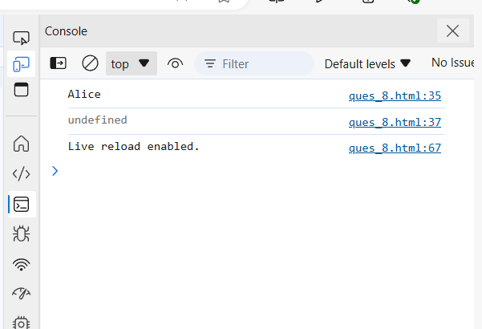

9..

write a function that filters out even numbers from

an array.

<!DOCTYPE html>

<html lang="en">

<head>

<meta charset="UTF-8" />

<meta name="viewport" content="width=device-width, initial-scale=1.0" />

<title>fibonacci</title>

</head>

<body>

<!-- write a function that filters out even numbers from

an array. -->

<script>

function filterEvenNumbers(array) {

return array.filter(function(number) {

return number % 2 !== 0;

});

}

let numbers = [1, 2, 3, 4, 5, 6, 7, 8, 9, 10];

let oddNumbers = filterEvenNumbers(numbers);

console.log(oddNumbers);

</script>

</body>

</html>

Output-

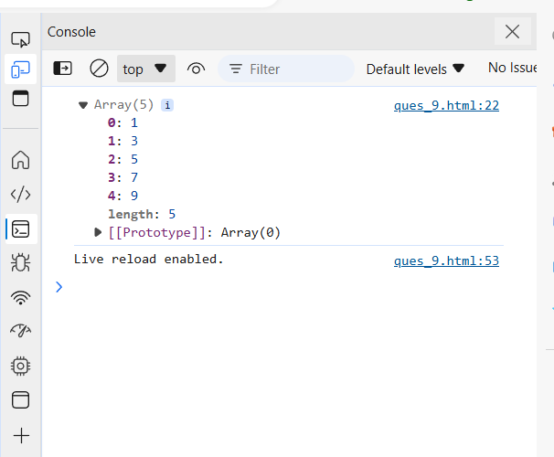

10..

write a function that converts a given string to title case (capitalizing the first letter of each word).

<!DOCTYPE html>

<html lang="en">

<head>

<meta charset="UTF-8" />

<meta name="viewport" content="width=device-width, initial-scale=1.0" />

<title>Document</title>

</head>

<body>

<!-- write a function that converts a given string

to title case (capitalizing the first letter of each word). -->

<script>

function toTitleCase(str) {

return str

.split(" ")

.map(function (word) {

return word.charAt(0).toUpperCase() + word.slice(1).toLowerCase();

})

.join(" ");

}

let inputString = "hello world, this is a test string.";

let titleCasedString = toTitleCase(inputString);

console.log(titleCasedString);

</script>

</body>

</html>

Output-

