Created a database named amazon_seller and created a Table named user in database amazon_seller :-

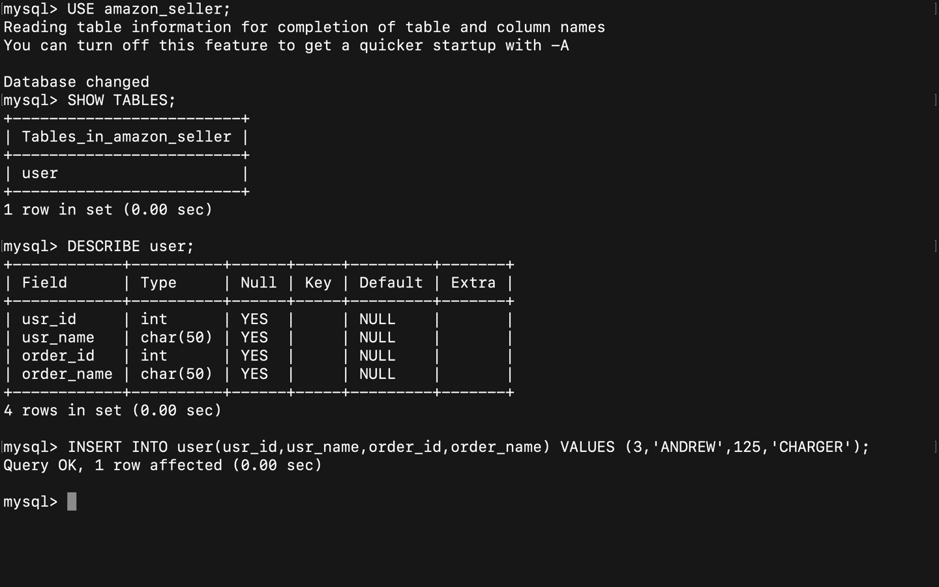

Above here is the table Schema of Table user

Added The Data to the table Using Commands

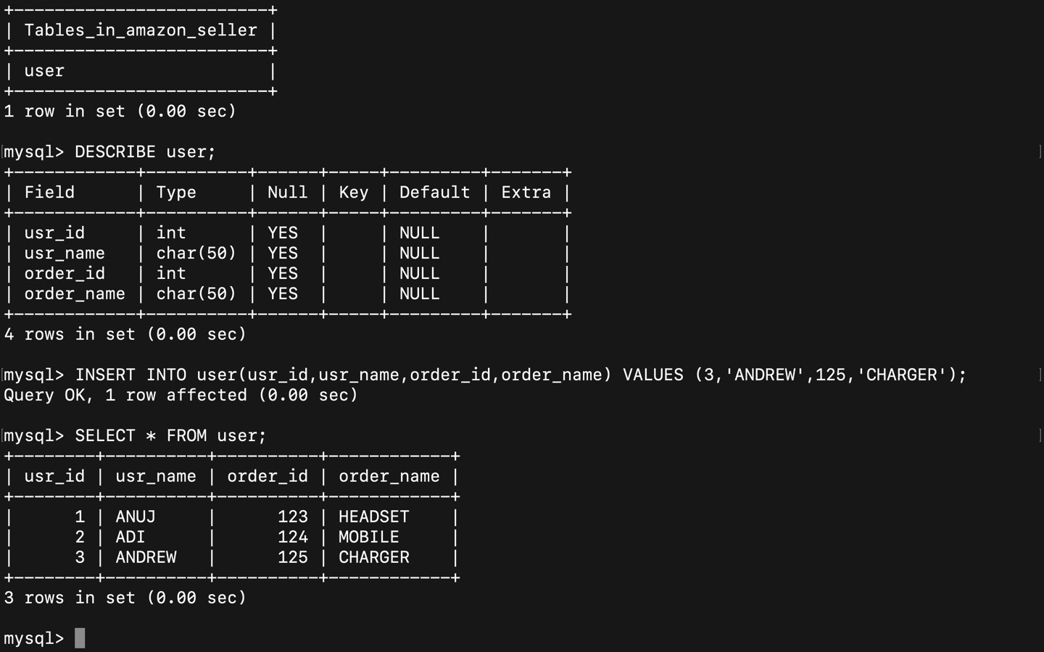

Above is the Screenshot of getting Table data from user table.