STEP 1: Open the android studio application

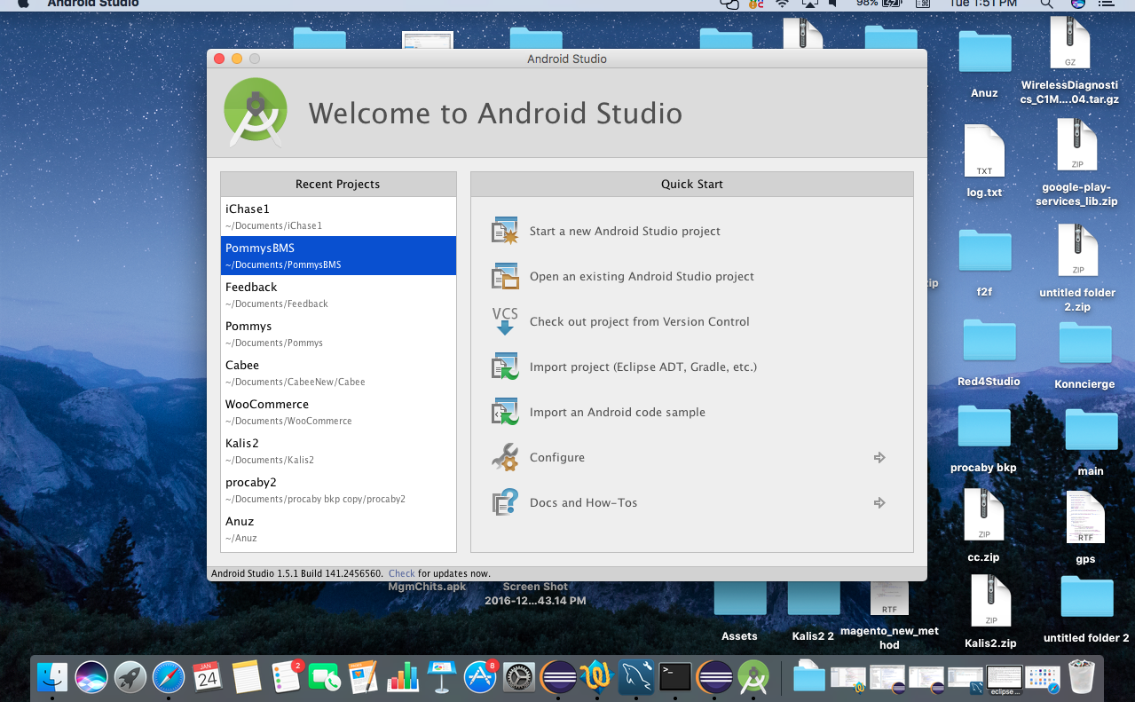

STEP 2: Now click open an existing android studio project , there select the project that is extracted from zip file.
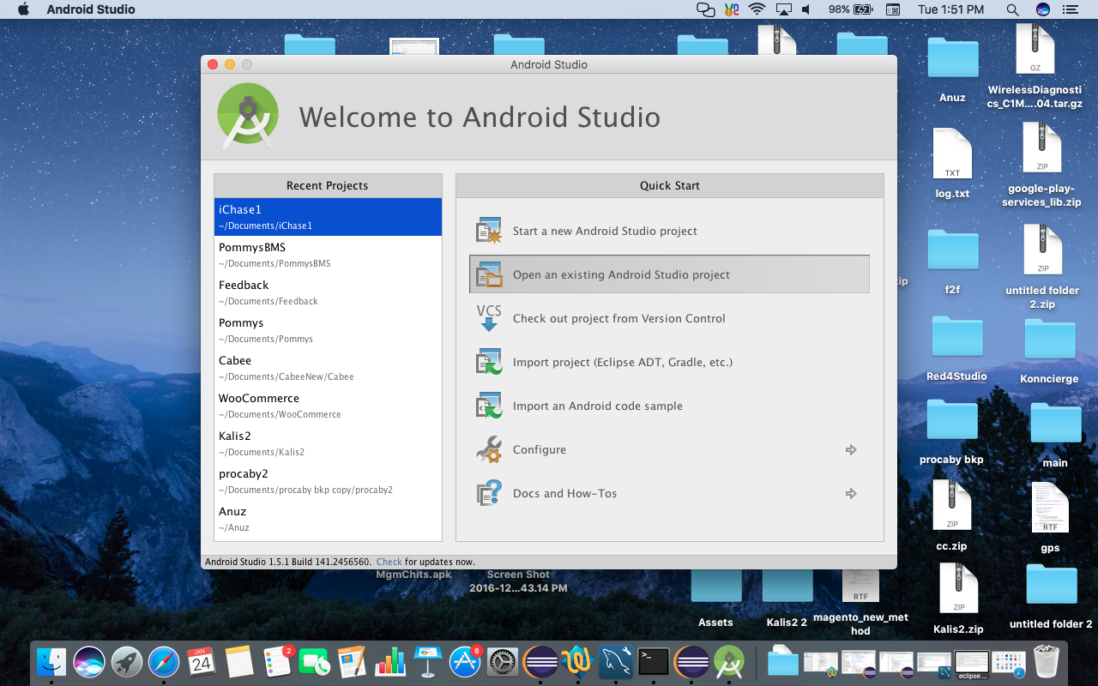

STEP 3: Select the project that and open it, If the project got opened it shows that the project opened successfully

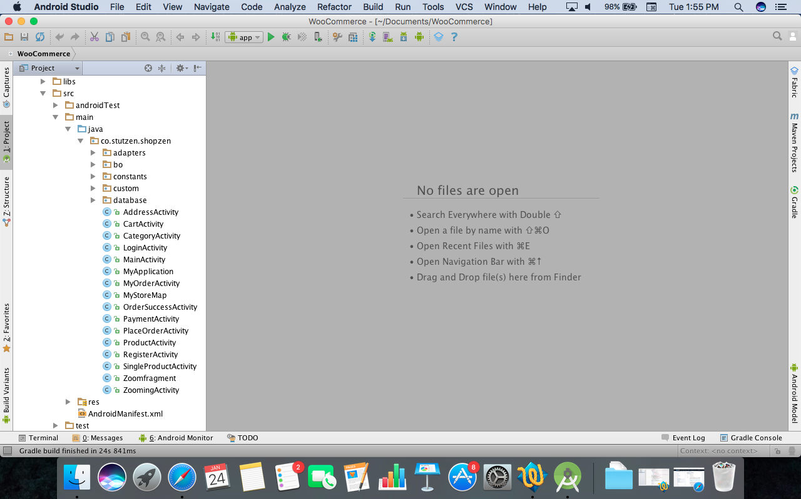

STEP 4: Now click build to export the APK.

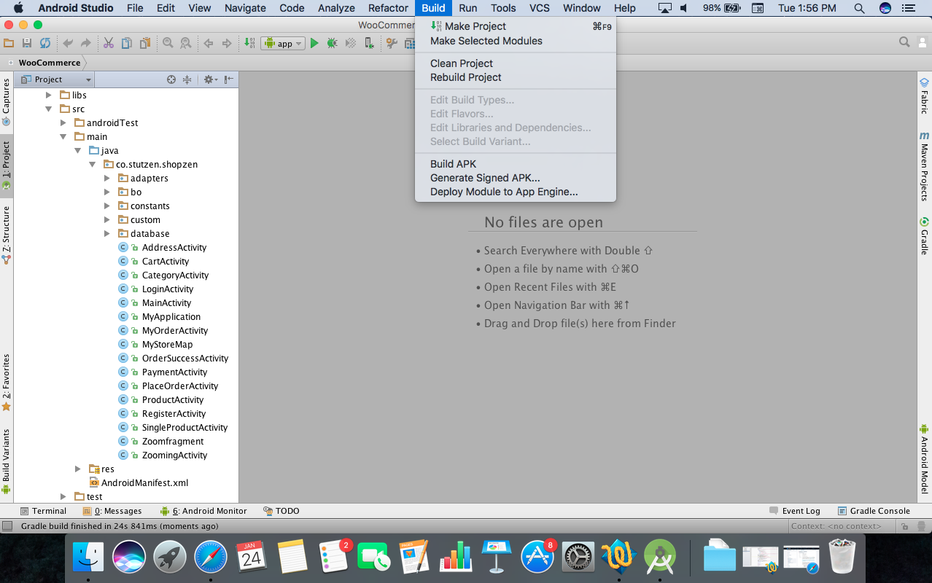

STEP 5: Click generate signed APK.

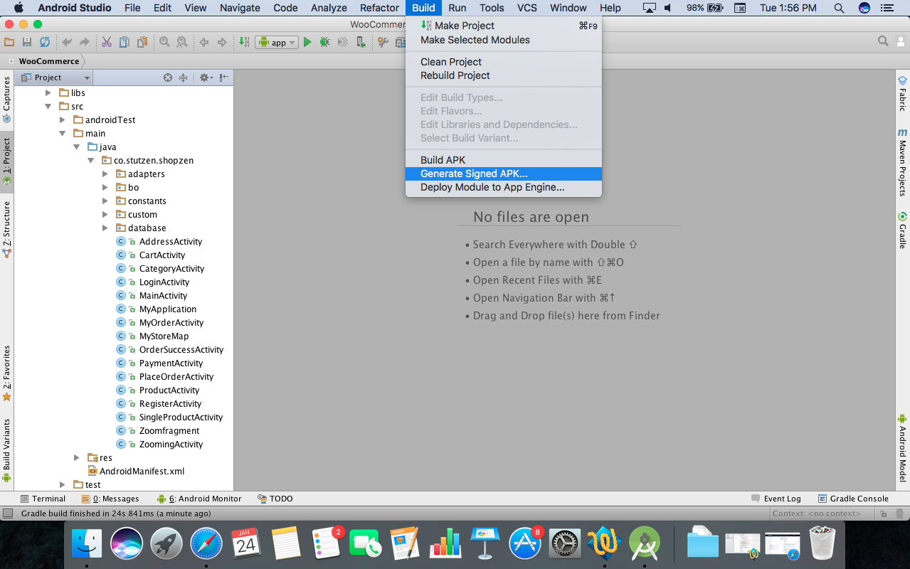

STEP 6: To generate the signed APK select the module name and click next.

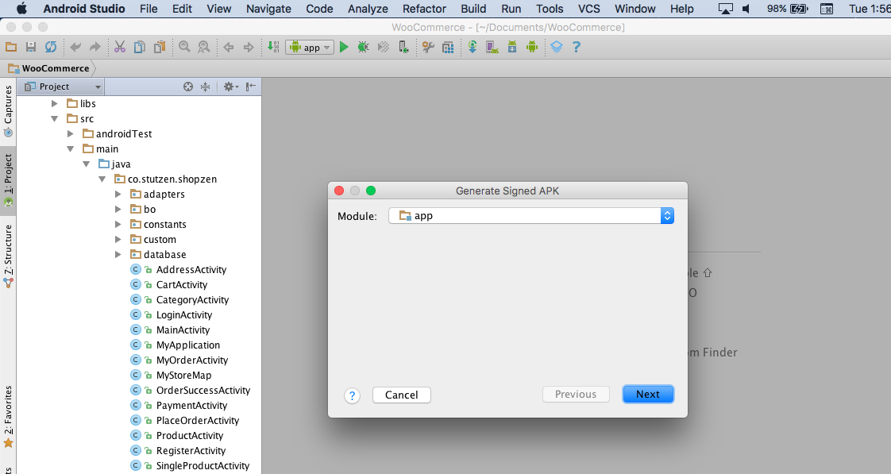

STEP 7: After selecting the module , key store page will open .

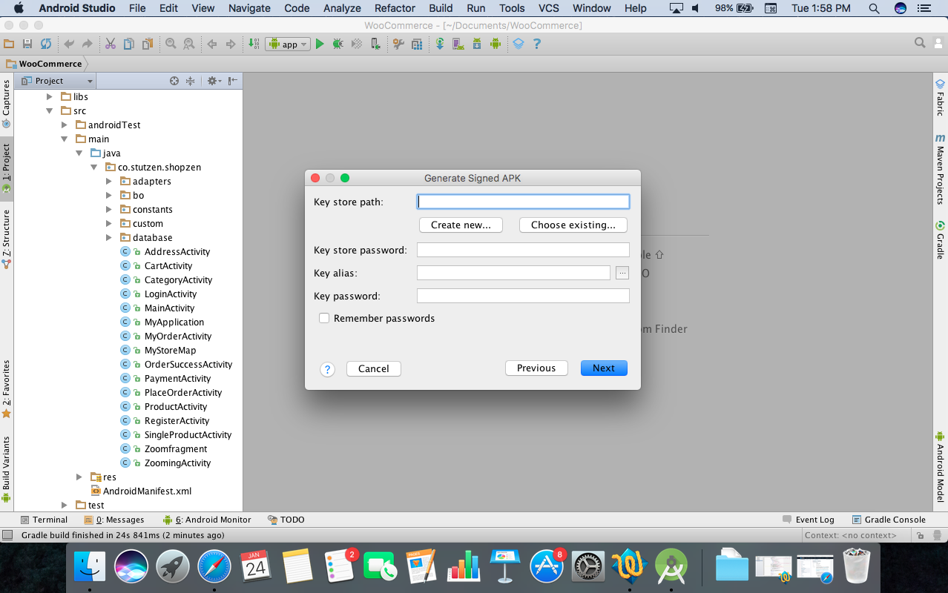

STEP 8: if you have existing key store click choose existing and fill the details and click next.

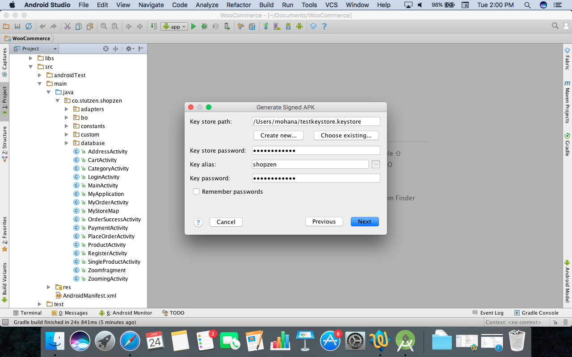

STEP 9: If there is no key store select create new and enter the details as below mentioned and click ok.

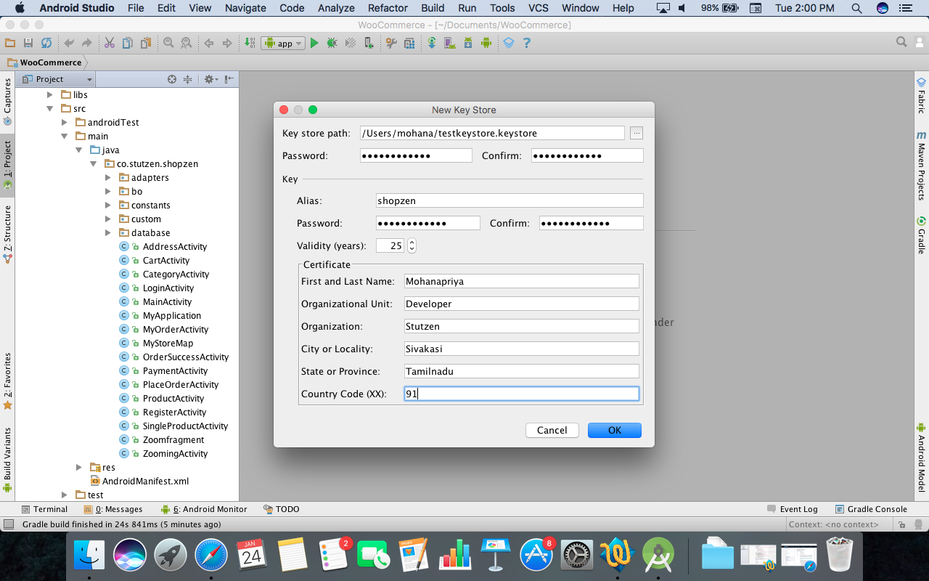

STEP 10: After that APK destination regarding page will open choose the APK destination folder for storage and click finish.

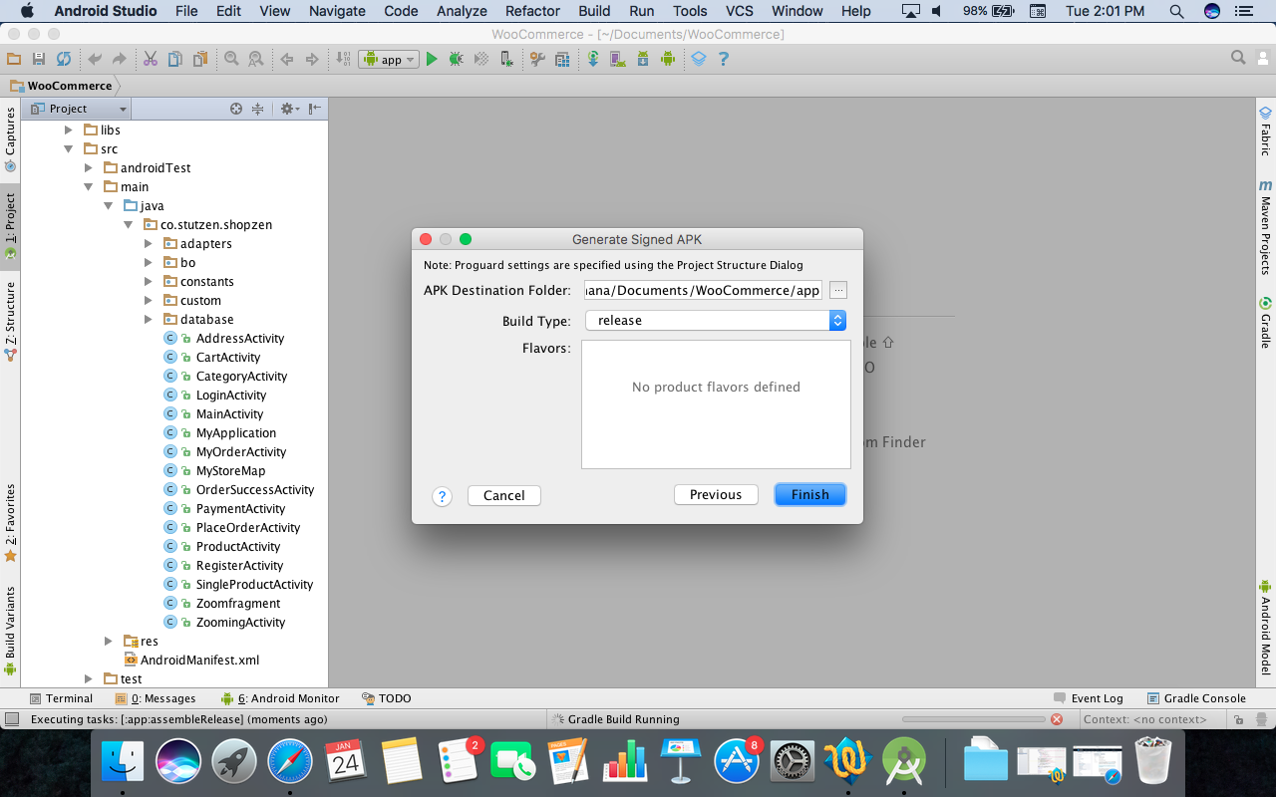

STEP 11: Now the APK will be stored in the selected destination .

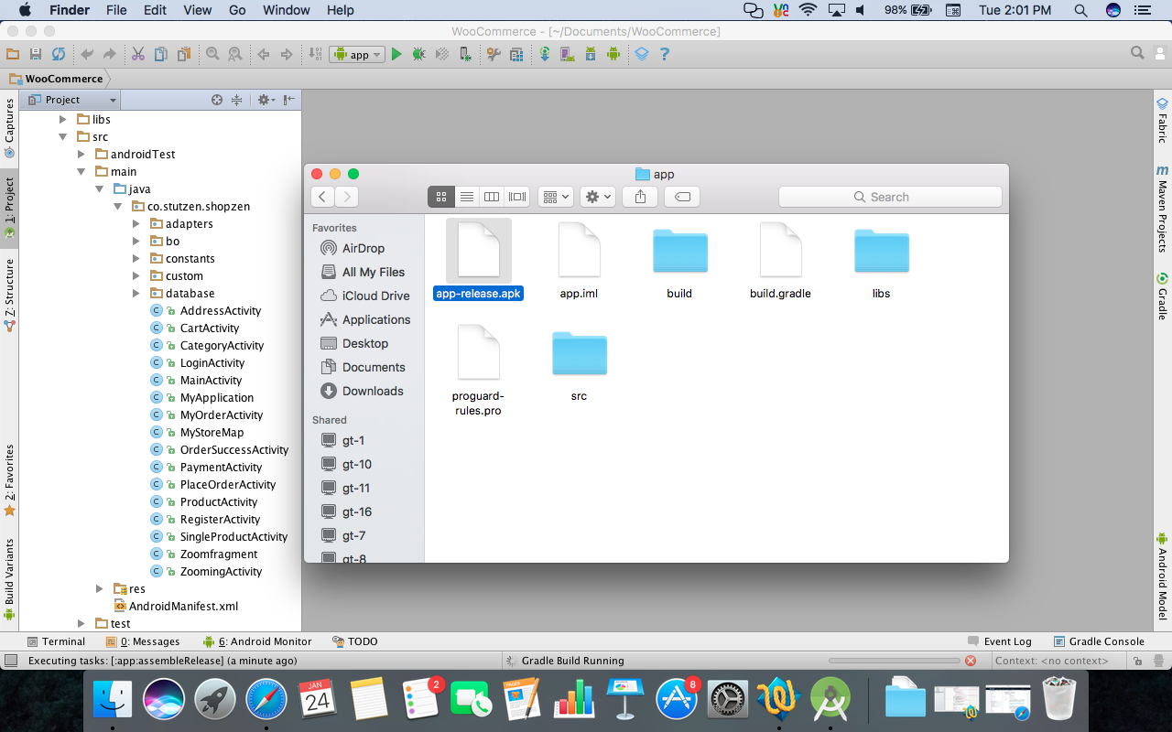

We have completed the below SDKs to enable just do the following steps:
- Facebook
- Paypal
- Google maps
- Onesignal push notification
Facebook: Register your APP with developer.facebook.com
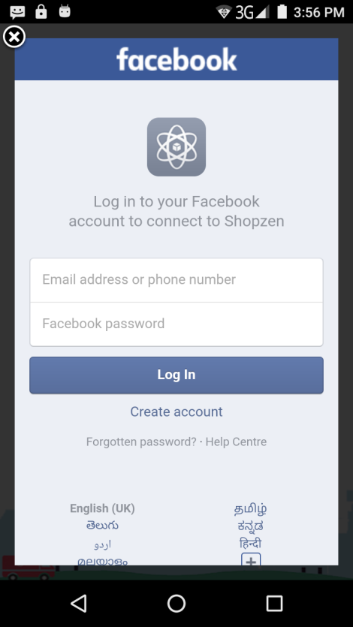

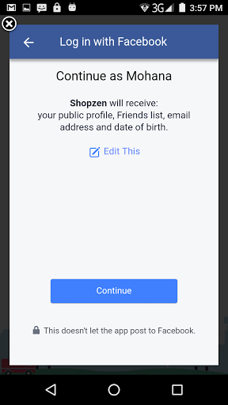

After the registration you will get an id for app place that id in string.xml and now you can access your app with facebook login.

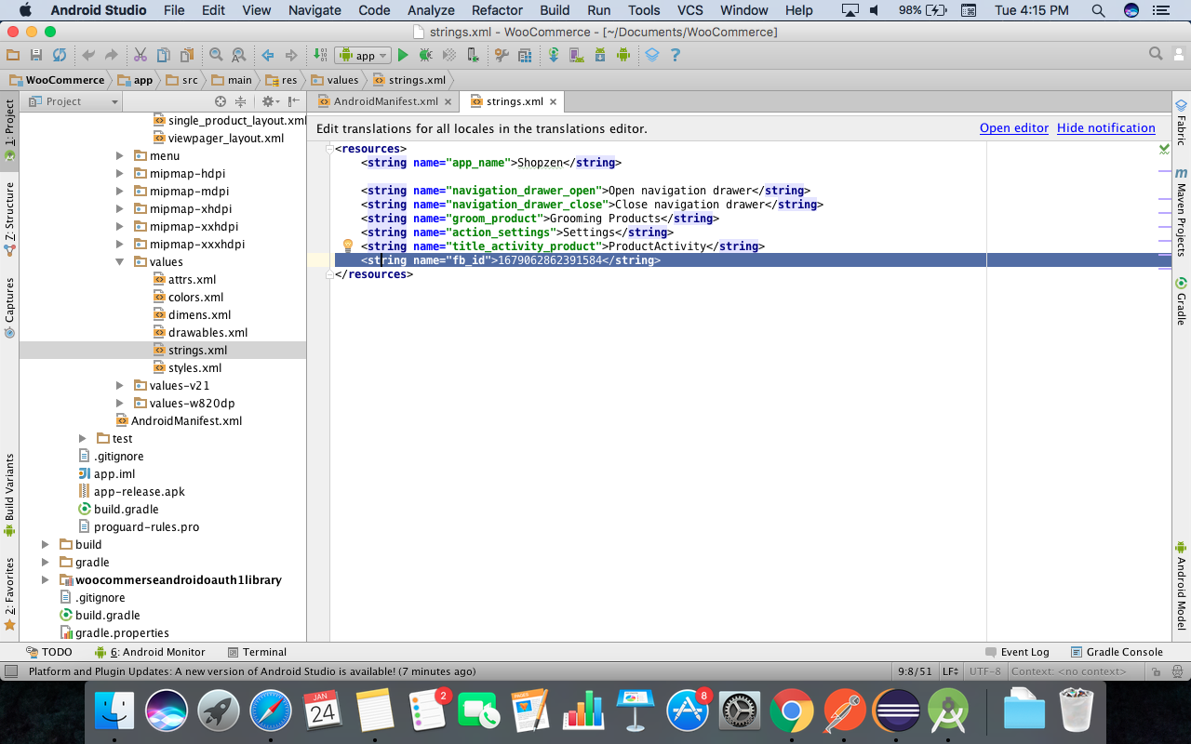

Google maps: To enable google map you need to get API key from console.developers.google.com paste the API key in android manifest.xml file

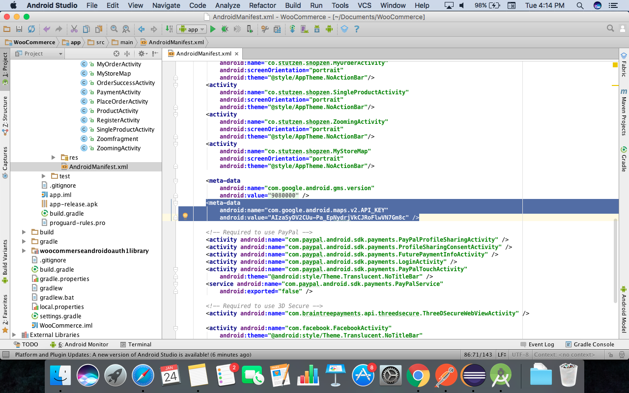

One signal push notification: To enable one signal push notification login with onesignal.com and create a new app

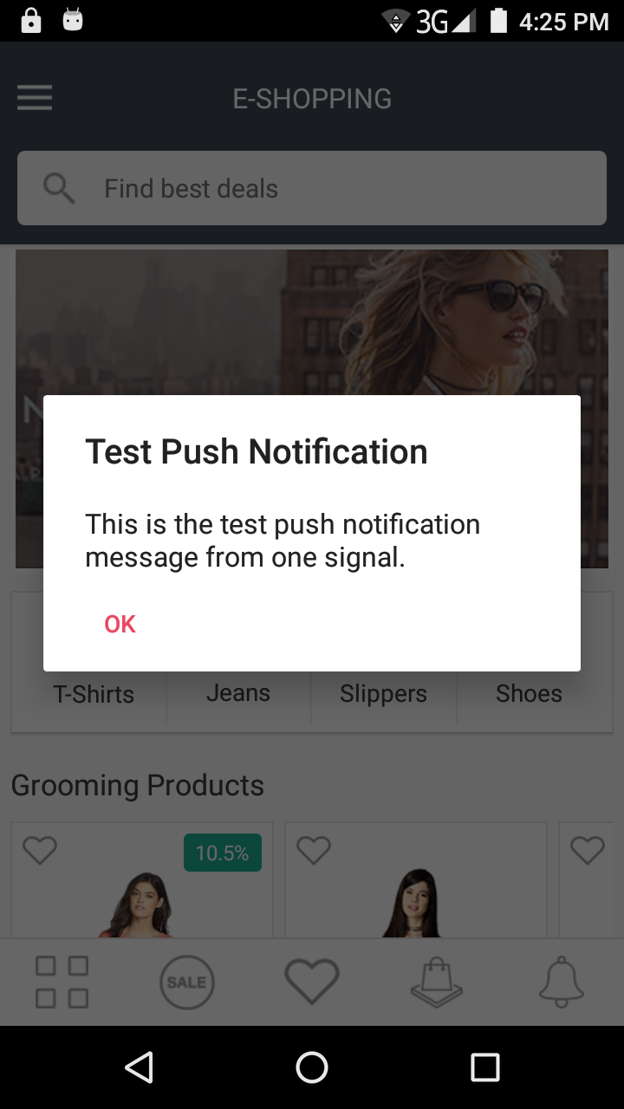

Paypal: To enable paypal gateway login with http://developer.paypal.com. from there you will get the mechant ID, public and private key replace the keys in Appconstants.java file. now the paypal can be successfully integrated.

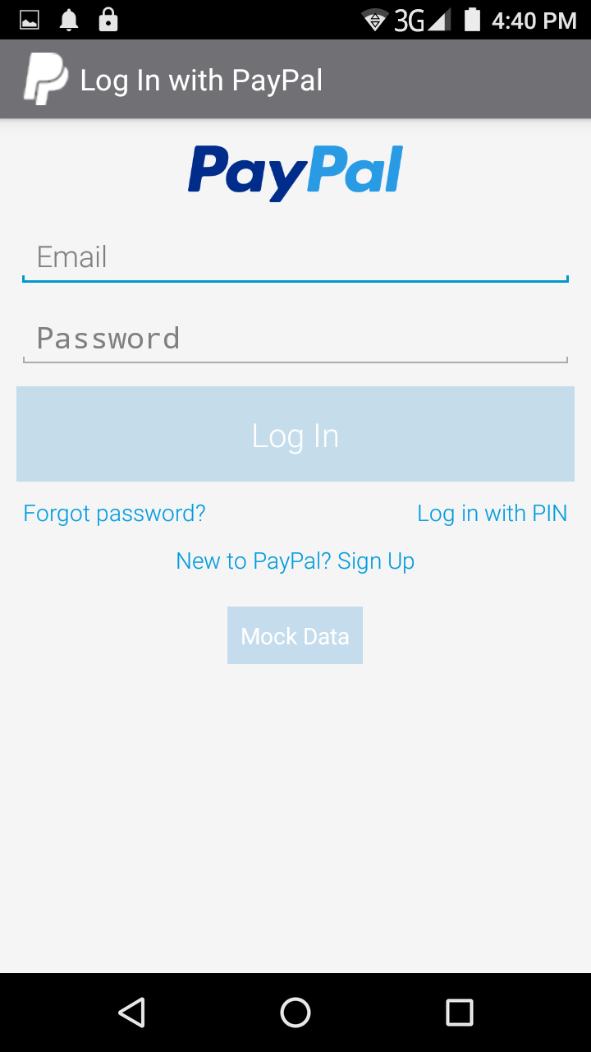

Login to your account

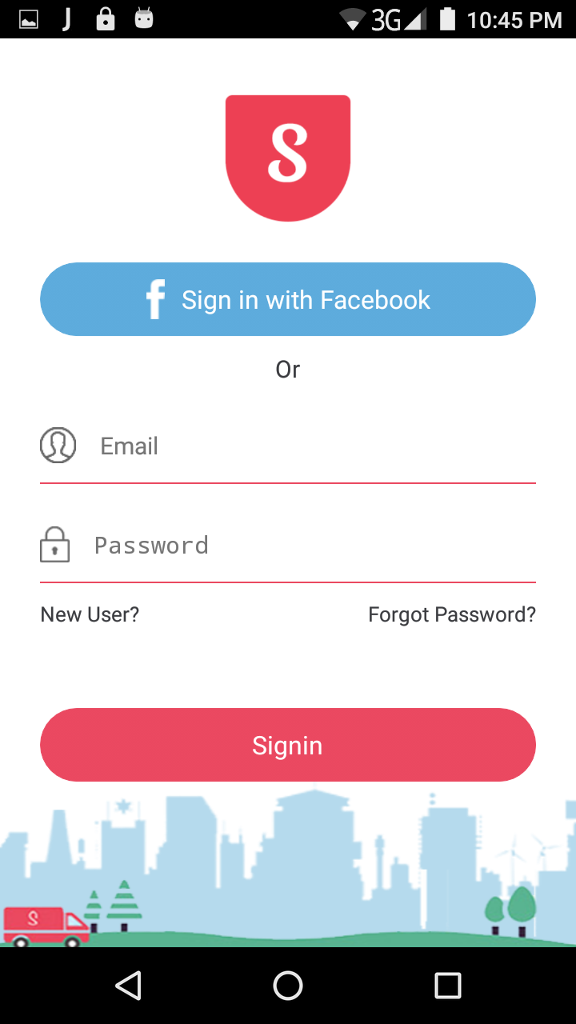

Shopzen home screen has customized drawer layout ,categories and products with an UX to add my favourites.
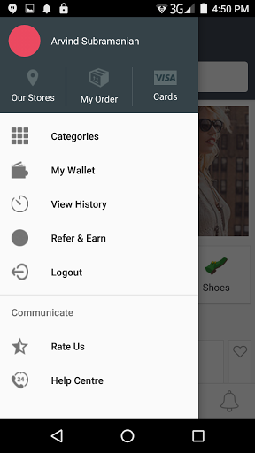

We can select the category and search the product by going to category page

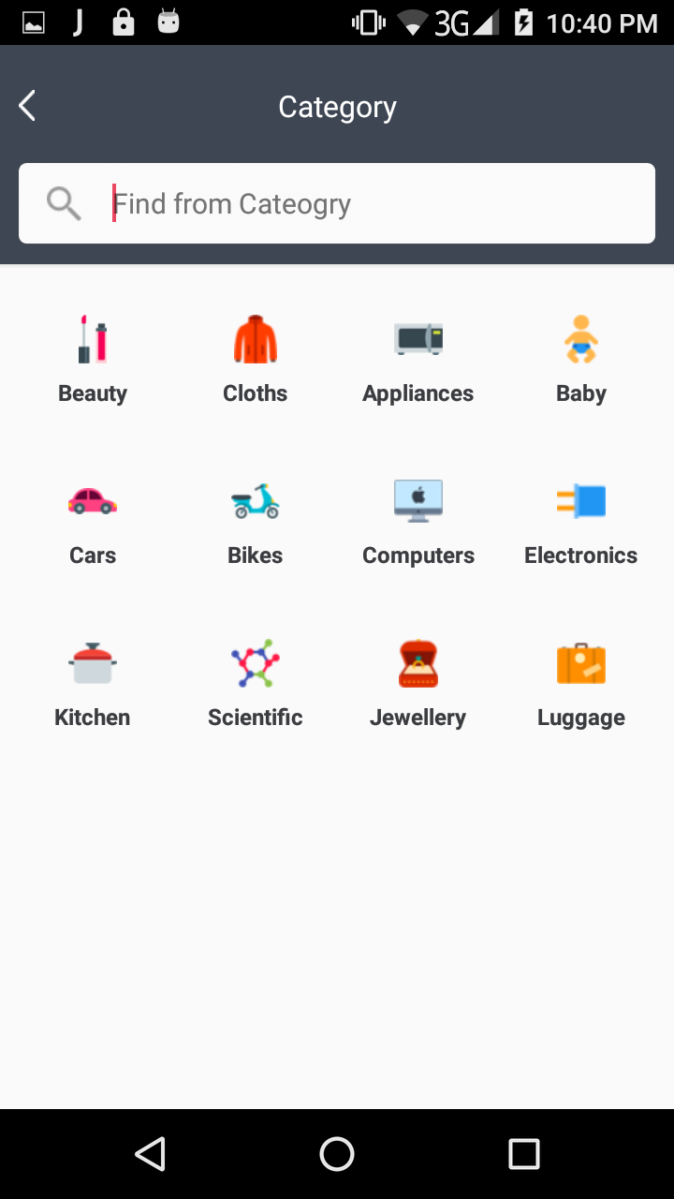

Home screen
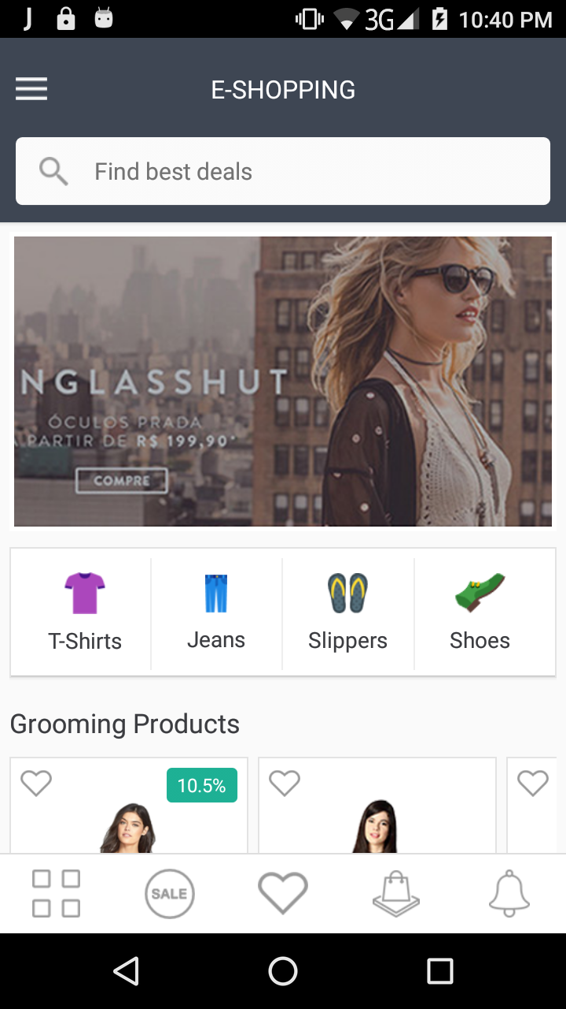

The products can be viewed either in grid or list view

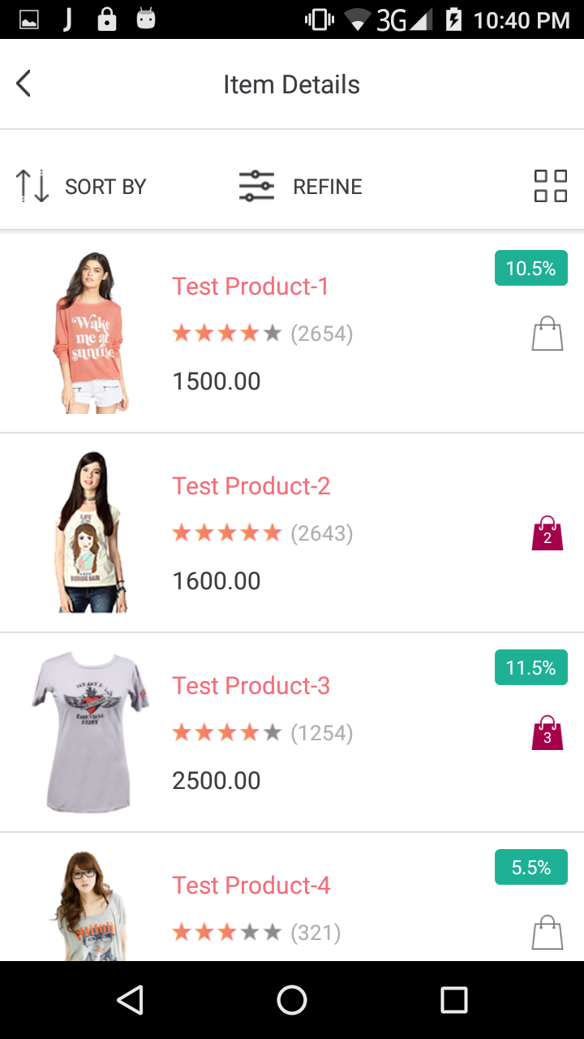

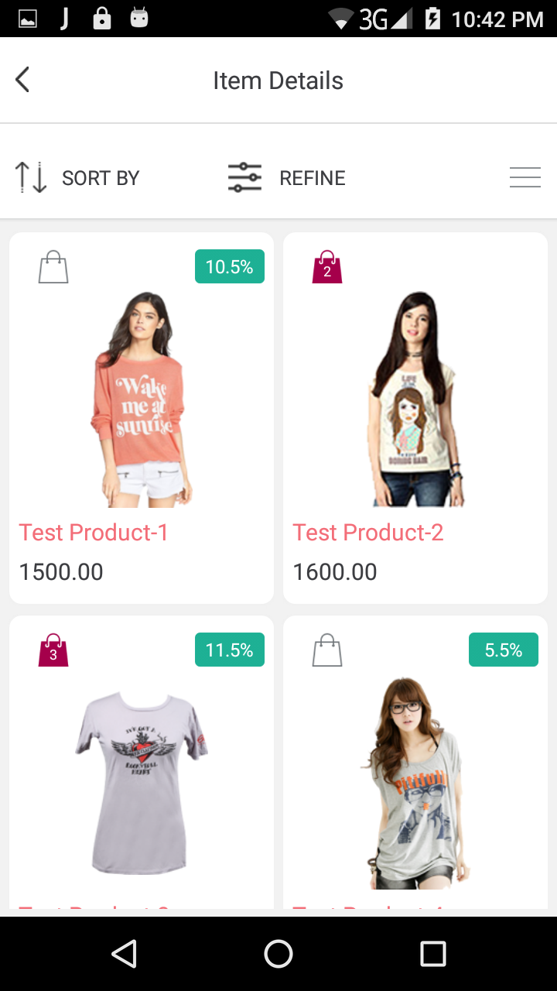

The product can be added to cart and the size colour aldo can be selected.

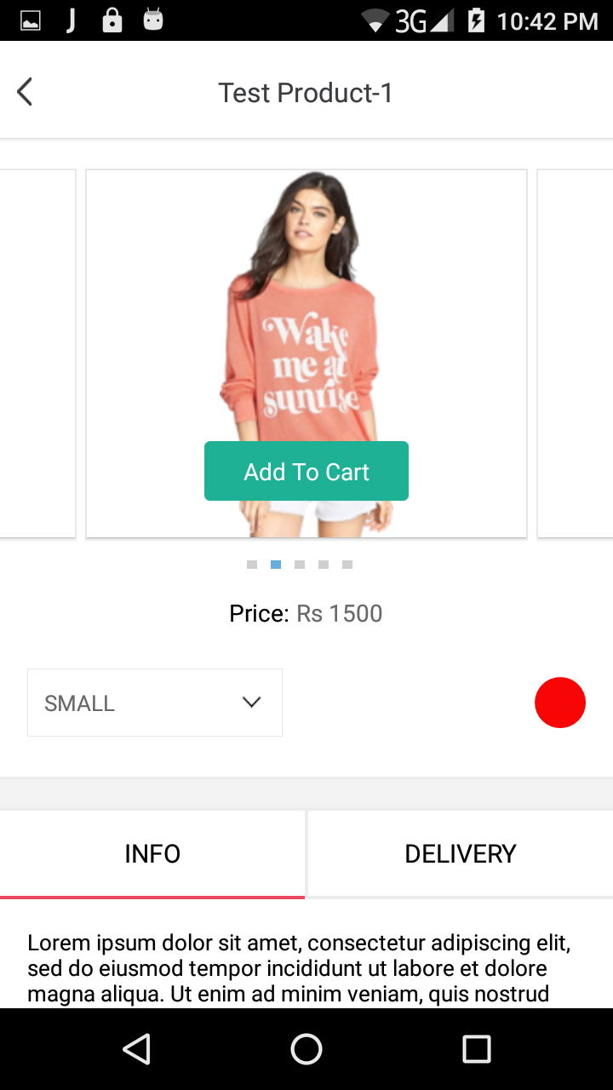

In the product detail page we can change the colour and size of the product as per our need. and when tap the image the zooming options enable with that

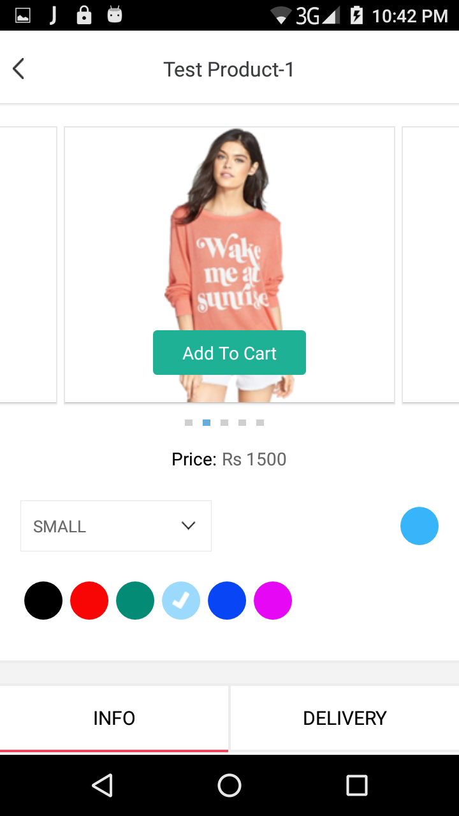

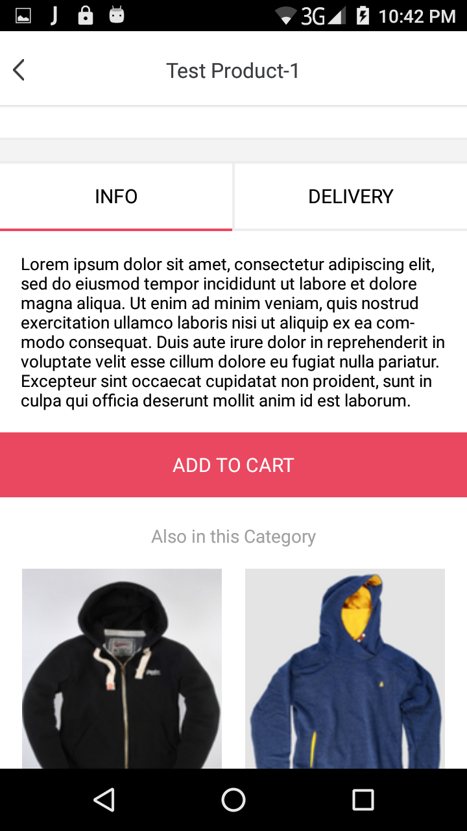

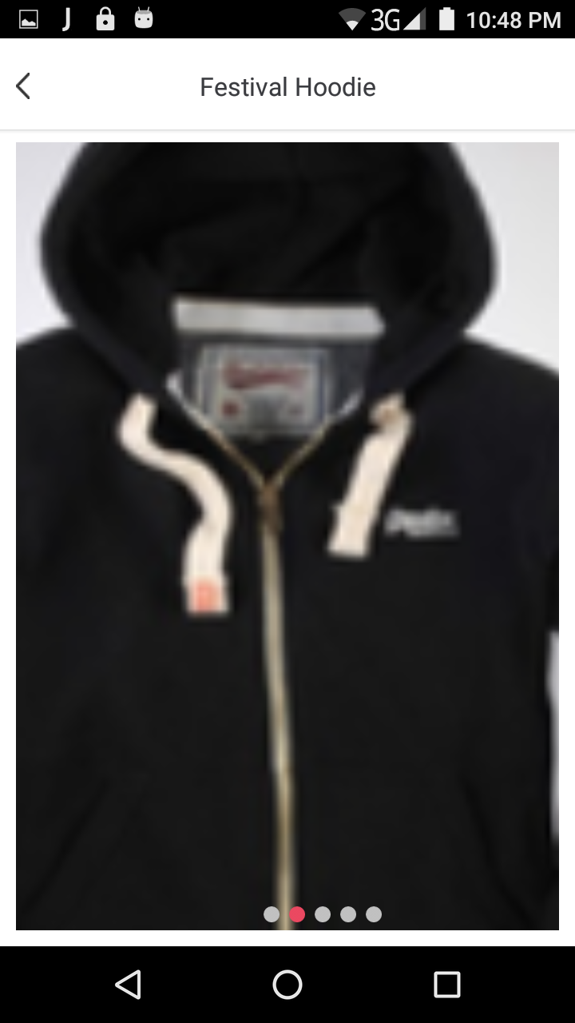

The product that is added to the cart can also removed and the product can be incremented or decremented.

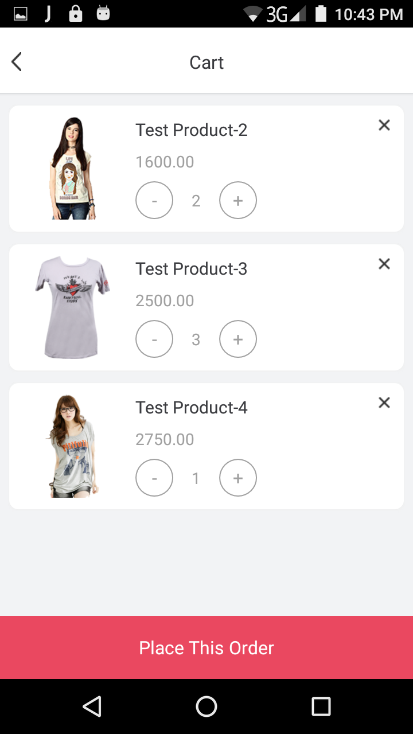

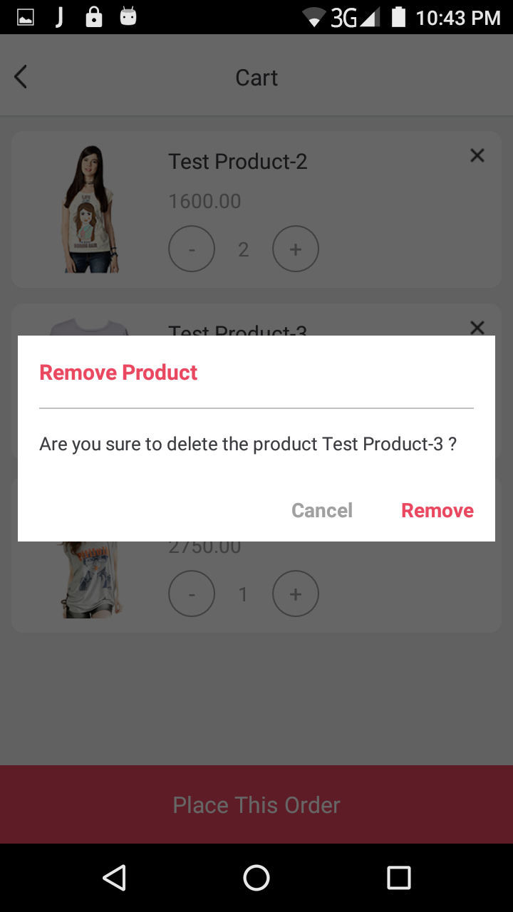

To order a product go to place this order.

we can use either gift wrap or coupon for order

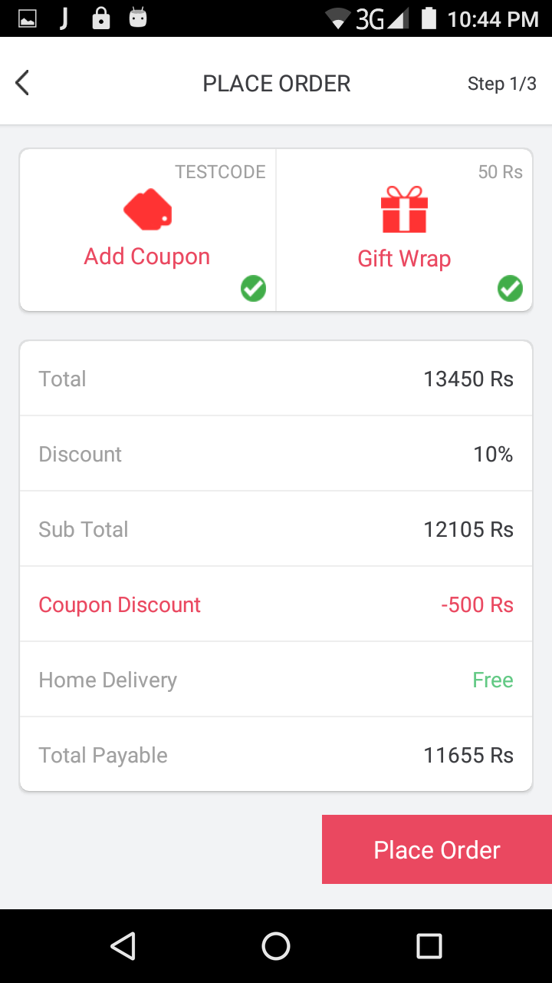

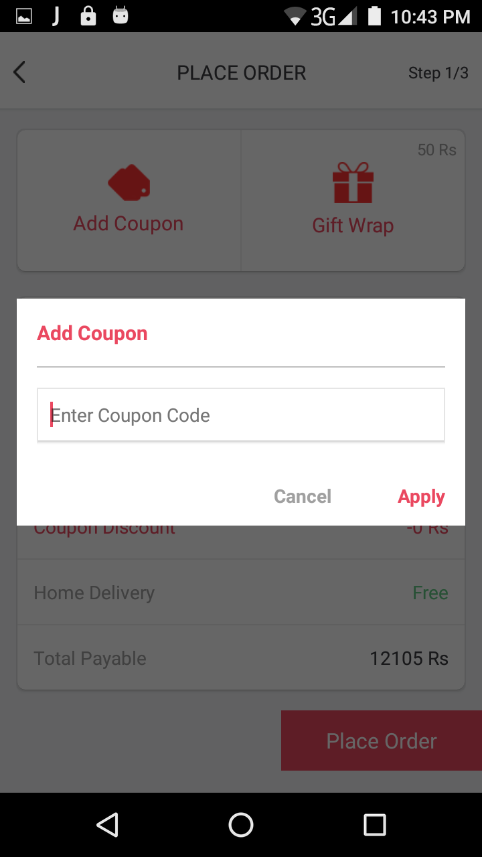

Address detail page for order
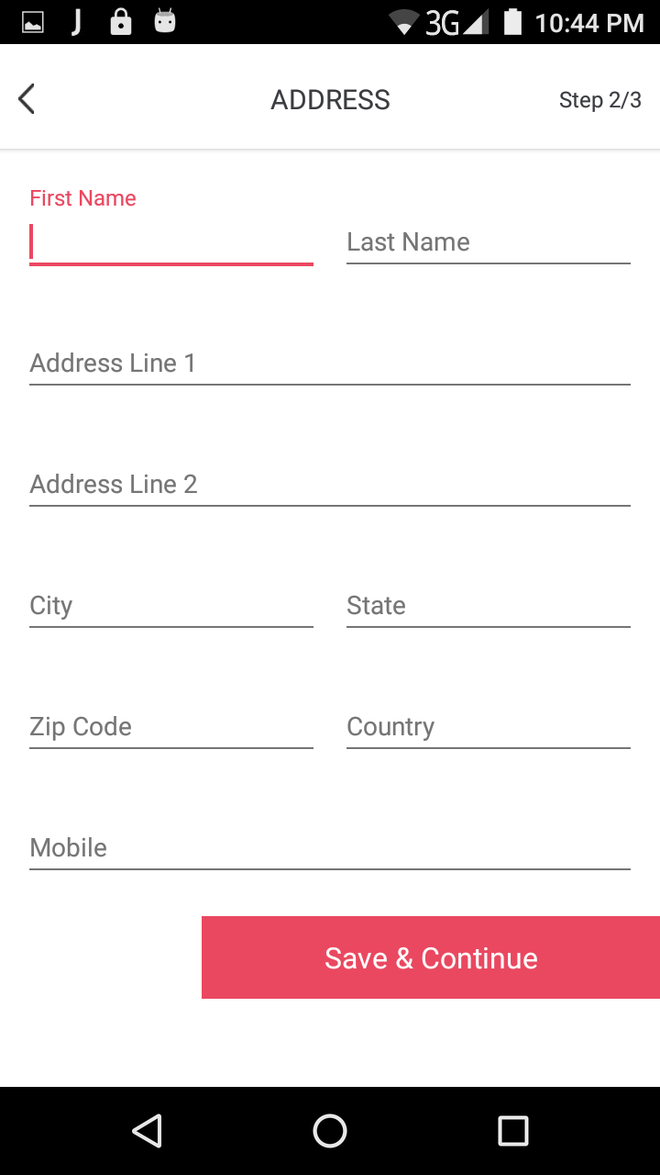

Select the payment which u want. currently we have integrated paypal payment gateway
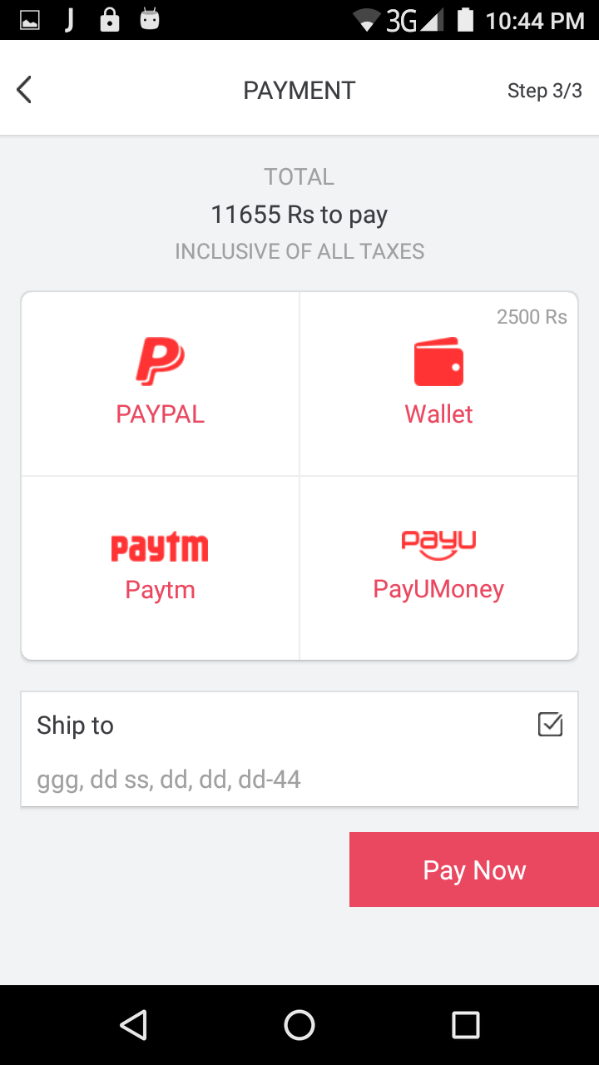
order success detail page

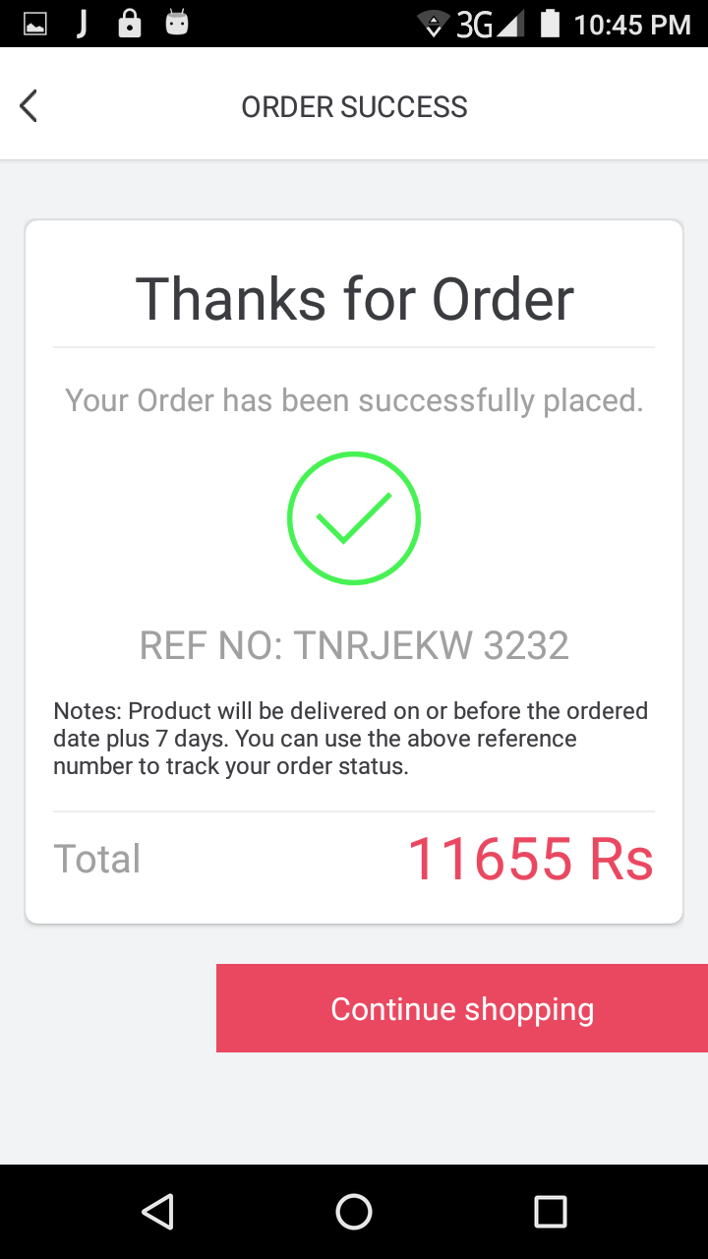

order list detail page
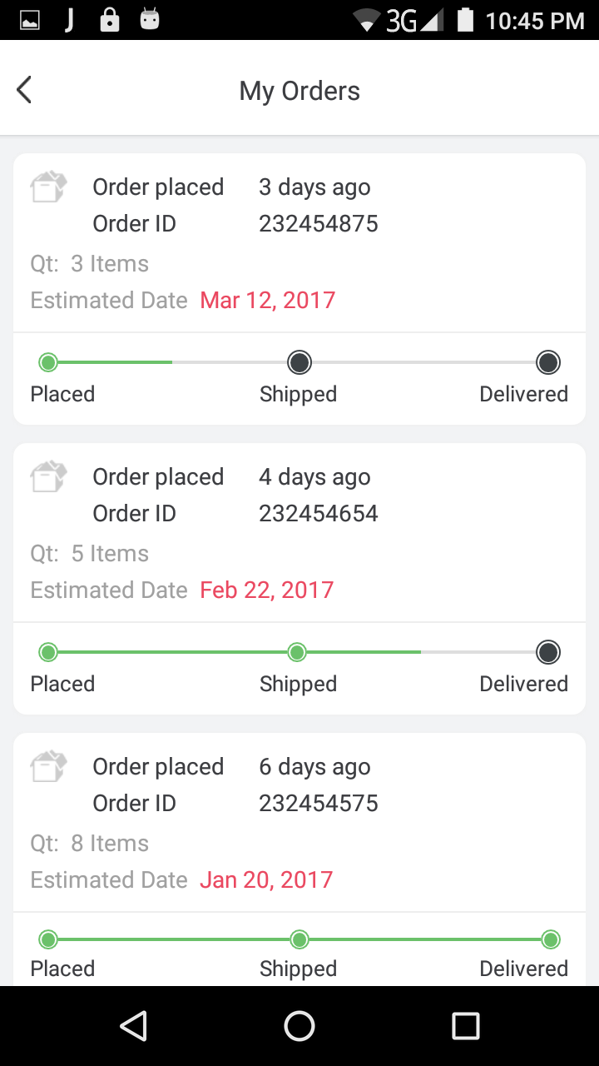

Our Stroes


