Zomato Bangalore Restaurant Analysis: Summary

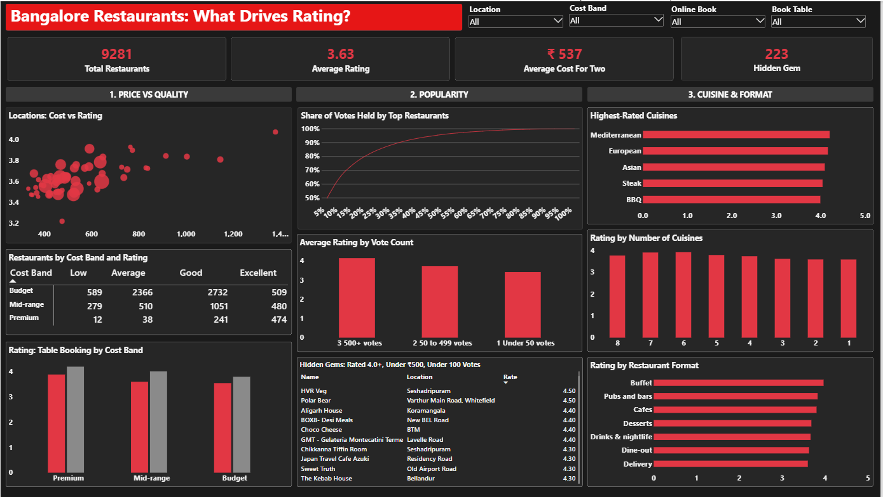
Zomato Bangalore Restaurant Dashboard
Data: Zomato Bangalore Restaurants (Kaggle), 51,717 raw rows · Tools: Python (Pandas), MySQL, Power BI

1. Overview
This project looks at what drives restaurant ratings in Bangalore. It covers pricing, popularity, cuisines and restaurant format. After cleaning, 9,281 unique restaurants remain. The analysis answers 15 business questions in SQL and presents the results in a one-page Power BI dashboard.

2. Data preparation
The raw file has 51,717 rows, but many restaurants appear more than once. Removing repeated name and address pairs leaves 12,499 unique restaurants. Removing those with no rating, cost, location or cuisine leaves 9,281 restaurants.
The main cleaning steps were:
- Converting the rating from text such as “4.1/5” to a number, and treating “NEW” and “-” as missing
- Converting the cost for two from text with commas to a number
- Creating three bands: cost band (Budget up to ₹500, Mid-range ₹500 to ₹1,000, Premium above ₹1,000), rating band and cuisine count
Two gaps were fixed in Power Query before the dashboard was built. Thirty-seven rows had no restaurant type and were set to “Unknown”. One ₹6,000 restaurant had no cost band and was set to “Premium”.

3. SQL insights
Q1. Locations with the most restaurants.
Whitefield leads with 614 restaurants, followed by BTM (517) and HSR (514).
Q6. Cost bands.
Budget restaurants make up 6,196 of the 9,281 (about 67%). Mid-range has 2,320 and Premium has 765. Average ratings rise with cost: 3.55 for Budget, 3.67 for Mid-range and 4.10 for Premium.
Q3 and Q13. Online ordering.
About 61% of restaurants take online orders. Their average rating is 3.65, against 3.59 for those without, so the gap is small.
Q4. Table booking.
Only about 10% of restaurants offer table booking. Those that do rate higher in every cost band, by roughly 0.2 to 0.4 points.
Q5 and Q11. Locations.
Lavelle Road has the highest average rating (4.07) among locations with at least 20 restaurants. It is also the most expensive, at about ₹1,380 for two.
Q8. Cheap and highly rated.
223 restaurants are rated 4.0 or higher, cost ₹500 or less for two, and have fewer than 100 votes. These are the hidden gems shown in the dashboard table.
Q7. Most-voted per location.
Window functions rank the top three restaurants in each location by votes.
Q9. Cuisine count.
Restaurants serving more cuisines rate slightly higher, rising from about 3.6 for one cuisine to about 3.9 for six or seven.
Q12. Votes by restaurant type.
Popularity varies by type, so votes are reported separately from ratings.
Cuisine analysis. Mediterranean (4.20), European (4.16) and Asian (4.09) have the highest average ratings among cuisines with at least 50 restaurants. These cuisines also cost more, at about ₹1,300 to ₹1,500 for two.

4. Power BI dashboard
The dashboard is a single page with a red title banner, four KPI cards, four slicers and nine visuals in three sections:
- Price vs Quality: cost against rating by location, the cost band by rating band matrix, and rating by table booking
- Popularity: the share of votes held by top restaurants, rating by vote count, and the hidden gems table
- Cuisine & Format: the highest-rated cuisines, rating by number of cuisines, and rating by restaurant format
The slicers for location, cost band, online ordering and table booking filter every visual.

5. Key takeaways
- Price and quality move together, but only modestly. The correlation between cost and rating is about 0.33. Premium restaurants rate about 0.5 points higher than Budget ones.
- Votes are concentrated. The top 10% of restaurants by votes hold about 65% of all votes, and the top 1% hold about 21%.
- Popular restaurants rate higher. Restaurants with 500 or more votes average 4.15, against 3.42 for those with fewer than 50.
- Good, cheap places are being overlooked. 223 restaurants are rated 4.0 or higher, cost ₹500 or less for two, and have fewer than 100 votes.
- Table booking is linked to higher ratings in every cost band. Only about 10% of restaurants offer it, so it is a clear way to stand out.
- Cuisine and format matter. Mediterranean, European and Asian cuisines rate highest. Among formats, Buffet leads at about 3.96, and Delivery is lowest at about 3.60.

6. Limitations
- Cost for two is an estimate from the listing, not an actual bill.
- Ratings and votes come from users, so popular places may be over-represented.
- Correlation is not causation. The results show that cost, booking and cuisine count go with higher ratings, not that they cause them.
- The data is a single snapshot and does not show changes over time.

