

**BITCODE V4.0 – 2023**

Department of Information Systems

Faculty of Management Studies

Rajarata University of Sri Lanka

**Task Sheet**

**Grand Task**

You need to develop a web-based application based on the user stories that were provided. Then you need to prepare for a presentation regarding the given requirements.

**Hotel Management System**

The "Cozy Hotel" is a renowned establishment nestled in the heart of a bustling city. With its reputation for exceptional service and comfortable accommodations, it has become a favored destination for travelers and business professionals alike. To streamline their operations and enhance guest experiences, the hotel relies on a sophisticated Hotel Management System.

1. **User Story:** User Authentication

**Description**

As an admin, I want to be able to log into the system with my username and password.

**Acceptance criteria:**

* The login page should have fields for entering a username and password.
* Upon entering valid credentials and clicking the "Login" button, the system should grant access to the admin dashboard.
* If invalid credentials are provided, the system should display an error message indicating that the login attempt was unsuccessful.
* The system should have a "Logout" option on the admin dashboard that logs the user out and redirects them to the login page.

1. **User Story:** Create Room type

**Description**

As an admin, I want to be able to create a new room type with specific details like Room Type, Maximum Guest Capacity, and Rate per Night, so that admin can accurately categorize rooms in the hotel management system.

**Acceptance Criteria:**

* When admin logged into the system and navigate to the dashboard, admin should see an option to "Add New Room Type".
* When admin click on the "Add New Room Type" button, admin should be able add Room Type details including Room Type Name, Maximum Guest Capacity, and Rate per Night.

1. **User Story:** Create New Room

**Description**

As an admin, I want to be able to add a new room to the system so that I can accurately reflect the hotel's inventory.

**Acceptance Criteria:**

* Using "Add New Room" option admin should be able to new Rooms.
* When admin click on the "Add New Room" button, admin should be able add Room details including Room type and Room Number.

1. **User Story**: Create Reservation

**Description**

As an admin, I should be able to create a Room Reservation.

**Acceptance Criteria**

* The Reservation should have Check In date, Check Out date, Room Type, Room Count, Guest Count.
* Customer will get a 10% discount if they reserve more than 3 nights.

1. **User Story:** Show Room types list

**Description**

As an admin I need show the Room types list, so it will be help to see available room types.

**Acceptance Criteria:**

Each room type in the list should display the following details:

* Room Type Name
* Maximum Guest Capacity
* Rate per Night

Any special features associated with the room type.

1. **User Story:** Edit Room Types

**Description**

As an admin I want to have a function to Edit Room types, so it will be help to see available room types.

1. **User Story:** Show Reservation List

**Description**

As an admin I want to show a list of Reservations.

**Acceptance Criteria:**

Each Reservation in the list should display the following details:

* Check In date
* Check Out date
* Room Type
* Room Count
* Guest Count

Any special features associated with the room type.

1. **User Story:** Edit Reservations

**Description**

When I logged as the admin, I want a function to Edit Reservations.

1. **User Story:** Cancel Reservation

**Description**

As an admin I want the ability to Cancel Reservations. So that guest able to cancel their existing reservation.

**Notable**

* Search Functions will be added advantage.
* Implementing data table filtering and backend pagination would be an additional advantage for final marks.
* Proper use of algorithms and data structures.
* OOP concepts are applied in the code
* Effectively use of exceptions to handle error conditions and unexpected situations.
* Use of architectural patterns.
* Modular components implementation that can be reused across the project.

**Development Guidelines**

* Competitors have 4 hours to develop their application
* Use any programming languages, frameworks, and libraries you are comfortable with.
* The application should have a responsive design to work on both desktop and mobile devices.
* Use a database (e.g., MySQL, MongoDB) to store information.
* Contesters need to develop front-End, Back-End and integration from each user story and points will add to those parts separately.

**Submission**

* Create a GitHub Public Repository.
* Set Up Front-end and Back-end Folders.
* Push both projects to relevant folders.
* Commit within Time Period

**Special note:** Ensure that the last repository commit is made within the given time period. If a commit is made after the specified time, it will not be considered.

* Share the repository links via [bitcode@mgt.rjt.ac.lk](mailto:bitcode@mgt.rjt.ac.lk)

**Presentation Gridlines**

* Presentation time 1 hour
* You need to prepare a presentation containing below requirements
* High level architecture diagram.
* Entity Relationship diagram.
* technology that you are used during the development and the reasons for select that technology.
* Solution demonstration.
* The team must manage the given time for both preparation and presentation.

**Evaluation criteria**

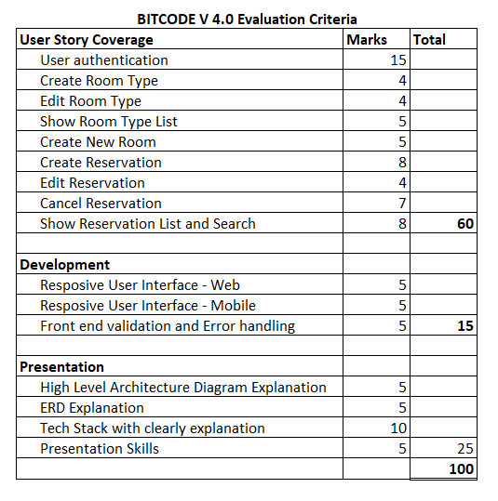

- The End -