Q1. First Palindromic String
Aim: To find the first palindromic string in a list.

Algorithm:
- Take input list of words.
- Traverse each word.
- Check if word == reverse of word.
- Print first palindrome found, else print "

Code (Python):
words = input("Enter words: ").split() ans = ""
for w in words:
if w == w[::-1]: ans = w break
print("First Palindrome:", ans)

Input:
abc car ada racecar cool

Output:
First Palindrome: ada
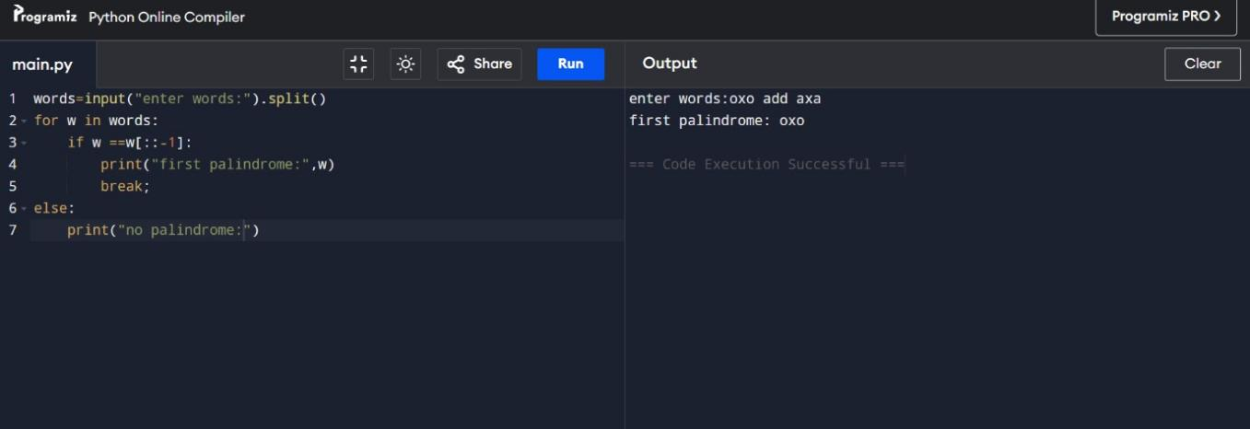

Q2. Count Common Indices in Two Arrays
Aim: To count how many elements of one list exist in another.

Algorithm:
- Take input arrays nums1 and nums2.
- For each element in nums1, check if in nums2 → count1.
- For each element in nums2, check if in nums1 → count2.
- Print [count1, count2].

Code (Python):
nums1 = list(map(int, input("Enter nums1: ").split())) nums2 = list(map(int, input("Enter nums2: ").split())) set1, set2 = set(nums1), set(nums2)
answer1 = sum(1 for x in nums1 if x in set2) answer2 = sum(1 for x in nums2 if x in set1) print("Output:", [answer1, answer2])

Input:
Enter nums1: 4 3 2 3 1
Enter nums2: 2 2 5 2 3 6

Output:
[3, 4]
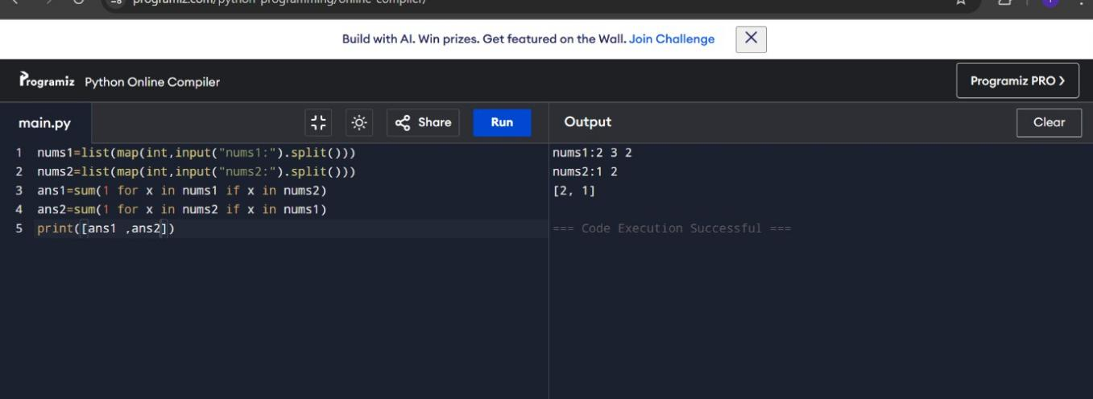

Q3. Sum of Squares of Distinct Counts of Subarrays Aim: To calculate sum of (distinct_count²) for all subarrays. Algorithm:
- Take input array nums.
- For each starting index i → create empty set.
- For each ending index j → add element, count distincts.
- Add square of count to total.
- Print total.

Code (Python):
nums = list(map(int, input("Enter numbers: ").split())) n = len(nums)
total = 0
for i in range(n): seen = set()
for j in range(i, n): seen.add(nums[j]) total += len(seen) ** 2
print("Sum of squares:", total)

Input:
Enter array: 1 2 1

Output:
Result: 15
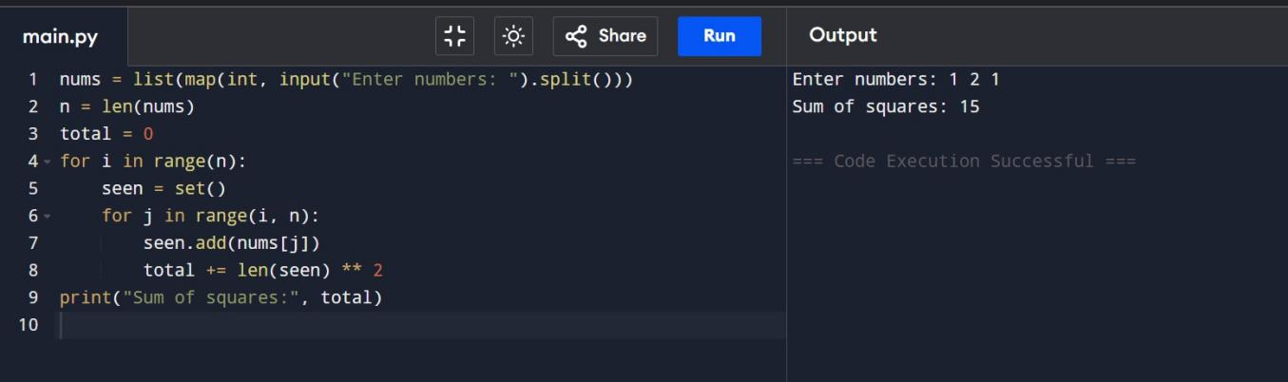

Q4. Count Pairs with Condition
Aim: To count pairs (i, j) where nums[i] == nums[j] and (i*j) divisible by k.

Algorithm:
- Take nums and k.
- Loop through all pairs (i < j).
- If nums[i] == nums[j] and i*j % k == 0 → count++.
- Print count.

Code (Python):
nums = list(map(int, input("Enter numbers: ").split())) k = int(input("Enter k: "))
count = 0
n = len(nums) for i in range(n):
for j in range(i+1, n):
if nums[i] == nums[j] and (i*j) % k == 0: count += 1
print("Pairs count:", count)

Input:
Enter nums: 3 1 2 2 2 1 3
Enter k: 2 Output: Pairs: 4
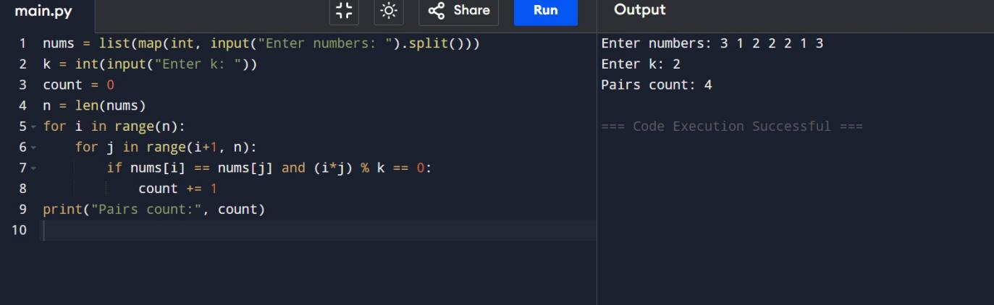

Q5. Max of Array (with given test cases)
Aim: To find maximum element in array with least time complexity.

Algorithm:
- Take input array.
- Use built-in max() for efficiency.
- Print max element.

Code (Python):
arr = list(map(int, input("Enter numbers: ").split())) if not arr:
print("Array is empty") else:
max_val = arr[0] for num in arr:
if num > max_val: max_val = num
print("Maximum:", max_val)

Input:
Enter array: -10 2 3 -4 5

Output:
Max: 5
