Dice Throw Problem using Dynamic Programming

Aim: Find number of ways to get a target sum with given number of dice and sides.

Algorithm:
Step-1: Create DP table dp[dice+1][target+1] Step-2: Initialize dp[0][0] = 1
Step-3: For each dice, for each sum, add ways using each face value Step-4: Return dp[num_dice][target]

Input & Output:

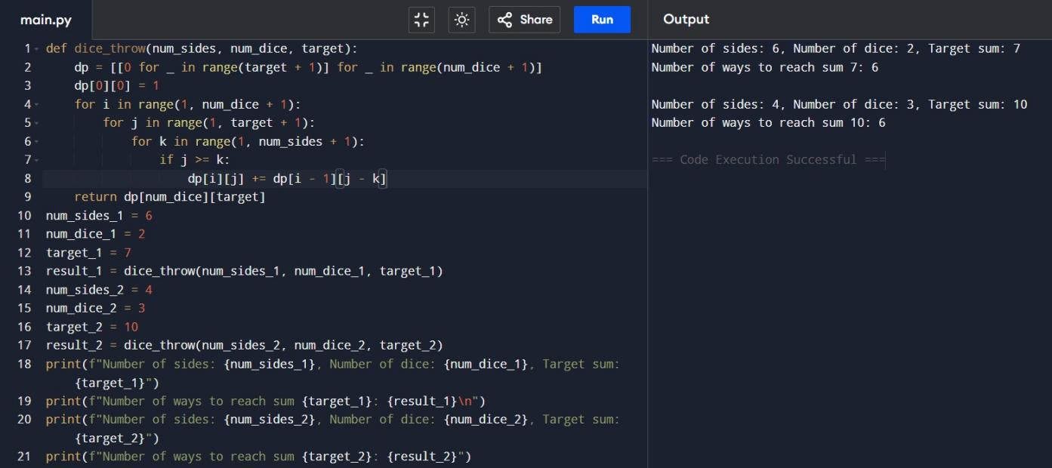
- Assembly Line Scheduling (2 Lines)
Aim: Find minimum time to assemble product through 2 lines.

Algorithm:
Step-1: Use DP arrays T1, T2 for each line
Step-2: Compute time at each station with/without transfer Step-3: Add entry and exit times
Step-4: Return min(T1[n-1]+x1, T2[n-1]+x2)

Input & Output:
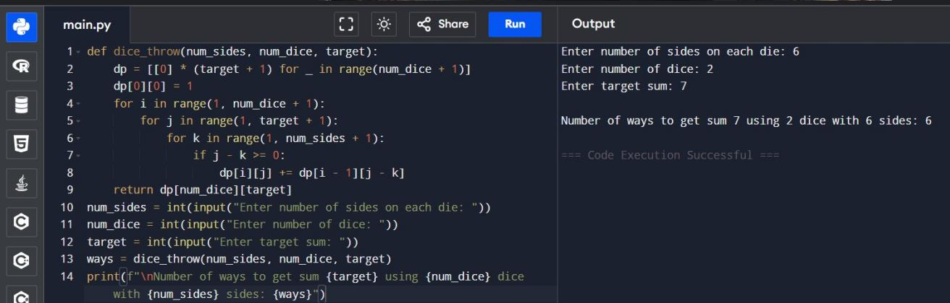

- Three Assembly Lines Scheduling

Aim: Minimize total time across 3 lines with dependencies.

Algorithm:
Step-1: Initialize dp[i][line] = time
Step-2: Add min transfer from previous station Step-3: Respect dependencies
Step-4: Return min total

Input & Output

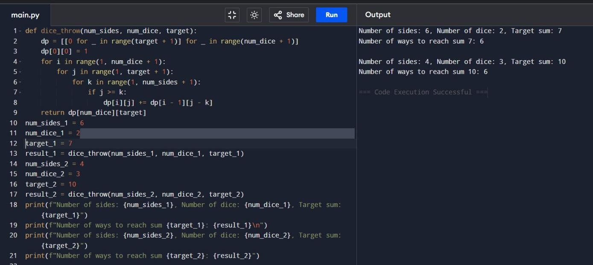
- Minimum Path Distance (Matrix form - TSP)
Aim: Find minimum path visiting all cities (TSP).

Algorithm:
Step-1: Use DP with bitmasking
Step-2: Recursively compute all paths Step-3: Return minimal cycle cost.

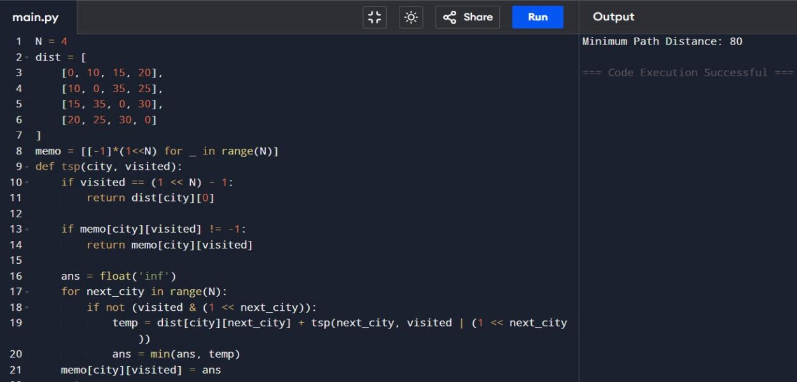
Input & Output:
- TSP with New City (E)
Aim: Find shortest route including new city.

Algorithm:
Step-1: Use permutations to check all paths Step-2: Compute total distance
Step-3: Return minimal route

Input & Output

