1: Find Maximum and Minimum in Array
Aim:
To find both the maximum and minimum elements in an array.

Algorithm:
- Read size N and array elements.
- Initialize min and max with first element.
- Traverse array, update min if smaller and max if larger.
- Print final values.

Code
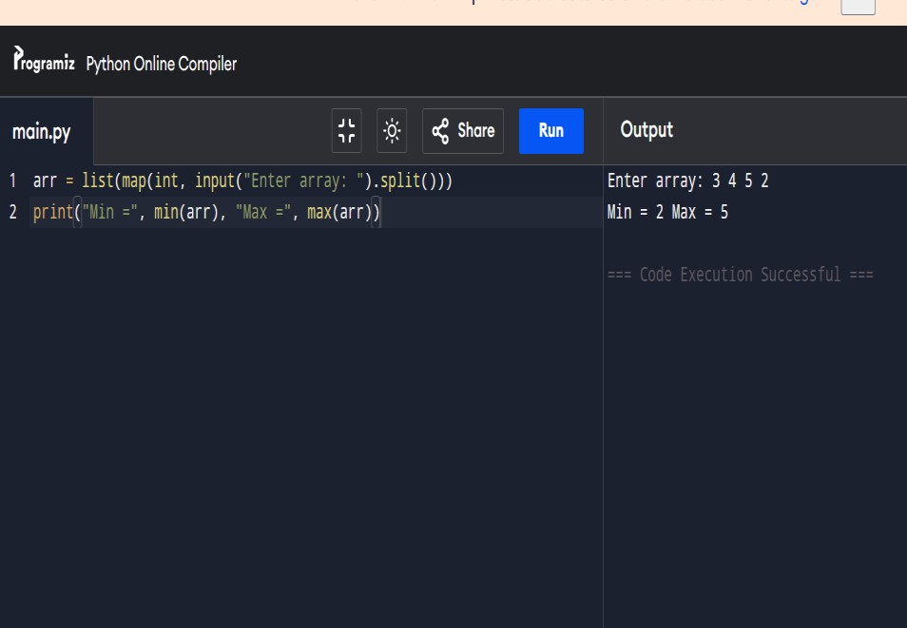
arr = list(map(int, input("Enter array: ").split())) print("Min =", min(arr)) print("Max =", max(arr)) Output:
Result: The program has been successfully executed.

2.Min and Max in Sorted Array
Aim:
To find min and max in a sorted array.

Algorithm:
- In a sorted array, min = first element, max = last element.
- Print both values.

Code:
arr = list(map(int, input("Enter sorted array: ").split())) print("Min =", arr[0]) print("Max =", arr[-1])

Output:
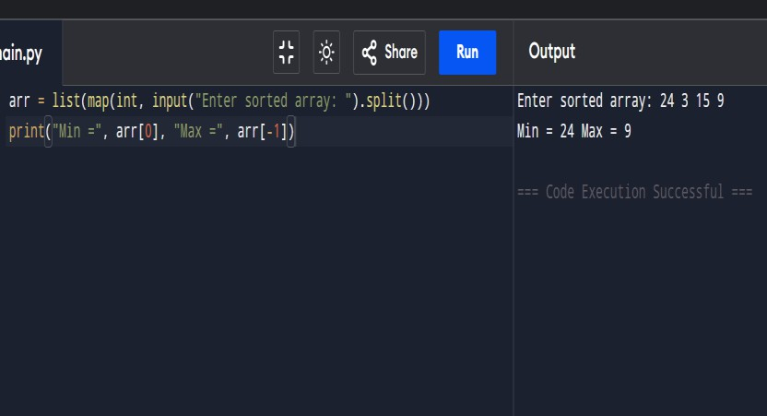
Result: The program has been successfully executed.

3: Merge Sort
Aim:
To sort an unsorted array using Merge Sort.

Algorithm:
- Divide array into two halves.
- Recursively sort both halves.
- Merge sorted halves.

Code:
def merge_sort(arr):
if len(arr) > 1:
mid = len(arr)//2 L = arr[:mid]
R = arr[mid:] merge_sort(L) merge_sort(R) i=j=k=0
while i < len(L) and j < len(R):

if L[i] < R[j]:
arr[k] = L[i]; i+=1 else:
arr[k] = R[j]; j+=1 k+=1
while i < len(L):
arr[k] = L[i]; i+=1; k+=1 while j < len(R):
arr[k] = R[j]; j+=1; k+=1
arr = list(map(int, input("Enter array: ").split())) merge_sort(arr)

print("Sorted:", arr) Output:
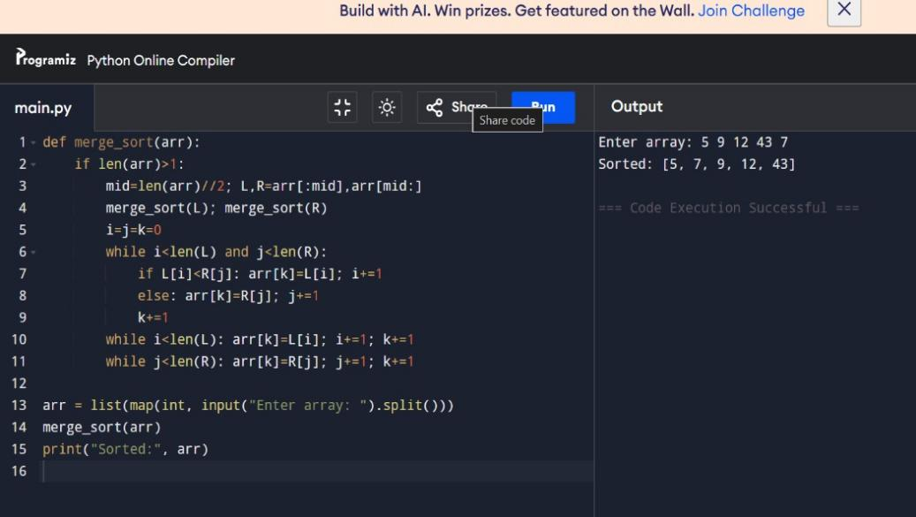
Result: The program has been successfully executed.

4: Merge Sort with Comparisons
Aim:
To sort array using Merge Sort and count comparisons. Algorithm:
- In a sorted array, min = first element, max = last element.
- Print both values.

Code:
comparisons = 0 def merge_sort(arr):
global comparisons if len(arr) > 1:
mid = len(arr)//2
L, R = arr[:mid], arr[mid:] merge_sort(L)
merge_sort(R) i=j=k=0
while i < len(L) and j < len(R): comparisons += 1
if L[i] < R[j]:
arr[k] = L[i]; i+=1 else:
arr[k] = R[j]; j+=1 k+=1
while i < len(L): arr[k] = L[i]; i+=1; k+=1 while j < len(R): arr[k] = R[j]; j+=1; k+=1
arr = list(map(int, input("Enter array: ").split())) merge_sort(arr)
print("Sorted:", arr)
print("Comparisons:", comparisons)

Output:

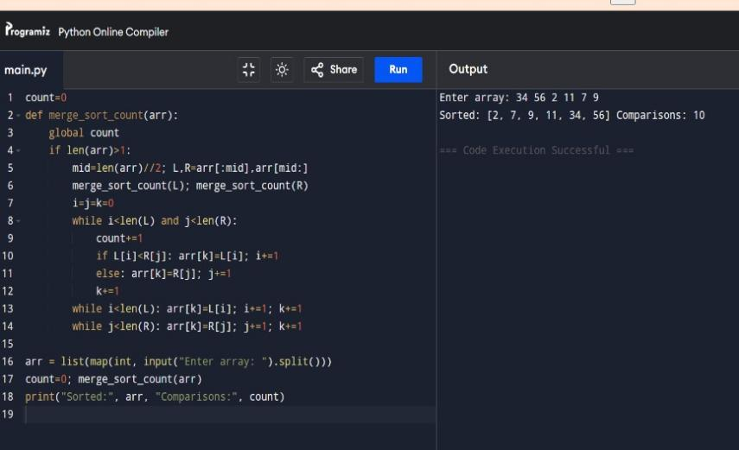
Result: The program has been successfully executed.

5: Quick Sort (First Element Pivot)
Aim:
To sort array using Quick Sort with first element as pivot.

Algorithm:
- Choose first element as pivot.
- Partition array into < pivot and > pivot.
- Recursively quicksort subarrays.

Code:
def quick_sort(arr):
if len(arr) <= 1:
return arr pivot = arr[0]
left = [x for x in arr[1:] if x <= pivot] right = [x for x in arr[1:] if x > pivot]
return quick_sort(left) + [pivot] + quick_sort(right) arr = list(map(int, input("Enter array: ").split()))
print("Sorted:", quick_sort(arr))

Output:

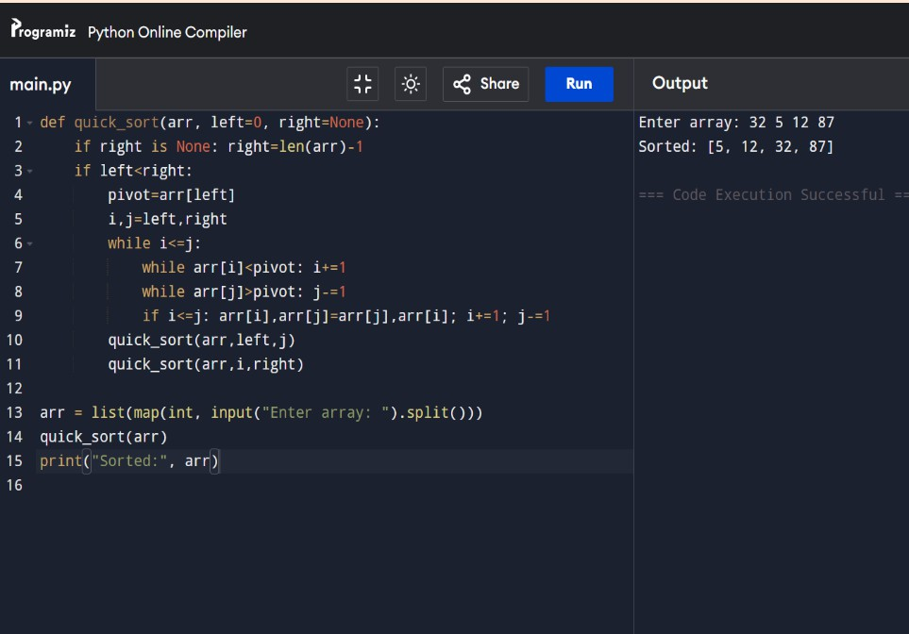

Result: The program has been successfully executed.

