SIMATS ENGINEERING (SAVEETHA SCHOOL OF ENGINEERING)
Department of Computer Science and Engineering
ASSESSMENT TOOL 1 – HANDS-ON API ASSIGNMENT (HUGGING FACE / OPENAI / GEMINI)

Course Code: | CSA65 | Course Title: | Generative AI and Large Scale Models
CO Assessed: | CO3 – Precision (BL2, BL3) | Assessment: | Assessment Tool 1 – Hands-on  API Assignment (Hugging  Face / OpenAI / Gemini)
Weightage: | 20% of CIA | Total Marks: | 2 * 50 = 100 (1 Question1)
CO3  Statement: | Develop intelligent applications using Retrieval-Augmented Generation (RAG), vector databases, and introductory AI agent concepts.(BL3, BL4)
Student Name: | C. Anu Keerthana | Reg. No.: | 192472057
Section / Batch: |  | Date:
Instructions to Students
- Answer 2 questions. Each question carries 50 marks.Total: 100 Marks.
- Use Python to implement the assigned problem.
- Use at least one API/platform: Hugging Face, OpenAI, or Google Gemini.
- Accept suitable user input and clearly display the generated output.
- Handle API errors, invalid input, and other suitable edge cases.
- Use readable, structured, and modular code wherever appropriate.
- Add comments and brief documentation explaining the implementation.
- Demonstrate the program with suitable test cases.
- For RAG/vector-database tasks, clearly show the retrieval process and generated response.
Code of Conduct
I _______C. Anu Keerthana(192472057)___________________ (Name / Reg No) certify that this submission is my original work and that I have adhered to the guidelines specified for this assessment. I understand that any violation of academic integrity rules will result in disciplinary action. Signature of the Student: _________C. Anu Keerthana________________

SECTION A – HANDS-ON API ASSIGNMENT (HUGGING FACE / OPENAI / GEMINI)

13.AI Resume Information Extractor: Accept resume text and extract candidate name, skills, education, experience, and certifications in structured JSON format.
33.Simple AI Agent with Calculator Tool: Develop an AI agent that answers normal questions and uses a calculator tool whenever mathematical computation is required.

13. AI Resume Information Extractor

1. Problem Statement

The AI Resume Information Extractor is a Generative AI-based application designed to automatically extract important candidate information from unstructured resume text. Resumes are generally written in different formats and styles, making manual extraction of candidate details time-consuming and inefficient.
The proposed system accepts resume text as input and uses a Generative AI model such as Google Gemini to identify and organize important information, including the candidate's name, skills, education, work experience, and certifications. The extracted information is then presented in a structured JSON format, making it easier for other applications such as recruitment systems, applicant tracking systems, and HR analytics tools to process the information.

2. Objective

The main objectives of the system are:
- To automatically analyze resume text using Generative AI.
- To extract important candidate information from unstructured text.
- To identify skills, education, experience, and certifications.
- To convert extracted information into structured JSON.
- To reduce the time required for manual resume screening.
- To handle missing information and invalid inputs appropriately.
- To demonstrate the use of a Generative AI API in a practical application.

3. Need for the System
Recruiters may receive hundreds or thousands of resumes for a single job position. Manually reading every resume and extracting relevant information can be slow and repetitive.
For example, one resume may list skills under "Technical Skills", while another may mention them inside the "Profile" or "Experience" section. Traditional rule-based systems may have difficulty handling these variations.
Generative AI can understand the context of the resume and identify relevant information even when the resume structure is different.
4. Proposed Solution
The proposed system uses Python and Google Gemini API.
The system follows these steps:
Resume Text
↓
Input Validation
↓
Gemini AI Model
↓
Information Extraction
↓
JSON Validation
↓
Structured Candidate Information
The user enters the resume text into the application. The text is sent to the Gemini model with a carefully designed prompt. The model extracts the required fields and returns the information in JSON format.

5. Information Extracted

The system extracts the following information:
Field | Description
Candidate Name | Full name of the applicant
Skills | Technical and professional skills
Education | Degree, institution and relevant details
Experience | Job role, organization and duration
Certifications | Professional or academic certifications
6. Technologies Used
- Programming Language: Python
- AI Platform: Google Gemini
- Python Library: google-genai
- Data Format: JSON
- Development Environment: Python IDLE / VS Code / Google Colab

Python Code
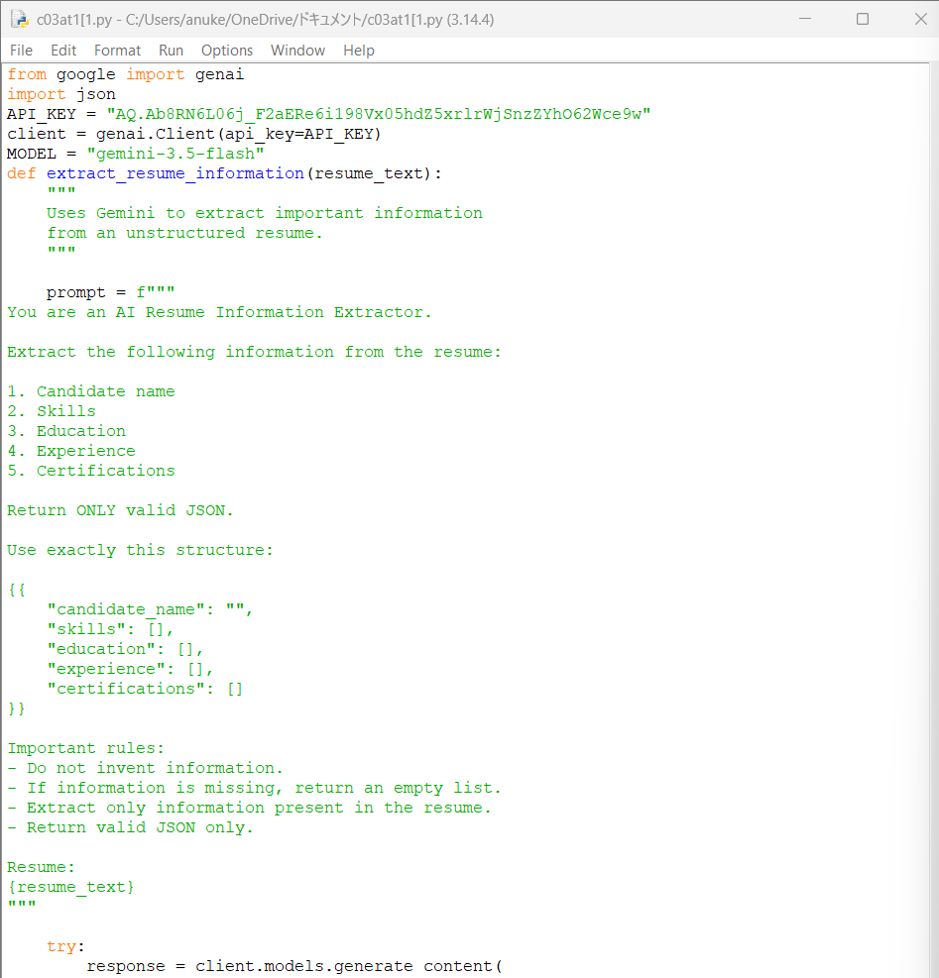

Expected Output
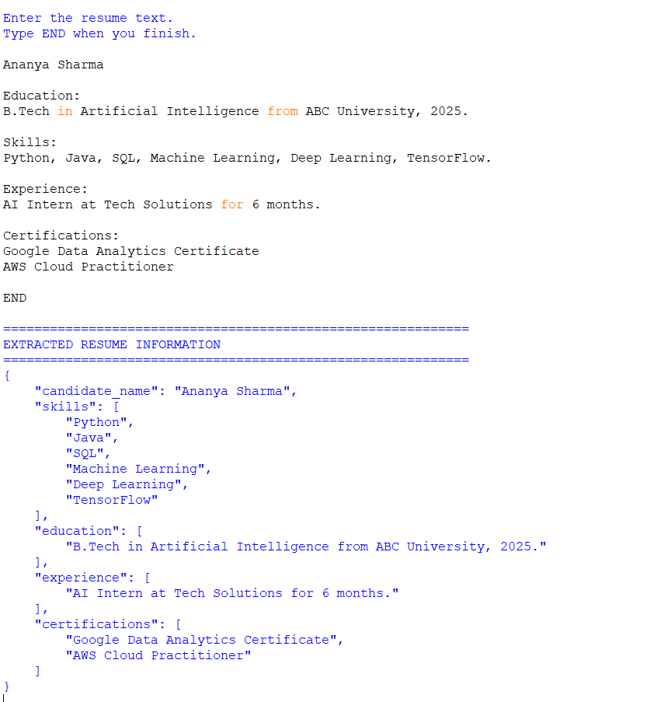
Applications
The Resume Information Extractor can be used in:
- Recruitment systems
- Applicant Tracking Systems (ATS)
- HR automation
- Resume screening
- Job portals
- Candidate database creation
- Employee recruitment analytics

Advantages
- Saves manual resume screening time.
- Handles different resume writing styles.
- Produces structured JSON output.
- Easy to integrate with other applications.
- Uses Generative AI for contextual understanding.
- Can handle missing information.

Limitations
- Requires a Gemini API key.
- Requires internet connectivity.
- API usage may have limitations.
- AI extraction may occasionally require validation.
- Highly complex resumes may require additional processing.

33. Simple AI Agent with Calculator Tool

1. Problem Statement

A normal AI chatbot can answer general questions, but mathematical calculations may sometimes produce incorrect results when performed directly by a language model.
The Simple AI Agent with Calculator Tool solves this problem by creating an AI agent that can understand the user's question and determine whether a calculation is required.
If the question is mathematical, the agent invokes a calculator tool. If the question is a normal question, the agent directly generates a response using Gemini.

2. Objective
The objectives are:
- To develop an AI agent using Python.
- To integrate Google Gemini API.
- To accept natural-language questions.
- To identify mathematical queries.
- To use a calculator tool when required.
- To provide accurate mathematical results.
- To handle invalid mathematical expressions.
- To handle API errors and invalid user input.

3. System Architecture
User Question
↓
AI Agent
↓
Is calculation needed?
/ \
YES NO
↓ ↓
Calculator Gemini
Tool Response
↓ ↓
Calculation Normal
Result Answer
\ /
\ /
Final Response

4. Example of Agent Behavior
Normal Question
User:
What is Artificial Intelligence?
The calculator is not required.
AI Agent
↓
Normal Question
↓
Gemini
↓
Answer

Mathematical Question
User:
What is 125 * 24 + 50?
The calculator is required.
AI Agent
↓
Mathematical Question
↓
Calculator Tool
↓
3050
↓
Final Answer

5. Technologies Used
Technology | Purpose
Python | Programming
Google Gemini | AI reasoning and response
google-genai | Gemini API
ast | Safe expression parsing
operator | Mathematical operations
re | Input validation

6. Python Code

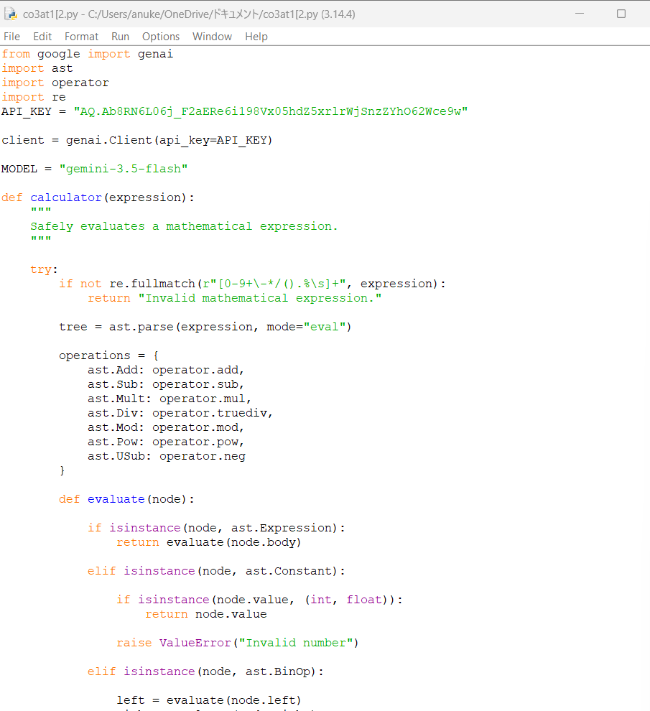

Expected Output
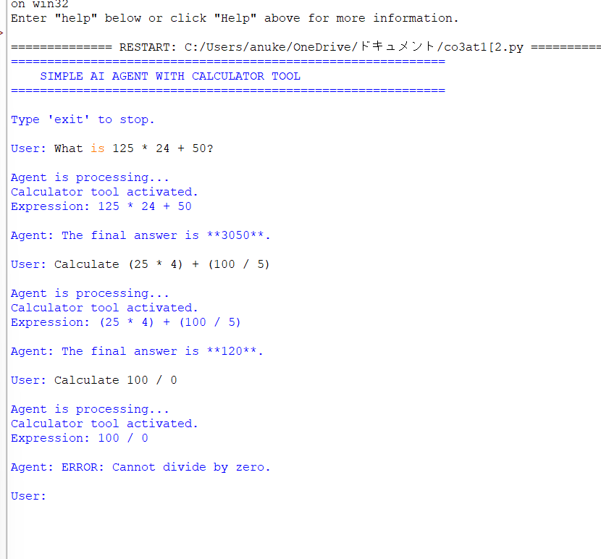

Advantages
- Combines Generative AI with an external tool.
- Provides accurate mathematical calculations.
- Handles normal questions.
- Demonstrates basic AI-agent behavior.
- Modular and easy to extend.
- Provides error handling.

Limitations
- Requires a Gemini API key.
- Requires internet access.
- Depends on the Gemini API for query classification.
- Calculator supports only the operations implemented in the program.
- API limits may apply.

Expected Outcome
The developed AI agent should be able to distinguish between normal questions and mathematical questions. For normal questions, it generates an answer using Gemini. For mathematical questions, it invokes the calculator tool and uses the calculated result to provide the final response.
This demonstrates an important Generative AI concept: an AI model can use external tools instead of relying entirely on its own generated knowledge or calculations.

Final Conclusion
The two applications demonstrate different practical uses of Generative AI. The AI Resume Information Extractor uses Gemini to transform unstructured resume text into structured JSON information, while the Simple AI Agent with Calculator Tool demonstrates how an AI model can decide when an external tool is required.
Both applications satisfy the requirements of using Python, a Generative AI API, user input, generated output, error handling, modular programming, comments, and test cases.

RUBRICS FOR CALCULATION

Criteria | Weight age | Level 4 –  Exemplary | Level 3 – Proficient | Level 2 –  Developing | Level 1 – Beginning
API  Integration  Correctness | 30% | Correct, efficient API integration; understands request/response flow | Correct integration with minor inefficiencies | Partial integration with functional errors | API integration non-functional / major errors
ProblemSolving  Completeness | 25% | Solves the given problem completely and robustly | Solves problem with minor issues | Partial solution to the problem | Does not solve the assigned problem
Code Quality | 20% | Clean, well-structured, error-handled code | Reasonably clean code | Code works but poorly structured | Code is unreliable or unstructured
Input/Output  Demo | 15% | Clear demo showing inputs/outputs and edge cases | Demo covers the main use cases | Demo is incomplete | No functional demo presented
Code Documentatio n | 10% | Well-commented code with clear  README/setup steps | Adequate comments/instructio ns | Minimal documentation provided | No  documentation provided
Marks Evaluation:
Questio n No. | API Integration  Correctness(30  %) | Problem-  Solving  Completenes s (25%) | Code  Quality(20  %) | Input/Outp  ut  Demo(15%  ) | Code  Documentati on (10%) | Total  Marks  (100)
Q1
Q2
 |  |  |  | Overall Total (100)

