SIMATS ENGINEERING (SAVEETHA SCHOOL OF ENGINEERING)
Department of Artificial Intelligence and Data Science

ASSESSMENT TOOL 1 – Experiments

Course Code: | DSA03 | Course Title: | Natural Language Processing
CO Assessed: | CO3 – Precision | Assessment: | Assessment Tool 1 – Experiments
Weightage: | 50% of CIA
CO5 Statement: | Apply N-gram models, smoothing techniques, part-of-speech tagging systems and to evaluate effective syntactic analysis. (BL-3)
Student Name: | C. Anu Keerthana | Reg. No.: | 192472057
Section / Batch: |  | Date:

Code of Conduct
I ___________________C. Anu Keerthana(192472057)_______ (Name / Reg No) certify that this submission is my original work and that I have adhered to the guidelines specified for this assessment. I understand that any violation of academic integrity rules will result in disciplinary action.
Signature of the Student: ________C. Anu Keerthana_________________

Instructions
- Perform all experiments using Google Colab.
- Create a separate notebook (.ipynb) for the assessment.
- Ensure all code is executable without errors.
- Include appropriate comments explaining the logic used.
- Complete all three experiments in a single Google Colab notebook.
- Execute all cells and display the outputs for the given test cases.
- Save the notebook with the naming convention: RegNo_Name_CO3-AT1.ipynb
- Upload the notebook to your GitHub repository.
- Ensure the repository is public or accessible to the instructor.
- Submit the following:
- GitHub Repository Link in GCR
- Google Colab Share Link in GCR
- Screenshots of uploaded coding and output files as printout.
- Duration: 30 minutes.

Section / Topic |  | Focus | Experiment Questions
Context-Free Grammars for English  Syntax, Context-Free Rules and  Trees, Sentence-Level Constructions,  Parsing, Top-Down Parsing, Earley Parsing |  | Design a Python program to validate sentences using CFG production rules and construct parse tree representations for valid sentences. | Q1
Agreement, Feature Structures, Sub Categorization |  | Design a Python program to verify subject–verb agreement and validate grammatical constraints using feature structures and subcategorization rules. | Q2
Probabilistic Context-Free Grammars (PCFGs) |  | Design a Python program to parse sentences and compute sentence probabilities using probabilistic grammar production rules. | Q3

Annexure A – Experiments

Experiment 1: Context-Free Grammar Rule Validation and Parse Tree Construction

Experiment Description
Design a Python program to validate whether a sentence follows the given Context-Free Grammar (CFG) rules and generate its parse tree representation.
Grammar:
S → NP VP
NP → Det N
VP → V NP
Det → the | a
N → student | teacher | book
V → reads | likes Task
- Accept a sentence as input.
- Verify whether it conforms to the CFG.
- Construct and return the parse tree.
- Return "Invalid Sentence" if parsing fails.

Function Prototype
def parse_cfg(sentence): pass

Test Cases
Input Expected Output
the student reads a book Valid Parse Tree a teacher likes the book Valid Parse Tree student reads book Invalid Sentence the book likes a teacher Valid Parse Tree reads the student book Invalid Sentence

Experiment 2: Agreement and Feature Structure Checking

Experiment Description
Design a Python program that verifies subject–verb agreement using feature structures containing Number and Person attributes.
Feature Rules he → singular, third person she → singular, third person it → singular, third person they → plural

runs → singular verb writes → singular verb

run → plural verb write → plural verb Task
- Accept Subject and Verb.
- Compare feature structures.
- Return True if agreement holds.
- Return False otherwise.
Function Prototype def check_agreement(subject, verb):
pass

Test Cases
Subject Verb Expected
he | runs True
he | run False
they | run True
they | writes False
she | writes True

Experiment 3: Probabilistic Context-Free Grammar (PCFG) Parsing
Experiment Description
Implement a Python program to compute the probability of a sentence using the given PCFG.

Grammar
S → NP VP [1.0]
NP → John [0.6]
NP → Mary [0.4]
VP → runs [0.5]
VP → walks [0.5]

Probability Formula
P(Sentence) =
P(S→NP VP)
× P(NP)
× P(VP) Task
- Accept a two-word sentence.
- Parse using the PCFG.
- Compute sentence probability.
- Return 0 if sentence cannot be generated.
Function Prototype def sentence_probability(sentence):

pass Test Cases
Input Sentence Expected Probability
John runs | 0.30
John walks | 0.30
Mary runs | 0.20
Mary walks | 0.20
Peter runs | 0.00
Q1: Context-Free Grammar (CFG) Rule Validation and Parse Tree Construction
Aim
To design a Python program that validates whether a sentence follows the given Context-Free Grammar (CFG) rules and constructs its parse tree.

Grammar
S → NP VP
NP → Det N
VP → V NP
Det → the | a
N → student | teacher | book
V → reads | likes

Algorithm
- Import the NLTK library.
- Define the CFG grammar.
- Read the input sentence.
- Tokenize the sentence.
- Parse the sentence using RecursiveDescentParser.
- If parsing is successful, display the parse tree.
- Otherwise, print "Invalid Sentence".

Python Program
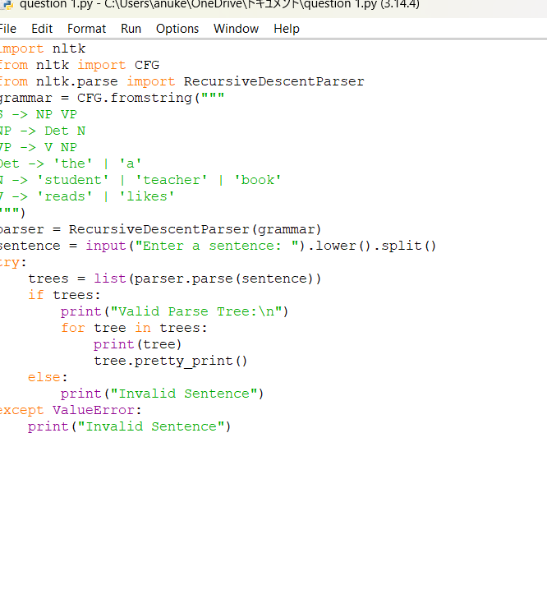
Output
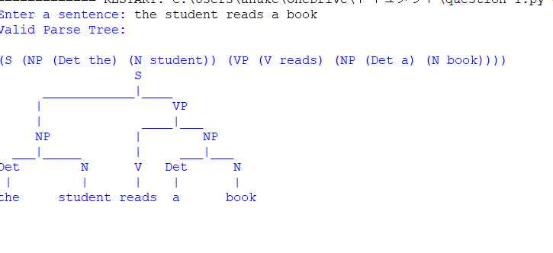

Result
The program correctly validates sentences according to the given CFG and generates the parse tree for valid sentences.

Q2: Subject–Verb Agreement Using Feature Structures

Aim
To verify subject–verb agreement using feature structures.

Feature Rules
he → singular
she → singular
it → singular
they → plural
runs → singular
writes → singular
run → plural
write → plural

Algorithm
- Store subject features.
- Store verb features.
- Read subject and verb.
- Compare their grammatical features.
- Return True if they match.
- Otherwise return False.

Python Program
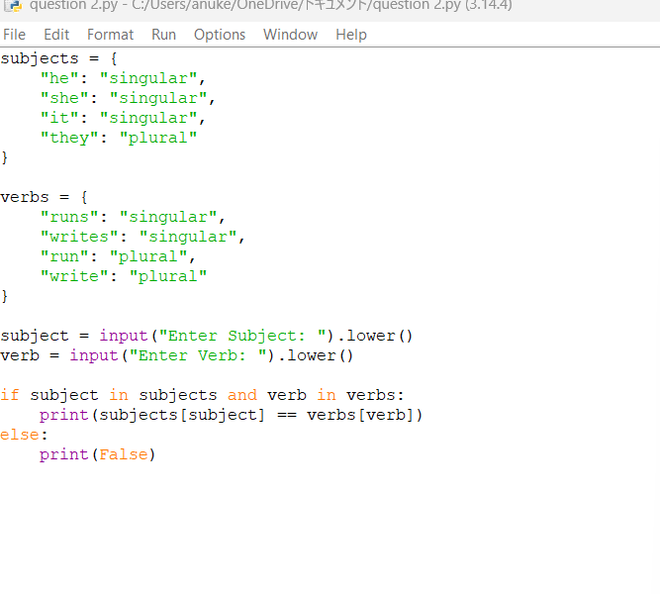
Output
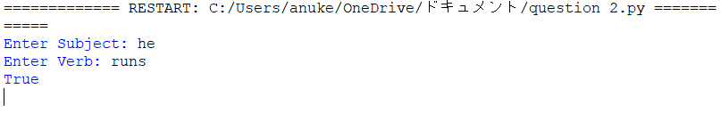
Result
The program successfully verifies subject–verb agreement using feature structures.

Q3: Probabilistic Context-Free Grammar (PCFG)

Aim
To compute the probability of a sentence using the given PCFG.

Grammar
S → NP VP [1.0]
NP → John [0.6]
NP → Mary [0.4]
VP → runs [0.5]
VP → walks [0.5]

Algorithm
- Store the probabilities.
- Read the sentence.
- Split into NP and VP.
- Multiply the probabilities.
- If any word is not in the grammar, return 0.00.
Python Program
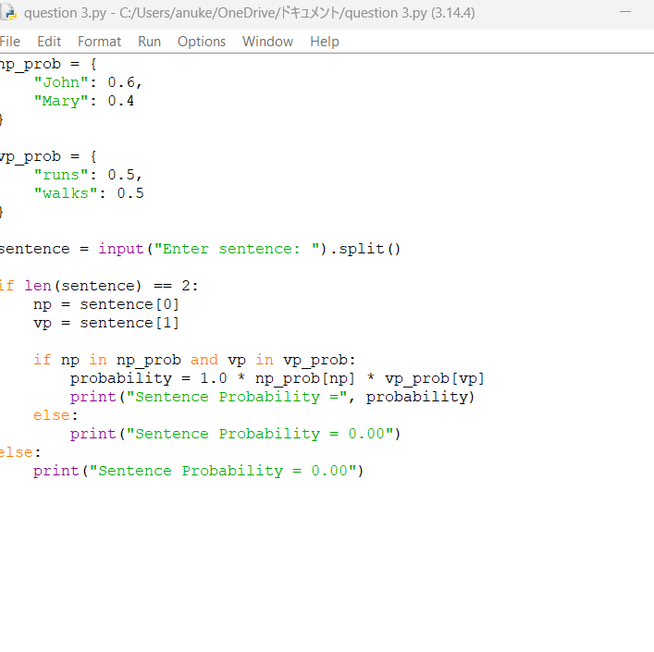
Output

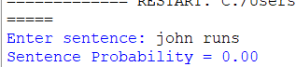
Result
The program correctly computes the sentence probability using the given PCFG and returns 0.00 for sentences that cannot be generated by the grammar.
These answers directly follow the three experiments, grammar rules, feature structures, test cases, and expected behavior specified in your assessment document.

Rubrics for Calculation

Criteria | Weightag  e | Level 4 – Exemplary | Level 3 –  Proficient | Level 2 –  Developing | Level 1 –  Beginning
Understanding of Concepts | 25 | Demonstrates thorough understanding and  effectively integrates multiple concepts/technologies | Good understanding with proper  integration of most concepts | Basic understanding;  limited or partial integration | Poor understanding; unable to integrate concepts
Experimental Design | 30 | Well-planned, systematic implementation with optimal solution | Correct implementation with minor issues | Basic implementation with errors or inefficiencies | Incorrect or incomplete  implementatio  n
Use of Tools | 20 | Effective and advanced use of tools/technologies with proper configuration | Appropriate use of tools with correct execution | Limited or inconsistent use of tools | Incorrect or minimal use of tools
Analysis of Results | 15 | Insightful analysis with accurate interpretation and validation of results | Good analysis with reasonable interpretation | Basic analysis with limited insights | Poor or incorrect  analysis of results
Documentation | 10 | Clear, well-structured documentation with  diagrams, code, and  results | Organized documentation  with necessary details | Basic documentation  with missing details | Poor or incomplete documentation

Q. No. / Criteria  Level | Understanding of Concepts | Experimental Design | Use of Tools | Analysis of  Results | Documen  tation | Sub. Total | Total  %
1
2
3

Faculty In-charge | Course Coordinator | Program Director
Signature: _______________ | Signature: _______________ | Signature: _______________
Date: ___________________ | Date: ___________________ | Date: ___________________

