SIMATS ENGINEERING (SAVEETHA SCHOOL OF ENGINEERING)
Department of Artificial Intelligence and Data Science
ASSESSMENT TOOL 1 – APPLICATION BASED QUESTIONS

Course Code: | DSA03 | Course Title: | Natural Language Processing
CO Assessed: | CO1 – Imitation (L1) | Assessment: | Assessment Tool 1 – Application Based Questions
Weightage: | 40% of CIA
CO1 Statement: | Analyse NLP models, regular expression patterns, finite state automata, morphological processing techniques and to interpret language processing. (BL-3)
Student Name: | C. Anu Keerthana | Reg. No.: | 192472057
Section / Batch: |  | Date:

Code of Conduct
I _____________C. Anu Keerthana(192472057)_____________ (Name / Reg No) certify that this submission is my original work and that I have adhered to the guidelines specified for this assessment. I understand that any violation of academic integrity rules will result in disciplinary action.
Signature of the Student: _________________________

Instructions
- Develop a modular and efficient Python program that satisfies all the functional requirements specified in the problem statement.
- Demonstrate the correctness of the implementation using suitable test cases and justify the output obtained.
- Follow good programming practices, including meaningful variable names, proper code indentation, comments, and error handling wherever applicable.
- Duration: 30 minutes.

Section / Topic | Focus | Q Nos
Information Extraction | Regex-Based Information Extraction | 1
Pattern Matching | Regex Pattern Matching | 2
Regular Expression Patterns | Regex-Based Input Validation | 3

Annexure A – Application Based Questions

Section 1: Regular Expressions – Resume Information Extraction
- A multinational recruitment company receives thousands of resumes every day in text format. The HR department requires an automated system to extract candidate information for shortlisting.

Design and implement a Python-based resume information extraction system using Regular Expressions that performs the following tasks:

Extract the candidate's name.
Identify email addresses.
Extract mobile numbers.
Detect technical skills (Python, Java, SQL, Machine Learning, NLP).
Extract years of experience.
Generate a structured summary of the candidate's profile.
Display candidates who satisfy the minimum eligibility criteria (minimum 2 years of experience and Python skill).

Section 2: Regular Expressions – Product Search System
- An e-commerce company plans to enhance its product search engine to improve customer experience through flexible keyword matching.

Design and implement a Python-based product search system using Regular Expressions that performs the following tasks:

Search products using an exact keyword.
Perform prefix-based searches.
Perform suffix-based searches.
Search using partial keywords.
Perform case-insensitive searches.
Display all matching product names.
Generate a report showing the total number of matching products for each search.
Section 3: Regular Expressions – University Registration System
A university is developing an automated online registration portal to verify student information before course enrollment.

Design and implement a Python-based validation system using Regular Expressions that performs the following tasks:

Validate the student register number.
Validate the institutional email address.
Validate the course code.
Validate the semester information.
Validate the student's mobile number.
Display appropriate validation messages for each field.
Generate a final registration status report indicating whether the registration is successful.

Rubrics for Calculation
Criteria | Weightage | Level 4 – Exemplary | Level 3 – Proficient | Level 2 – Developing | Level 1 – Beginning
Understanding of Problem Context | 20 | Clearly understands the problem and accurately identifies all requirements | Good understanding with minor gaps | Basic understanding; some requirements unclear | Poor understanding or misinterpretation of the problem
Application of Concepts | 30 | Accurately applies appropriate concepts to solve complex problems | Applies relevant concepts correctly with minor errors | Applies basic concepts with limited accuracy | Fails to apply appropriate concepts
Problem-Solving Approach | 20 | Logical, well-structured, and efficient approach | Mostly logical approach with minor gaps | Basic approach with some inconsistencies | Illogical or unclear approach
Accuracy of Solution | 20 | Completely correct solution with proper justification | Mostly correct with minor errors | Partially correct solution | Incorrect or incomplete solution
Clarity | 10 | Clear, well-organized, and properly explained solution | Understandable with minor clarity issues | Limited clarity and explanation | Poorly presented and difficult to understand

Q. No. / Criteria | Understanding of Problem Context | Application of Concepts | Problem-Solving Approach | Accuracy of Solution | Clarity | Sub. Total | Total %
1
2
3

Faculty In-charge | Course Coordinator | Program Director
Signature: _______________ | Signature: _______________ | Signature: _______________
Date: ___________________ | Date: ___________________ | Date: ___________________

Question 1: Resume Information Extraction System using Regular Expressions
Title: Resume Information Extraction System using Regular Expressions
Aim:
To design and implement a Python-based Resume Information Extraction System using Regular Expressions that automatically extracts important candidate information from resumes, generates a structured summary, and identifies eligible candidates based on predefined criteria.
Problem Statement
A multinational recruitment company receives thousands of resumes every day in text format. Manually reviewing these resumes is time-consuming and error-prone. Therefore, the HR department requires an automated system that can extract candidate information using Regular Expressions.
The system should:
- Extract the candidate's name.
- Identify email addresses.
- Extract mobile numbers.
- Detect technical skills (Python, Java, SQL, Machine Learning, NLP).
- Extract years of experience.
- Generate a structured summary of the candidate's profile.
- Display candidates who satisfy the minimum eligibility criteria (minimum 2 years of experience and Python skill).
Objectives
- Automate resume processing.
- Reduce manual effort in recruitment.
- Improve the accuracy of information extraction.
- Identify eligible candidates quickly.
- Generate a structured candidate profile.
Requirements
Software Requirements
- Python 3.x
- IDLE / VS Code / Jupyter Notebook
Python Module
- re (Regular Expressions)
Algorithm
- Import the re module.
- Read the resume text.
- Use Regular Expressions to extract:
  - Candidate Name
  - Email Address
  - Mobile Number
  - Technical Skills
  - Years of Experience
- Display the extracted information.
- Check whether:
  - Experience is at least 2 years.
  - Python skill is present.
- If both conditions are satisfied, display Eligible Candidate.
- Otherwise display Not Eligible.
Python Program
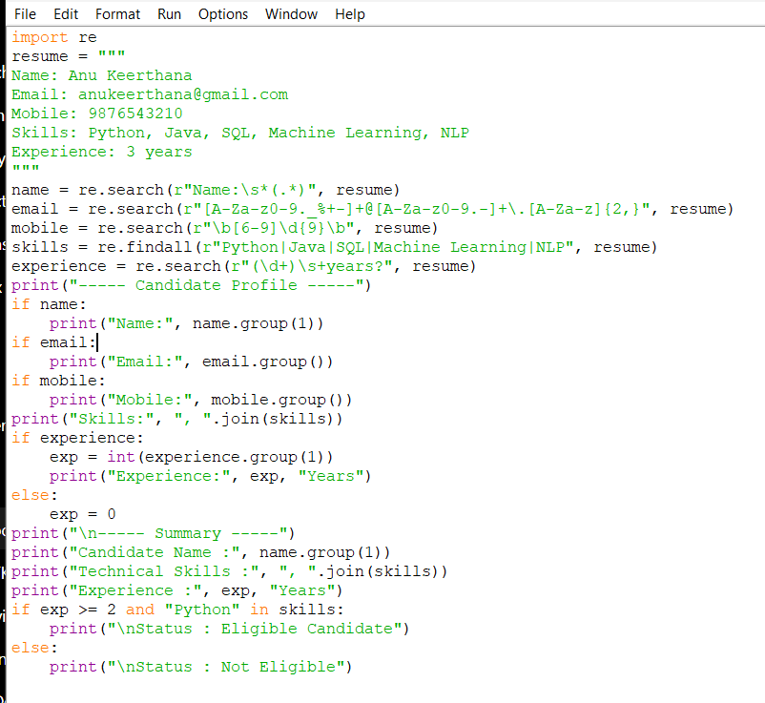
RESULT:
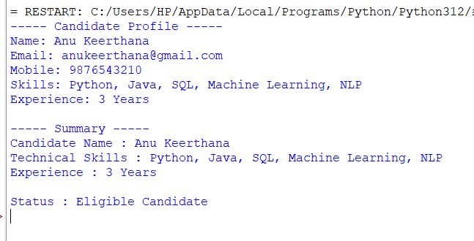
Explanation
The program uses the Python re module to identify different patterns in the resume text. Regular Expressions are used to extract the candidate's name, email, mobile number, technical skills, and years of experience. After extracting the information, the program checks whether the candidate has at least two years of experience and possesses Python skills. If both conditions are satisfied, the candidate is considered eligible for shortlisting.
Advantages
- Fast resume processing.
- Reduces manual work.
- Accurate extraction of candidate details.
- Easy to modify for additional skills.
- Improves recruitment efficiency.
Applications
- Recruitment companies.
- HR departments.
- Job portals.
- Resume screening systems.
- Placement management systems.
Result
The Resume Information Extraction System was successfully implemented using Python Regular Expressions. The system correctly extracted candidate information, generated a structured profile summary, and identified eligible candidates according to the specified criteria.

Question 2: Product Search System using Regular Expressions
Title: Product Search System using Regular Expressions
Aim
To design and implement a Python-based Product Search System using Regular Expressions that performs flexible product searches using exact keywords, prefix, suffix, partial keywords, and case-insensitive matching.
Problem Statement
An e-commerce company plans to improve its product search engine to enhance customer experience through flexible keyword matching. The system should:
- Search products using an exact keyword.
- Perform prefix-based searches.
- Perform suffix-based searches.
- Search using partial keywords.
- Perform case-insensitive searches.
- Display all matching product names.
- Generate a report showing the total number of matching products for each search.
Objectives
- Improve product searching.
- Reduce search time.
- Support multiple search methods.
- Display all matching products.
- Count the total number of matches.
Software Requirements
- Python 3.x
- IDLE / VS Code
- re module
Algorithm
- Import the re module.
- Store product names in a list.
- Display the search menu.
- Accept the user's choice.
- Perform the selected search using Regular Expressions.
- Display matching products.
- Display the total number of matches.

Python Program
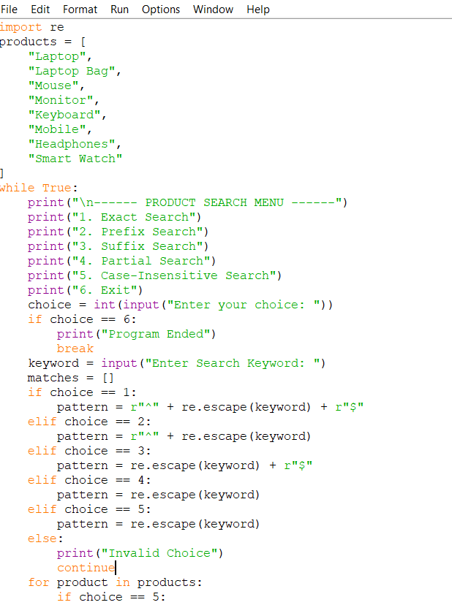
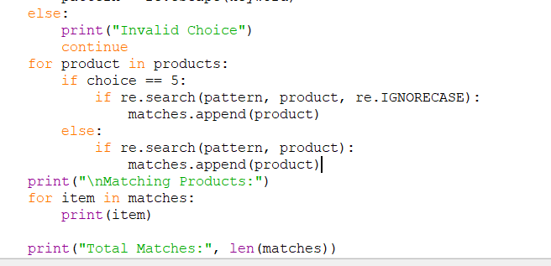
OUTPUT:
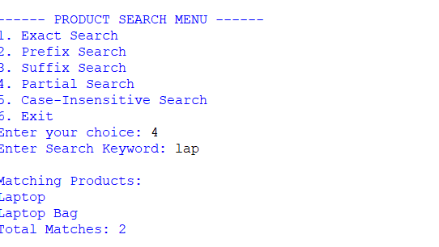

Explanation
The program stores product names in a list and performs different types of searches using Regular Expressions. It supports exact, prefix, suffix, partial, and case-insensitive searches and displays all matching products along with the total count.
Advantages
- Fast searching.
- Flexible keyword matching.
- User-friendly.
- Reduces search time.
- Easy to extend.
Applications
- Online Shopping Websites
- E-commerce Platforms
- Product Catalog Systems
- Inventory Management
Result
The Product Search System was successfully implemented using Python Regular Expressions and correctly displayed matching products for different search methods.

Question 3: University Registration Validation System using Regular Expressions
Title: University Registration Validation System using Regular Expressions
Aim
To design and implement a Python-based validation system using Regular Expressions to verify student registration details before course enrollment.
Problem Statement
A university is developing an automated online registration portal to verify student information before course enrollment. The system should:
- Validate the student register number.
- Validate the institutional email address.
- Validate the course code.
- Validate the semester information.
- Validate the student's mobile number.
- Display appropriate validation messages.
- Generate the final registration status report.
Objectives
- Validate student details.
- Prevent incorrect registrations.
- Ensure correct data entry.
- Display validation messages.
- Generate registration status.
Software Requirements
- Python 3.x
- IDLE / VS Code
- re module
Algorithm
- Import the re module.
- Accept student details.
- Validate:
  - Register Number
  - Institutional Email
  - Course Code
  - Semester
  - Mobile Number
- Display validation messages.
- If all validations are successful, display Registration Successful.
- Otherwise, display Registration Failed.
Python Program
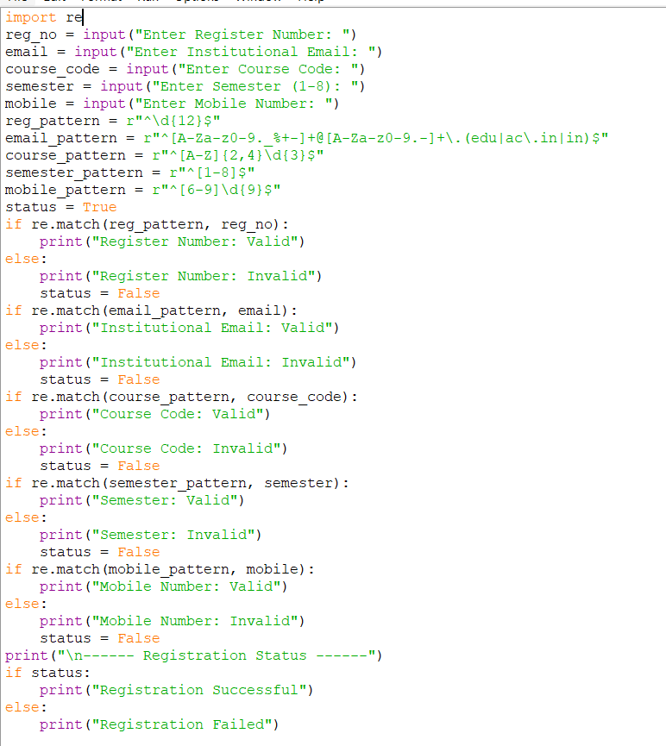
OUTPUT:
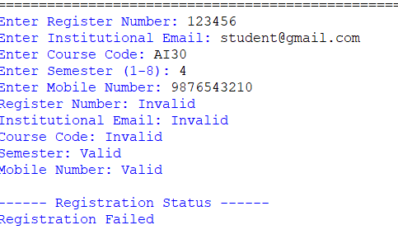
Explanation
The program validates each student detail using Regular Expressions. If all fields match the required format, the registration is successful; otherwise, the system displays appropriate validation messages and reports that registration has failed.
Advantages
- Ensures accurate student data.
- Reduces manual verification.
- Prevents invalid registrations.
- Easy to maintain.
- Fast validation.
Applications
- University Registration Portals
- Student Information Systems
- College Admission Systems
- Online Enrollment Platforms
Result
The University Registration Validation System was successfully implemented using Python Regular Expressions. It correctly validated all input fields and generated the final registration status based on the validation results.

