SIMATS ENGINEERING (SAVEETHA SCHOOL OF ENGINEERING)
Department of Artificial Intelligence and Data Science
ASSESSMENT TOOL 3 – CODING CHALLENGE

Course Code: | DSA03 | Course Title: | Natural Language Processing
CO Assessed: | CO1 – Imitation (L1) | Assessment: | Assessment Tool 3 – Coding Challenge
Weightage: | 30% of CIA
CO5 Statement: | Analyse NLP models, regular expression patterns, finite state automata, morphological processing techniques and to interpret language processing. (BL-3)
Student Name: | C. Anu Keerthana | Reg. No.: | 192472057
Section / Batch: | B.Tech-AI&DS | Date: | 15-07-2026

Code of Conduct
I Ch Sai Reshma_ (Name / Reg No) certify that this submission is my original work and that I have adhered to the guidelines specified for this assessment. I understand that any violation of academic integrity rules will result in disciplinary action.
Signature of the Student: C. Anu Keerthana

Instructions
- Develop a complete and modular Python program that meets all the functional requirements specified in the coding challenge using appropriate algorithms, data structures, and programming practices.
- Test the program using multiple valid and invalid test cases, and clearly display the input, processing, and output to verify the correctness of the implementation.
- Follow standard coding practices by using meaningful variable names, proper indentation, comments, exception handling (where applicable), and upload the source code, sample outputs, and README file to the designated GitHub repository.
- Duration: 40 minutes.

Section / Topic | Focus | Q Nos
Regular Expression Pattern Matching | Regular Expressions, Basic Regular Expression Patterns | 1
Finite State Automata Implementation | Finite State Automata, Models and Algorithms | 2
Advanced Regular Expression Search | Regular Expressions, Basic Regular Expression Patterns | 3

Annexure A – Coding Challenge

Section 1: Intelligent Email and Password Validator using Regular Expressions
- Problem Statement:
A software company is developing a user registration system. Before creating an account, the system must validate user credentials based on predefined security policies.

Develop a Python application that validates:
Email Address
Password
Mobile Number

using Regular Expressions.

Validation Rules
Email
Must start with an alphabet.
May contain letters, digits, '.', '_' before '@'.
Domain should contain only alphabets.
Valid extensions: .com, .org, .edu, .net, .in
Password
Minimum 8 characters
At least one uppercase letter
At least one lowercase letter
At least one digit
At least one special character (@,#,$,%,&,!)
Mobile Number
Must contain exactly 10 digits.
First digit should be between 6–9.
Expected Output

Display:

Valid Email / Invalid Email
Strong Password / Weak Password
Valid Mobile Number / Invalid Mobile Number

Section 2: Design a Finite State Automata (FSA) Simulator
- Problem Statement

Develop a Python-based Deterministic Finite Automata (DFA) simulator.

The program should:
- Accept the DFA description
    - States
    - Input alphabet
    - Transition table
    - Initial state
    - Final state(s)
- Accept multiple input strings.
- Simulate state transitions.
- Display whether the string is Accepted or Rejected.
Example

Language:
Strings ending with "ab"

Input
abaab

Output
Transition Path:
q0 → q1 → q0 → q1 → q2
Accepted
Section 3: Smart Pattern Matching Engine using Regular Expressions
- Problem Statement

Develop a Python-based text search engine that performs pattern matching using Regular Expressions.

The system should support:
Word Search
Prefix Search
Suffix Search
Date Search
Phone Number Search
Hashtag Search
Mention (@username) Search

Example Input
Meeting on 12/09/2026
Call 9876543210
#NLP
@OpenAI
natural language processing

User Menu
1.Search Date
2.Search Phone Number
3.Search Hashtag
4.Search Mention
5.Search Prefix
6.Search Suffix

Expected Output
Display all matching patterns based on user selection.

Question 1: Intelligent Email and Password Validator using Regular Expressions
Title
Intelligent Email and Password Validator using Regular Expressions
Aim
To design and implement a Python-based validation system using Regular Expressions that validates an email address, password, and mobile number according to predefined security rules.

Problem Statement
A software company is developing a user registration system. Before creating an account, the system must verify user credentials using Regular Expressions.
The system should:
- Validate Email Address
- Validate Password
- Validate Mobile Number
- Display whether each input is valid or invalid
- Ensure secure user registration by enforcing validation rules

Objectives
- Validate email format.
- Verify password strength.
- Validate mobile number format.
- Reduce invalid user registrations.
- Improve application security.

Software Requirements
- Python 3.x
- IDLE / VS Code / Jupyter Notebook
Python Module
- re (Regular Expressions)

Algorithm
- Import the re module.
- Read email, password, and mobile number from the user.
- Create Regular Expression patterns for:
  - Email
  - Password
  - Mobile Number
- Compare user input with the corresponding pattern.
- Display:
  - Valid Email / Invalid Email
  - Strong Password / Weak Password
  - Valid Mobile Number / Invalid Mobile Number
- End the program.

Python Program
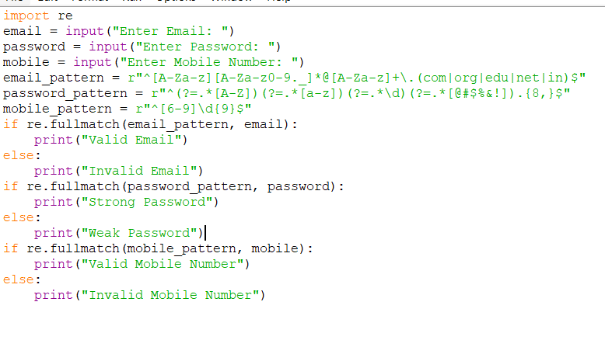

OUTPUT:
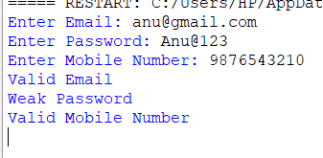
Explanation
The program uses Python's re module to validate user credentials based on predefined Regular Expression patterns. The email pattern verifies the correct email structure, the password pattern ensures that the password contains at least one uppercase letter, one lowercase letter, one digit, one special character, and has a minimum length of eight characters. The mobile number pattern checks whether the number contains exactly ten digits and starts with a digit between 6 and 9. Appropriate validation messages are displayed for each input.

Advantages
- Provides secure user validation.
- Prevents invalid user registrations.
- Reduces manual verification.
- Fast and efficient validation.
- Easy to modify according to future requirements.

Applications
- User Registration Systems
- Online Banking
- College Admission Portals
- E-Commerce Websites
- Social Media Applications
- Employee Registration Systems

Result
The Intelligent Email and Password Validator using Regular Expressions was successfully implemented using Python. The system correctly validated the email address, password, and mobile number according to the specified rules and displayed appropriate validation messages.

Question 2: Design a Finite State Automata (DFA) Simulator
Title
Design a Finite State Automata (DFA) Simulator

Aim
To design and implement a Python-based Deterministic Finite Automata (DFA) Simulator that accepts multiple input strings, simulates state transitions, and determines whether each string is accepted or rejected.

Problem Statement
A software company is developing a text processing application that requires pattern recognition using Deterministic Finite Automata (DFA). The system should simulate the working of a DFA based on user-defined states and transitions.
The system should:
- Accept DFA states.
- Accept input alphabet.
- Accept transition table.
- Accept initial state.
- Accept final state(s).
- Accept multiple input strings.
- Display the transition path.
- Display whether the string is Accepted or Rejected.

Objectives
- Simulate the working of a DFA.
- Verify whether an input string belongs to the language.
- Display state transitions clearly.
- Improve understanding of Finite State Automata.
- Automate DFA execution.

Software Requirements
- Python 3.x
- IDLE / VS Code / Jupyter Notebook
Python Module
- No external modules required.

Algorithm
- Define the DFA states.
- Define the input alphabet.
- Define the transition table.
- Specify the initial state.
- Specify the final (accepting) state.
- Read the input string from the user.
- Start from the initial state.
- For each character in the input string:
  - Move to the next state according to the transition table.
  - Store the transition path.
- After processing all characters:
  - If the final state is an accepting state, display Accepted.
  - Otherwise, display Rejected.
- Display the complete transition path.

Python Program
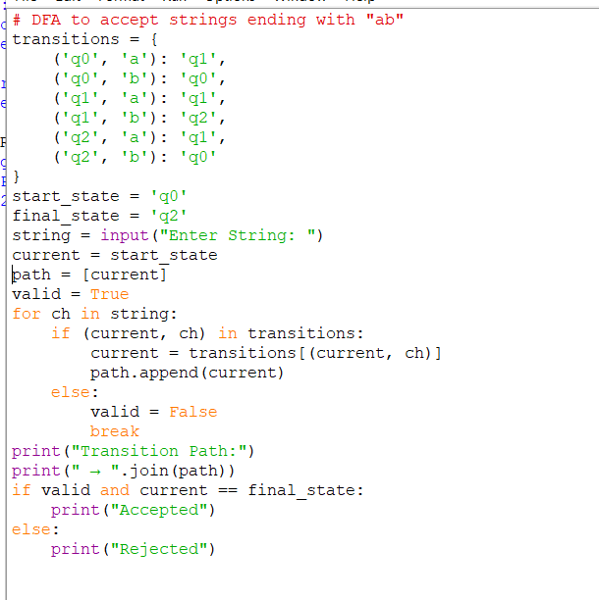
OUTPUT:
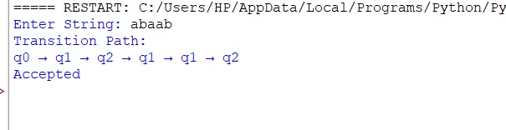
Explanation
The program simulates a Deterministic Finite Automata (DFA) for the language consisting of strings ending with "ab". It begins from the initial state (q0) and processes each input symbol using the predefined transition table. The transition path is displayed step by step. After the entire string is processed, the program checks whether the current state is the accepting state (q2). If yes, the string is accepted; otherwise, it is rejected.

Advantages
- Simple and efficient implementation.
- Clearly demonstrates DFA state transitions.
- Easy to modify for different languages.
- Useful for pattern matching.
- Helps understand automata concepts.

Applications
- Lexical Analysis in Compilers
- Pattern Matching
- Text Processing
- Input Validation
- Token Recognition
- Digital Circuit Design

Result
The Deterministic Finite Automata (DFA) Simulator was successfully implemented using Python. The simulator correctly processed input strings, displayed the transition path, and determined whether each string was accepted or rejected according to the defined DFA.

Question 3: Smart Pattern Matching Engine using Regular Expressions
Title
Smart Pattern Matching Engine using Regular Expressions

Aim
To design and implement a Python-based Smart Pattern Matching Engine using Regular Expressions that performs word search, prefix search, suffix search, date search, phone number search, hashtag search, and mention (@username) search from a given text.

Problem Statement
A software company is developing a text search engine to extract useful information from text documents using Regular Expressions. The system should identify different types of patterns efficiently.
The system should:
- Search for words.
- Perform prefix search.
- Perform suffix search.
- Search for dates.
- Search for phone numbers.
- Search for hashtags.
- Search for mentions (@username).
- Display all matching patterns based on the user's selection.

Objectives
- Perform efficient text pattern matching.
- Extract important information from text.
- Support multiple search operations.
- Reduce manual searching effort.
- Improve text processing efficiency.

Software Requirements
- Python 3.x
- IDLE / VS Code / Jupyter Notebook
Python Module
- re (Regular Expressions)

Algorithm
- Import the re module.
- Store the input text.
- Display the search menu.
- Accept the user's choice.
- Apply the corresponding Regular Expression pattern:
  - Date Search
  - Phone Number Search
  - Hashtag Search
  - Mention Search
  - Prefix Search
  - Suffix Search
- Display all matching patterns.
- End the program.

Python Program
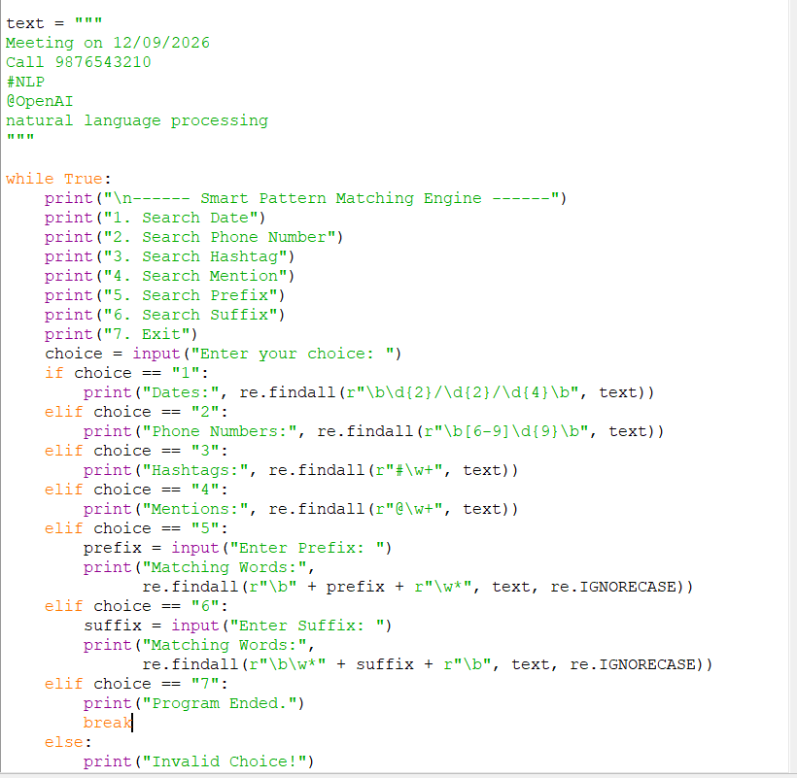

OUTPUT:
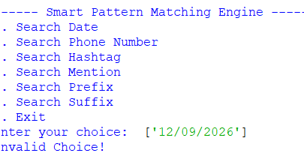
Explanation
The program uses Python's re module to perform pattern matching on a given text. It provides a menu-driven interface where the user can search for dates, phone numbers, hashtags, mentions, prefixes, and suffixes. Each option applies a suitable Regular Expression pattern to extract matching information from the text and displays the results.

Advantages
- Fast and efficient pattern searching.
- Supports multiple search operations.
- Easy to modify and extend.
- Reduces manual text searching.
- Improves text processing accuracy.

Applications
- Search Engines
- Text Mining
- Social Media Analysis
- Document Processing
- Information Extraction Systems
- Natural Language Processing (NLP)

Result
The Smart Pattern Matching Engine using Regular Expressions was successfully implemented using Python. The system correctly identified dates, phone numbers, hashtags, mentions, prefixes, and suffixes from the given text and displayed the matching results accurately.

Rubrics for Calculation
Criteria | Weightage | Level 4 – Exemplary | Level 3 – Proficient | Level 2 – Developing | Level 1 – Beginning
Problem Understanding | 20% | Clearly understands problem constraints, edge cases, and competitive requirements | Understands problem with minor gaps in constraints | Partial understanding; misses key constraints | Misinterprets problem or constraints
Algorithm | 25% | Selects optimal algorithm with best time and space complexity for competitive constraints | Uses efficient algorithm with minor scope for improvement | Uses basic/inefficient approach | No clear algorithmic approach
Code Implementation | 20% | Writes correct, efficient, and clean code that passes all constraints | Code works with minor errors or inefficiencies | Partially correct code; fails for some cases | Code does not execute or gives incorrect results
Competitive Performance | 20% | Solves problem within time limits and handles large inputs effectively | Solves within acceptable time with minor delays | Struggles with time limits or larger inputs | Unable to solve within time constraints
Test Case Handling | 15% | Handles all test cases including edge and hidden cases | Handles most test cases | Misses important edge cases | Fails on multiple test cases

Q. No. / Criteria | Problem Understanding | Algorithm | Code Implementation | Competitive Performance | Test Case Handling | Sub. Total | Total %
1
2
3

Faculty In-charge | Course Coordinator | Program Director
Signature: _______________ | Signature: _______________ | Signature: _______________
Date: ___________________ | Date: ___________________ | Date: ___________________

