ANUKEERTHANA S

Module 1 - Data structures and Algorithms
Exercise – 07
Financial Forecasting
1. Understanding Recursive Algorithms
Definition
Recursion is a programming technique where a function calls itself to solve smaller instances of the same problem.
Key Components
- Base Case → Stops recursion
- Recursive Case → Function calls itself with reduced input
Why recursion is useful in forecasting?
Financial growth is naturally repetitive:
- Each year depends on the previous year
- Growth is applied repeatedly over time
2. Problem Setup
We calculate future value using:
Formula
$$FV(n)=FV(n-1)×(1+r)$$
Where:
- FV(n) → Future value at year n
- r → Growth rate
- FV(0) → Initial value
3. Implementation
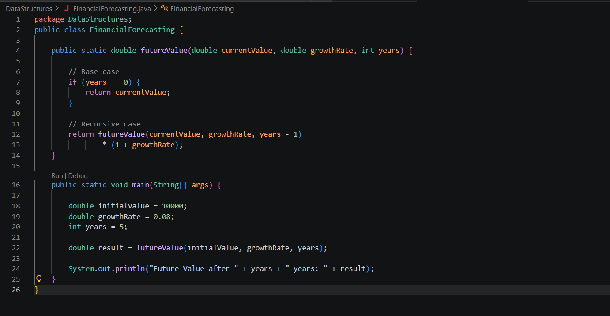

Output:
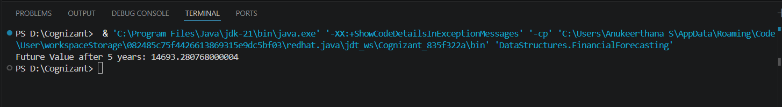
4. Analysis
Time Complexity
The recursive algorithm calls itself once for each year.
- Best Case: O(1) (years = 0)
- Average Case: O(n)
- Worst Case: O(n)
Overall Time Complexity: O(n)
Space Complexity
Each recursive call is stored in the stack.
Space Complexity: O(n)
Optimization
To avoid excessive computation:
- Memoization: Store results to avoid repeated calculations
- Iteration: Replace recursion with loop → O(1) space
- Formula method: Use $FV=PV×(1+r)^{n}$→ fastest (O(1))

