ANUKEERTHANA S
727723EUCS017
CSE-A
Create and Validate a Virtual Machine Using VirtualBox
1. VirtualBox VM Settings Screenshot
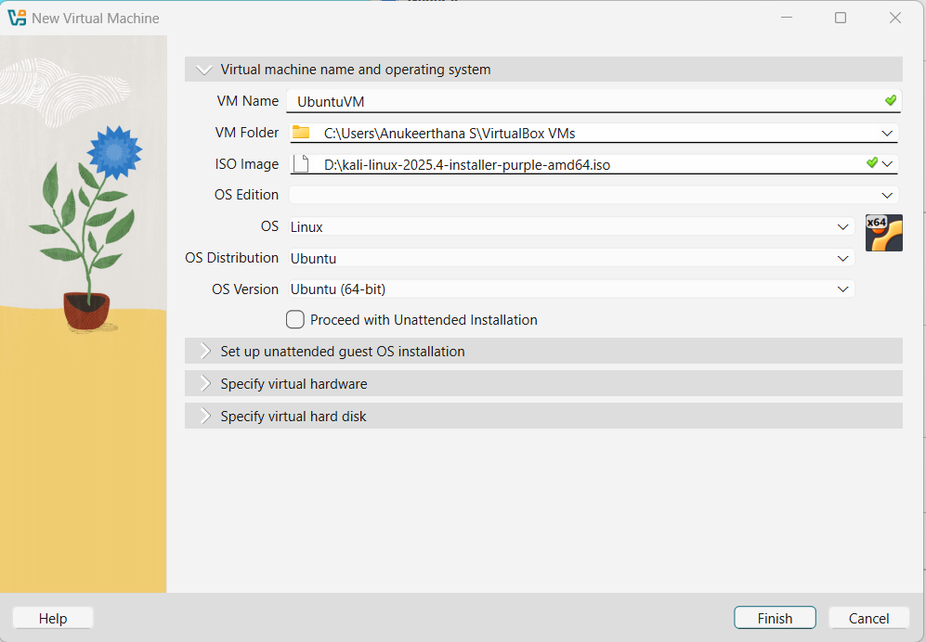
2. Storage Configuration Screenshot
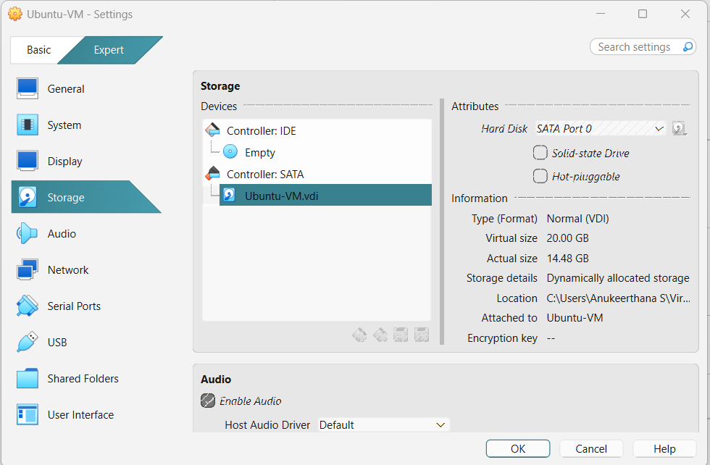

3. Guest OS Running Screen
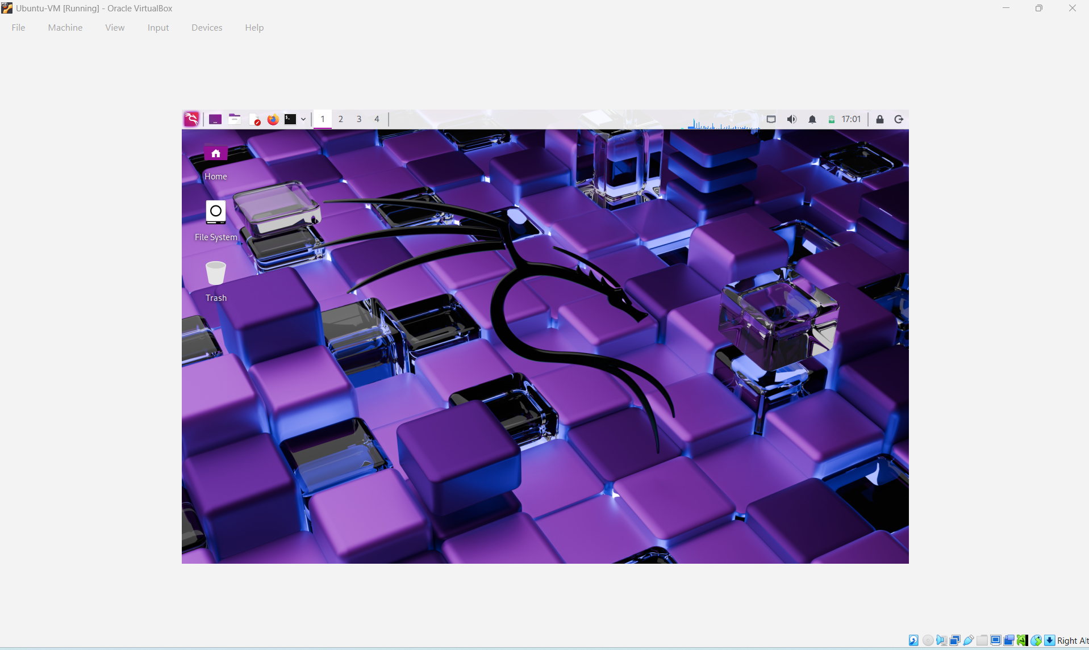

4. Terminal Output Showing OS Version
