GreenCircle Certified Database
Analyst Certificate Guide
How to create, edit, publish and import certificates, and what the system does on its own.
Version | 1.0
Issued | September 2026
Applies to | Test environment
Prepared by | Anuki Consulting
Audience | Analysts and administrators

ABOUT THE SCREENSHOTS
Every screenshot was taken from the current build on the test site, signed in as an analyst. Company names, product names and certificate numbers in the pictures are whatever happened to be on screen at the time.

Contents
Right-click and choose Update Field to build the contents.

1. What you can do
Analysts and administrators share the certificate screens. Signing in takes you to the internal certificate list, and the menu gives you Certificates, Dashboard, and Companies & Products. Administrators additionally get Administration; everything in this guide is available to both roles.
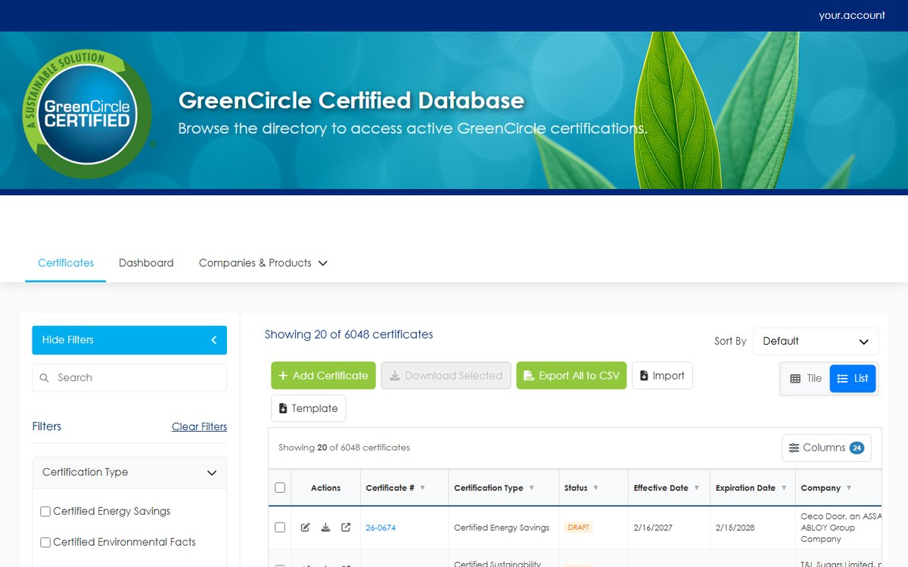
Figure 1 The internal certificate list. This is the working view — every certificate, every status, with the filters and columns you choose.
The internal list differs from what a company or partner sees in one important way: it shows every certificate in every status, including Draft, Hold and Expired. The company's own view shows only certificates that are in force. Section 2 explains which is which.

2. The eight statuses
Status is the single most consequential field on a certificate. It decides whether the certificate appears on the public database, whether it reaches a partner feed, and whether the certified company can see it at all.
Status | In force? | On the public database? | Company sees it?
Draft | No | No | No
Client Approved - Not Paid | No | No | No
Client Approved - Confidential | Yes | No — deliberately embargoed | Yes
Client Approved - Paid | Yes | Yes | Yes
Hold | No | No | No
Republished | Yes | Yes | Yes
Expired | No | No | No
Expired - No Annual Verification | No | No | No

CONFIDENTIAL IS AN EMBARGO, NOT A PAUSE
A Confidential certificate is paid, in force and badgeable. It is withheld from the anonymous public listing and from nothing else — the certified company sees it, and it still counts as active. Do not use Confidential to park work that is not ready; use Hold or Draft for that.

2.1 There is no enforced path between statuses
You may move a certificate from any status to any other. The system does not restrict the order, and it will not stop you going from Draft straight to Republished.
Two things still happen automatically, and they are covered in section 7: a certificate whose expiration date has passed is forced to Expired when you save it, and every status change is recorded against the certificate whether you made it or the system did.

3. Creating a certificate
Open Certificates, then Create Certificate.
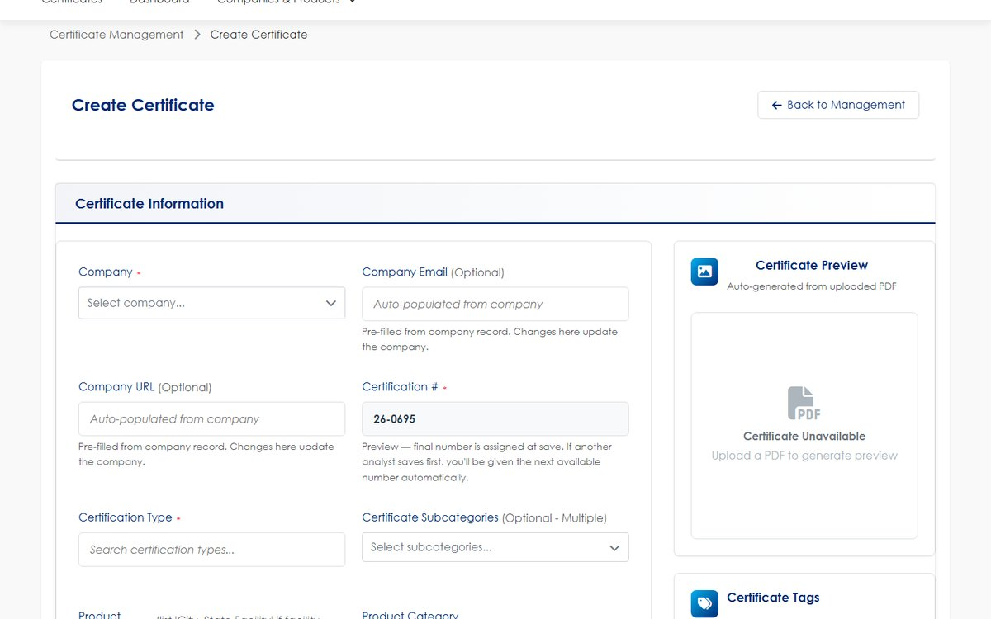
Figure 2 The top of the Create Certificate form. The certification number is assigned for you.

3.1 The certificate number is assigned, not typed
Certification # is filled in and read-only. The number shown is a preview of the next available number — the final number is assigned when you save, and if another analyst saves first you are given the next one automatically. You never need to work out the next number yourself, and you cannot collide with a colleague who is creating a certificate at the same moment.

3.2 Fields that do more than they look like
Three fields have effects beyond the certificate in front of you.
Field | What it also does
Company Email, Company URL | Pre-filled from the company record. Editing them here updates the company record, so the change applies to that company's other certificates too
Product Name | Selecting a product links the certificate to a product record. Product Category, Type and Subcategory are not auto-filled from it — set them deliberately
Status | Decides publication immediately on save. See section 2

Certification Results is free text and is stored and displayed exactly as you type it. The field is required for Amazon CPF certificates and optional otherwise. Nothing reformats it, so type the value in the form it should appear in.
Partner(s) may hold more than one partner. Each partner sees only its own association — adding two partners does not show either of them the other.
Country may also hold more than one value, and Location is the free-text "City, State" line.

4. The certificate file
A PDF is required to create a certificate. Drop it on the upload zone or browse for it; the preview image is generated from it automatically.
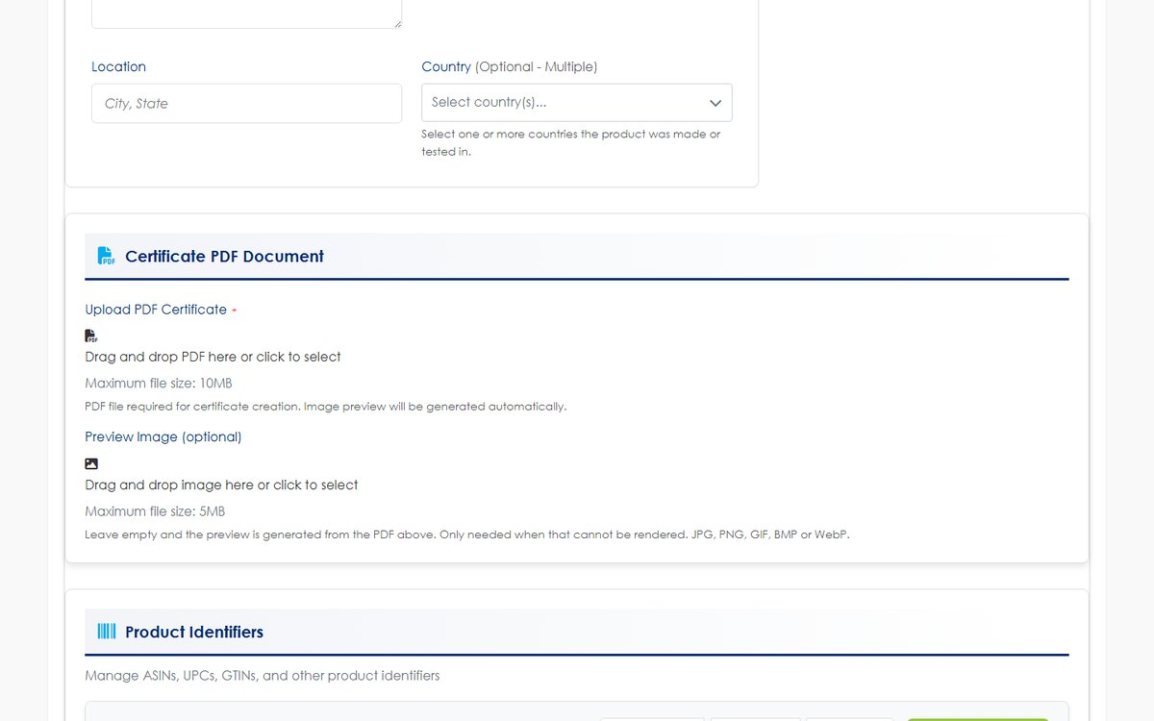
Figure 3 The PDF upload zone, with the tag panel beside it.
THE PREVIEW IS BLANK UNTIL YOU SAVE
The preview panel shows "Certificate Unavailable" while you are still filling the form. That is expected — the image is generated from the PDF after the certificate is saved, not while you are typing.

To replace a file later, open the certificate in Edit and upload a new PDF over the old one.

5. Tags, and product identifiers
External Tags are visible to the certified company and on public surfaces. Internal Tags are for GreenCircle only and are never shown to a company or partner account. Both are free to create as you type.
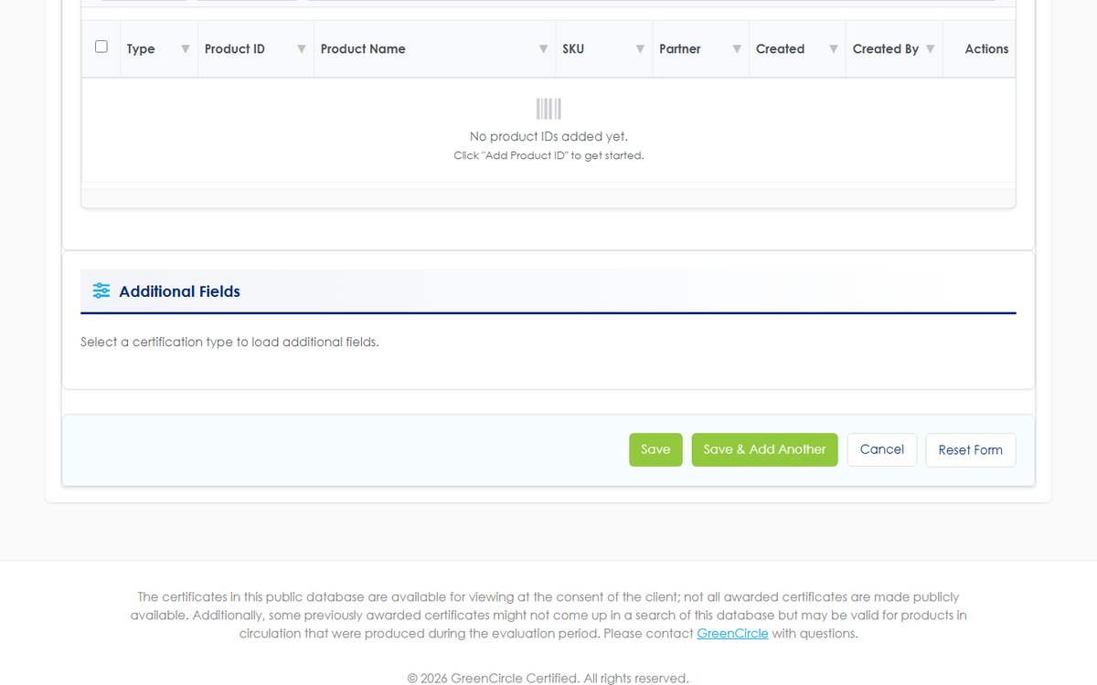
Figure 4 Product Identifiers and Additional Fields, at the foot of the form.
Product Identifiers holds the ASINs, UPCs, GTINs and other identifiers for this certificate. They belong to the certificate rather than to the product, so two certificates on the same product can carry different identifiers.
IDENTIFIERS FOLLOW THE CERTIFICATE
An identifier's active state follows its certificate. When the certificate stops being in force, its identifiers stop being reported with it — you do not need to deactivate them separately.

Additional Fields shows the custom fields that apply to the certification type you chose. Choosing a different type changes which fields appear.

6. Editing a certificate
Open a certificate from the list and choose Edit. The form is the Create form with the values filled in.
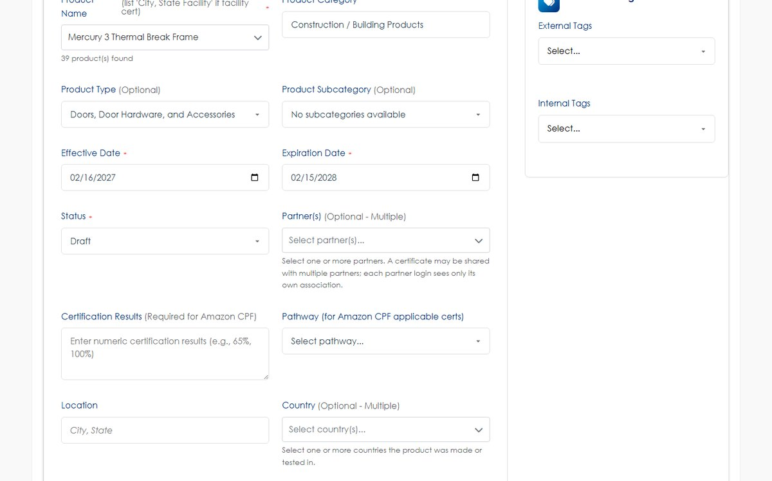
Figure 5 The Edit form. Status, partners, certification results and pathway sit together.
Certificate numbers are the key to a certificate, so Edit is reached by number. The number field itself is read-only; a number that is already issued to another certificate is refused if something tries to move a certificate onto it.
EDITING A CERTIFICATE THAT IS ALREADY EXPIRED
If the certificate was Expired when you opened the form, you are asked to confirm before the save goes through. This is deliberate — it is the point at which to decide whether you meant to revise an expired record.

Changing the dates does not change the status. If you correct an expiration date on an expired certificate, the status stays Expired until you change it yourself. The system will not infer what you meant.

7. Expiration, and what happens without you
Two things happen automatically. Knowing them prevents most "the status changed on its own" questions.
- A daily sweep expires certificates whose expiration date has passed. The status moves to Expired and the change is recorded.
- Saving a certificate whose expiration date is in the past forces it to Expired, whatever status you selected on the form. If you intend a certificate to be in force, its expiration date has to be today or later.
A certificate is live through its expiration date and expires the day after — an expiration date of 30 June means the certificate is still valid on 30 June.
The effective date behaves the same way at the other end: a certificate is live on its effective date. A certificate approved ahead of time sits in the certified company's own list straight away, but does not appear on the public database until its effective date arrives.
Every status change is recorded against the certificate — who changed it, when, and from what to what — whether a person or the daily sweep made it.

8. Importing certificates from a spreadsheet
Certificates → Import takes a CSV and creates or updates certificates in bulk. The page states the rules, and they are worth reading before the first import of the day.
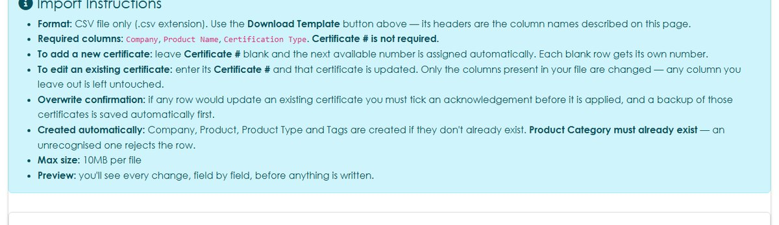
Figure 6 The import rules, as shown on the Import page.

8.1 The template
Download Template gives you the column headers with no sample rows. Use it rather than building a file by hand — the headers are what the importer matches on, and several columns carry their allowed values in the header text.
Only three columns are required: Company, Product Name and Certification Type.

8.2 Adding versus updating
This is decided entirely by the Certificate # column.
Certificate # | Result
Blank | A new certificate is created and the next available number is assigned. Each blank row gets its own number
Filled in | That certificate is updated. Only the columns present in your file are changed — any column you leave out is left untouched

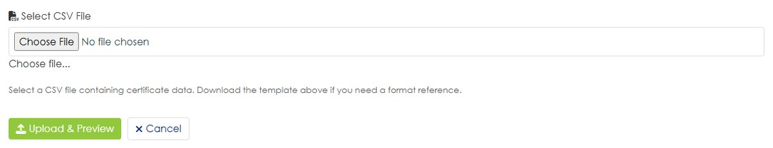
Figure 7 The upload step.
Upload the file, and the system shows you a preview of what it is about to do before anything is written. If any row would update an existing certificate you must tick an acknowledgement, and a backup of those certificates is saved automatically first.
Company, Product, Product Type and Tags are created if they do not already exist. Product Category must already exist — an unrecognised category rejects the row rather than inventing one.
Files are CSV only, up to 10MB.

8.3 If an import goes wrong
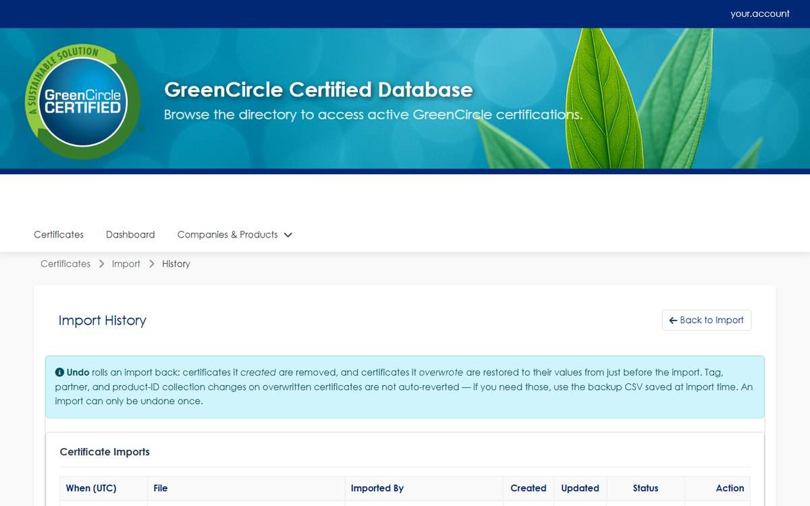
Figure 8 Import History. Each batch can be reviewed and undone.
Import History lists every batch with what it did. A batch can be undone from here, which reverses the rows it wrote.
IMPORT IN SMALL BATCHES THE FIRST TIME
A batch is the unit you can undo. A hundred-row file that is half wrong is one decision; ten ten-row files are ten smaller ones.

9. Exporting to CSV
Export All to CSV on the certificate list exports what the list is currently showing, so filter and search first and the export follows. The columns follow your current column selection.
The export and the import template share a column set deliberately: you can export, edit in a spreadsheet, and re-import the same file to apply the changes in bulk.
CSV is the only export format.

10. Troubleshooting
Symptom | Cause | What to do
A certificate saved as Expired although you chose another status | Its expiration date is in the past | Correct the expiration date, then set the status again
A status you set reverted overnight | The daily sweep expired it on its expiration date | Extend the expiration date if the certificate is still in force
A company cannot see a certificate you published | It is in a status that is not in force, or its expiration has passed | Check section 2
A certificate is in force but missing from the public database | Its status is Confidential, or its effective date has not arrived | Both are intended. See sections 2 and 7
Editing a company email changed other certificates | That field writes to the company record | Edit the company record deliberately, or leave it alone
An import row was rejected for its category | Product Category must already exist | Create the category first, then re-import
An import updated certificates you did not intend | A Certificate # was present in those rows | Undo the batch from Import History, then re-import with the column blank
The preview is empty on a certificate you are creating | The image is generated after save | Save, then reopen
A number you expected was skipped | Numbers are assigned at save; another analyst saved first | Nothing to do — the number is still unique and sequential

Appendix A — Create and Edit field reference
Field | Required? | Notes
Company | Required | Selecting it pre-fills the email and URL
Company Email · Company URL | Optional | Pre-filled from the company. Edits here update the company record
Certification # | Assigned | Read-only. Final number set at save
Certification Type | Required | Determines which Additional Fields appear
Certificate Subcategories | Optional | Several may be chosen
Product Name | Required | Links the certificate to a product record
Product Category · Type · Subcategory | Category required | Not auto-filled from the product — set them deliberately
Effective Date | Required | The certificate is live on this date
Expiration Date | Required | The certificate is live through this date
Status | Required | See section 2. Freely selectable
Partner(s) | Optional | Several may be chosen; each partner sees only its own
Certification Results | Required for Amazon CPF | Free text, stored and shown exactly as typed
Pathway | Optional | For Amazon CPF applicable certificates
Location | Optional | Free text, "City, State"
Country | Optional | Several may be chosen
External Tags | Optional | Visible to the company and publicly
Internal Tags | Optional | GreenCircle only — never shown externally
Certificate PDF | Required to create | The preview image is generated from it
Product Identifiers | Optional | ASIN, UPC, GTIN and others. Held against the certificate

Appendix B — Import columns
The template carries these headers, in this order. Certificate #, and everything below Company, may be left out of your file.
Column | Notes
Certificate # | Blank creates; filled updates
Certification Type | Required
Cert Subcategories
Status | Defaults to Draft if blank
Company | Required
Company Email · Company URL
Product Name | Required
Product Category | Must already exist
Product Type · Subcategory | Created if new
Partner | Separate several with commas
Pathway
Cert Results
Effective Date · Expiration Date
Location
Country | Separate several with commas
External Tag · Internal Tag | Created if new
ASIN · UPC · GTIN · EAN

What each role can see
 | Admin | Analyst | Partner | Company | Public
All certificates, every status | Yes | Yes | No | No | No
Own company's in-force certificates | Yes | Yes | — | Yes | No
Partner's associated certificates | Yes | Yes | Yes | — | No
Public directory | Yes | Yes | Yes | Yes | Yes
Create and edit certificates | Yes | Yes | No | No | No
Bulk import, and undo an import | Yes | Yes | No | No | No
Internal tags | Yes | Yes | No | No | No
Administration menu | Yes | No | No | No | No
Dashboard | Yes | Yes | No | No | No

Confidential certificates are visible to Admin, Analyst, the owning company and that company's associated partners. They are withheld from the public directory only.
A certificate that has not reached its effective date behaves differently by audience: the owning company sees it in their own list straight away, while the public directory and the partner feed wait for the effective date to arrive.

Glossary
Term | Meaning
Admin | Internal role with full access, including the Administration menu. Administrator accounts cannot be deleted
Analyst | Internal role that operates the certificate work day to day — create, edit, import, export. No Administration menu
ASIN | Amazon Standard Identification Number, the identifier Amazon uses for a product
Badgeable | A certificate that is commercially in force: Client Approved - Paid, Client Approved - Confidential, or Republished, inside its certification period
Certification # | The number identifying a certificate. Assigned by the system when the certificate is saved, never typed
Certification period | The span from the effective date to the expiration date, inclusive of both
Certification Results | Free text recorded against a certificate, shown exactly as it was entered. Required for Amazon CPF certificates
Client Approved - Confidential | In force and badgeable, but deliberately withheld from the public database. An embargo, not a pause
Client Approved - Paid | In force and listed publicly
Company user | A person from a certified company, signing in to see their own company's certificates. The role is named External
CPF | Amazon's Climate Pledge Friendly programme
Database Listing URL | The public address of a single certificate, for sharing with someone who has no account
Effective date | The first day a certificate is in force. It is live on this date
Expiration date | The last day a certificate is in force. It is live through this date and expires the day after
External tag | A tag visible to company and partner accounts and on public surfaces
GTIN · EAN · UPC | Product identifiers recorded against a certificate alongside ASIN
Internal tag | A tag visible only to GreenCircle staff. Never shown to a company or partner account
Partner | A role for a partner organisation, scoped to the certificates associated with that partner
Pathway | An optional certification pathway on a certificate, used for Amazon CPF
Product category · type · subcategory | The three levels of the product hierarchy. The category must exist before a product can use it
Public | The anonymous public directory. No account is needed
Republished | A certificate re-issued with a fresh certification period. In force and listed publicly

Getting help
Before contacting anyone, three things resolve most problems on their own.
- Check this guide's contents. The answer is often in another section — the troubleshooting table in particular lists the symptoms that have actually been reported.
- Sign out and sign back in. This clears anything left over from an interrupted session.
- Reload the page. If the site has been updated recently, a reload picks up the new version.
If the problem persists, report it with these five details. They are what makes a problem reproducible rather than a description of a feeling.
Include | Example
What you were trying to do | "Upload a certificate for a new product"
What happened instead | The exact wording of any message on screen
The certificate number | If the problem concerns a particular certificate
Browser and device | "Chrome on Windows 11", "Safari on an iPad"
Roughly when | The date and approximate time, so the event can be found

A screenshot of the whole browser window, including the address bar, is worth all five.

GreenCircle Certified Database — Analyst Certificate Guide, version 1.0. Prepared by Anuki Consulting, September 2026. Screenshots taken from the test environment; the live site may differ in minor visual detail. For anything not covered here, contact your system administrator.

