GreenCircle Certified Database
Administrator Guide
How to configure the database — companies, products, certification types, tags, users and roles.
Version | 1.0
Issued | September 2026
Applies to | Test environment
Prepared by | Anuki Consulting
Audience | Administrators

ABOUT THE SCREENSHOTS
Every screenshot was taken from the current build on the test site, signed in as an administrator. The companies, counts and configuration shown are whatever was on the test environment at the time.

Contents
Contents 2
1. The Administration menu 3
2. Companies 4
3. Products and the product hierarchy 5
4. Certification Types 6
5. Tags 7
6. Pathways 9
7. Users 9
8. Roles and permissions 10
9. Partners and the partner API 11
10. Google Analytics 11
11. The Dashboard 11
12. Troubleshooting 12
What each role can see 14
Glossary 14
Getting help 15

1. The Administration menu
Administrators see everything an analyst sees, plus an Administration menu. Day-to-day certificate work is covered in the Analyst Certificate Guide; this guide covers the configuration behind it.
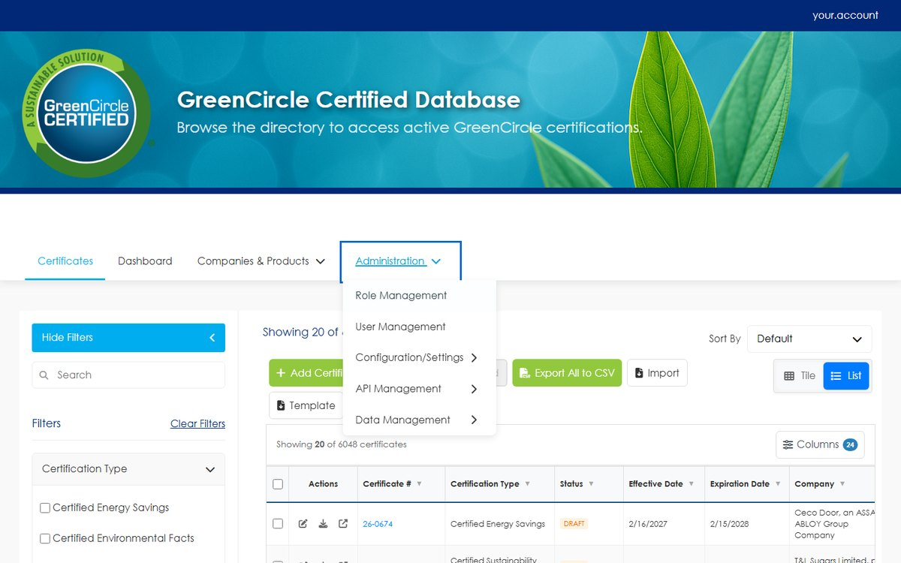
Figure 1 The Administration menu.
Menu item | What it controls | Covered in
Role Management | The roles, and what each one may do | Section 8
User Management | Accounts, their role, and the companies or partners they are scoped to | Section 7
Configuration/Settings → Google Analytics | Site analytics tracking | Section 10
API Management → Partner API | Partner API keys | Section 9
Data Management → Certificate Types | Certification types and their subcategories | Section 4
Data Management → Product Types | The product category hierarchy | Section 3
Data Management → Certificate Fields | The definitions behind the Additional Fields that appear on a certificate | —
Data Management → Tags | Internal and external tags | Section 5
Data Management → Partners | Partner organisations | Section 9
Data Management → Pathways | Certification pathways | Section 6

Companies and Products sit outside this menu, under Companies & Products in the main navigation.
A RULE THAT APPLIES ACROSS EVERY PAGE IN THIS GUIDE
Anything referenced by a product or a certificate cannot be deleted while that reference exists. The usage count beside each row is what the system checks. Remove or re-point the references first, then delete.

2. Companies
Companies & Products → Companies lists every certified company, with its contact details and the number of certificates held.
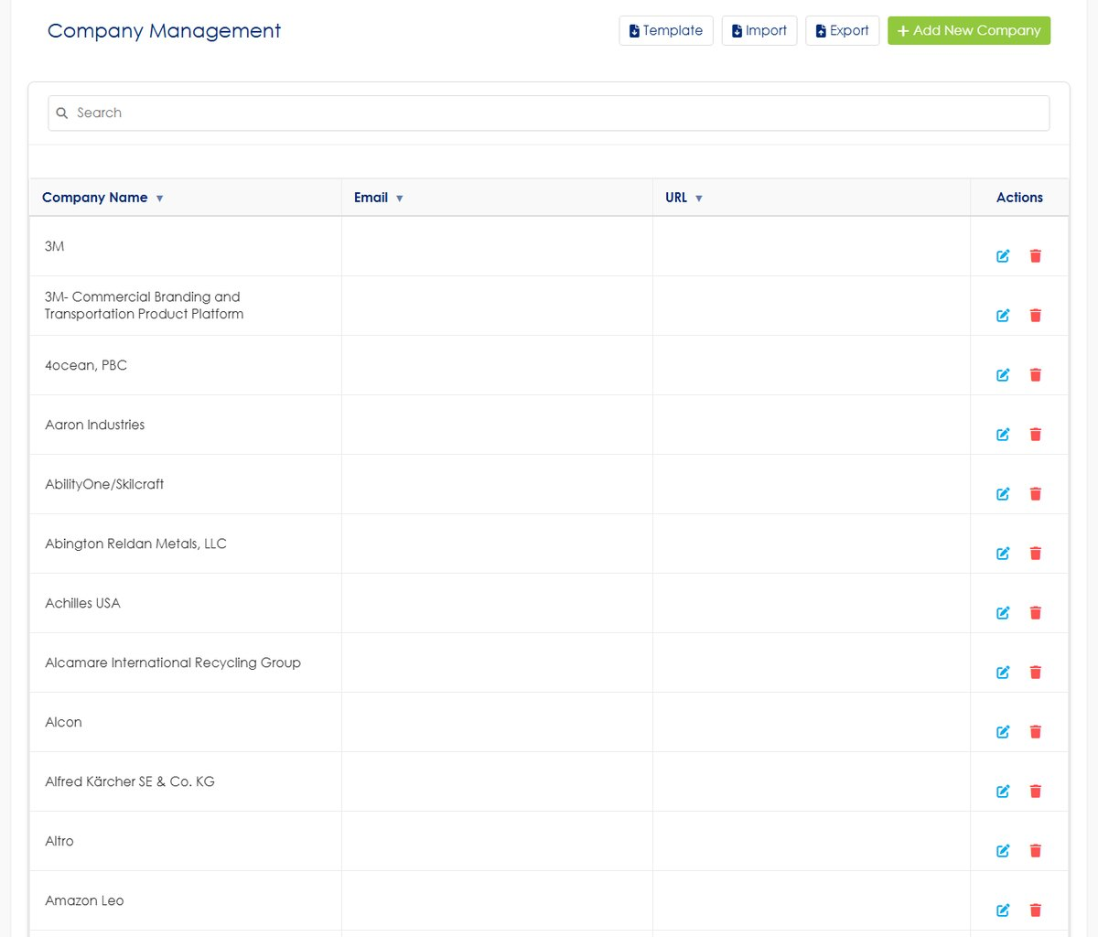
Figure 2 Company Management.
A company record is the owner of its certificates and the thing an External user account is scoped to. Two consequences worth knowing:
- Company email and URL are shared. These fields also appear on the certificate form, and editing them there updates this record — so a change made while editing one certificate applies to the company everywhere.
- A company with certificates cannot be deleted. Reassign or remove its certificates first.
Use Export for a CSV of the list.

3. Products and the product hierarchy
Data Management → Product Types is where the product taxonomy lives. It has three levels.
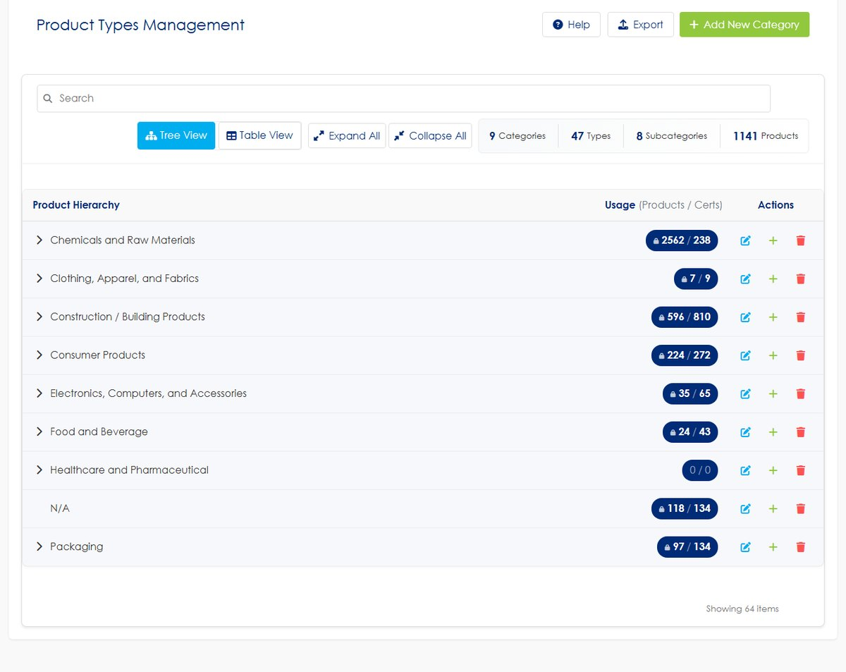
Figure 3 Product Types Management, in tree view. The counters above the tree show how many of each level exist.
Level | Example | Notes
Category | Construction / Building Products | The top level. Must exist before a product can use it
Type | Moisture Control | Sits under a category
Subcategory | — | Sits under a type. Optional

Tree View shows the hierarchy and lets you expand a branch; Table View lists everything flat. Expand All and Collapse All act on the whole tree.
Each row carries a usage count in the form products / certificates, and the padlock beside it means what the rule in section 1 says: while that count is non-zero the item cannot be deleted.
To add a level, use Add New Category for a top-level entry, or the + on a row to add a child beneath it.
CATEGORIES MUST EXIST BEFORE AN IMPORT RUNS
A bulk certificate import creates companies, products, product types and tags that it does not recognise — but not product categories. A row naming a category that does not exist here is rejected. Create the category first.

Individual product records are managed separately, under Companies & Products → Products.

4. Certification Types
Data Management → Certificate Types holds the certification types and their subcategories.
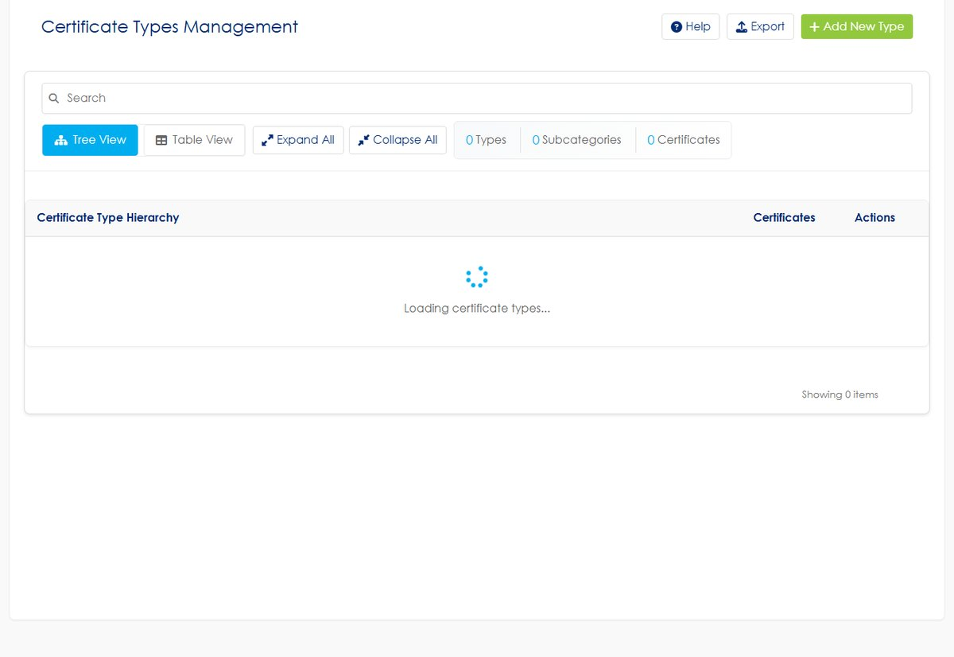
Figure 4 Certificate Types Management.
The certification type drives two things elsewhere in the system:
- It appears on every certificate and is one of the three columns a bulk import requires.
- It determines which Additional Fields appear on the certificate form.
Subcategories sit beneath a type, and a certificate may carry several of them. Both the type and its subcategories are searchable and filterable on the certificate views.

5. Tags
Data Management → Tags manages the tags that can be attached to certificates.
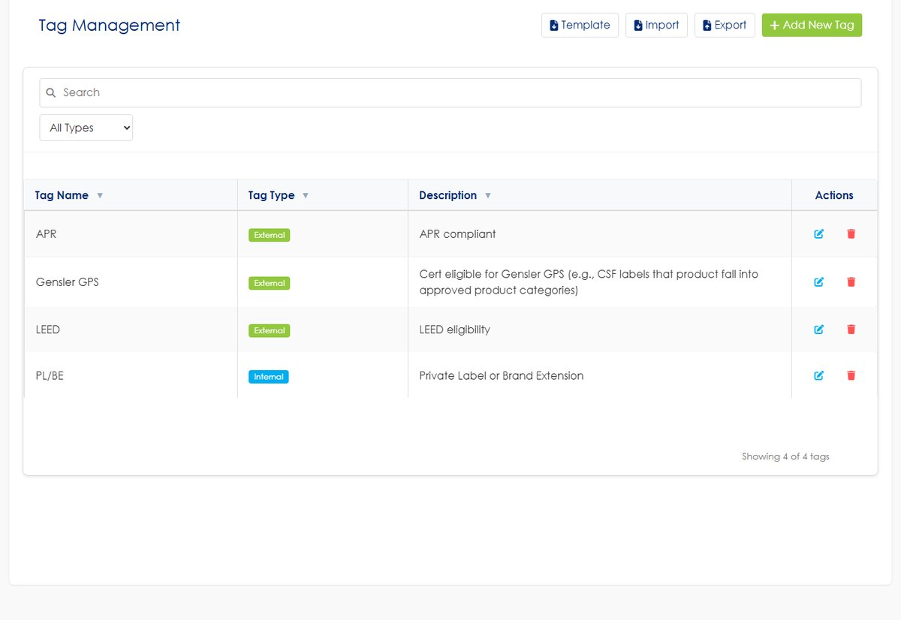
Figure 5 Tag Management.
There are two kinds, and the difference is a permission, not a label:
Tag type | Who sees it
External | Everyone, including company and partner accounts, and public surfaces
Internal | GreenCircle staff only — never shown to a company or partner account, and never exported to them

INTERNAL TAGS ARE A CONFIDENTIALITY BOUNDARY
An internal tag is invisible to the certified company. Anything written in one should be safe to keep from them — but treat the tag name as internal-only content, because that is exactly what it is.

Analysts can create either kind while editing a certificate, so this page is for reviewing, renaming and tidying the set rather than being the only way to add one.

6. Pathways
Data Management → Pathways manages the certification pathways that can be assigned to a certificate.
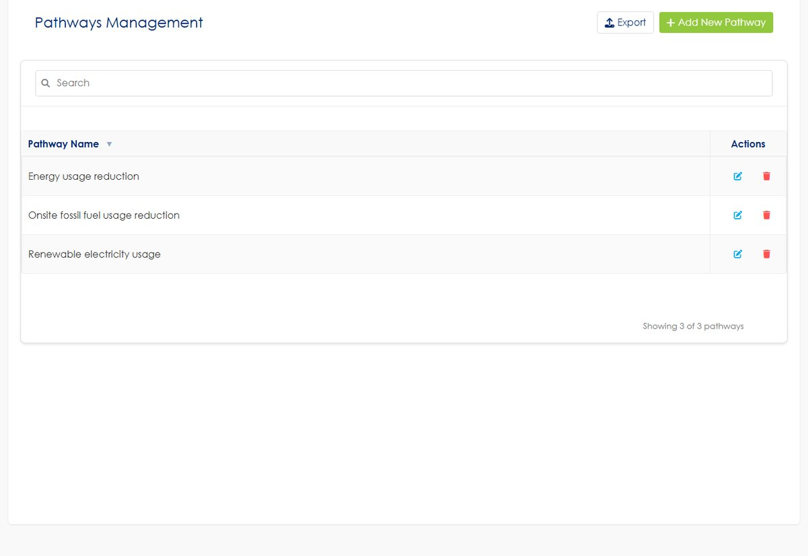
Figure 6 Pathways Management.
A pathway is optional on a certificate and applies to Amazon CPF certifications. The pathway chosen on a certificate appears on the certificate form beside Certification Results, which is the field Amazon CPF requires.

7. Users
User Management lists every account with its role, status and whether two-factor authentication is enabled.
Creating accounts, assigning a role, scoping an account to companies or partners, two-factor authentication and password resets are covered in full by the separate Accounts & Sign-In Guide. Three points belong here because they are administrative rather than procedural:
- An account's scope is what limits its data, not its role. An External account with no company attached sees nothing at all.
- Email addresses must be unique across all accounts.
- Administrator accounts cannot be deleted. Set an account to Inactive instead — it blocks sign-in without removing the record or its history.

8. Roles and permissions
Role Management lists the roles, what each may do, and how many accounts hold it.
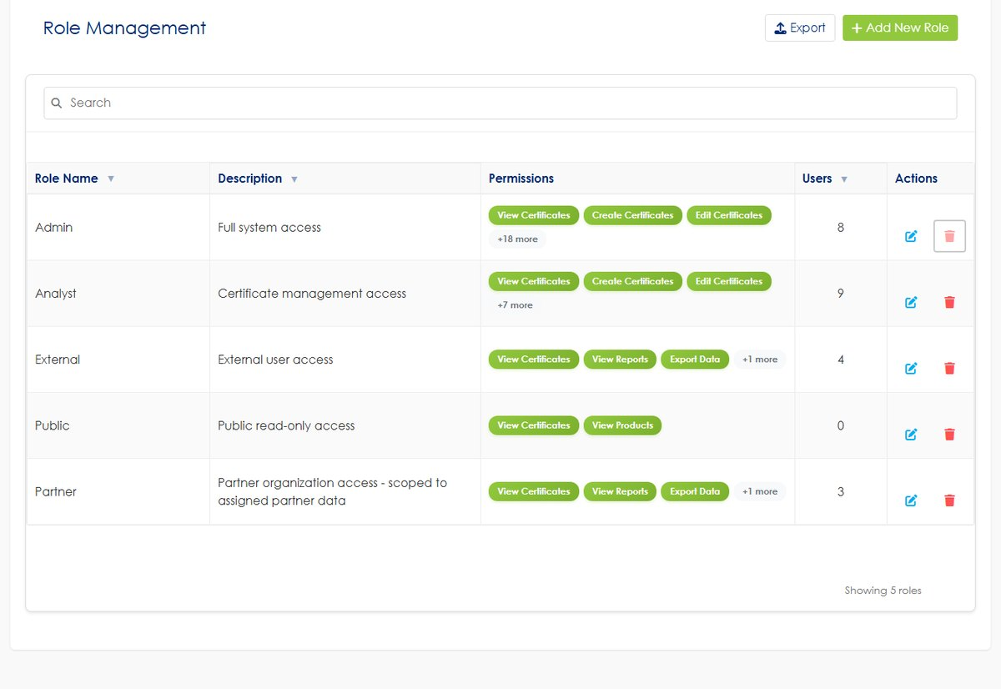
Figure 7 Role Management. The permission chips show the first few permissions; the count beside them covers the rest.
Role | Intended for
Admin | Full system access, including this menu
Analyst | Certificate work — create, edit, import, export
External | A certified company's own staff, scoped to that company
Partner | A partner organisation, scoped to that partner's associated certificates
Public | The public directory. No account is needed to use it

Add New Role creates a role and Export produces a CSV of the list. Editing a role opens its permission set.
CHANGING A ROLE CHANGES EVERY ACCOUNT THAT HOLDS IT
The Users column tells you how many accounts a change will affect. Removing a permission from Analyst applies to every analyst immediately. There is no per-account override.

System roles cannot be deleted. The delete control is unavailable on them, which is why the Admin row's is greyed out.

9. Partners and the partner API
Data Management → Partners manages partner organisations, and API Management → Partner API manages their API keys.
Both are covered end to end — including tagging certificates to a partner, generating and revoking keys, and what the partner receives — in the separate Partner API Setup Guide. Use that guide rather than this section; it exists so the two do not drift apart.
The one rule worth repeating here: a partner sees only the certificates associated with that partner, and a certificate may be associated with several partners without either partner seeing the other's association.

10. Google Analytics
Configuration/Settings → Google Analytics holds the tracking configuration for the site. Enter the measurement ID supplied by whoever manages your analytics account and save.
This affects only visitor analytics. It does not change what any account can see, and it does not touch certificate data.
The site also serves a Privacy Policy page, linked from the footer. It is maintained as a single document outside the running application and is not editable from these screens — to change its wording, contact whoever maintains the site.

11. The Dashboard
Dashboard summarises the certificate population.
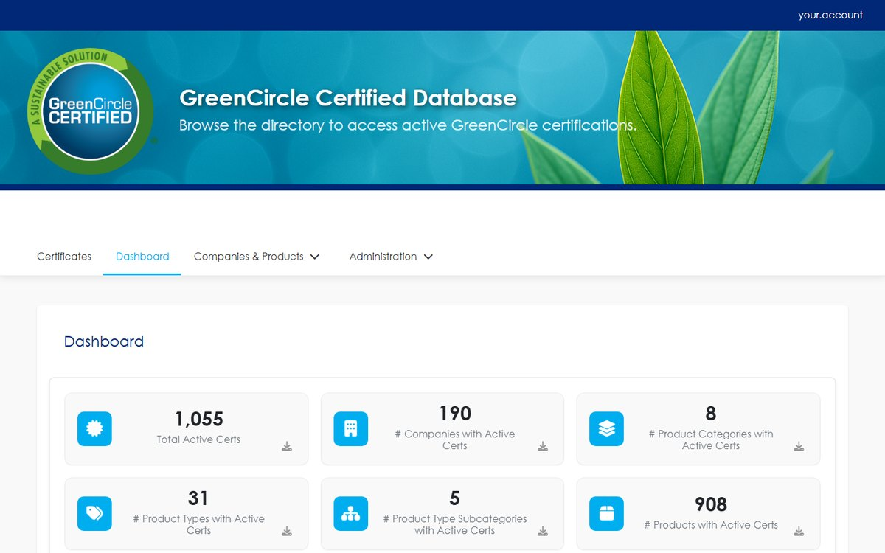
Figure 8 The Dashboard.
Total Active Certs counts certificates that are commercially in force — Client Approved - Paid, Client Approved - Confidential, and Republished — and inside their certification period. It deliberately includes Confidential certificates: those are paid, in-force work whose public listing is withheld.
Beneath it, the same population is broken down by certification type, by company, by status, by product type and by product category. The by status table is the one that shows the whole picture, including the statuses that are not in force.
WHY THE DASHBOARD TOTAL AND THE PUBLIC DATABASE DISAGREE
They answer different questions. The Dashboard counts what is in force; the public database shows what a stranger may see, which excludes Confidential certificates and anything whose effective date has not arrived. A gap between the two figures is expected, not an error.

12. Troubleshooting
Symptom | Cause | What to do
A category, type or tag will not delete | Something still references it | Check the usage count on the row; re-point or remove those records first
An import rejects rows for their category | Product categories are never created by import | Add the category in Product Types, then re-import
An administrator account cannot be deleted | Administrator accounts are protected | Set it to Inactive instead
A role will not delete | System roles are protected | Only roles you added can be removed
Editing a company email changed several certificates | That field belongs to the company record | Expected. Edit it deliberately
An External account sees nothing | It has no company attached | Attach a company in User Management
A partner sees fewer certificates than expected | Certificates must be associated with the partner individually | Check the partner association on the certificates themselves
The Dashboard total is higher than the public database | Confidential and not-yet-effective certificates are in force but not public | Expected — see section 11
A company user cannot see an internal tag | Internal tags are never shown externally | Expected. Use an external tag if they should see it

What each role can see
 | Admin | Analyst | Partner | Company | Public
All certificates, every status | Yes | Yes | No | No | No
Own company's in-force certificates | Yes | Yes | — | Yes | No
Partner's associated certificates | Yes | Yes | Yes | — | No
Public directory | Yes | Yes | Yes | Yes | Yes
Create and edit certificates | Yes | Yes | No | No | No
Bulk import, and undo an import | Yes | Yes | No | No | No
Internal tags | Yes | Yes | No | No | No
Administration menu | Yes | No | No | No | No
Dashboard | Yes | Yes | No | No | No

Confidential certificates are visible to Admin, Analyst, the owning company and that company's associated partners. They are withheld from the public directory only.
A certificate that has not reached its effective date behaves differently by audience: the owning company sees it in their own list straight away, while the public directory and the partner feed wait for the effective date to arrive.

Glossary
Term | Meaning
Admin | Internal role with full access, including the Administration menu. Administrator accounts cannot be deleted
Analyst | Internal role that operates the certificate work day to day — create, edit, import, export. No Administration menu
ASIN | Amazon Standard Identification Number, the identifier Amazon uses for a product
Badgeable | A certificate that is commercially in force: Client Approved - Paid, Client Approved - Confidential, or Republished, inside its certification period
Certification # | The number identifying a certificate. Assigned by the system when the certificate is saved, never typed
Certification period | The span from the effective date to the expiration date, inclusive of both
Certification Results | Free text recorded against a certificate, shown exactly as it was entered. Required for Amazon CPF certificates
Client Approved - Confidential | In force and badgeable, but deliberately withheld from the public database. An embargo, not a pause
Client Approved - Paid | In force and listed publicly
Company user | A person from a certified company, signing in to see their own company's certificates. The role is named External
CPF | Amazon's Climate Pledge Friendly programme
Database Listing URL | The public address of a single certificate, for sharing with someone who has no account
Effective date | The first day a certificate is in force. It is live on this date
Expiration date | The last day a certificate is in force. It is live through this date and expires the day after
External tag | A tag visible to company and partner accounts and on public surfaces
GTIN · EAN · UPC | Product identifiers recorded against a certificate alongside ASIN
Internal tag | A tag visible only to GreenCircle staff. Never shown to a company or partner account
Partner | A role for a partner organisation, scoped to the certificates associated with that partner
Pathway | An optional certification pathway on a certificate, used for Amazon CPF
Product category · type · subcategory | The three levels of the product hierarchy. The category must exist before a product can use it
Public | The anonymous public directory. No account is needed
Republished | A certificate re-issued with a fresh certification period. In force and listed publicly

Getting help
Before contacting anyone, three things resolve most problems on their own.
- Check this guide's contents. The answer is often in another section — the troubleshooting table in particular lists the symptoms that have actually been reported.
- Sign out and sign back in. This clears anything left over from an interrupted session.
- Reload the page. If the site has been updated recently, a reload picks up the new version.
If the problem persists, report it with these five details. They are what makes a problem reproducible rather than a description of a feeling.
Include | Example
What you were trying to do | "Upload a certificate for a new product"
What happened instead | The exact wording of any message on screen
The certificate number | If the problem concerns a particular certificate
Browser and device | "Chrome on Windows 11", "Safari on an iPad"
Roughly when | The date and approximate time, so the event can be found

A screenshot of the whole browser window, including the address bar, is worth all five.

GreenCircle Certified Database — Administrator Guide, version 1.0. Prepared by Anuki Consulting, September 2026. Screenshots taken from the test environment; the live site may differ in minor visual detail. For anything not covered here, contact your system administrator.

