GreenCircle Certified Database
Setting Up a Partner with API Access
How to create a partner, tag the certificates they should receive, generate their API key, and prove it works before you hand it over.
Version | 1.1
Issued | September 2026
Applies to | Test environment
Prepared by | Anuki Consulting
Audience | Administrators

ABOUT THE SCREENSHOTS
Every screenshot was taken from the current build on the test environment. API key values are deliberately blurred — no real key appears anywhere in this guide, and the confirmation panel that displays a newly generated key is described rather than shown, so that producing this guide never required creating a live credential.

Contents
Contents 2
1. What you are setting up 3
1.1 The two checks that decide what a partner sees 3
2. Create the partner record 3
3. Tag the certificates 6
4. Generate the API key 6
4.1 What you cannot set per key 9
5. Which address the partner uses 9
6. Test the key before you hand it over 9
6.1 Delivering the key 10
7. Revoking and rotating a key 10
8. What the partner receives 11
8.1 The endpoints 11
9. Troubleshooting 11
10. Appendix — filling in a partner's "Your Connection" panel 12
10.1 Row by row 12
10.2 The questions this panel keeps producing 13

TAG THE CERTIFICATES FIRST, OR THE PARTNER SEES NOTHING
An API key on its own returns an empty list. What a partner receives is decided by two separate checks, and the certificate tagging is the one people forget. Work through the steps in the order given below.

1. What you are setting up
A partner is an external organisation — Amazon, Novi, or another — that pulls certificate data from GCC over the Partner API. Setting one up has four parts, and all four are yours to do. You do not need to raise a request with Anuki for any of them.
Step | What it does | Where
1. Create the partner record | Gives the organisation an identity in the system | Administration → Partners
2. Tag certificates to the partner | Decides which certificates they may receive | On each certificate
3. Generate an API key | Gives them a credential tied to that partner | Administration → Partner API Access
4. Test, then deliver the key | Proves it works before the partner tries it | Terminal, then secure channel

1.1 The two checks that decide what a partner sees
This is the single most useful thing to understand, because almost every "the feed is empty" or "why can't they see this certificate" question comes back to it.
- Is the certificate tagged to that partner? If not, it reaches nobody — regardless of status.
- Is the certificate commercially in force? Its status must be Client Approved – Paid, Client Approved – Confidential, or Republished, and today's date must fall inside its effective and expiration dates.
Both must be true. The checks are independent, so a perfectly valid certificate that nobody tagged is invisible, and a tagged certificate that has expired is equally invisible.
CONFIDENTIAL CERTIFICATES DO GO TO PARTNERS
Confidential is an embargo on the public website only. Those certificates are paid, in-force work and they are still sent to partners and still badged. Do not assume Confidential means withheld from everyone.

2. Create the partner record
- Sign in as an Administrator.
- Go to Administration → Partners.
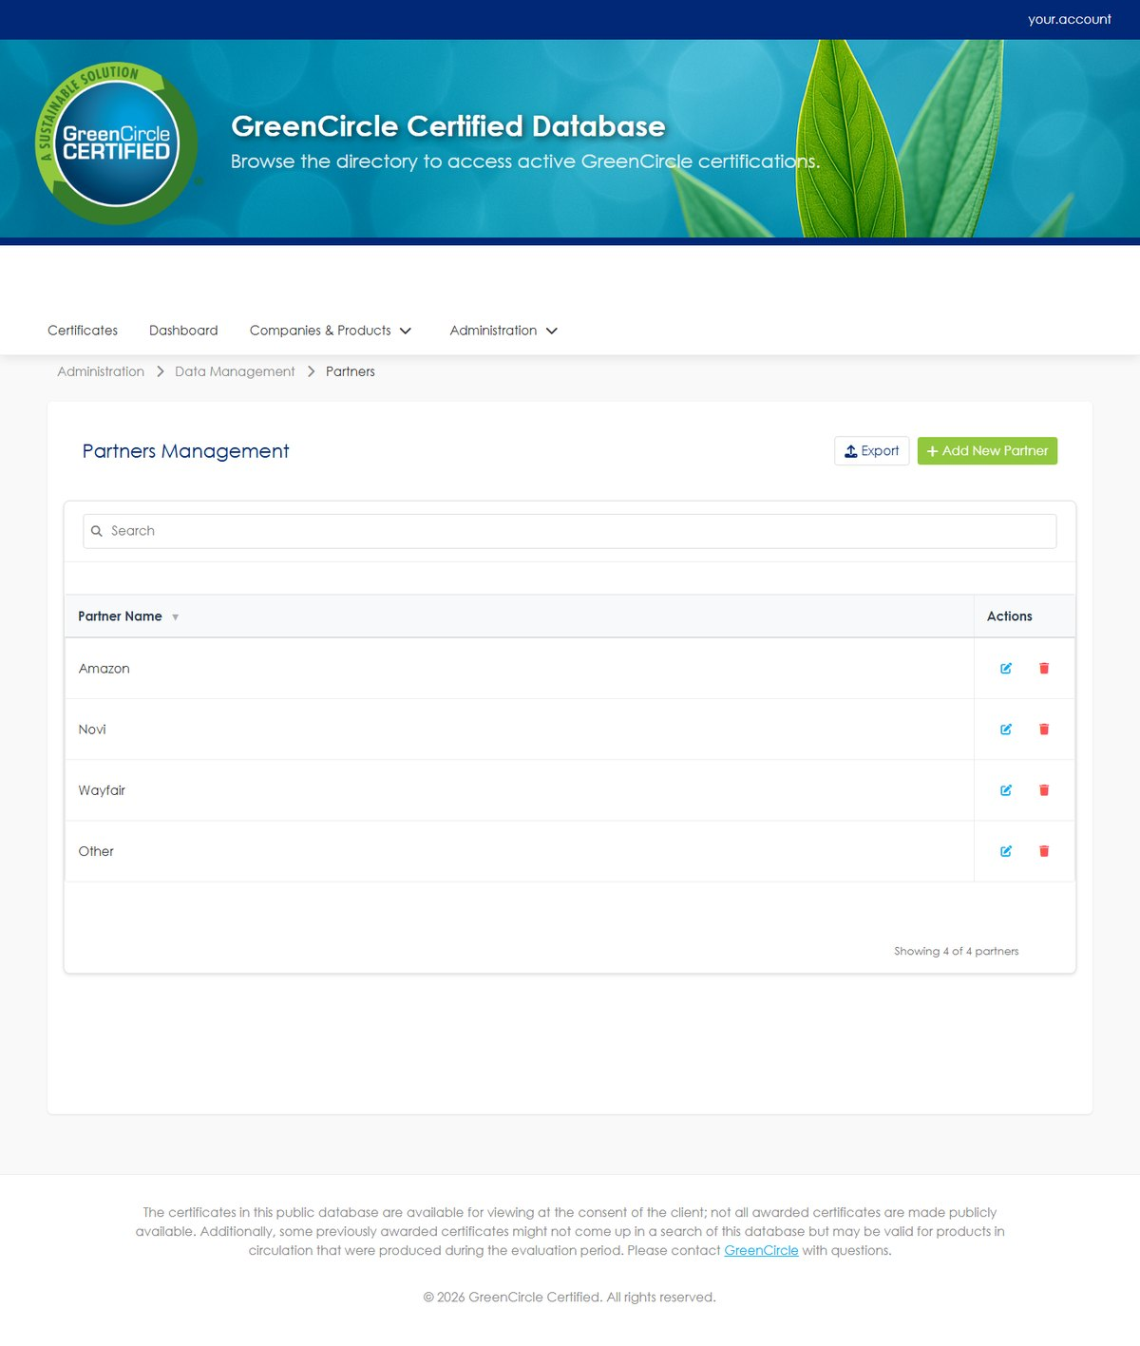
Figure 1 The Partners page. Export and Add are the only actions — there is no import, because partner records are core entities rather than bulk data.
- Click Add. A new editable row appears at the top of the table — this is an inline row, not a pop-up dialog.
- Enter the Partner Name. It must be unique and is limited to 100 characters. This exact name is what the partner sees returned in the partner field of their API responses, so spell it the way you want it to appear.
- Add a Description if useful — free text, up to 500 characters.
- Save the row. New partners are Active by default.
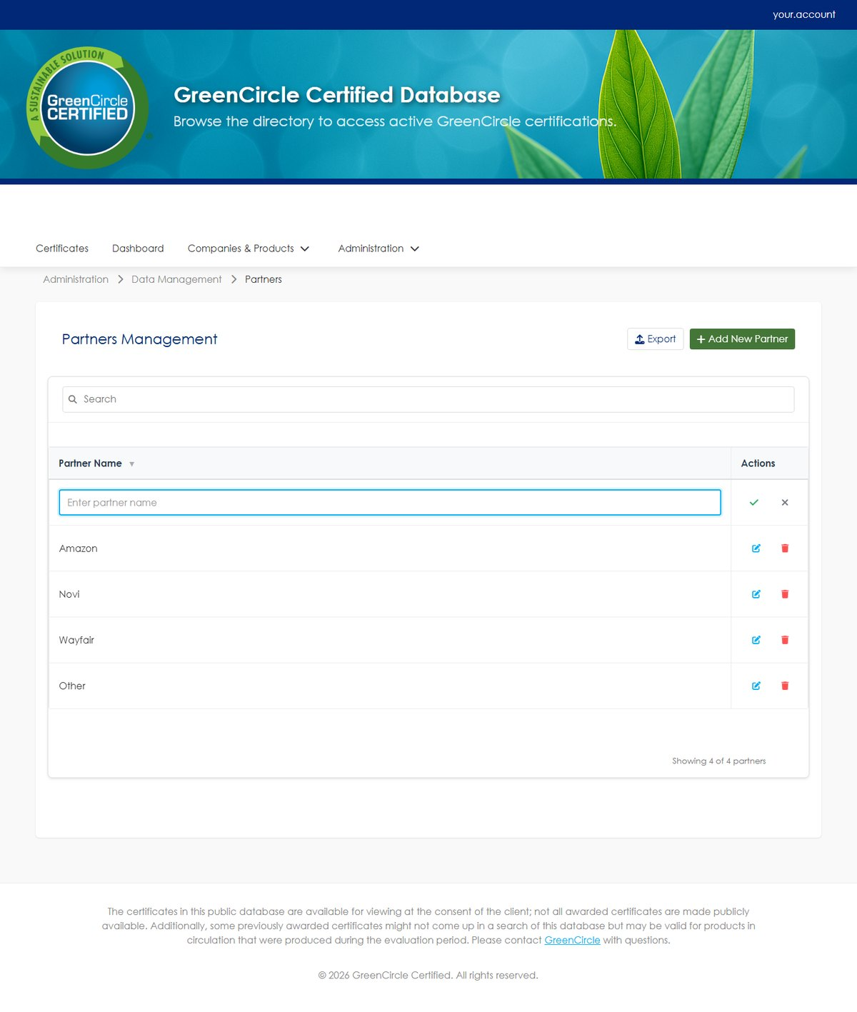
Figure 2 Clicking Add opens an editable row at the top of the table rather than a dialog.
DEACTIVATING A PARTNER DOES NOT CUT OFF THEIR API ACCESS
This is worth knowing before you rely on it. Setting a partner to inactive does not stop their API keys from working — the key check does not consult the partner's Active flag. The only way to stop a partner calling the API is to revoke each of their keys (section 7). Deactivating affects where the partner appears in the application, not their API access.

3. Tag the certificates
A partner receives only the certificates explicitly associated with them. Open each certificate that should be included and add the partner in its Partners field.
For certificates that carry product identifiers — ASINs, UPCs, GTINs and so on — identifiers behave slightly differently from the certificate itself:
Identifier is tagged to | Does this partner receive it?
Nobody | Yes — untagged identifiers are treated as shared
This partner | Yes
A different partner only | No — it is withheld

That last row is deliberate. Two partners can share a certificate without either of them seeing the other's product identifiers.

4. Generate the API key
- Go to Administration → Partner API Access.
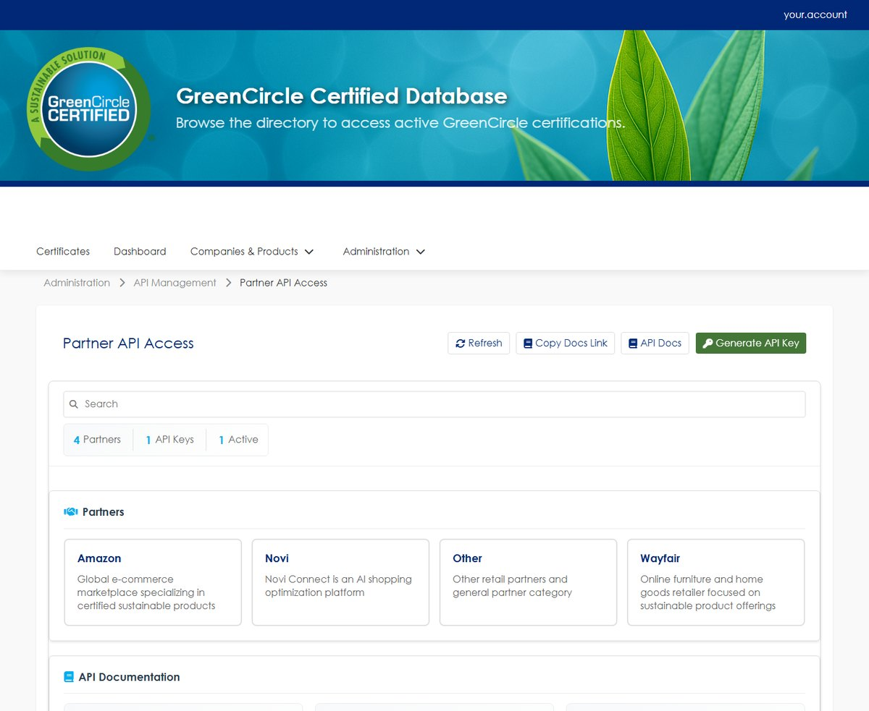
Figure 3 The Partner API Access page. The counts at the top show how many partners and keys exist, and how many of those keys are still active.
- Click Generate API Key. A dialog opens with three fields.
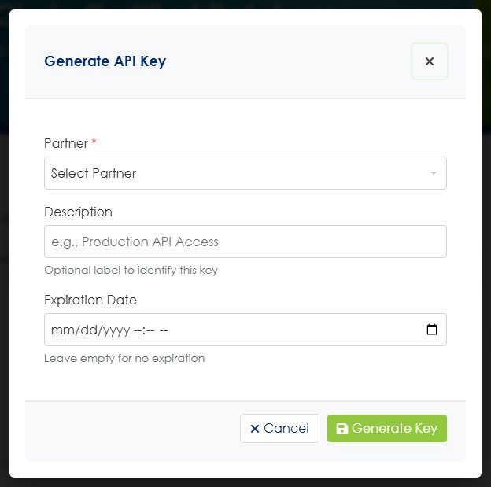
Figure 4 The Generate API Key dialog. Only Partner is required.
- Choose the Partner. This is the only required field, and it is what scopes the key.
- Enter a Description. Optional, and internal only — something like "Amazon production" or "Amazon test" so you can tell keys apart later.
- Set an Expiration Date. Optional. Leave it blank for a key that never expires; set a date for a time-boxed test key.
- Click Generate Key. The new key is shown with a copy button. Copy it now — see the warning below.
Keys are 76 characters: the prefix gcc_partner_ followed by 64 hexadecimal characters.
COPY THE KEY BEFORE YOU CLOSE THAT DIALOG — IT IS SHOWN ONLY ONCE
This is the only moment the full key is visible. Afterwards the list shows every key masked, and the only action on each row is Revoke. There is no way to retrieve the value later. If you close the dialog without copying it, the key is unusable: revoke it and generate a replacement. Paste it somewhere safe before you click away.

4.1 What you cannot set per key
Two values that look configurable are not. They are system-wide, and there is no field for either on the key:
Setting | Value | Per key?
Rate limit | 200 requests per hour | No — the same for every partner
Endpoints permitted | All endpoints | No — keys are not scoped to a subset

So only three things genuinely vary between partners: the partner name, the key itself, and the key's expiry date.

5. Which address the partner uses
Environment | Base URL | Status
Test | https://dbtest.greencirclecertified.com/api/v1 | Live now — use for all integration work
Production | https://db.greencirclecertified.com/api/v1 | Live now — use for production

Partners build and test against the test address, then change the hostname to go live. Nothing else changes — the paths, the X-API-Key header and the response are identical.
GIVE PARTNERS DB., NOT DATABASE.
db.greencirclecertified.com is the address the certificate database has always used, so links already in circulation keep working. database.greencirclecertified.com forwards web visitors to it, but always give a partner the db. address: an API client should not rely on a redirect.

6. Test the key before you hand it over
Always prove the key works yourself first. A partner hitting a problem on day one costs far more time than this check.
- Open a terminal and run the request below, substituting the key.
- Read the response code before anything else.
curl -i -H "X-API-Key: gcc_partner_..." https://dbtest.greencirclecertified.com/api/v1/certificates

Response | What it means | What to do
200 with certificates | The key works | Deliver it
200 with an empty list | The key is fine; nothing is tagged to that partner | Go back to section 3
401 | Key wrong, revoked, or expired | Check the key row is still active
429 | Rate limit hit — 200 requests in the last hour | Wait, then retry

DO NOT TEST BY PASTING THE URL INTO A BROWSER WHERE YOU ARE ALREADY SIGNED IN
A signed-in session takes priority over the API key, so the page may load perfectly while the key itself is invalid. The result tells you nothing. Use a terminal, or a private browsing window.

Responses are cached for five minutes. If you tag a certificate and immediately re-test, wait five minutes before concluding that something is wrong.

6.1 Delivering the key
Send the key by a secure channel — a password manager share, or another route your organisation already trusts for credentials. Never paste it into the Integration Guide, an email body, or a chat message. The Integration Guide gets forwarded inside partner organisations, and a key printed in it is a key you will have to rotate.

7. Revoking and rotating a key
Use Revoke on the key's row. It takes effect immediately and cannot be undone — every request using that key starts returning 401. Revoked keys are retained for audit.
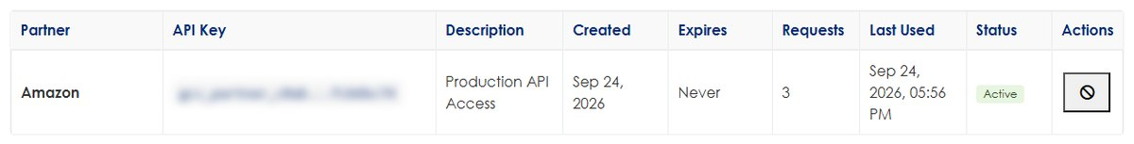
Figure 5 The key list. Each row shows its partner, when it was created, whether it expires, how many requests it has served, and its status. Key values are masked by the application and blurred again for this guide. The single button in the Actions column is Revoke — or Delete, once a key has been revoked.
Revoke a key when the partner no longer needs access, when a key may have been exposed, when you issue the production key and the test key is no longer needed, or as part of routine rotation.
To rotate without an outage, generate the new key first, give the partner time to switch, then revoke the old one. Both keys work while the changeover happens.

8. What the partner receives
Certificates | Only those tagged to them, and only while in force
Status field | Always the literal string "Active" — internal status names are never exposed
Product identifiers | Untagged ones, plus those tagged to them
Internal tags | Never returned
External tags | Returned
Analyst notes, audit history | Never returned

The API expresses validity by presence, not by a status value. A certificate that is no longer in force does not appear with an "expired" status — it stops appearing at all. Partners should treat disappearance as authoritative, and should not wait for a status change that will never arrive.

8.1 The endpoints
Endpoint | Purpose
GET /certificates | List everything the calling partner may see
GET /certificates/{id} | One certificate by its internal numeric ID
GET /certificates/number/{number} | One certificate by its certificate number
GET /certificates/search | Search by term, company, type or date range
GET /certificates/search/productid | Find certificates by product identifier such as an ASIN
GET /certificates/{id}/download | Download the certificate PDF
GET /certificates/gs1 | GS1 JSON-LD format, used by Amazon
GET /certificates/gs1/{number} | One certificate in GS1 format

9. Troubleshooting
Symptom | Almost always
Partner sees an empty list | No certificates tagged to that partner — section 3
A specific certificate is missing | Not tagged, expired, not yet effective, or still in draft
401 on every request | Key revoked or expired; check the key row
403 on one path | The endpoint is outside what that key may call
429 | 200-per-hour rate limit reached
Partner sees a certificate you expected to be private | Confidential is embargoed from the public site only — it still reaches partners
Changes not showing | Five-minute response cache; wait it out

If a partner asks why a particular certificate is not visible, tell them rather than letting them infer it. The API deliberately makes "expired", "not tagged to you" and "never existed" look identical, so that a key cannot be used to probe for certificates outside its scope. That is by design, and it means the partner genuinely cannot work it out from the response.

10. Appendix — filling in a partner's "Your Connection" panel
The Partner Integration Guide — the document sent to the partner's engineering team — opens with a panel headed Your Connection, introduced as "values specific to the key issued to you." Filling it in is the last step before issuing that guide, and it is where nearly every question about partner setup has come from.
The panel overstates how much varies. It reads as eight or nine values to look up per partner. Only three actually change between partners. The rest are the same for everybody, and two of them cannot be configured per key at all — there is no field for them anywhere in the application.

10.1 Row by row
Row in the panel | Where the value comes from | Varies per partner?
Partner name | The Partner record you created in section 2 — spelled exactly as stored | Yes
API key | The Generate Key dialog, section 4 | Yes
Key expiration | The Expiration Date field in that dialog; blank means never | Yes
Base URL | Fixed. https://db.greencirclecertified.com/api/v1, live now | No
Test base URL | Fixed. https://dbtest.greencirclecertified.com/api/v1, live now | No
Rate limit | System-wide: 200 requests per hour. No per-key field exists | No
Endpoints permitted | All endpoints. Keys are not scoped to a subset | No
Certificate status mode | Always Presence — validity is expressed by whether a certificate is returned at all. See section 8 | No
Product identifier scope | Fixed: identifiers tagged to nobody, plus those tagged to this partner. See section 3 | No

TWO ROWS USED TO CARRY AN INSTRUCTION THAT COULD NOT BE FOLLOWED
Earlier revisions of the Integration Guide told the issuer to "check the rate limit and permitted endpoints against the API key actually issued to that partner." There is nothing on the key to check them against — both are system-wide. If you are working from an older copy of that guide, ignore that instruction; the current template has the two values pre-filled as the constants they are.

10.2 The questions this panel keeps producing
- "Where do we get the API key — does this have to be requested from the developer?" No. You generate it yourself in Administration → Partner API Access. Section 4 of this guide is the whole procedure.
- "Where would this information come from?" — asked against the rate limit, the endpoint scope, the status mode and the key expiry. Of those four, only the expiry is something you choose; see the table above.
- "Can the partner name be whatever we enter, or does it have to match something in the key?" It must match. The value the partner receives in the partner field is the Partner record's name as held in the database, and that same name decides which certificates the key can see. It is not a free-text label.
- "After go-live, does the test address stay or is it production only?" Both, depending on the partner's stage. During onboarding the partner works against the test address. Once they are live, their copy of the guide should mark that row as no longer applicable — a live test address left in a document that gets forwarded internally invites somebody to build against the wrong environment. The test environment itself stays, because the next partner needs it.
- "Is amazonCode relevant to anyone but Amazon — should it be removed?" Keep it. That field is returned in the payload to every partner, not only Amazon. Removing it from the field table would leave a partner looking at a field in the JSON that the documentation never mentions.
- "Who does the onboarding checklist's Owner column refer to?" It should read GCC in the partner-facing copy — GreenCircle is the partner's counterparty. Internally, the steps that were historically done by the developer are issuing the test and production keys, and those are the screens documented in section 4.
NEVER PASTE A LIVE KEY INTO THE INTEGRATION GUIDE
That document is circulated by email and forwarded inside partner organisations. A key printed in it is a key you will have to rotate. The API key row should describe the format and say the key is delivered separately — which is what the current template does.

GreenCircle Certified Database — Setting Up a Partner with API Access, version 1.1. Prepared by Anuki Consulting, September 2026. Every behaviour described here was verified against the running application in September 2026. For anything not covered here, contact your system administrator.

