

Revolutionizing Business Processes

Contract Prepared For:

GreenCircle Certified

Certified Database Proposal

Change Order

Executive Summary

Through our collaborative discovery process, the GCC Database project has evolved significantly from its original scope, resulting in a more comprehensive and valuable solution for your organization. This change order documents the enhanced deliverables and adjusted timeline that have emerged from our iterative design process.

Project Evolution:
- Enhanced Value: Transformed from basic interface to enterprise-grade system.
- Timeline Adjustment: +23-29 weeks to accommodate comprehensive requirements.
- Collaborative Discovery: Iterative stakeholder feedback process revealed additional business-critical needs.

Scope Enhancement & Timeline Impact Summary
Scope Enhancement | Timeline Impact | Priority Level | Business Value
Collaborative Requirements Discovery Process | +8 weeks | HIGH | Comprehensive stakeholder alignment
Front-End System Redesign | +4–5 weeks | HIGH | Enterprise-grade user experience
Stakeholder Design Refinement Process | +3–4 weeks | MEDIUM | Polished, user-tested interface
Product Management & Bulk Upload System | +2–3 weeks | HIGH | Operational efficiency & scalability
Enhanced Field Management System | +2 weeks | HIGH | Dynamic content management
Enhanced User Role System | +1–2 weeks | MEDIUM | Security & access control
Dashboard & Metrics System | +1–2 weeks | MEDIUM | Real-time business intelligence
Partner & Status Management Enhancements | +1–2 weeks | MEDIUM | Multi-partner workflow support
Advanced Search & Filtering | +1 week | MEDIUM | Enhanced user productivity
Amazon API Integration Enhancement | TBD | PENDING | Strategic partnership alignment
TOTAL IMPACT | +23–29 weeks | - | Comprehensive Enterprise Solution

Original Scope

Timeline: 14-18 weeks
Budget: $70,000
Primary Goal: Replace Ecomedes platform with basic database interface
Original Deliverables
- Database expansion with enhanced fields
- Basic front-end interface (simple replacement)
- Amazon Climate Pledge Friendly API integration
- Role-based user management
- Certificate viewing and management
- Internal testing and validation
Original Client Responsibilities
- Complete requirements gathering and user stories (upfront)
- Business Acceptance Testing (BAT/UAT)
- Content review and approval
- Go-live coordination

Enhance Project Scope & Value Delivery

Through our collaborative discovery process, we've identified opportunities to deliver significantly enhanced value beyond the original project scope. These scope enhancements reflect a deeper understanding of your business needs and will result in a more comprehensive, enterprise-ready solution.

1. Collaborative Requirements Discovery Process
Timeline Impact: +8 weeks
Discovery Process Evolution: Our initial plan anticipated complete requirements documentation upfront. However, the collaborative discovery process revealed that the most effective approach was iterative requirements gathering, allowing for:
- Deeper Understanding: Weekly stakeholder sessions uncovered business needs not evident in initial discussions
- Stakeholder Alignment: Multiple department perspectives required integration and consensus-building
- User Story Development: Anuki developed comprehensive user stories based on stakeholder input for validation and refinement
Process Benefits:
- Enhanced understanding of business workflows
- Better stakeholder buy-in through participatory design
- More thorough requirement validation
- Reduced risk of post-deployment change requests
2. Front-End System Redesign
Timeline Impact: +4-5 weeks | Scope Impact: HIGH
Original Scope: Basic interface to replace Ecomedes Expanded to Include:
- 60+ wireframe screens across 4 user roles
- Advanced filtering and search with multi-level categories
- Responsive design (desktop and mobile)
- Role-based UI customization
- Interactive dashboards with real-time metrics
- Advanced forms with conditional field logic
- Multi-select interfaces and bulk operations
- Modern UX patterns and professional visual design
3. Enhanced Field Management System
Timeline Impact: +2 weeks | Scope Impact: HIGH
Added Requirements:
- Certificate Field Management interface
- Dynamic field addition capabilities
- Inline editing for all certificate fields
- CSF Attributes management system
- Admin control over field visibility and requirements
4. Product Management & Bulk Upload System
Timeline Impact: +2-3 weeks | Scope Impact: HIGH
Original: Basic product association Expanded to Include:
- Multi-format product identifier management (ASIN, UPC, GTIN, EAN)
- Bulk upload capabilities (business critical requirement)
- Individual columns for each identifier type
- Multi-select deletion and status changes
- Partner-specific product visibility
- Import/export capabilities
- Creation date and creator tracking
Business-Critical Enhancement: During requirements discovery, bulk upload capabilities were identified as essential for operational efficiency and moved from future-phase consideration to immediate implementation.
Note: This change demonstrates our responsive approach to emerging business needs during the collaborative design process.
5. Partner & Status Management Enhancements
Timeline Impact: +1-2 weeks | Scope Impact: MEDIUM

Added During Design Review:
- Partner Field (Amazon/Wayfair) as required field with multi-select
- Status Type Field for tracking non-proceeding clients
- Multiple partner support requiring database restructuring
- Company Contact Fields split (URL and Email separation)
6. Enhanced User Role System
Timeline Impact: +1-2 weeks | Scope Impact: MEDIUM
Original: Basic role-based access Enhanced to Include:
- Four distinct user roles (Public, External, Analyst, Admin)
- Granular field-level permissions
- External user assignment based on tags/fields
- Company-specific access control
- Tag-based partner access
7. Dashboard & Metrics System
Timeline Impact: +1-2 weeks | Scope Impact: MEDIUM
New Requirements:
- 10+ specific dashboard metrics
- Real-time certificate status tracking
- Monthly creation/expiration reporting
- Active certificate counts by various dimensions
- Role-based dashboard access control
8. Advanced Search & Filtering
Timeline Impact: +1 week | Scope Impact: MEDIUM
Enhanced Features:
- Flexible search with misspelling tolerance
- Multi-level category filtering (3 levels deep)
- Dynamic filter options based on active certificates
- Advanced sorting capabilities
- Mobile-responsive filter interfaces
9. Stakeholder Design Refinement Process
Timeline Impact: +3-4 weeks | Scope Impact: MEDIUM
Collaborative Design Enhancement: Multiple stakeholder review cycles ensured the final design meets all user needs and business requirements:
- Visual Optimization: Typography, alignment, and spacing refinements for better user experience.
- Functional Enhancements: Additional filter options (APR, LEED) identified through user feedback.
- Content Standardization: Category naming and formatting consistency improvements
- Usability Improvements: Enhanced readability and intuitive navigation based on stakeholder testing.
- Value Added: These iterative refinements ensure a polished, user-friendly interface that meets enterprise standards.
10. Amazon API Integration Enhancement
Timeline Impact: TBD | Scope Impact: TO BE DETERMINED
Collaborative Assessment: We're scheduling a joint session within 1-2 weeks to align additional field requirements requested by Amazon, ensuring optimal integration value for your certification program.

Items Out of Scope

To manage scope, several items were documented as out-of-scope:
- Notifications & Alerts System
- Clone Feature Enhancements (selective field carry-over)
- Product-Specific ASIN Fields (additional metadata)
- Customized Reporting Widgets
- Additional Third-Party API Integrations (beyond Amazon)
Note: Bulk Upload for Product Identifiers was initially listed as out-of-scope but was later confirmed as in-scope due to business requirements.

Timeline Updates

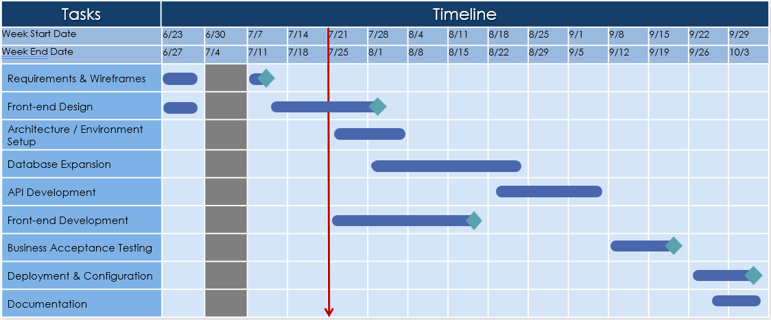

Milestones:
- 6/27 – Wireframes & Requirement complete
- 9/5 – Development Complete
- 9/19 – Testing Complete
- 10/3 – Go live

Coordination:
- 9/8 – 9/19: Business Acceptance Testing, Defect Resolution
- 9/8 – 9/19: API Testing with Amazon
- 9/22 – 10/3: Deployment Activities

Fees and Payment Terms

The total cost for the database project is $70,000. The payment will be structured as follows:
- 30% Upfront Payment: A payment of $21,000 is required upfront before the commencement of the project. This will cover the initial phases, including requirements gathering, analysis, and architectural design.
- 40% Midway Payment: An additional $28,000 will be due upon completion of the API development phase, ensuring that database and front-end structures are in place.
- 30% Upon Completion: The remaining $21,000 will be due upon successful project delivery and post-deployment validation.
Please note that the estimate provided does not include hosting fees, monitoring, or ongoing maintenance costs. These services can be arranged at an additional cost if required.

IN WITNESS WHEREOF, the parties hereto have executed this proposal as of the date last written below.

Acknowledgment
I hereby acknowledge that I have read, understood, and agree to the terms and conditions outlined in this proposal.

Approval
By signing this proposal, the client authorizes Anuki Consulting to proceed with the project as outlined and agrees to the payment terms specified.

Client Information
GreenCircle Certified, LLC
Name: Julie Golden
Title: Vice President of Marketing
Signature: __________________________
Date: __________________________

Consultant Information
ANUKI CONSULTING, LLC
Name: Shawn West
Title: Vice President
Signature: __________________________
Date: __________________________

