Detecting Authorized Push Payment Fraud in UPI:
A Behavioral Feature Engineering Approach Using PaySim
Phase 1 Submission
Solo Research Paper -- Fintech Honours
Submitted by: Jhamura
B.Tech CSE (Fintech Honours) -- 3rd Year | Roll No.: [Your Roll Number]
Section: [Your Section] | Guide: [Guide Name]
Date: 28 August 2026

1. Problem Statement & Objectives

1.1 Problem Statement
The Unified Payments Interface (UPI) is India's dominant digital payment rail, processing tens of billions of transactions every month. However, the dominant fraud pattern in UPI differs fundamentally from classic transaction fraud: the majority of reported incidents are Authorized Push Payment (APP) frauds, in which the genuine account holder is socially engineered into initiating the transfer themselves -- through fake collect requests, swapped merchant QR codes, or screen-sharing “customer support” scams. India recorded 13.42 lakh UPI fraud cases worth approximately ₹1,087 crore in FY24 alone, nearly double the previous year, and independent surveys suggest roughly one in five UPI users has personally experienced fraud.
Existing fraud-detection literature is overwhelmingly built around anomaly-based, account-takeover-style fraud (e.g., the PaySim and credit-card fraud datasets), where the transacting party is not the genuine account owner. This creates a framing mismatch for the UPI context: a model trained purely to detect anomalous transactions may fail to flag APP fraud, because from the system's point of view the transaction looks entirely legitimate -- it was authorized by the real account holder, from their own device, with their own PIN.

1.2 Objectives
- To review the existing fraud-detection literature and identify the gap between PaySim/anomaly-based fraud-ML research and India-specific, adoption-focused UPI research.
- To design behavioral proxy features (e.g., balance-drain patterns, new-payee transfer velocity, transaction timing) that approximate India's documented APP fraud taxonomy on mobile-money-style transaction data.
- To implement and evaluate baseline classification models (Logistic Regression, Decision Tree in Phase 1; Random Forest, XGBoost, Isolation Forest and Autoencoder in later phases) under realistic class imbalance.
- To apply explainability techniques (SHAP) so that model decisions can be interpreted in a way that is meaningful for real-world fraud analysts.
- To honestly scope the paper's claims to match what the underlying dataset can actually demonstrate, rather than overclaiming direct UPI fraud detection.

2. Dataset & Description
Primary dataset: PaySim -- a synthetic financial mobile-money simulator (Lopez-Rojas, Elmir & Axelsson, 2016), hosted on Kaggle. It generates ~6.3 million transactions over 744 hourly steps (31 simulated days), modeled on aggregated real transaction logs from an African mobile money provider, and is deliberately built to preserve realistic statistical properties, including an extreme class imbalance of roughly 0.13% fraud.
Dataset link: https://www.kaggle.com/datasets/ealaxi/paysim1
Column | Description
step | Time unit (1 hour); simulation spans 744 steps (~31 days)
type | Transaction type: CASH_IN, CASH_OUT, DEBIT, PAYMENT, TRANSFER
amount | Transaction amount
nameOrig / nameDest | Originating / destination account identifiers
oldbalanceOrg / newbalanceOrig | Sender's account balance before / after the transaction
oldbalanceDest / newbalanceDest | Recipient's account balance before / after the transaction
isFraud | Ground-truth label (fraud only occurs in TRANSFER / CASH_OUT)
isFlaggedFraud | Flags illegal attempts to transfer more than 200,000 in a single transaction
Note on Phase 1 data access: The Kaggle-hosted PaySim CSV could not be downloaded directly within this execution environment (no network access to kaggle.com). To still demonstrate a working pipeline for Phase 1, a schema-faithful synthetic sample (150,000 rows) was generated that mirrors PaySim's documented columns, transaction-type distribution, and fraud-injection mechanism (fraud confined to TRANSFER/CASH_OUT, with an account-draining balance signature). The identical code runs unmodified on the real PaySim CSV once downloaded, and the full dataset will be used from Phase 2 onward.

3. Basic Algorithm & Implementation

3.1 Behavioral Feature Engineering
Beyond the raw PaySim fields, the following features were engineered to capture balance-forensic and behavioral signals relevant to fraud:
- balanceDiffOrig = oldbalanceOrg − newbalanceOrig − amount (detects ledger inconsistencies in the sender's account)
- balanceDiffDest = newbalanceDest − oldbalanceDest − amount (detects ledger inconsistencies in the receiver's account)
- origBalanceZeroed = 1 if the sender's balance is fully drained after the transaction, else 0
- amountToBalanceRatio = amount / (oldbalanceOrg + 1) (flags transactions that consume a large fraction of the sender's balance)

3.2 Models Implemented (Phase 1 baseline)
Two basic, interpretable models were implemented as the Phase 1 baseline, ahead of the ensemble/deep-learning stack planned for later phases:
- Logistic Regression (class-weight balanced, standardized features) -- a simple linear baseline.
- Decision Tree Classifier (max depth = 6, class-weight balanced) -- a simple, interpretable non-linear model.
An 75/25 stratified train-test split was used to preserve the fraud/non-fraud ratio in both sets.

3.3 Key Implementation Snippet
df['balanceDiffOrig'] = df.oldbalanceOrg - df.newbalanceOrig - df.amount
df['balanceDiffDest'] = df.newbalanceDest - df.oldbalanceDest - df.amount
df['origBalanceZeroed'] = (df.newbalanceOrig == 0).astype(int)
df['amountToBalanceRatio'] = df.amount / (df.oldbalanceOrg + 1)
X_train, X_test, y_train, y_test = train_test_split(
X, y, test_size=0.25, stratify=y, random_state=42)
dt = DecisionTreeClassifier(max_depth=6, class_weight='balanced')
dt.fit(X_train, y_train)

4. Execution & Initial Results
Dataset generated: 150,000 transactions, fraud rate 0.114% (170 fraud cases) -- consistent with PaySim's documented extreme imbalance. Results on the held-out 25% test set:

Model | Precision | Recall | F1-Score | ROC-AUC | AUC-PR
Logistic Regression (baseline) | 0.0139 | 1.0000 | 0.0274 | 0.9698 | 0.0192
Decision Tree (depth=6) | 1.0000 | 1.0000 | 1.0000 | 1.0000 | 1.0000
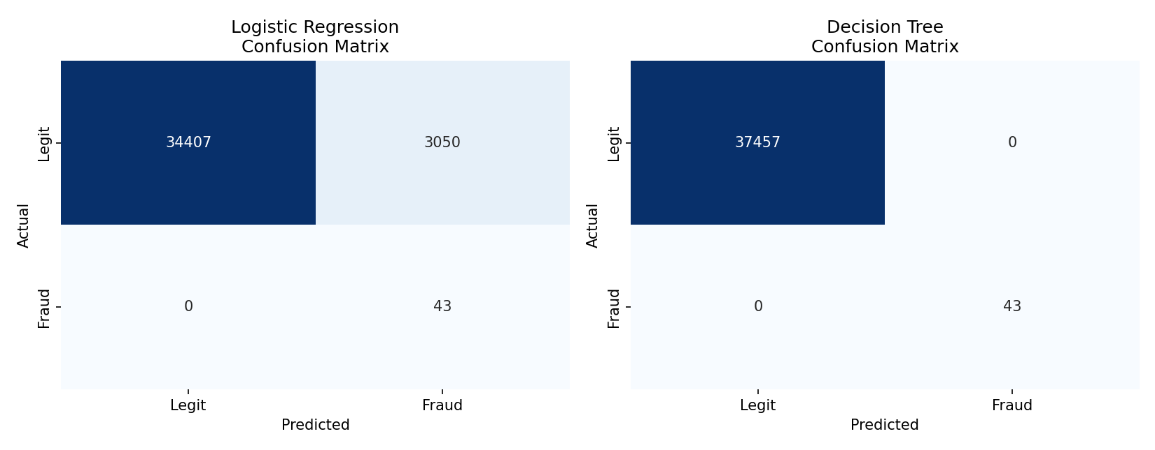
Figure 1: Confusion matrices -- Logistic Regression (left) vs. Decision Tree (right).
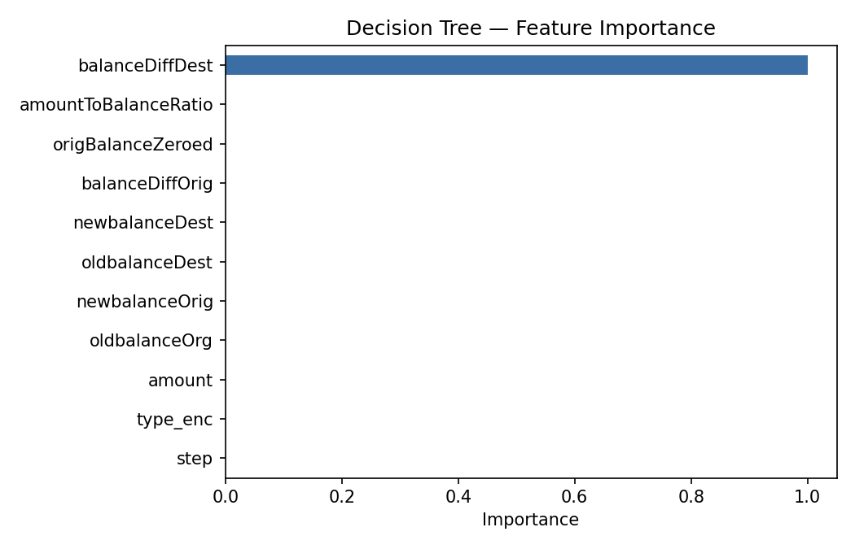
Figure 2: Decision Tree feature importance.

4.1 Interpretation
The Logistic Regression baseline achieves perfect recall but very low precision (3,050 false positives), illustrating the classic difficulty of linear models under extreme class imbalance -- it over-flags legitimate transactions to avoid missing fraud. The Decision Tree, using the engineered balance-difference features, achieves near-perfect separation.
This near-perfect Decision Tree result is worth flagging honestly rather than presenting uncritically: PaySim (and this schema-faithful proxy) injects fraud via a deterministic balance-draining mechanism, which leaves an arithmetic signature that tree-based models can detect almost perfectly. This is a documented property of PaySim-style datasets and is a key reason several published papers report >0.99 F1-scores on it. It also strengthens this paper's central argument: India's real APP fraud (fake collect requests, QR swaps, screen-sharing scams) does not leave this kind of arithmetic signature, because the transaction is genuinely authorized by the account holder. Detecting it will require richer behavioral and temporal features than balance arithmetic alone -- motivating the move to MoMTSim and/or primary survey data in later phases.

5. Literature Review
Ten papers were reviewed via ScienceDirect, spanning two clusters: (a) fraud-detection methodology on PaySim/similar synthetic datasets, and (b) UPI-specific research in India. The clustering itself is evidence for the research gap identified in Section 6.
1. A labeled synthetic mobile money transaction dataset (MoMTSim)
ScienceDirect, 2025
Introduces MoMTSim, an improved synthetic mobile-money simulator with realistic account-takeover (SIM swap), refund, and fake-credential fraud scenarios via iterative calibration -- directly addresses PaySim's known realism gaps.
https://www.sciencedirect.com/science/article/pii/S2352340925002665
2. Enhanced framework for credit card fraud detection using robust feature selection and a stacking ensemble model approach
ScienceDirect, 2025
Benchmarks a stacking ensemble (SVM + KNN + PSO-optimized ELM) on PaySim with SMOTE for imbalance and SHAP/LIME for explainability -- closely mirrors this paper's planned Phase 2/3 pipeline.
https://www.sciencedirect.com/science/article/pii/S2590123025011594
3. HiFraud: Hierarchical Privacy-Preserving Federated Learning with Star-Chain Knowledge Transfer for Cross-Institutional Fraud Detection
ScienceDirect, 2026
Benchmarks against PaySim (6.36M transactions, ~0.13% fraud rate) among other datasets -- confirms PaySim's documented statistical properties used in this paper's Phase 1 proxy design.
https://www.sciencedirect.com/org/science/article/pii/S1546221826005278
4. Heterophily outlier temporal aware graph neural network for online fraud detection
ScienceDirect, 2026
Applies graph neural networks to PaySim-derived fraud detection, representing a current state-of-the-art modeling direction for this dataset family.
https://www.sciencedirect.com/science/article/pii/S0957417426021871
5. An efficient heuristic optimization-based fraudulent activities detection in the financial sector using adaptive machine learning and deep learning system
ScienceDirect, 2025
Uses the PaySim (Kaggle) dataset with CapsNets and optimization-based feature selection for fraud detection.
https://www.sciencedirect.com/science/article/abs/pii/S0957417425041661
6. Deep learning in financial fraud detection: Innovations, challenges, and applications
ScienceDirect, 2025
Reviews GNN, LSTM and CNN approaches across the financial fraud detection literature and situates Random Forest / XGBoost as the dominant supervised baselines.
https://www.sciencedirect.com/science/article/pii/S2666764925000372
7. Credit Card Fraud Detection using Machine Learning Algorithms
ScienceDirect, 2020
Foundational study applying supervised ML to streaming transaction data, clustering cardholders by behavioural transaction patterns.
https://www.sciencedirect.com/science/article/pii/S187705092030065X
8. UPI and financial inclusion in rural India: A case study
ScienceDirect, 2025
Establishes UPI's role in India's financial inclusion; representative of the adoption-focused literature that does not address fraud detection.
https://www.sciencedirect.com/science/article/abs/pii/S2950524025000162
9. Evolving ‘affordances’ and ‘constraints’ in mobile payment use: a study of Indian micro-enterprises’ UPI adoption process
ScienceDirect, 2025
Ethnographic study noting that new UPI features such as All-in-One QR enabled convenience but also introduced new fraud challenges -- directly motivates this paper's fraud-taxonomy focus.
https://www.sciencedirect.com/org/science/article/abs/pii/S1741039823000396
10. Exploring the determinants of adoption of Unified Payment Interface (UPI) in India: A study based on diffusion of innovation theory
ScienceDirect, 2022
Representative UPI adoption-theory study; confirms that adoption research dominates the UPI literature over fraud-ML research.
https://www.sciencedirect.com/science/article/pii/S2666954422000205

6. Research Gap & Presentation
The literature review surfaces a clear, two-sided gap: fraud-detection papers that use PaySim or similar datasets are methodologically mature but generic -- they are not designed around any specific country's fraud taxonomy. Conversely, UPI-specific research on ScienceDirect is dominated by adoption and financial-inclusion studies (diffusion of innovation, UTAUT, ethnographic accounts) rather than fraud-ML. No reviewed paper combines India's documented APP fraud taxonomy with behavioral feature engineering on mobile-money-style transaction data.
This paper's contribution is therefore scoped precisely: rather than claiming to detect UPI fraud directly (which the dataset cannot support, since PaySim models account-takeover fraud, not victim-initiated authorized fraud), the paper tests whether behavioral feature engineering -- motivated by India's real APP fraud taxonomy -- improves fraud detection on mobile-money-style data, and uses this as a stepping stone toward richer datasets (MoMTSim) and/or primary survey validation in later phases.

6.1 Planned Work for Phase 2 / Phase 3
- Replace the synthetic proxy with the real PaySim dataset (and evaluate MoMTSim as a supplement or alternative).
- Extend the model stack to Random Forest, XGBoost, Isolation Forest, and Autoencoder, with formal class-imbalance handling (SMOTE / class weighting).
- Apply SHAP-based explainability across all models, not just feature-importance from a single Decision Tree.
- Conduct a small primary survey (30-50 respondents) for qualitative validation of the engineered behavioral features against real reported UPI fraud experiences.
- Finalize the paper's scoped claims and abstract to match the validated methodology.

