**1. Introduction**

E-panchayat The vast majority of India’s population lives in the village and the Panchayat represent the face of the governance for these villagers.e-Panchayat is an initiative for providing software solution attempting automation of Gram Panchayat functions .Benefits are improved citizen services, better transparency, streamlining of procedures and monitoring of revenues & services. The gram panchayat provide birth ,death certificate, domicile certificate, receipts for house tax, water tax etc… They give order for construction of road,buildings, renewal of building. They keep records of their monthly &amp; yearly budget. E-Panchayat provides online service to the people living in that area. All the services which are done manually are made online in the project. The people can about their panchayat,activity notifications and all other information related their villages are applied and verified online. The users on the people in the village can complain about their problem through online.

The people can about their panchayat, activities notifications and all other information related their villages. All the applications and certificates are applied and verified online. The users on the people in the village can complain about their problem through online.Suggestions are also accepted from the people for the development of their village.The user can request any application, suggestion, and complaint at anywhere and at anytime.The grampanchayat provide birth certificate, death certificate, domicile certificate, receipts for house tax, water tax etc..

**2**. **Problem Statement**

Design and develop a comprehensive digital platform for Gram Panchayats that integrates administrative functions, citizen services, and community engagement. The platform should address challenges such as inefficient paper-based processes, lack of transparent information dissemination, and limited citizen participation. It should provide efficient online services, promote transparency in governance, and empower local communities to actively participate in decision-making and development initiatives.

**3. Objectives**

* Objectives for a digital Gram Panchayat might include improving governance.

enhancing citizen services, promoting transparency, and enabling efficient communication.

* It could also involve digitizing records, facilitating online transactions, and fostering community participation through digital platforms.
* Improving internal management and efficiency.

**4. Proposed Work:**

**4.1 System Requirement**

**System requirements for developer:**

**Software requirements:**

* Sublime text 3
* Xampp

**Hardware requirements:**

* Laptop\Desktop

**4.2 System architecture diagram:**

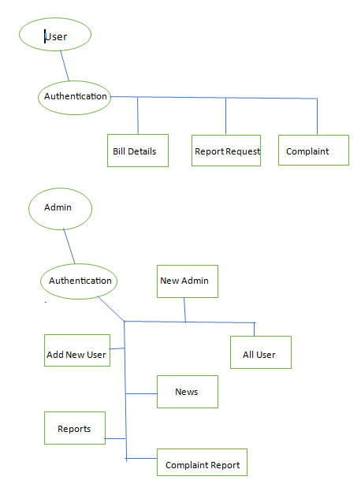

Fig: Proposed System Architecture of E-Grampanchayat

In the above system, the user interacts with a web portal for the E-Gram Panchayat. This platform serves as the central hub for all online services and interactions. Residents of the village can register themselves on the E-Gram Panchayat platform. They provide their basic information and contact details during this process. Citizens can use the platform to submit requests for services or documents. This may include requests for birth certificates, property tax payments, or filing grievances. In admin site we can add sub-admin and users. Collect all complaints form users.

**4.3 Module Details**

**1. Dynamic Pages**

- These are interactive pages typically accessible after user authentication (login):

* **User Page**

- This page provides personalized information for individual users. Users can view details such as their water and land bill statements. They can also request certificates and submit complaints online. Additionally, display news that is relevant to individual users' concerns and interests.

* **Admin Panel**

- This is an administrative interface for managing the Gram Panchayat's online presence. Key features include:

- Adding and managing user accounts, including updating user information and handling access permissions.

- Retrieving information for all users, useful for responding to inquiries and managing services.

- Posting and managing news updates for the entire community. This includes announcements, project updates, and community events.

- Handling certificate requests, verifying eligibility, and issuing certificates.

- Managing and responding to complaints submitted by users**.**

**2. Static Pages**

- These are the informational static pages accessible to anyone visiting your Gram Panchayat's website:

* **Home Page**

- This page serves as the entry point for visitors. Include historical information about the Gram Panchayat, its milestones, and a brief overview of its activities. Mention any major public utilities or services provided by the Gram Panchayat. Showcase a media gallery with images and videos of Gram Panchayat initiatives, projects, and community events.

* **Members Page**

- Provide a list of all Gram Panchayat members, including their names, positions, and contact details. This page helps villagers and visitors know who their representatives are and how to reach them.

* **Contact Us Page**

- Share detailed contact information for the Gram Panchayat, including physical addresses, phone numbers, email addresses, and office hours. This page makes it easy for community members to get in touch with the Gram Panchayat for various purposes

**5. Implementation Details**

1. Data Acquisition:

* Data Source:

Collect data from reliable sources such as car marketplaces, dealership, etc.

Consider features like make, model, year, mileage, condition, etc.

* Data Cleaning:

Remove duplicates, if any.

Handle missing values.

Address outliers and anomalies.

* Data Exploration:

Conduct exploratory data analysis to gain insights into the dataset.

Visualizations can be very helpful.

2. Data Preprocessing:

* Feature Engineering:

Extract relevant information from the data.

Scale or normalize numerical features.

* Train – Test Split:

Divide the data into training and testing sets. Common splits are 70-30 or 80-20.

3. Model Selection:

* Regression Models:

Consider models like Linear Regression.

* Ensemble Methods:

Combine multiple models for improved accuracy.

4. Model Training:

* Hyperparameter Tuning:

Consider using cross – validation to prevent overfitting.

* Model Evolution:

Use appropriate metrics to assess performance.

5. Deployment:

* Web Application:

Deploy the model using platform Flask.

Consider cloud platforms like AWS, Google Cloud.

* User Interface:

Create a user – friendly interface for users to input car details and get predictions.

6. Testing and Validation:

* Unit Testing:

Ensure that each component of the project works as expected.

* End - to - End Testing:

Verify that the entire pipeline from data input to prediction output functions correctly.

7. Documentation and Reporting:

* Code Documentation:

Add comments and docstrings to make the code understandable.

* Project Report:

Summarize the project, including data sources, preprocessing steps, model selection, training process and evaluation results.

8. Maintenance and Updates:

* Monitoring:

Set up monitoring to track model performance over time.

* Model Updates:

Periodically retrain the model with new data to maintain accuracy.

9. Future Enhancements:

* Additional Features:

Consider adding more features that might impact car prices.

* Model Improvement:

Experiment with different algorithms or ensemble techniques for potential performance gain.

**Outcomes / Result:**

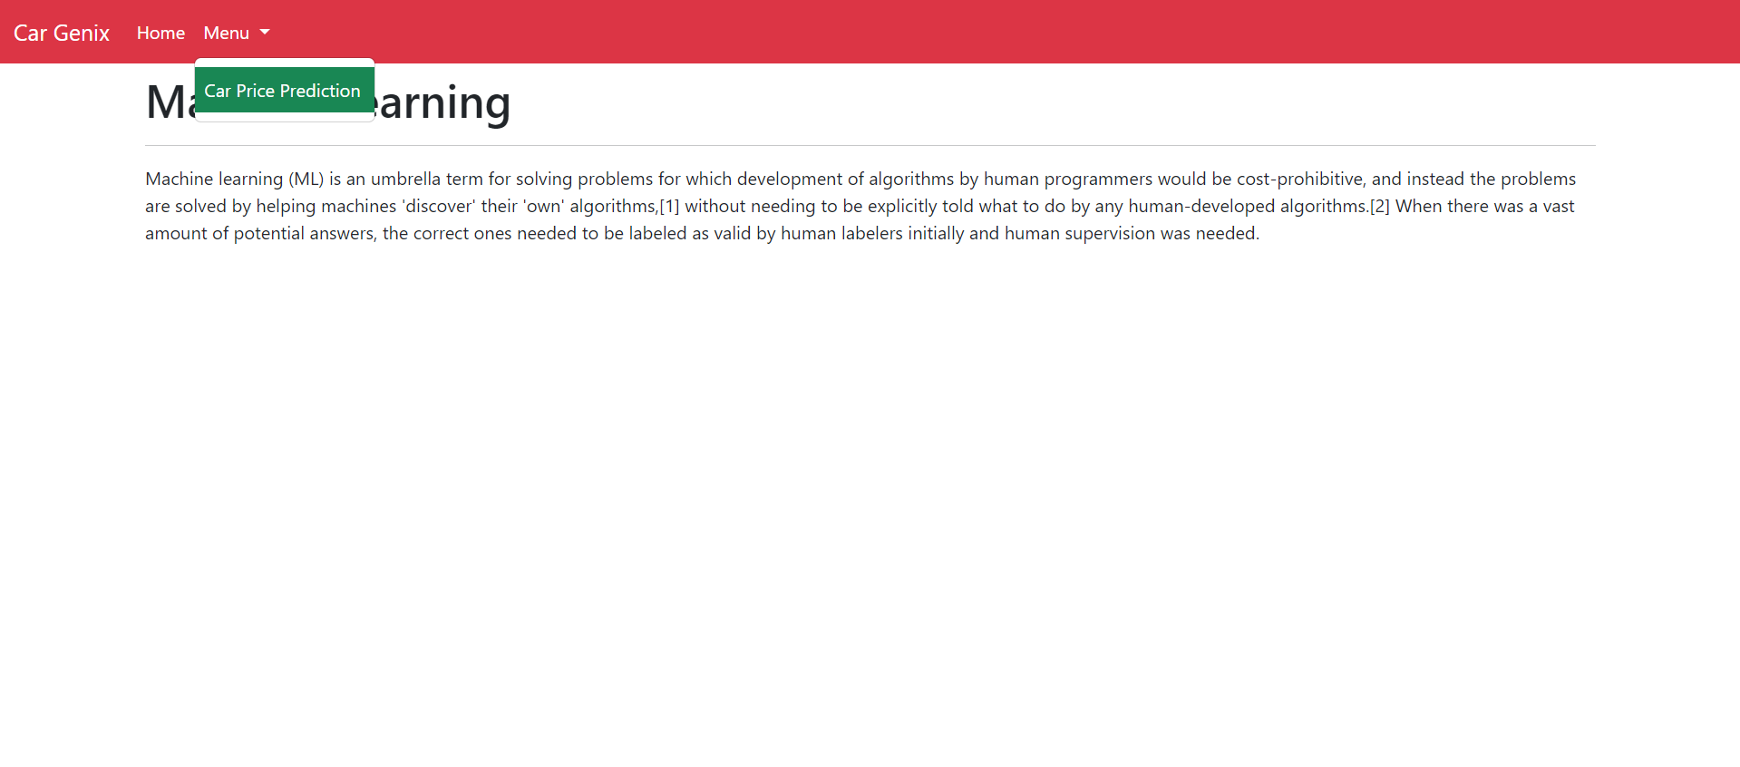

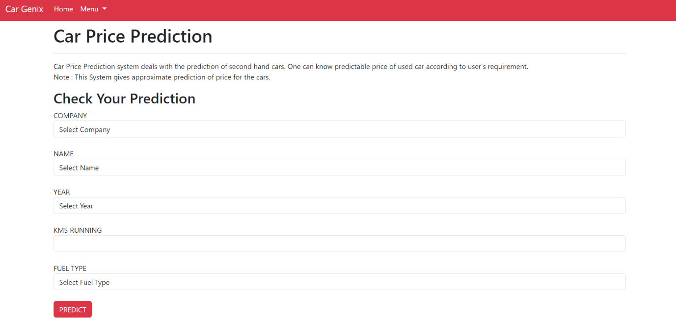

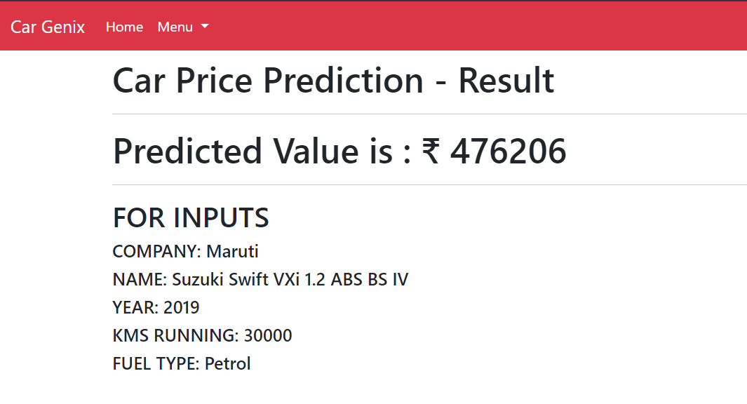

**6. Conclusion & Future Work**

Conclusion:

In conclusion, the development of the Car Price Predicting System has been a significant endeavor that has yielded valuable insights into the realm of data science, machine learning, and user interface design. The project’s primary goal was to create a reliable and user-friendly platform for predicting car prices based on historical data and relevant features. Through rigorous planning, implementation, and testing, we have successfully achieved this objective.

Future Work:

* Explore more sophisticated algorithms or advanced machine learning techniques such as deep learning models like neural networks to potentially improve prediction accuracy.
* Investigate additional features or data sources that could provide valuable information for predicting car prices. This might include factors like market trends, consumer sentiment or economic indicators.
* Factor in regional or geographical information that might impact car prices. Different areas may have varying supply and demand dynamics, influencing the value of cars.
* Connect with external APIs or databases to gather more comprehensive information about cars, such as vehicle history reports, accident records or maintenance history which could influence pricing.
* Utilize NLP techniques to provide better explanations for the predictions made by the model. This can enhance trust and transparency in the system.
* Enhance the user interface for ease of use and to provide more informative outputs, possibly with interactive visualizations.

**References:**

a.Scikit-Learn Documentation: <https://scikit-learn.org/stable/documentation.html>

b. TensorFlow Documentation: <https://www.tensorflow.org/guide>

c. Keras Documentation: <https://keras.io/api/>

d. Kaggle Datasets: <https://www.kaggle.com/datasets>

J. Zhang, S. Zhang, X. Cao, and J. Li, "DeepAR: Probabilistic Forecasting with Autoregressive Recurrent Networks," in Proceedings of the International Conference on Machine Learning (ICML), 2018.