Water Quality Monitoring System
Raspberry pi Mini Project Report
Using: Raspberry Pi, ADS1115 ADC, TDS & Turbidity Sensors, LED and email Alert & Visualization
Name | Roll No. | Branch | Semester | Project Type | Academic Year
Anulipi Jana | 25-15-02 | Applied Physics | II Sem MTech | Mini Project | 2025–26

1. Abstract
Access to clean water is fundamental to human health. This project presents a low-cost, real-time water quality monitoring system built around a Raspberry Pi single-board computer. The system acquires analog sensor data—Total Dissolved Solids (TDS) and turbidity—through an ADS1115 16-bit ADC over the I²C bus, computes quality metrics using calibrated polynomial equations, and displays live readings on a 16×2 LCD. An LED-based alert sub-system provides immediate visual feedback when measured parameters exceed safe thresholds. The integrated solution delivers actionable water quality information suitable for rural, domestic, and field deployment scenarios.

2. Introduction
Embedded IoT-based systems, portable, affordable, and capable of delivering real time continuous data without specialist intervention.
This project targets two of the most critical water quality indicators:
- Total Dissolved Solids (TDS) – quantifies dissolved salts, minerals, and organic matter (measured in ppm).
- Turbidity – measures the optical clarity of water (measured in NTU). High turbidity signals suspended particles, sediment, or biological contamination.
By combining these two sensors with a Raspberry Pi and a real-time LCD display , visualization and LED alert system, the project provides a complete pipeline from raw analog sensing to human-interpretable output.

3. System Architecture

3.1 Hardware Components
Component | Module / Part | Role in System
Microcontroller | Raspberry Pi | Central processing, I²C master, GPIO control
ADC | ADS1115 (16-bit) | Converts analog sensor voltages to digital values
TDS Sensor | Gravity TDS Probe | Measures dissolved solids in water (ppm)
Turbidity Sensor | SEN0189 / analog | Measures water clarity (NTU)
Display | 16×2 LCD (I²C PCF8574) | Shows real-time TDS, turbidity, and status
Alert System | RGB / Tri-colour LEDs | Green = safe, Yellow = caution, Red = unsafe
Power Supply | 5 V / 3 A USB-C | Powers RPi and peripherals
Connection | Breadboard & Jumper wires | Make connection between all devices.

3.2 I²C Bus Configuration
Both the ADS1115 ADC and the LCD backpack (PCF8574) share the Raspberry Pi's I²C bus (GPIO 2 – SDA, GPIO 3 – SCL). The ADS1115 occupies address 0x48 (default) and the LCD occupies 0x27. The turbidity sensor is connected to ADS channel P0 and the TDS sensor to channel P1.

3.3 TDS sensor
It measures the water's electrical conductivity (EC) and converts it to a TDS value using a conversion factor.
Working Principle: When inorganic salts (like NaCl, CaCO₃) dissolve in water, they split into ions (positively charged cations & negatively charged anions). The sensor has two electrodes immersed in water. A voltage is applied, and the current flowing between them is measured. More ions = higher conductivity. Pure water has very low conductivity; saltwater has high conductivity .

3.4 Turbidity Sensor
Use optical phenomena to quantify suspended particles scatter light to measures water clarity.
Working Principle: Light source and photodetector positioned at 90° angle. Measures light scattered sideways. Receiver detects light reflected/back scattered by particles .Measures light absorbed/transmitted through the sample. more light absorbed = higher turbidity

3.5 LED Alert Logic
Three GPIO-controlled LEDs provide a colour-coded visual alert layer on top of the LCD display:
LED Colour | Water Status
Green | Safe
BLUE | Polluted

4. Software Design

4.1 Libraries & Dependencies
The system software is written in Python 3 and relies on the following libraries:
Library | Purpose
adafruit-circuitpython-ads1x15 | ADS1115 ADC driver (I²C)
RPLCD | 16×2 I²C LCD character display driver
RPi.GPIO | GPIO control for LED outputs
board / busio | Circuit Python hardware abstraction layer
time.sleep | Loop delay for 2-second sampling interval
matplotlib | Graph plot to show how the tds and turbidity change with water quality.

4.2 Signal Processing & Calibration
Raw voltage readings from the ADS1115 are converted to physical units using experimentally derived polynomial equations:
TDS (ppm) = (133.42 × V³ – 255.86 × V² + 857.39 × V) × 0.5
Turbidity (NTU) = –1120.4 × V² + 5742.3 × V – 4352.9
where V is the measured voltage in volts.

5. Circuit Connection

Rpi | ADS1115 | TDS (ppm) | Turbidity (NTU) | LED | LCD Status
Power 5V |  | VCC | VCC | Power | VCC
GND | GND | GND | GND | GND | GND
SCL (Pin 5) | SCL |  |  |  | SCL
SDL (Pin 3) | SDL |  |  |  | SDL
Power 3V | VDD
 | A0 |  | A0
 | A1 | A1
Pin 11 |  |  |  | GREEN
Pin 13 |  |  |  | BLUE

6. Circuit Loop
The integrated main loop (combined from tds_check.py and turb_check.py) executes the following steps every 2 seconds:
- Read TDS voltage from ADS1115 channel P1 and turbidity voltage from channel P0.
- Compute TDS (ppm) and turbidity (NTU) using the calibration equations above.
- Classify water status: No Water / Clean / Dirty / Salty for TDS; Clear / Cloudy / Turbid for turbidity.
- Drive the appropriate LED (Green / Yellow / Red) via GPIO based on combined thresholds.
- Update the 16×2 LCD — Line 1: sensor values; Line 2: combined status string.
- Print a formatted debug summary to the serial console for logging and graphical representation.

7. Results & Observations
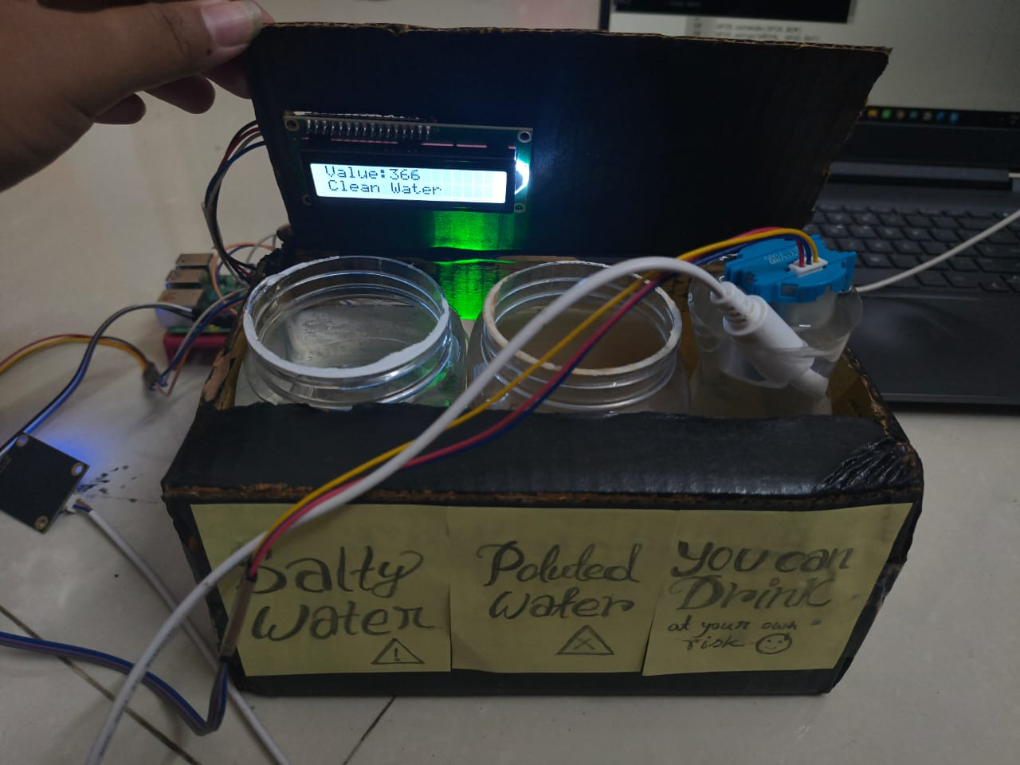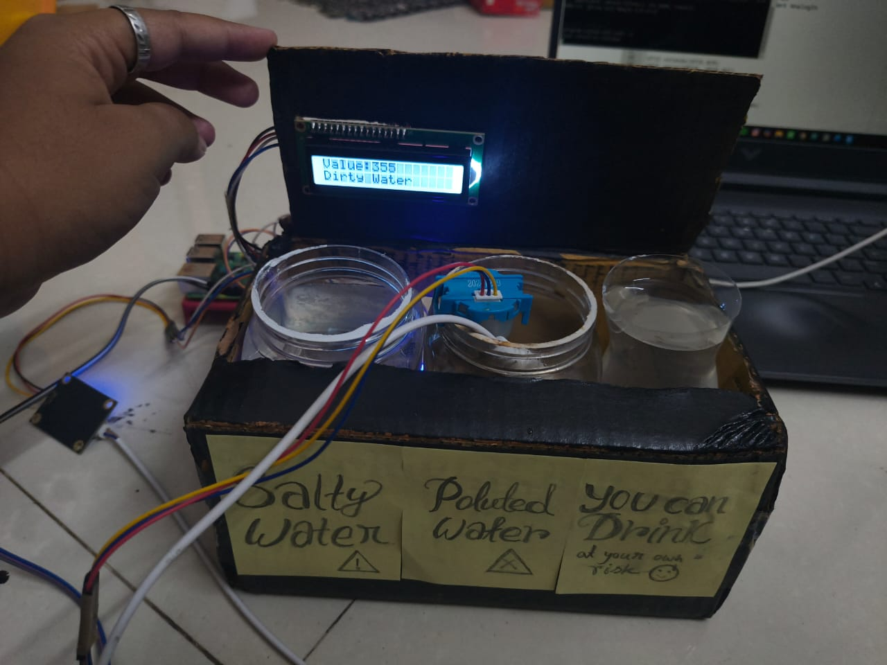
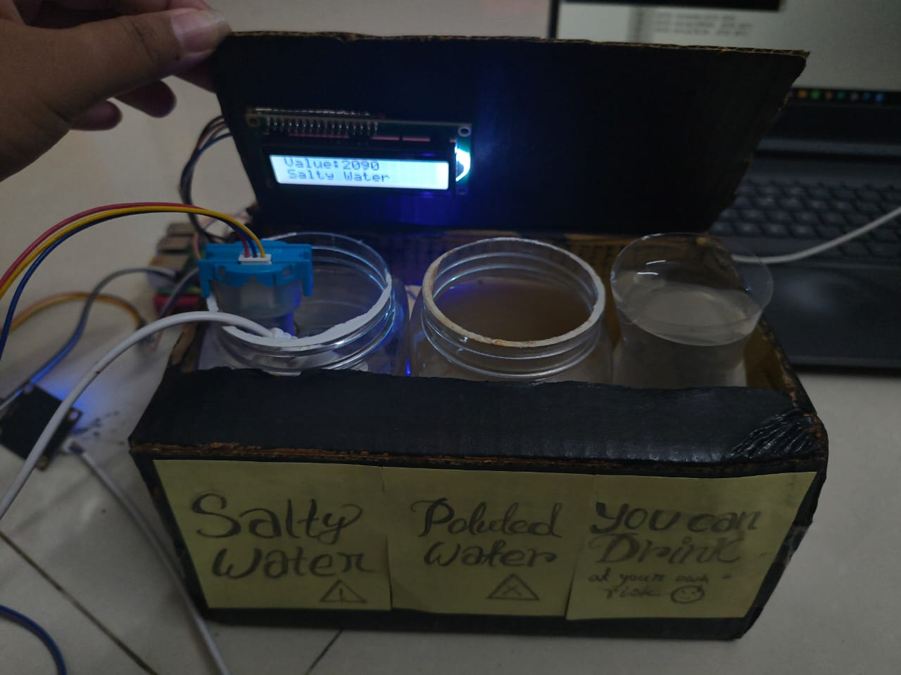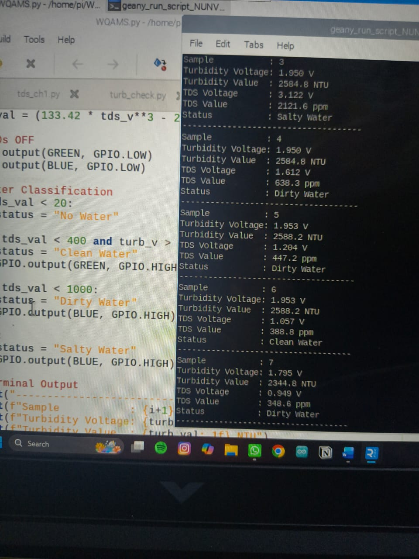

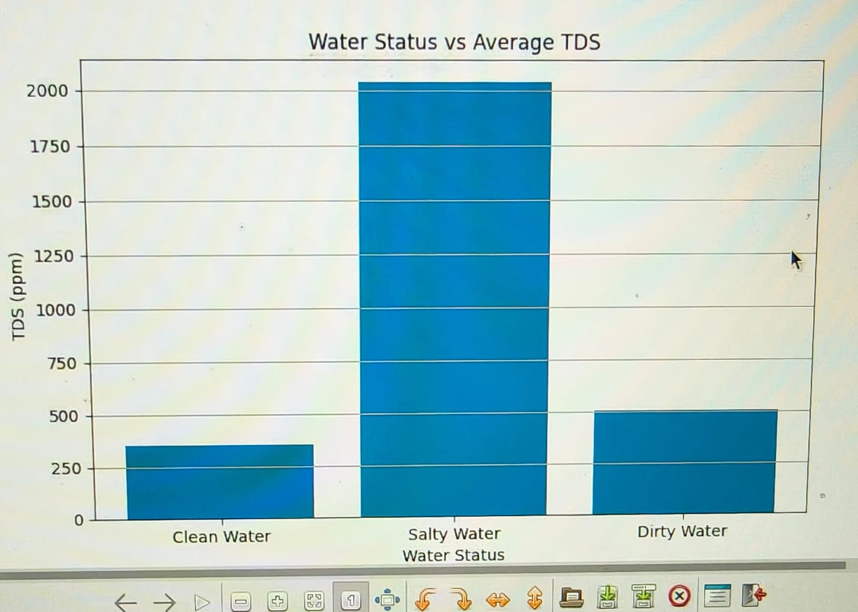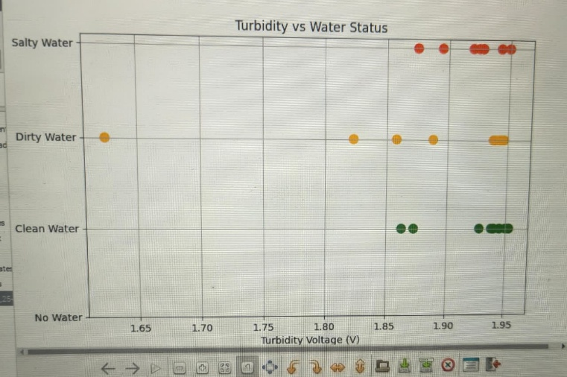
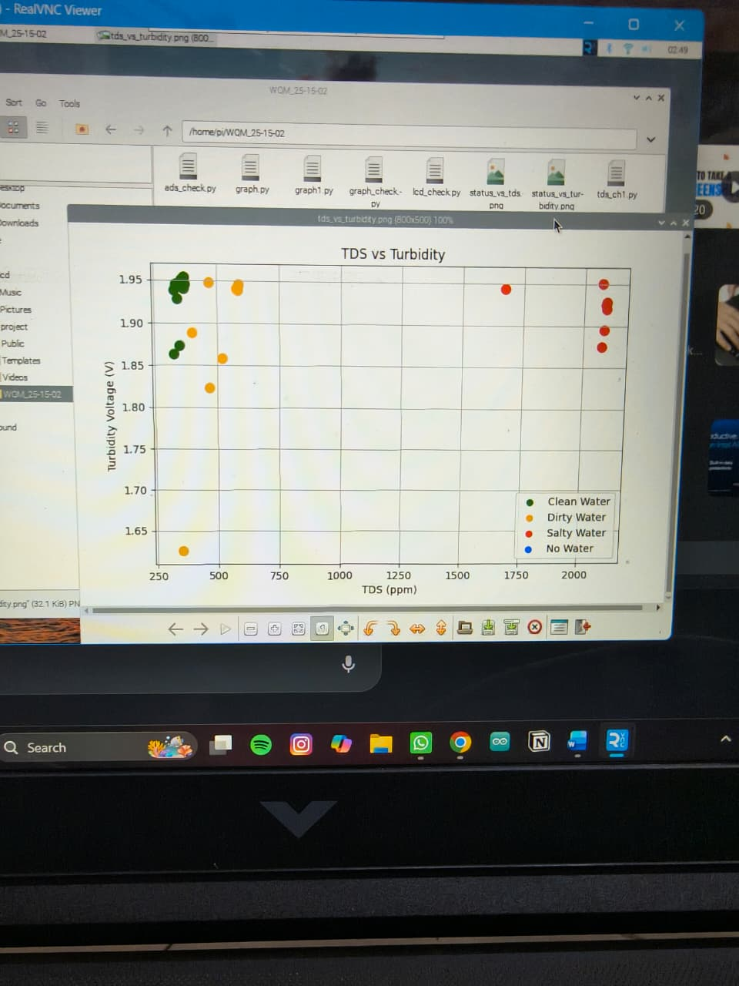

8. Challenges
8.1> Rpi is slower than other processor. Take multiple attempts just to connect properly.
- Patient
8.2> Compatibility of each device as they have difference version, port, IP addresses.
- version check before write code. If mismatch install properly.
8.3> As there are multiple components connected on a single chip difficult to find out issues on HW or software.
- Divide into modules check each and every code individually then combine them.
8.4> Installation problem. Libraries like Pandas, LCD drive, adafruit-circuitpython-ads1x15 some time create path, version problems also take a lot of time.
8.5> Due to voltage or manufacturing or other reason Sensor’s output range became very small. 0.001 difference.
- Calibration

9. Conclusion & Future Scope
The Water Quality Monitoring System successfully demonstrates real-time, multi-parameter water quality assessment using low-cost embedded hardware. The combination of TDS and turbidity measurements with an LED alert system provides an intuitive, actionable output suitable for non-expert users.
Planned enhancements for future iterations include:
- Addition of pH and dissolved-oxygen sensors for a more comprehensive water quality index.
- Wi-Fi/MQTT data uplink to an IoT dashboard (e.g., ThingSpeak or Node-RED) for remote monitoring and historical trending.
- Buzzer-based audible alerts for environments where visual LEDs may be missed.
- Machine-learning-based anomaly detection trained on historical sensor data to distinguish contamination events from sensor drift.
- Waterproof enclosure design with IP67 rating for outdoor or submerged deployment.

