· 1

·1
I
A' PP. V 118
:1 . ·1 1·

Bank AL Habib Limited
:
FORM 'R'
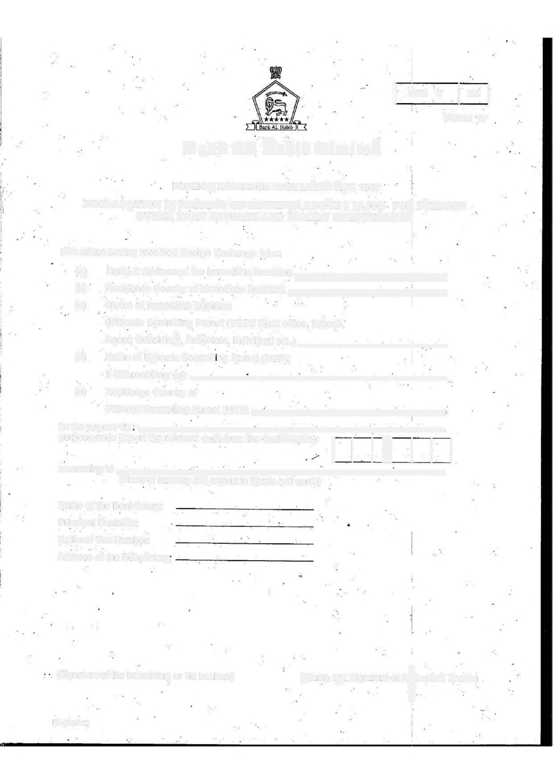

FOREIGN EXCHANGE REGULATION ACT, 1947

DECLARATION IN RESPECT OF RECEIPTS ABOVE $ 10,000/- FOR PURPOSE
- . OTHER THAN EXPORTS AND FAMILY MAINTENANCE
• • . - ·1 .
I
'i
We advise having received foreign Exchange from:

(a) Namie & Address of the Immediate Remitter: •
(b) Residence Country of Immediate Remitter: _

(c) Status of Immediate Remitter: · "
' ' .
(Ultimate Controlling Parent (UCP)/ Head office, Branch,

Agent, Subsidiary, Associate, Individual etc.) _
(d) Name of Ultimate Controlling Parent (UCP): . I
' .
I
jfifferent.for (a) _ (e) Residence Country of
Ultimate Controlling Parent (UC) _

tort/le Du4f[OS&VLe; •
purpose code (Insert the relevant code from the CodeGuide):
[LILLLJ
ff!f[if.IQ
(Name of currency and amount in figures and words)

Name of the Beneficiary: Principal Business:
National Tax Number: Address of the Beneficiary.

,·

(Signatureof the beneficiary or his bankers) (Stamp and Signature of AthodSed Dealer)

FX.-55 (0412)

